How to look up the status of a requisition.

Role: SAP S/4 Requisitioner | Frequency: As Needed

1.Begin Create Purchase Requisition app (ME51N) | 
2.Click on the Menu Button | 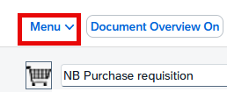
3.Follow the drop down menus and click on Other Requisition | 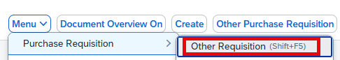
4.Enter the requisition number and then enter on your keyboard | 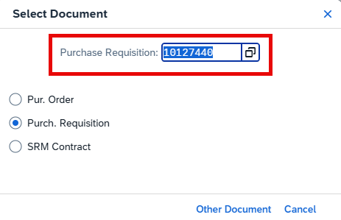
5.A: Click the Status Tab  5.B: The PO number will be displayed here | 