University faculty and staff who do not have a formal SAP S/4 Procurement role on behalf of their departments may access and browse e-catalogs and products on the Ariba Network for pricing comparisons and other information. Visitors may place items into a shopping cart and create a downloadable .pdf of the contents. They cannot check out with items or make purchases of any Ariba Network e-catalog products.

Note: Visitors may encounter a pop-up blocker upon first access to the Ariba Network. Set your pop-up blocker to always allow for Ariba Network.

Note: When visiting e-catalogs on the Ariba Network for the first time, if you are presented with cookies options, always select Accept Cookies for all e-catalogs.

Role: Open Access - Faculty and Staff | Frequency: As Needed

1. From myUK portal, access the University Services selection from the top menu. Under Procurement, click View only Ariba catalog. | 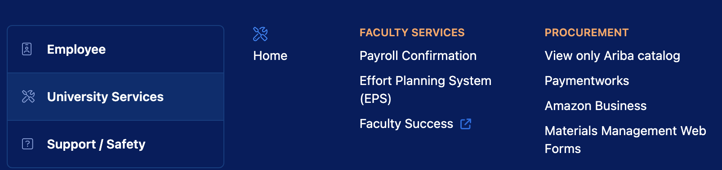
2. Upon reaching the network, locate the Shop By box on the left panel. Hover over the > icon to right of Supplier and click View All Suppliers. | 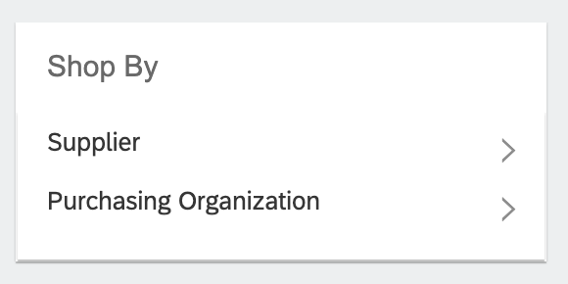
3. The next screen displays the listing of available e-catalogs. Click any supplier name to visit their catalog for product information. | 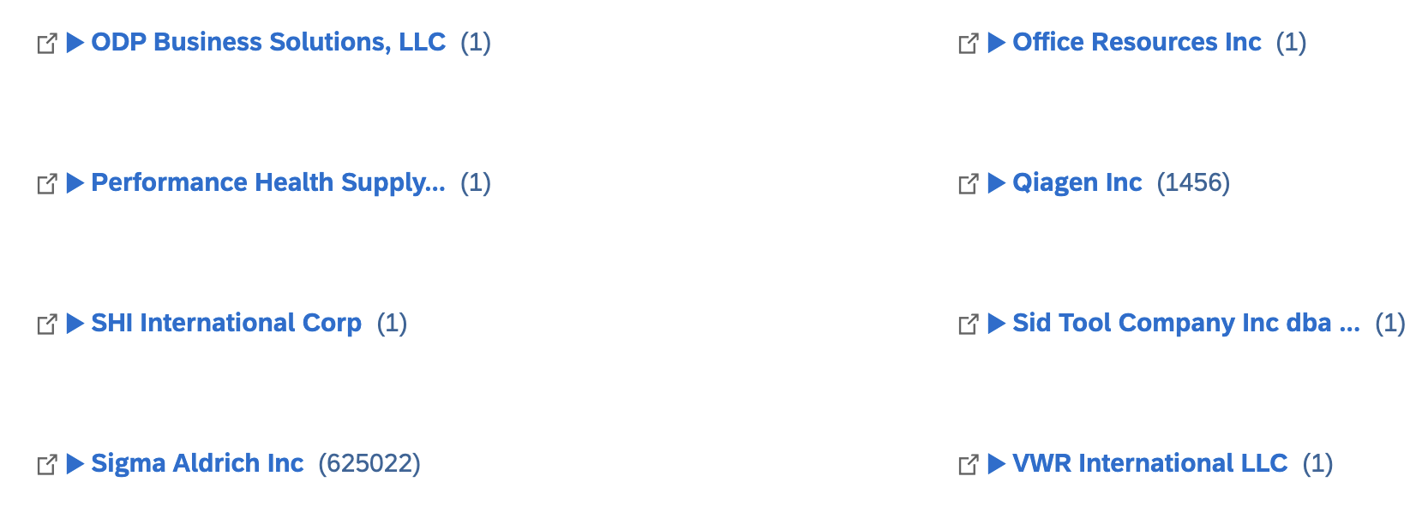
4. You may place items from a supplier’s e-catalog into a Shopping Cart to create a downable Shopping List.  Check out from any e-catalog supplier with products to return to Ariba Network. | 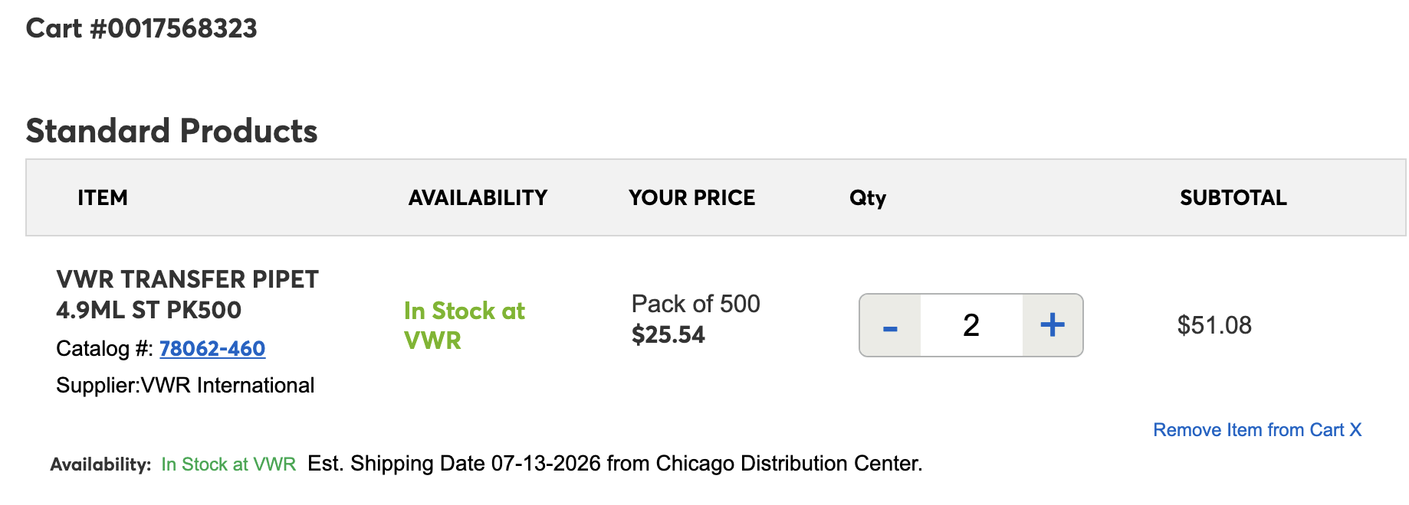
5. Upon returning to Ariba Network, click Review Cart. | 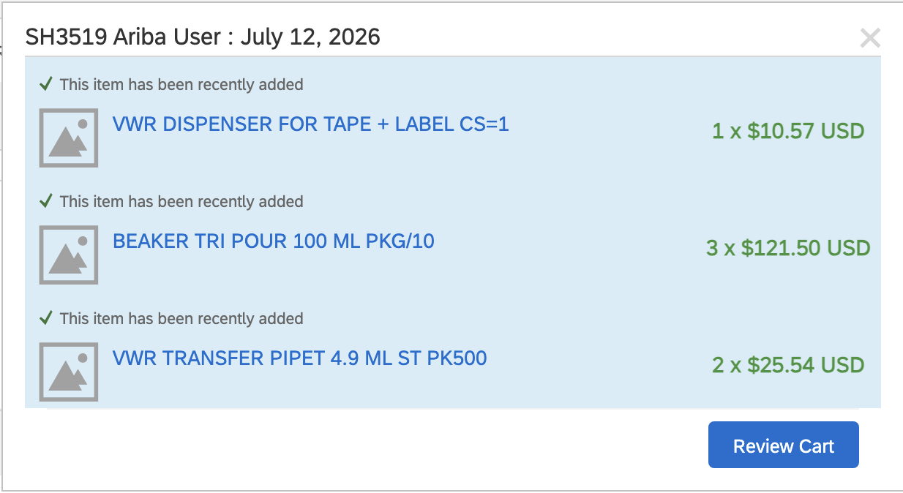
6. Click the Print icon at top of the Shopping Cart. | 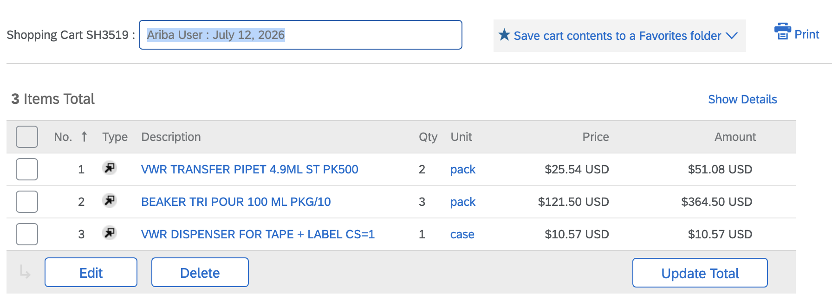
7. Right click anywhere on the Shopping List screen and select Print from the pop-up menu. | 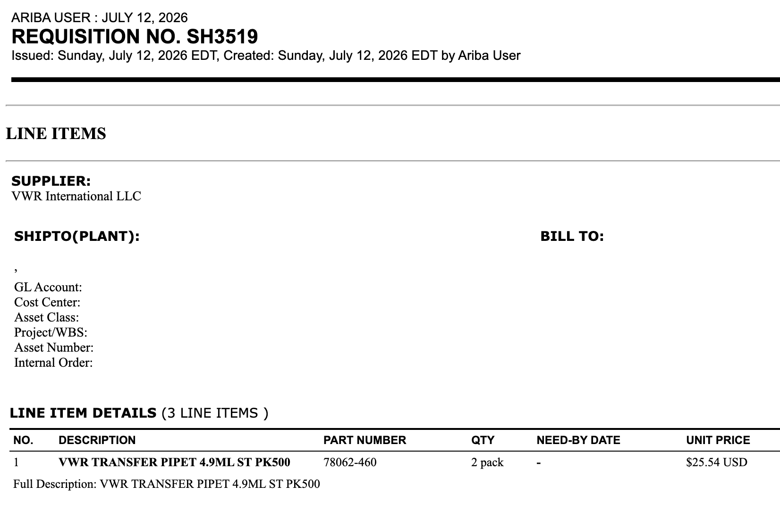
8. Save as PDF or direct to printer for hard copy. | 