Requisitions created using the Fiori Manage Purchase Requisitions Professional app can be displayed and potentially edited when needed.

Important: Requisitions can only be edited to the point of their first level of approval. If a change is needed to an order after it is approved, contact the Procurement Services buyer responsible for the resultant purchase order. The buyer name can be found on the requisition under Purchasing Group.

Role: SAP S/4 Requisitioner | Frequency: As Needed

From the myUK Landing Page, Click the SAP Fiori Launchpad icon to begin. | 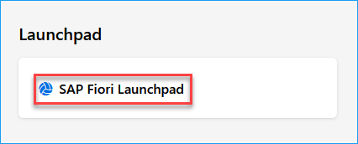
1. Begin Manage Purchase Requisitions Professional app | 
2. The following screen features tools for requisition searches | 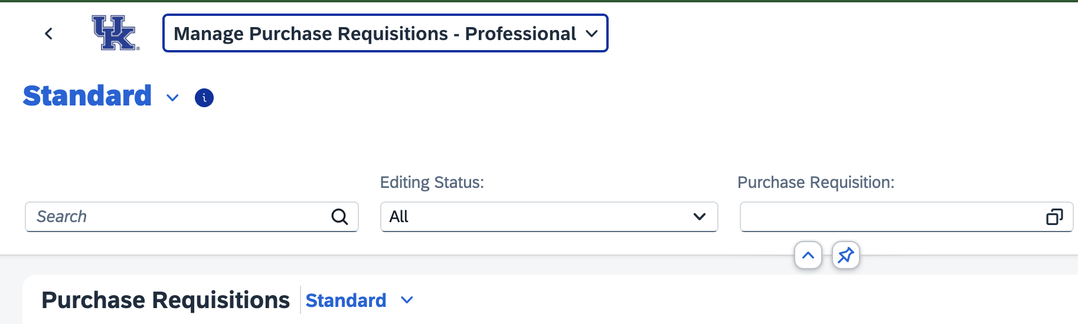
3. Click Adapt Filters on the right | 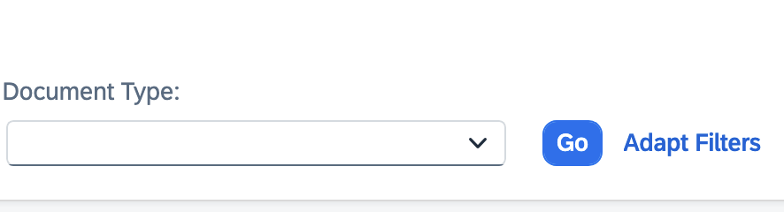
4. Set additional selections on which you need to conduct requisition searches. At a minimum, ensure to add Created by and Draft Created On to your view. | 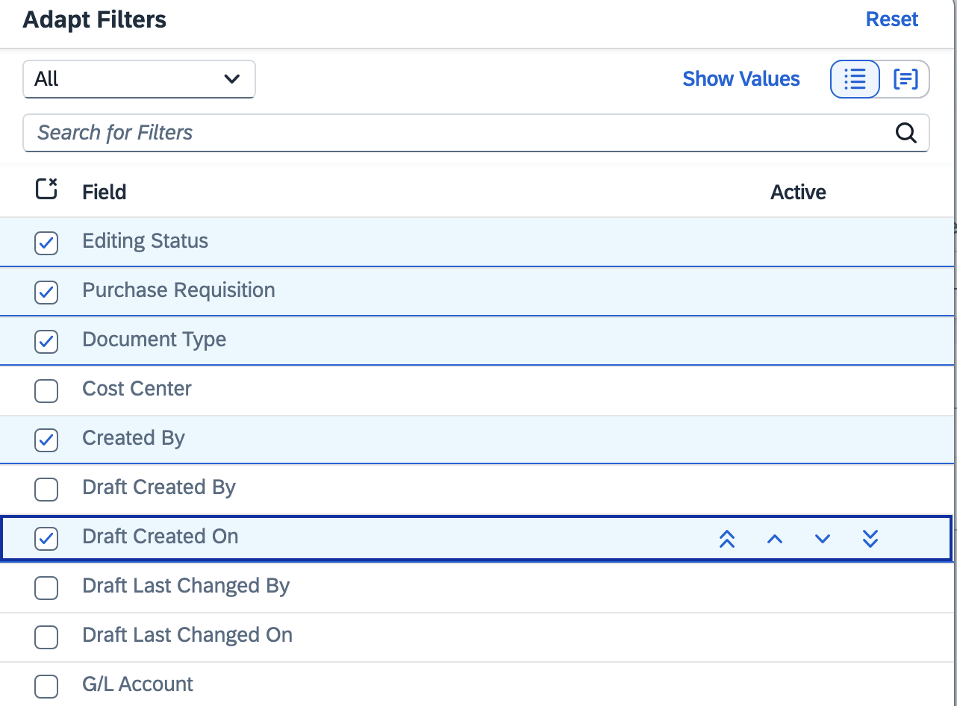
5. Enter search selections needed to locate documents.  Example: Enter your linkblue ID under “Created By” along with a “Draft Created On” date interval. | 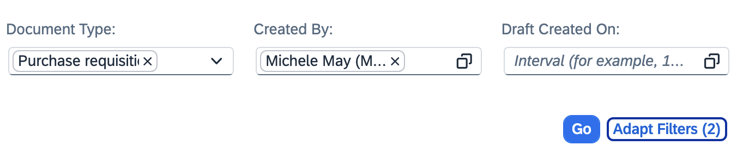
6. Search results will show in the bottom section. The display will include the requisition name, value, status, etc. | 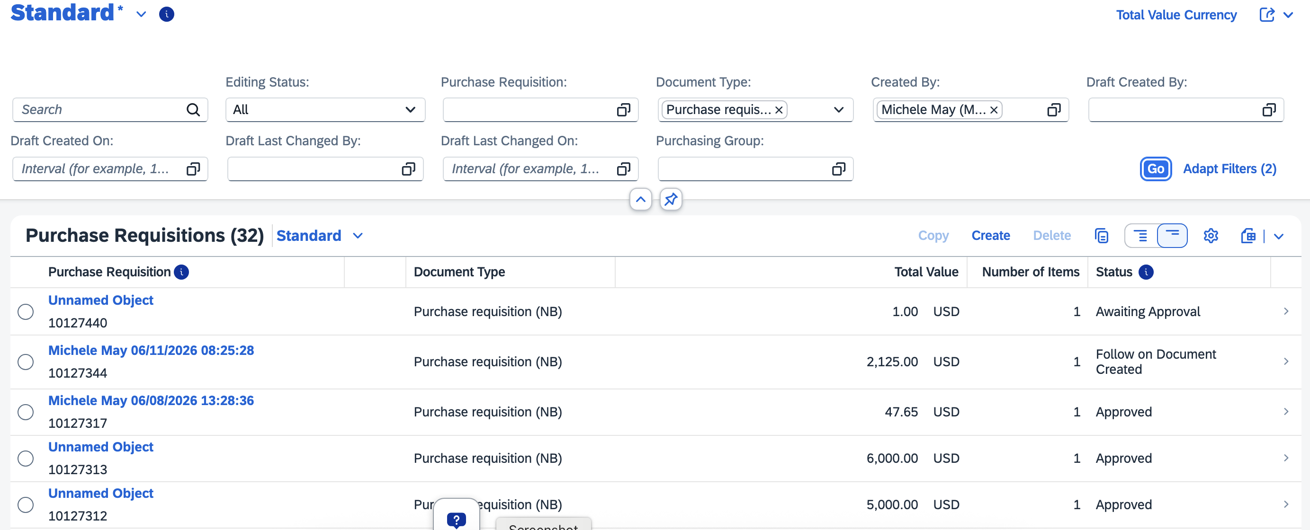
TIP: A toolbar is available to the right to adjust layout, export data to Excel, etc. | 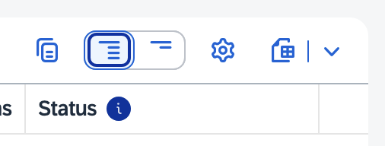
7. Click into any requisition line to display contents. | 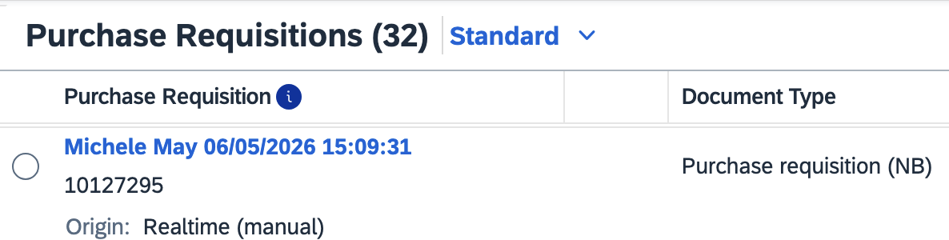
8. Click Edit to make needed changes to the requisition.  Remember: Requisitions can only be edited to the point of their first level of approval. If a change is needed to an order after it is approved, contact the Procurement Services buyer responsible for the resultant purchase order. The buyer name can be found on the requisition under Purchasing Group. | 
9. Perform needed changes and click Save when finished to retrigger Approval workflow. | 