Integrated ordering systems utilize specific master data in specific cells for correct order placement and processing. It’s important to follow the exact steps below to enter your delivery address information correctly and not enter any building name or address components via free text entry.
Failure to follow the delivery steps will cause an order to fail to process or deliver correctly.

Completing the Delivery Address section is one of the last steps for completing either an e-catalog or Free Text requisition.

Role: SAP S/4 Requisitioner | Frequency: As Needed

1. Navigate to Delivery Address section | 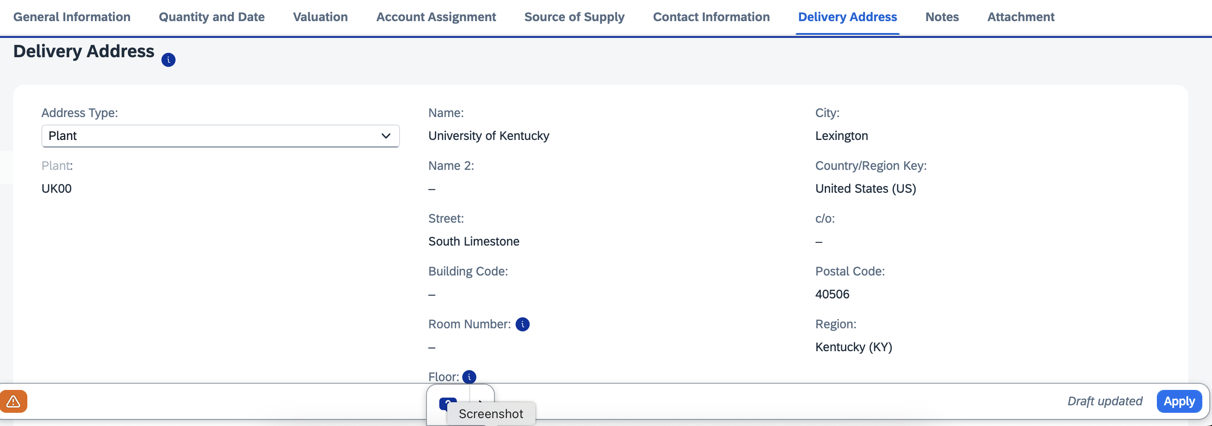
2. Select Reference from the Address Type dropdown menu | 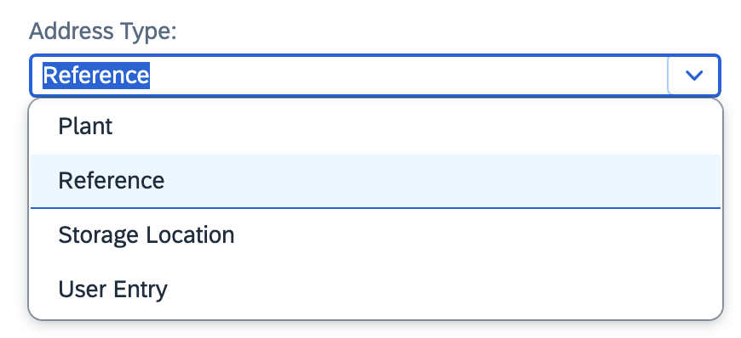
3. Click the Search icon on the right side of Address Number field | 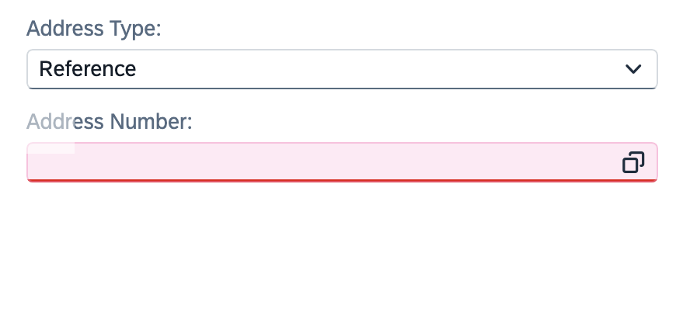
4. Expand to Show All Filters, if needed | 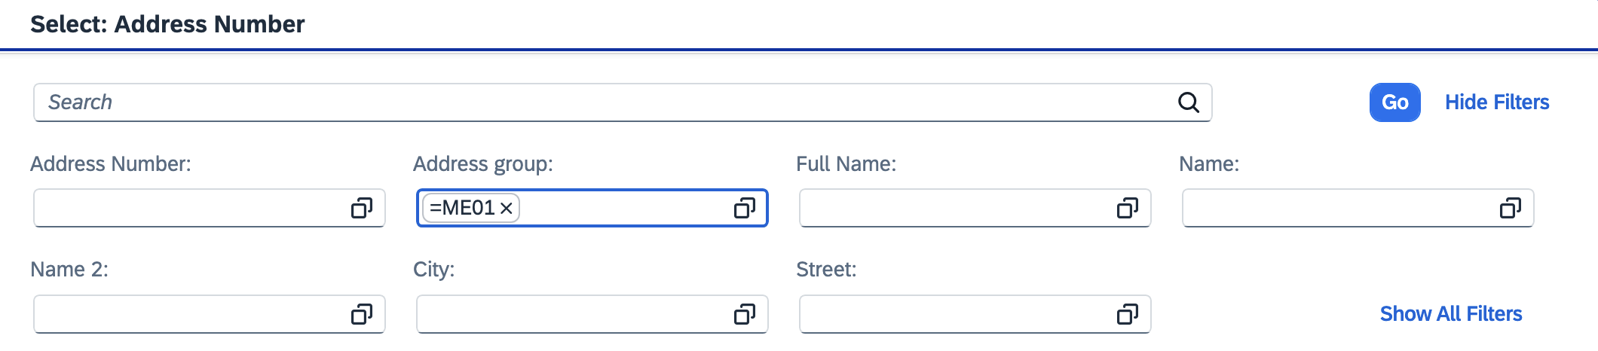
5. Ensure ME01 is selected for Address Group.  Enter your Delivery Building Location Code in the Search 2 field. For campus-based buildings, this is typically your postal speed-sort code. If needed, a full building listing is available on the Procurement Services website. Click Go. | 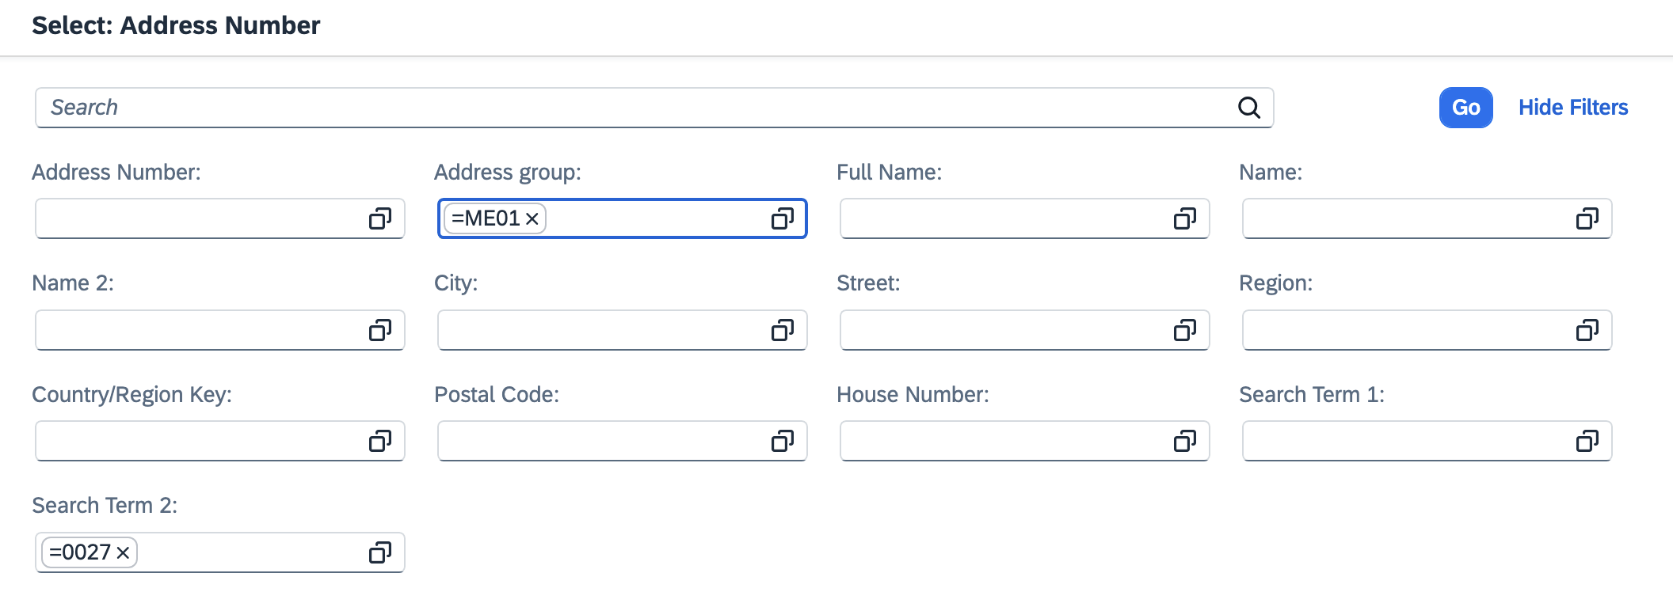
6. Select your delivery building from the search results | 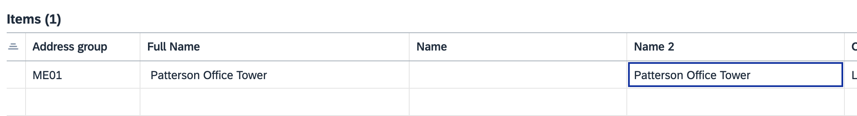
TIP: It is a good idea to record this number for convenient and quick usage on future orders. | 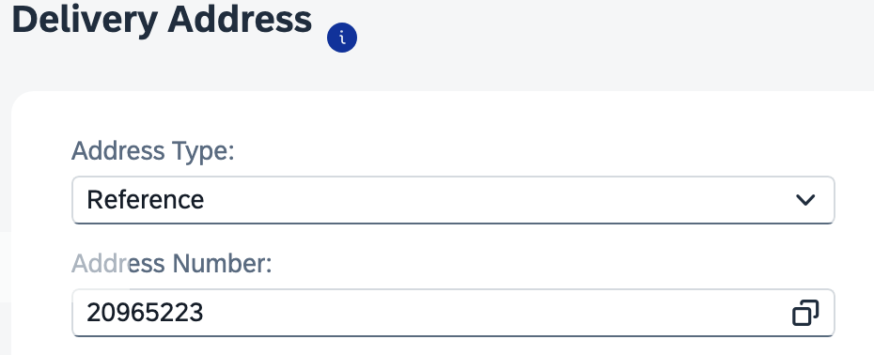
7. Select User Entry from the dropdown menu | 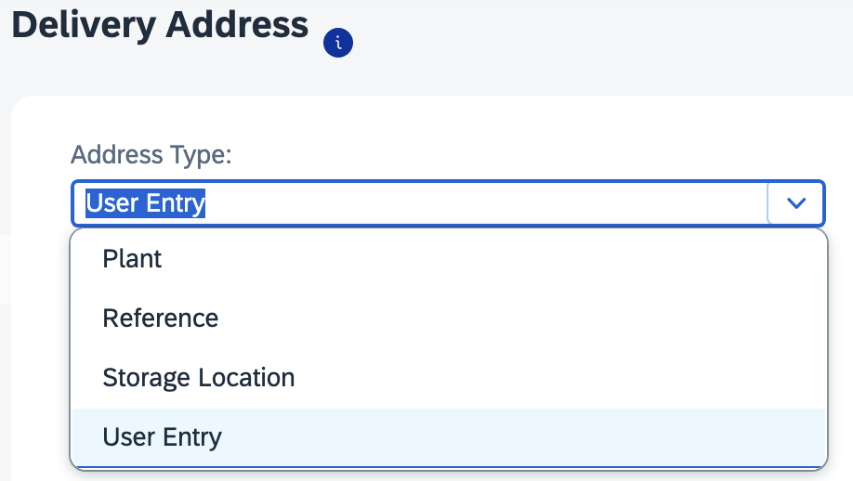
8. Add the following to the User Entry panel:  > Add the room number to the end of the street address  >Add the room number in the Room Number field  >Add the Floor  >Enter the c/o person’s name | 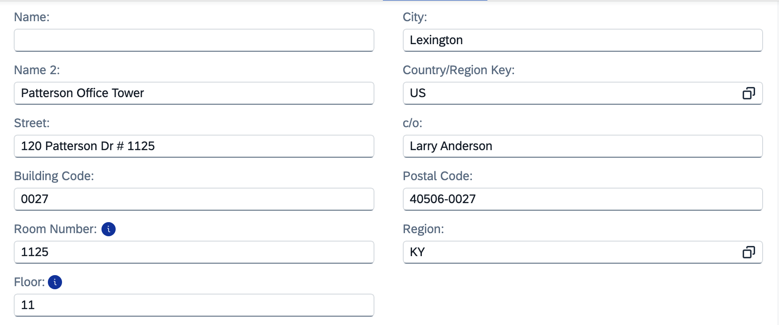
9. Click Apply to finish Line-Item Details | 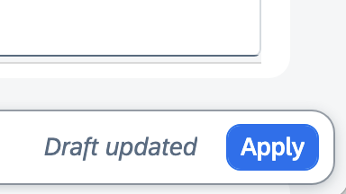
10. Repeat completion of Delivery Address Details on each remaining line item(s) along with other needed details depending on order type. | 