Use this Quick Reference Card (QRC) to create Free Text requisitions via SAP S/4 Fiori App – Manage Purchase Requisitions Professional.

Important: You must load and complete the Default Settings for Users app prior to creating a Fiori Requisition. Ensure first to bookmark the Default Settings for Users app to your SAP S/4 home page and complete the requirements. Steps are listed directly on the app itself for guidance or you may utilize a Quick Reference Card from the Procurement Services website, Learning and Training page for support.

You must also bookmark the Manage Purchase Requisitions Professional app to your home page from the Add Apps menu.

Role: SAP S/4 Requisitioner | Frequency: As Needed

From the myUK Landing Page, Click the SAP Fiori Launchpad icon to begin. | 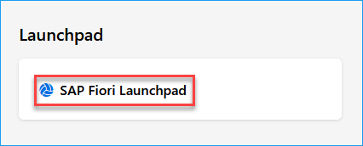
1. Select Manage Purchase Requisitions Professional | 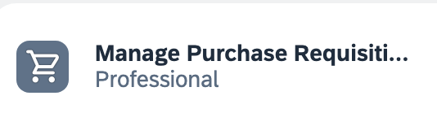
2. Click Create at the right of the Requisitions page | 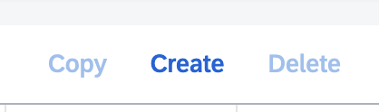
3. If desired, you may overwrite the Purchase Requisition Description cell with a customized entry specific to the order. | 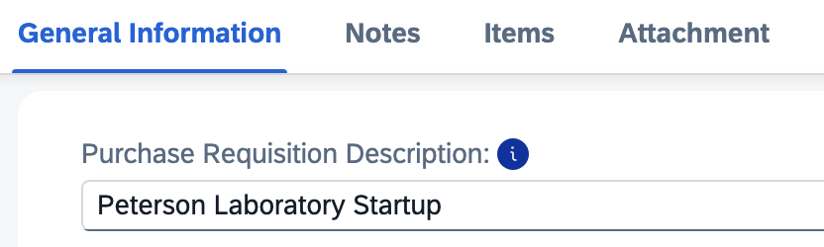
4. Ensure the Document Type is NB for campus areas for Free Text orders.  Note: For Free Text orders, UKHC-specific areas may utilize NB or ZB Document Types depending on the nature of each purchase. A ZB/NB decision matrix is available on the Procurement Services website, Hospital Procurement section for UKHC Requisitioners. | 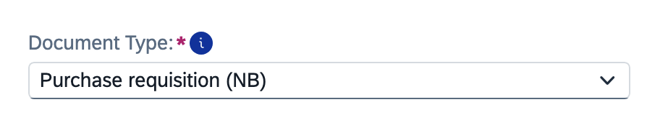
5. Ensure the Automatic Source Determination box is checked | 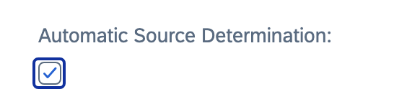
6. Enter a header note related to business purpose or justification. | 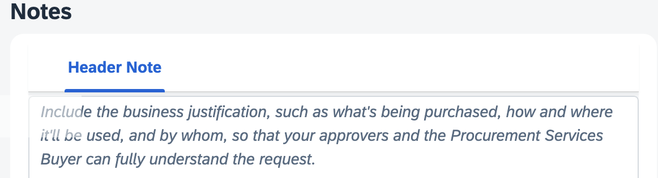
7. Scroll to the Items section to begin Line-Item 1. Click Create on the right and select Material from the dropdown. | 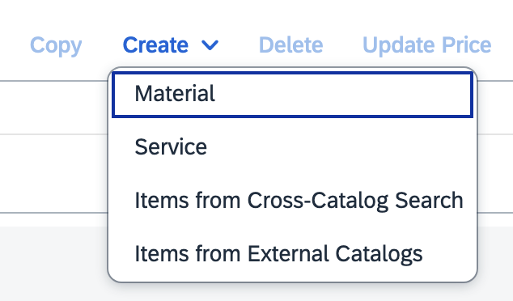
8. Begin on the left side of the General Information section for Line Item 1.  Your Default Settings entries should auto-populate most entries.  Account Assignment Category can be changed as needed for specific order needs.  >Set to K if cost object is Cost Center  >Set to P if cost object is WBS element  >Set to X if you plan to charge to multiple cost objects  Distribution Indicator should be Single Account Assignment unless you plan to split the line-item cost among multiple funding sources. | 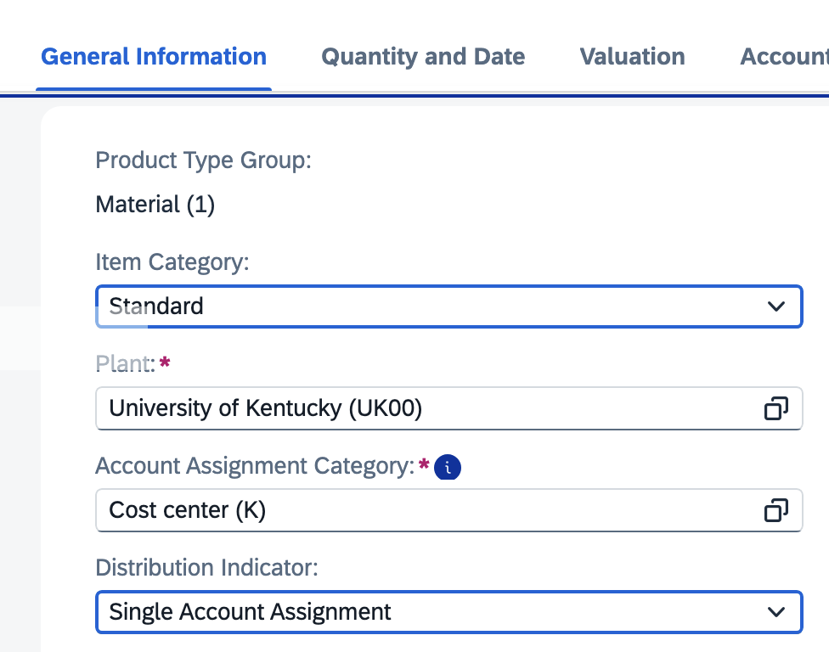
9. Enter description for this line item | 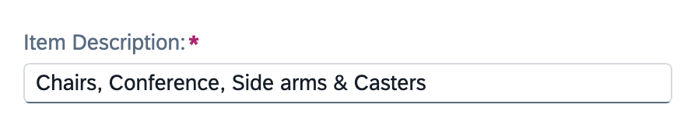
10. Click the icon on the right to search and select the Material Group | 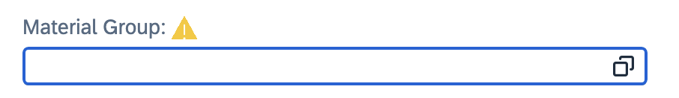
11. Select the Material Group that most closely aligns with the description of the commodity that you are ordering.  You may use the search bar for a keyword search or click the column headers to sort in ascending or descending order for manual search.  >For campus users, use only Material Groups with an 8-digit number.  >For UKHC areas, use only Material Groups other than 8-digit.  *Important: Do not use material groups preceded with any alpha-characters (e.g., C).  *Important: Assign the same Material Group to every line-item on your requisition. | 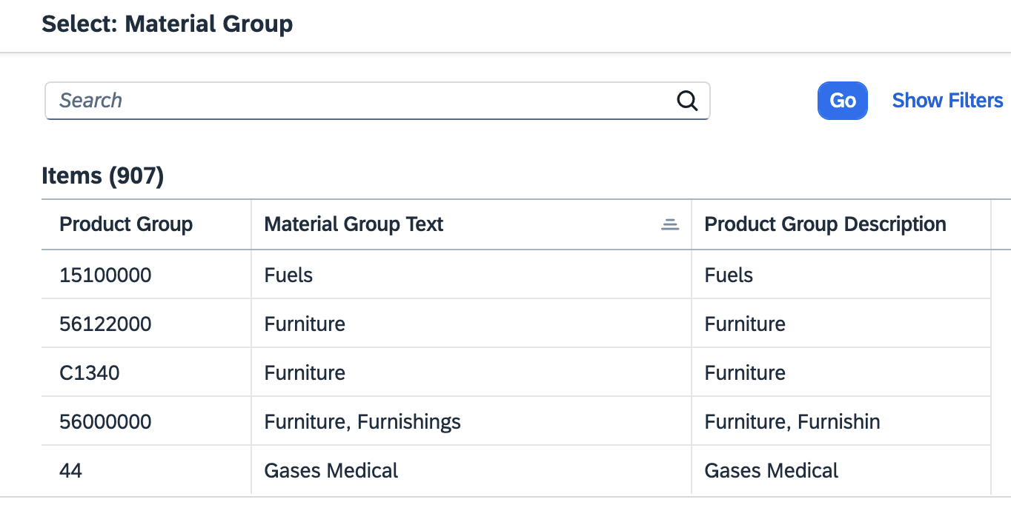  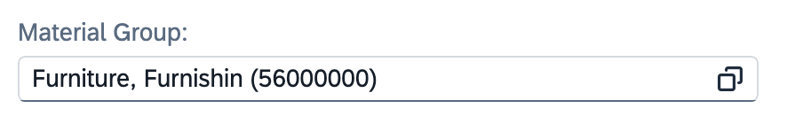
12. Enter the supplier product (catalog) number from the quote | 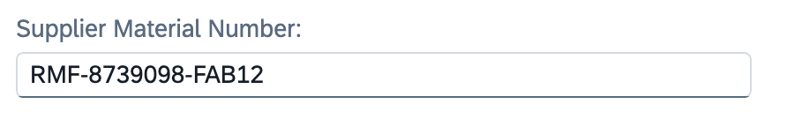
13. Click the search icon on the right of Desired Vendor | 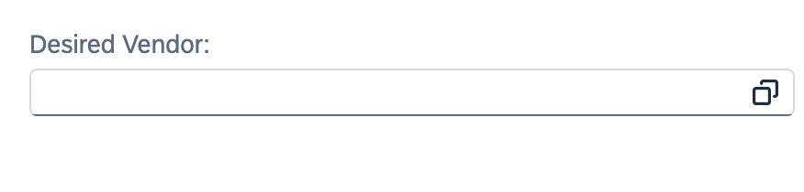
14. Perform a wildcard search for the vendor name by placing asterisks (*) at the ends of and between keyboards.  Ensure to select the correct vendor entry from the results.  If after conducting a thorough search it is determined the needed vendor is not available, send a new vendor invitation via the PaymentWorks application. | 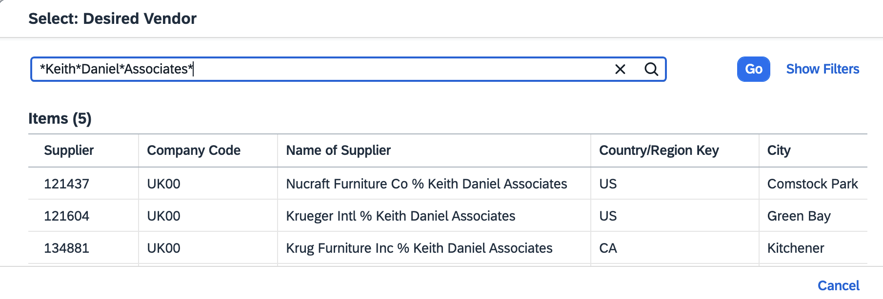
15. Navigate to the Quantity and Date tab. Enter the order quantity for the line item and the Desired Delivery Date. | 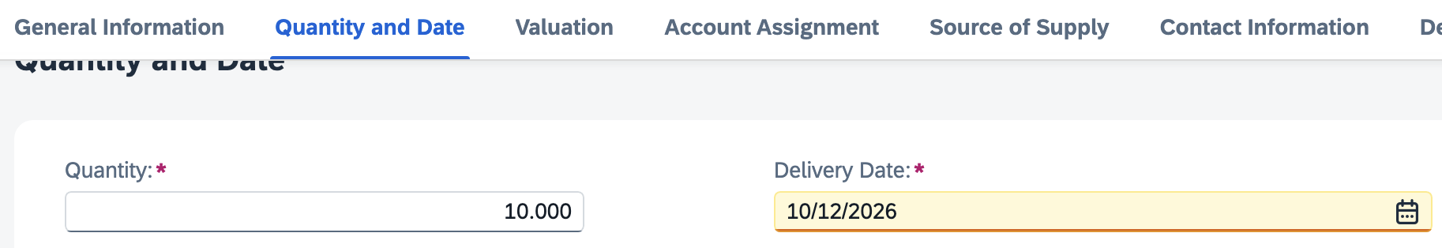
16. Scroll to the Valuation section and enter the price per unit.  Enter the correct Unit of Measure using the search icon on the right. | 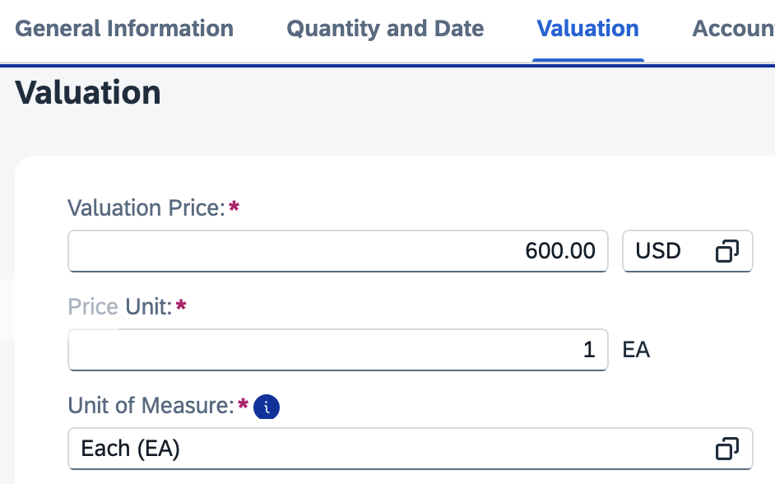
17. Navigate to Account Assignment section.  >If needed, enter or overwrite the GL Account with the appropriate selection  >If you did not set a default cost center or WBS Element-Grant in your Default Settings, it must be entered here to complete Account Assignment. Click the small triangle on the right to expand the Account Assignment section. | 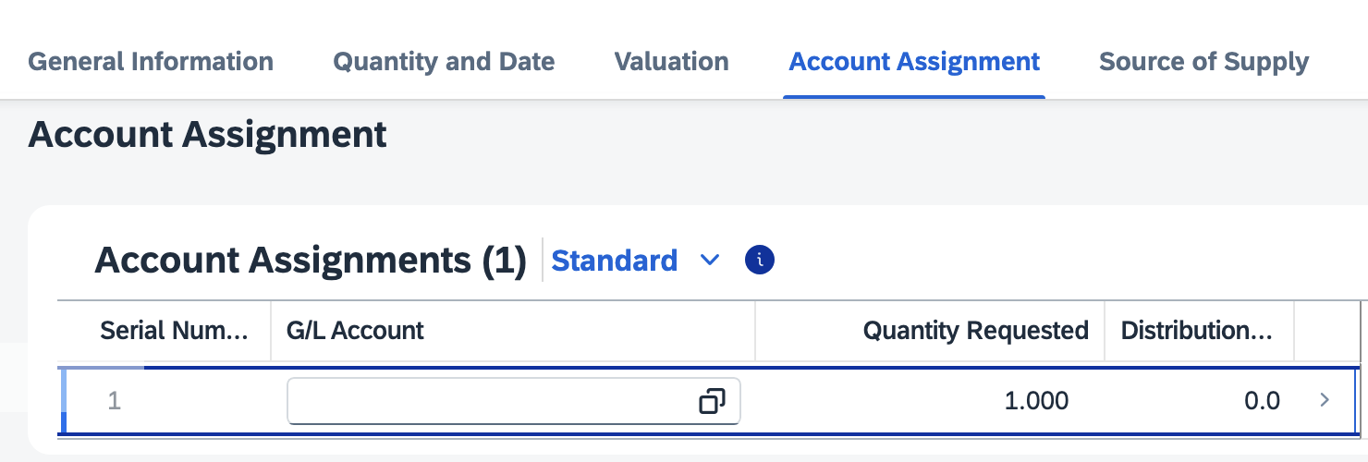
18. If needed, enter or update any cost object entries and click Apply to collapse the section. | 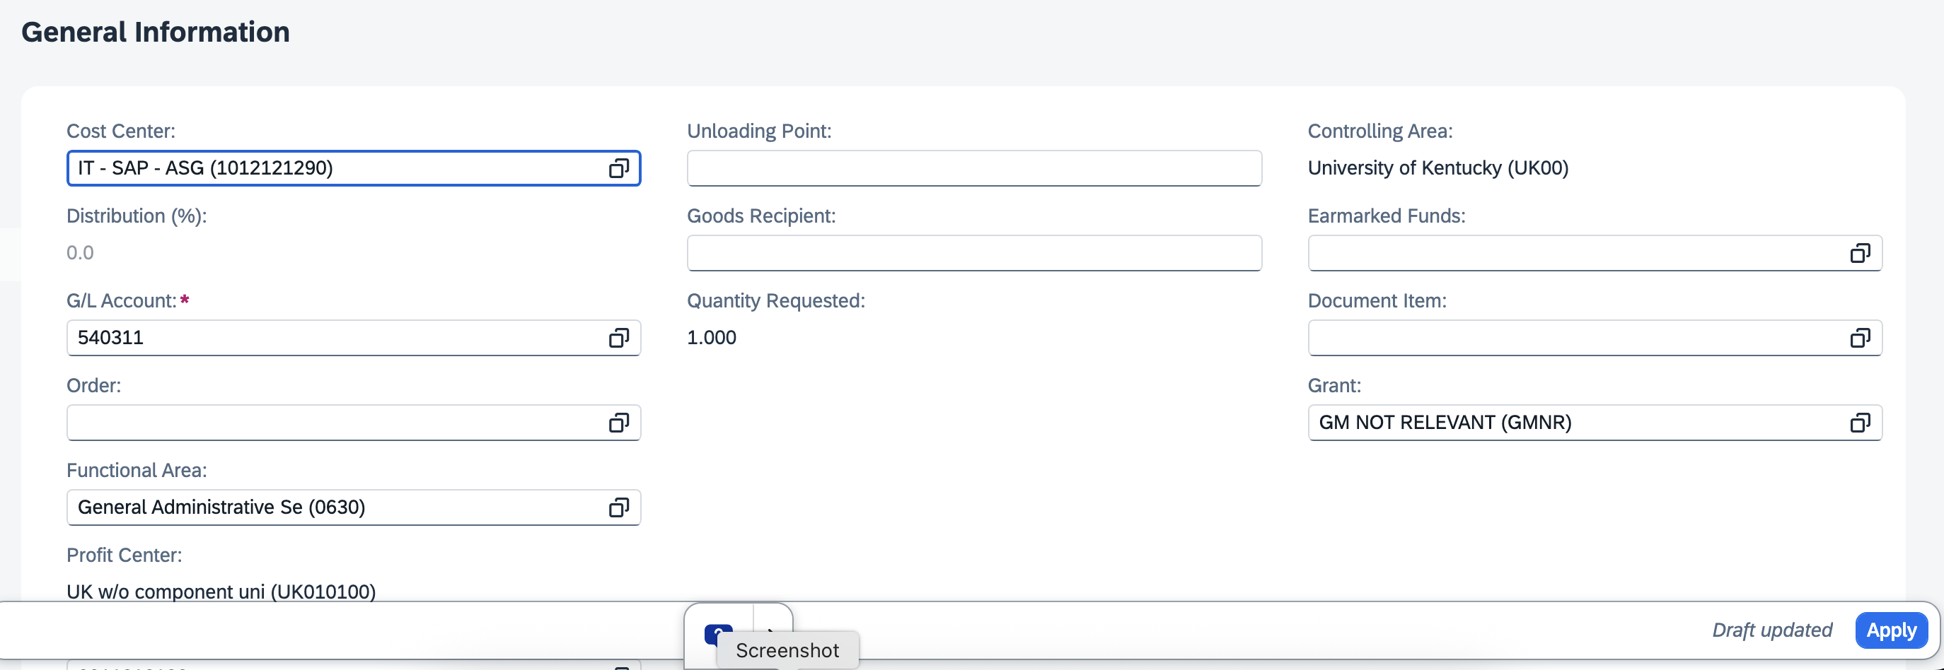
19. Navigate to Delivery Address section | 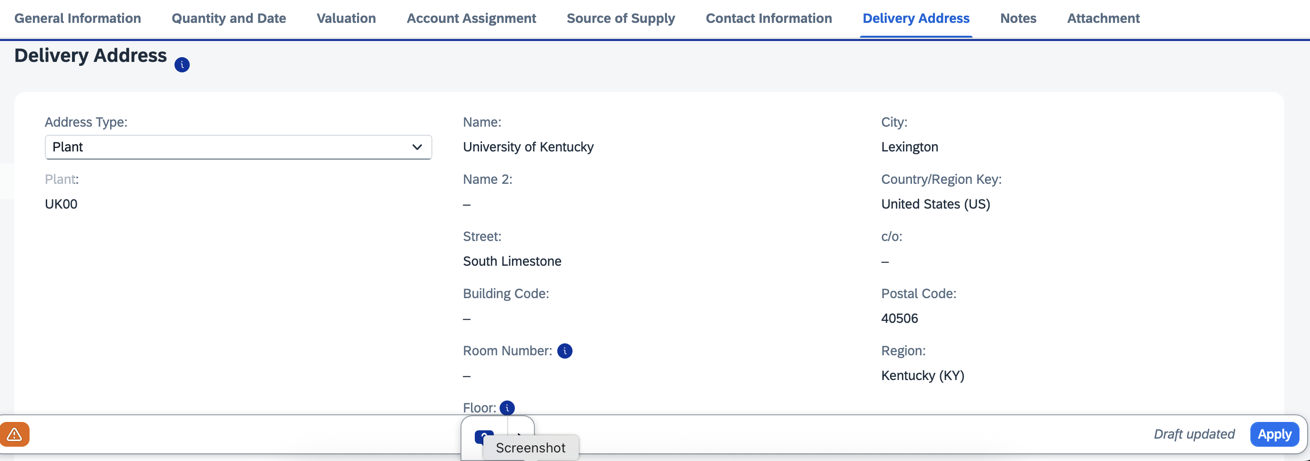
20. Select Reference from the Address Type dropdown menu | 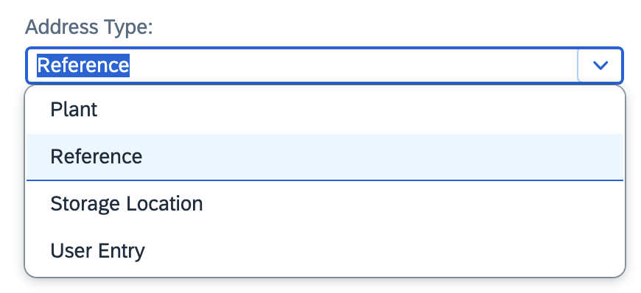
21. Click the Search Icon on the right side of Address Number field | 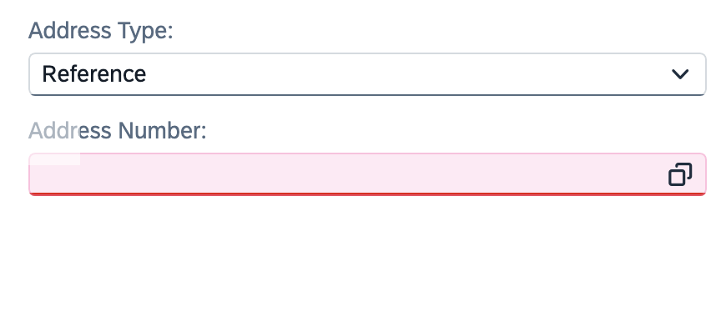
22. Expand to Show All Filters, if needed | 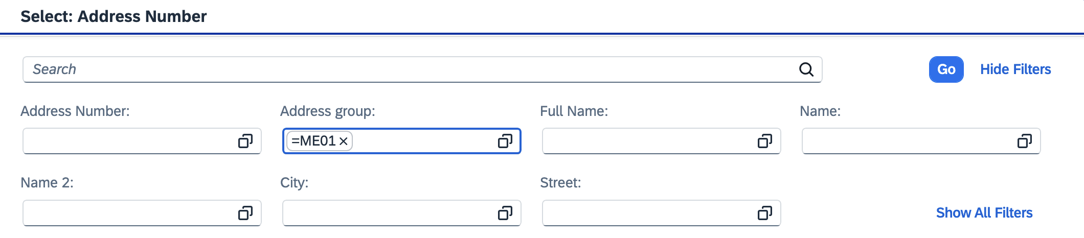
23. Ensure ME01 is selected for Address Group.  Enter your Delivery Building Location Code in the Search 2 field. For campus-based buildings, this is typically your postal speed-sort code. If needed, a full building listing is available on the Procurement Services website. Click Go. | 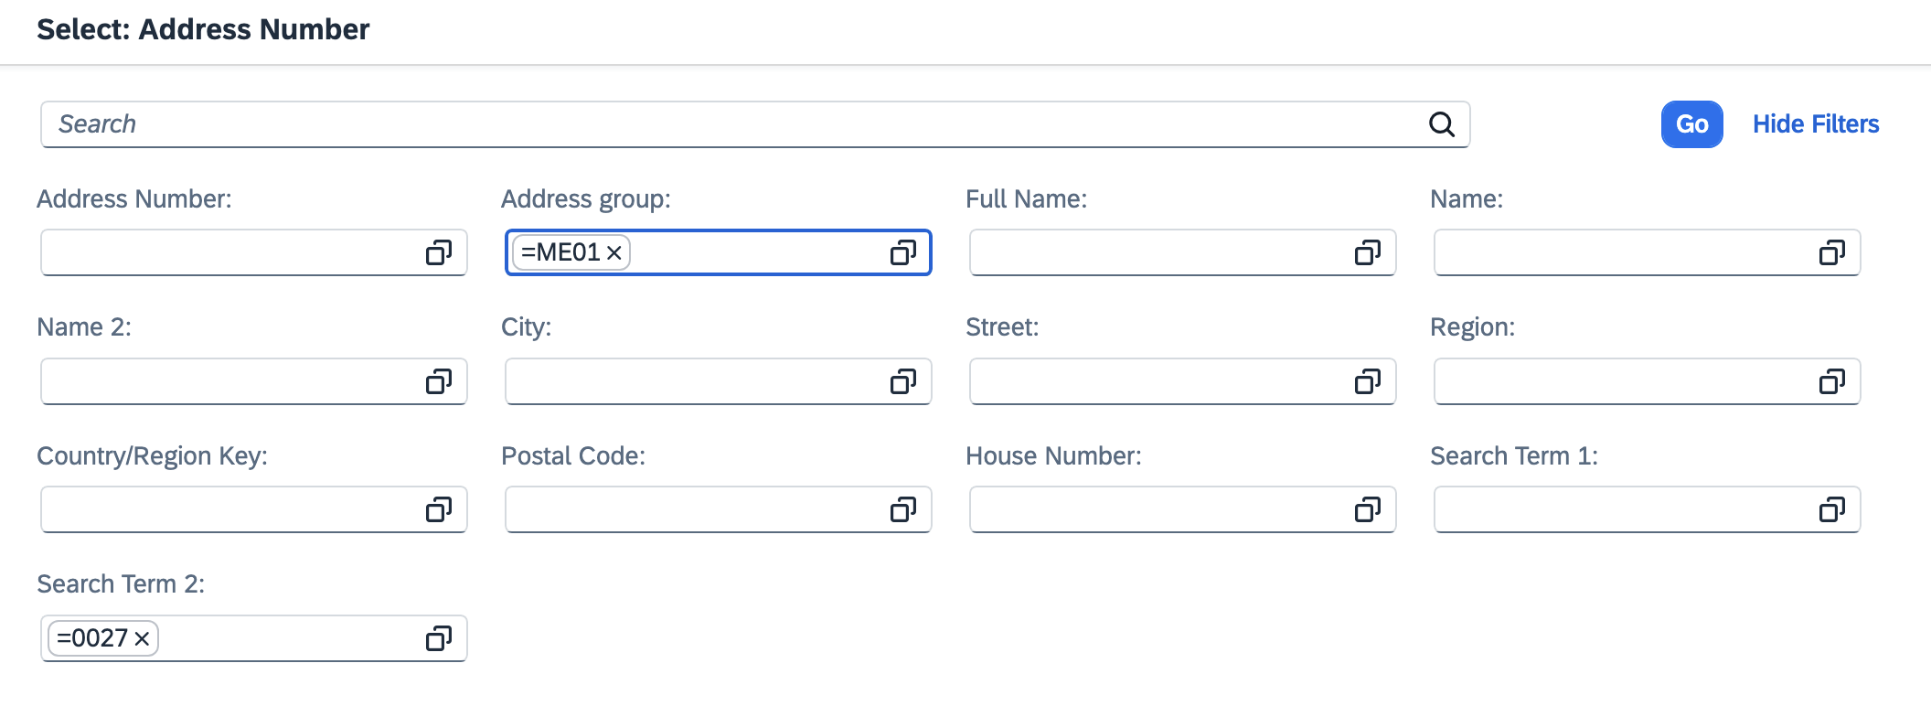
24. Select your delivery building from the search results | 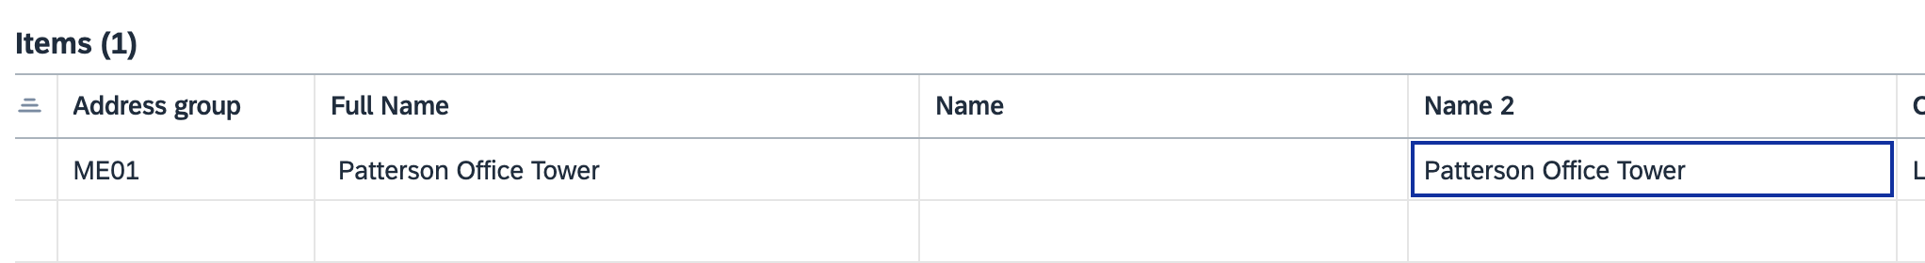
TIP: It is a good idea to record this number for convenient and quick usage on future orders. | 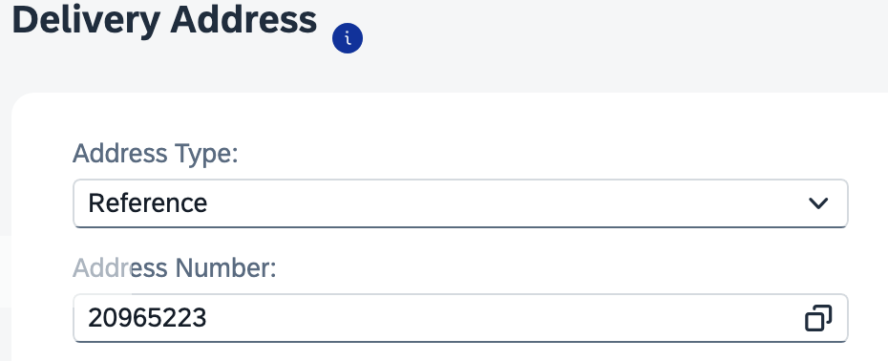
25. Select User Entry from the dropdown menu | 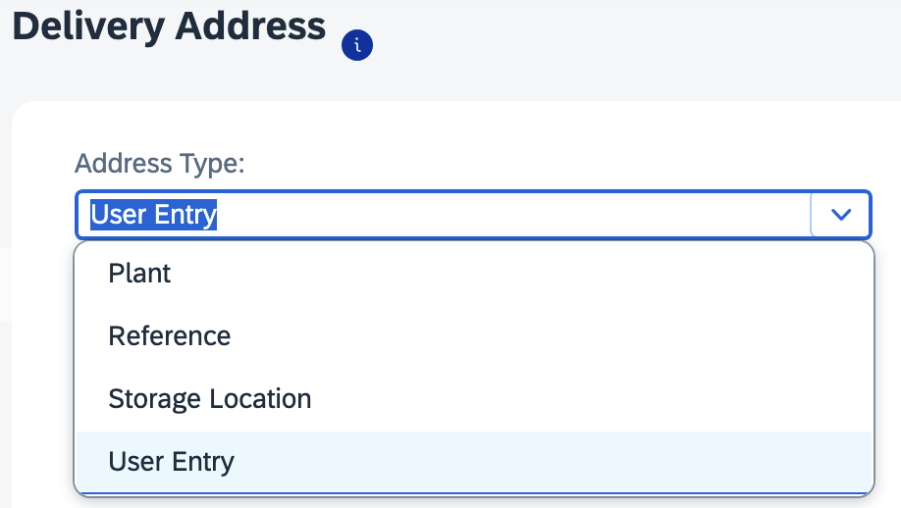
26. Add the following to the User Entry panel:  > Add the room number to the end of the street address  >Add the room number in the Room Number field  >Add the Floor  >Enter the c/o Deliver-to person’s name | 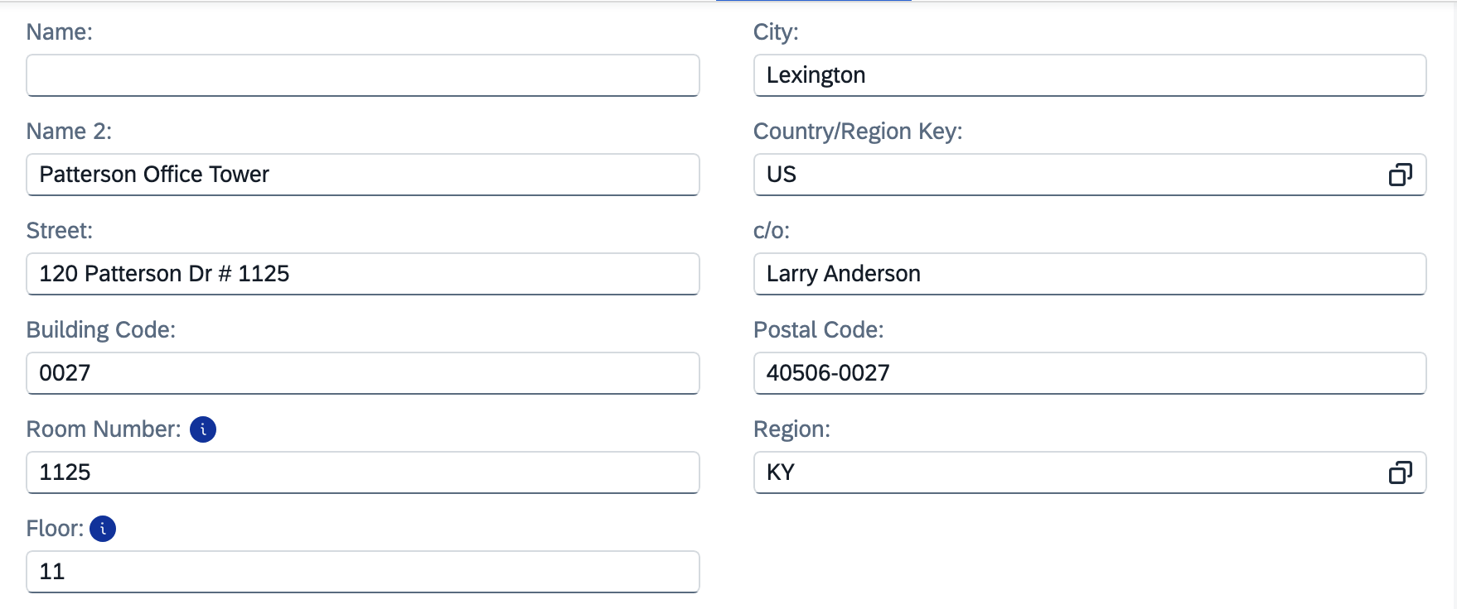
27. Click Apply to finish Line-Item Details | 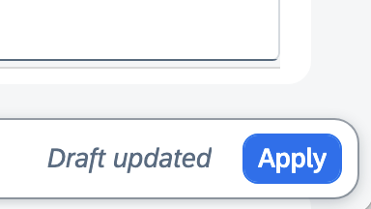
28. Repeat process for other line items on the requisition. | 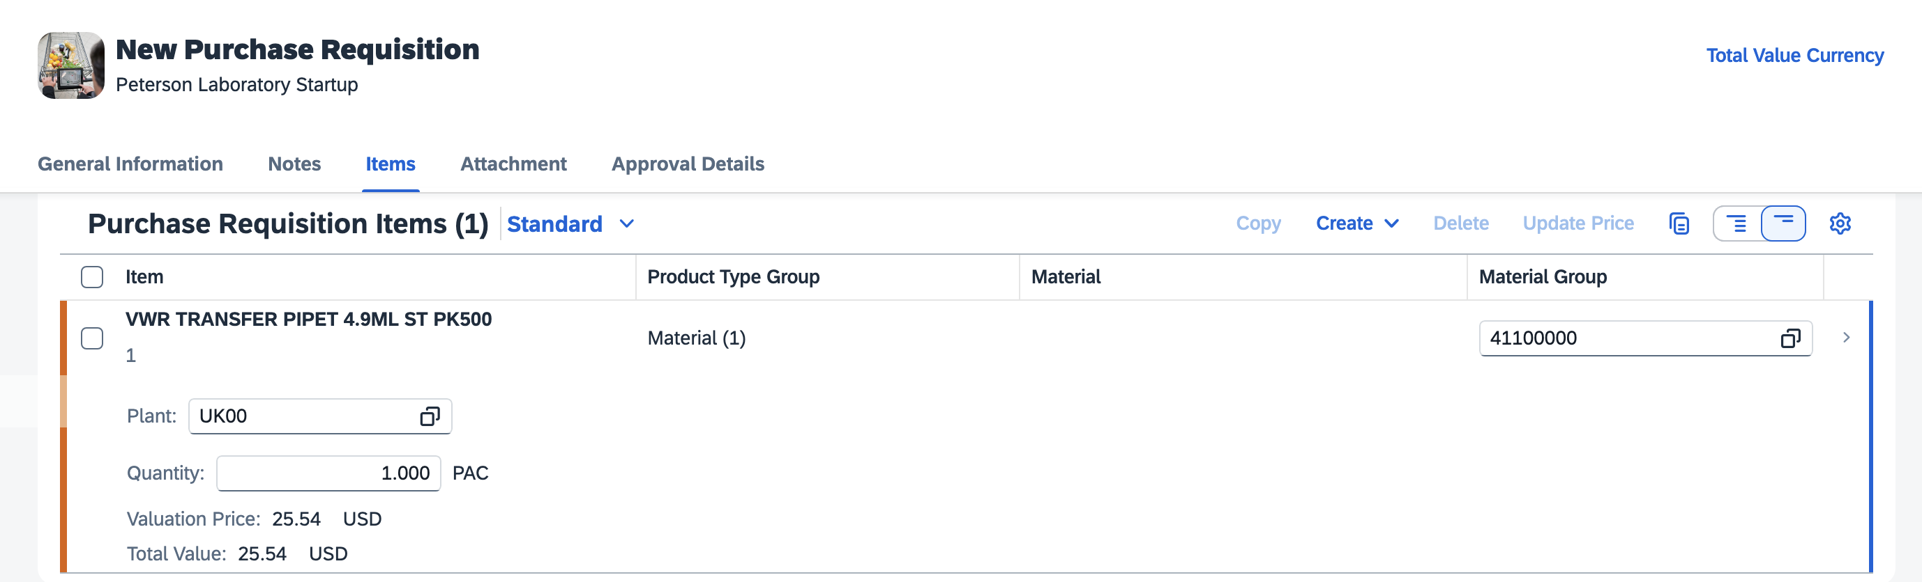
29. From the requisition main page, add supplier quote and other relevant documentation via the Attachment upload tab. | 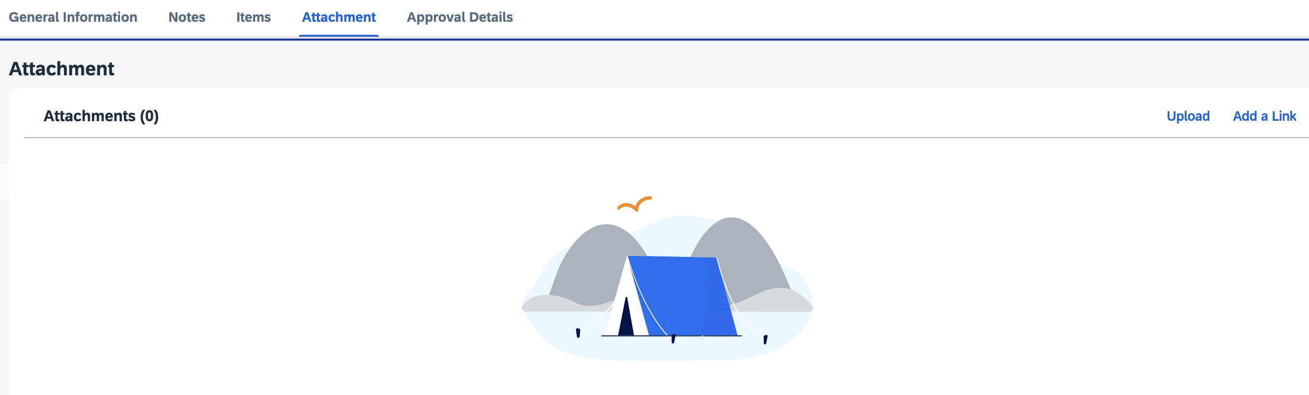
30. From the requisition main page, click Create at bottom right to complete and submit Requisition for approval  Note: If needed, disregard any soft (orange) block messages. | 