Use this Quick Reference Card (QRC) to create requisitions via SAP S/4 Fiori App – Manage Purchase Requisitions Professional and order items from e-catalogs via the Ariba Network.

Important: You must load and complete the Default Settings for Users app prior to creating a Fiori Requisition. Ensure first to bookmark the Default Settings for Users app to your SAP S/4 home page and complete the requirements. Steps are listed directly on the app itself for guidance or you may utilize a Quick Reference Card from the Procurement Services website, Learning and Training page for support.

You must also bookmark the Manage Purchase Requisitions Professional app to your home page from the Add Apps menu.

Once you shop and checkout from the Ariba Network e-catalogs using the Fiori Manage Purchase Requisitions Professional app, you only need to enter or confirm Account Assignment Details and complete Delivery Address for each line item to finish. Other line-item entries are typically auto-populated.

Role: SAP S/4 Requisitioner | Frequency: As Needed

From the myUK Landing Page, Click the SAP Fiori Launchpad icon to begin. | 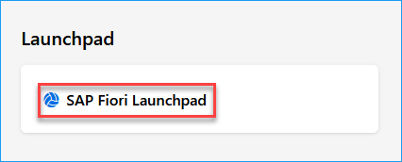
1. Select Manage Purchase Requisitions Professional | 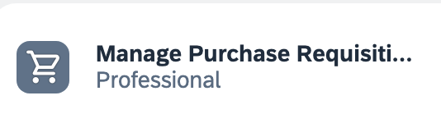
2. Click Create at the right of the Requisitions page | 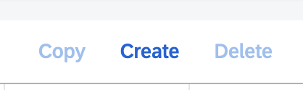
3. If desired, you may overwrite the Purchase Requisition Description cell with a customized entry specific to the order | 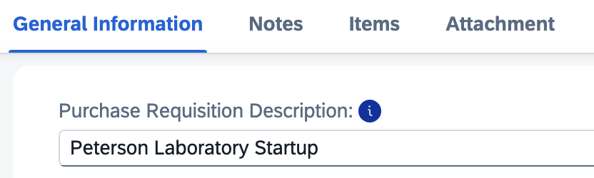
4. Ensure the Document Type is NB for all e-catalog orders | 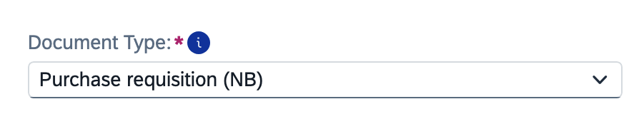
5. Ensure the Automatic Source Determination box is checked | 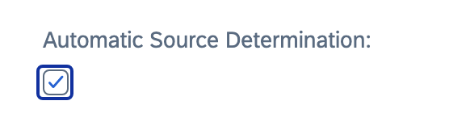
6. Enter a header note related to business purpose or justification. | 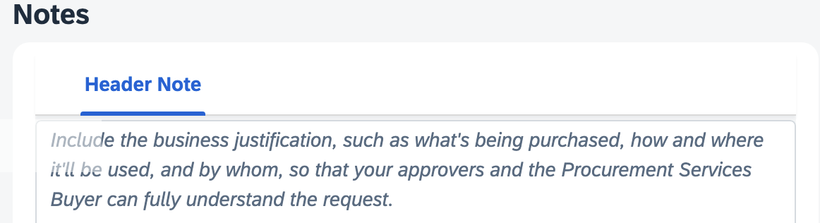
7. Scroll to the Items section. Click Create on the right and select Items from External Catalogs from the dropdown menu. | 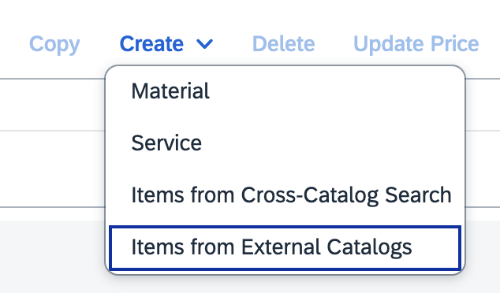
8. Select UK Ariba Catalog  Note: Ensure you have pop-ups allowed on your first visit to the Ariba Network.  Note: When prompted always click to Accept Cookies on any e-catalog when visiting sites. | 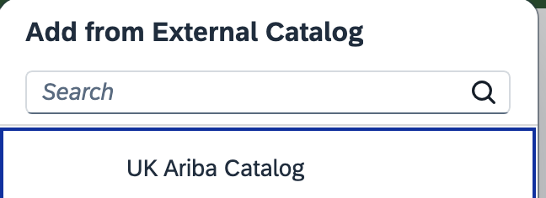
9. When navigating the Ariba Network landing page, hover over the > icon to the right of Supplier on the Shop By menu. Then click View All Suppliers. This will provide a listing of all e-catalogs on a single page for viewing and access. | 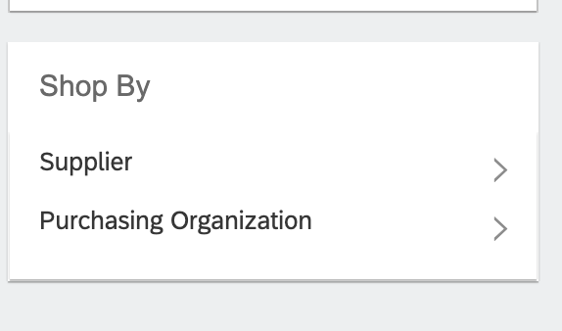
10. Select needed catalog from the available listing | 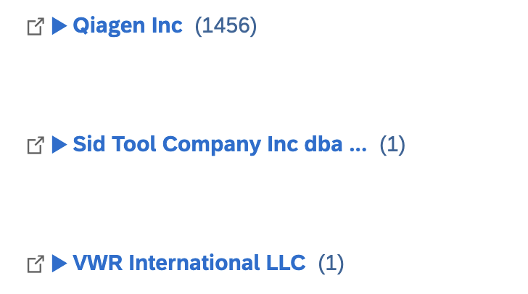
11. Add item(s) to your Shopping Cart. Check out to return to Ariba Network and complete final return to Requisition. | 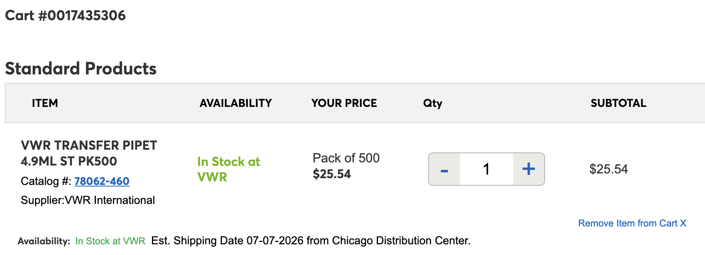
Item(s) will populate to Requisition | 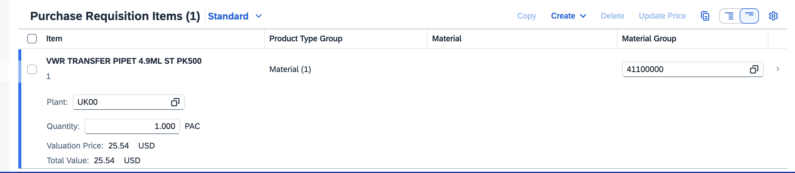
12. Click the triangle on the right end of line item 1 to expand the Line-Item Details. | 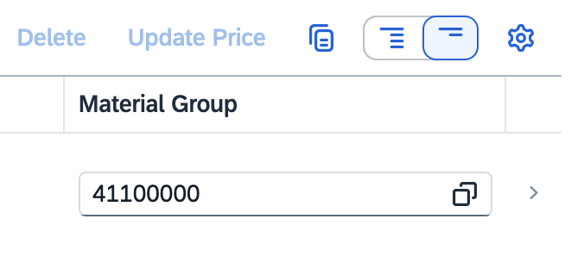
13. Navigate to Account Assignment section.  >If needed, enter or overwrite the GL Account with the appropriate selection  >If you did not set a default cost center or WBS Element-Grant in your Default Settings, it must be entered here to complete Account Assignment. Click the small triangle on the right to expand the Account Assignment section. | 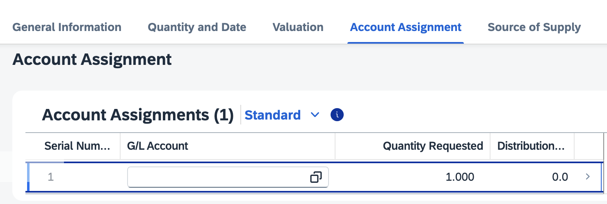
14. If needed, enter or update any cost object entries and click Apply to collapse the section. | 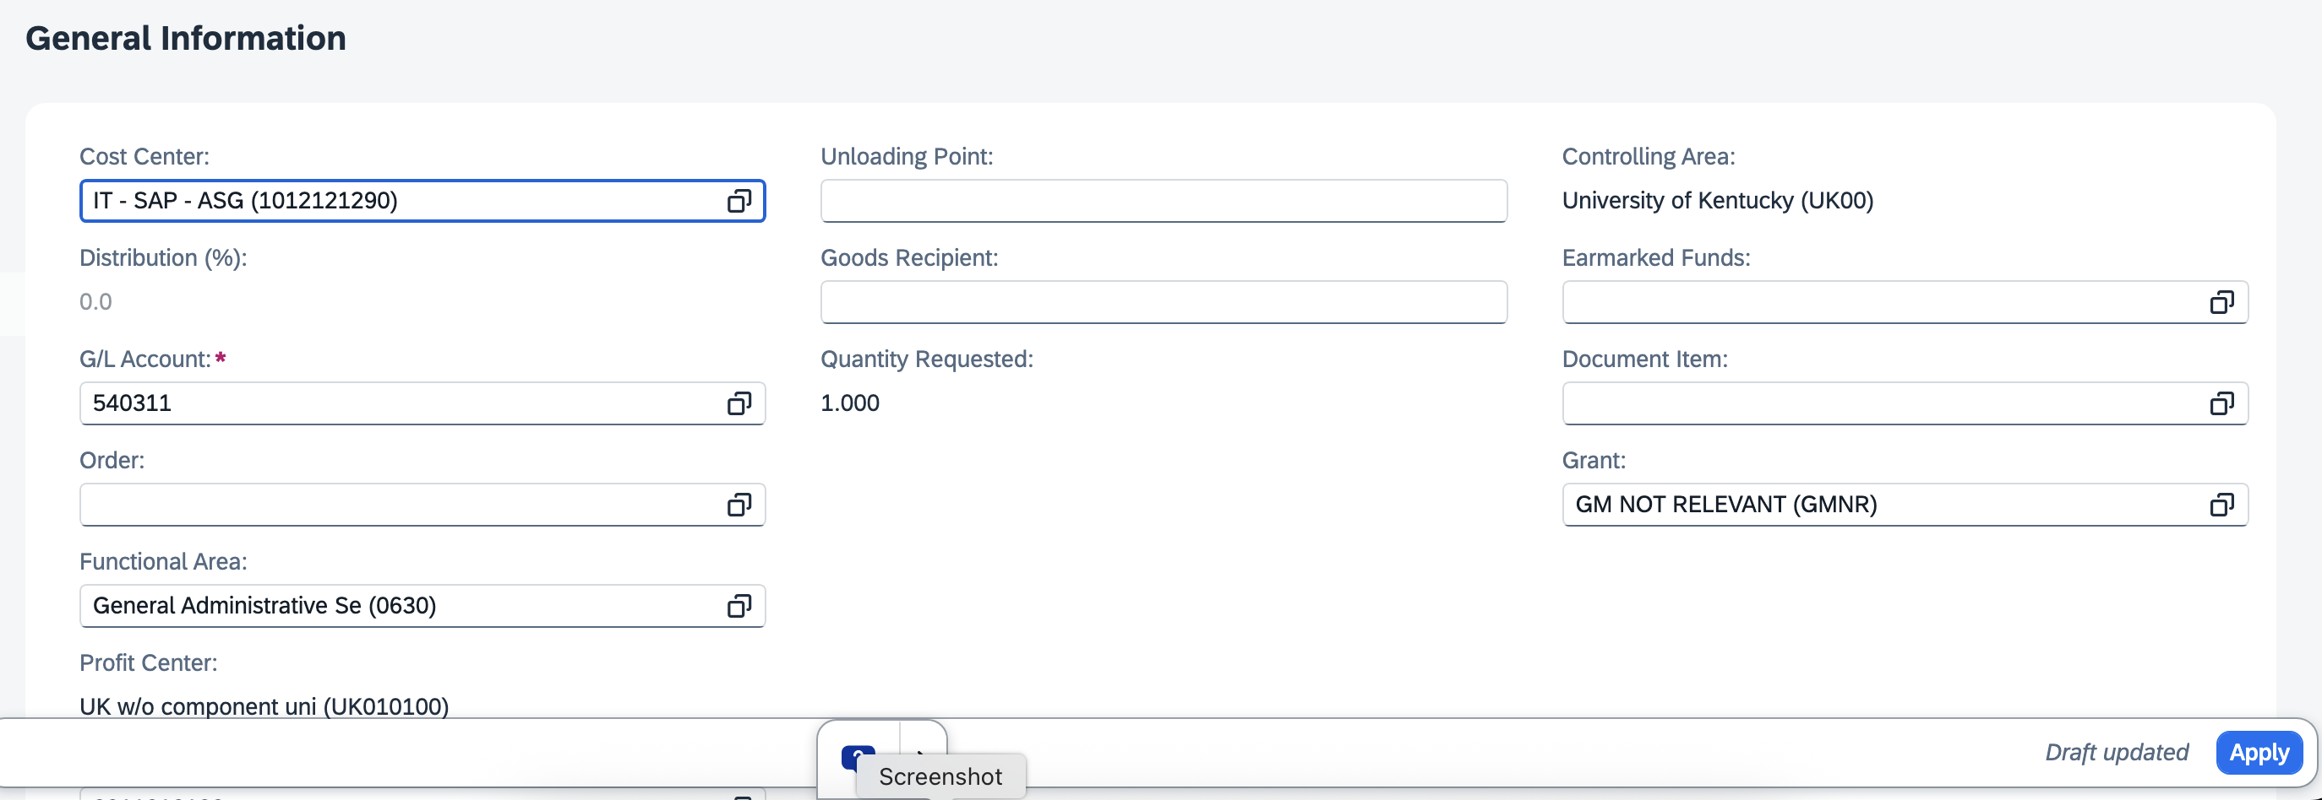
15. Navigate to Delivery Address section | 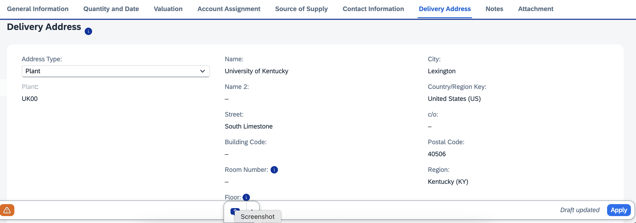
16. Select Reference from the Address Type dropdown menu | 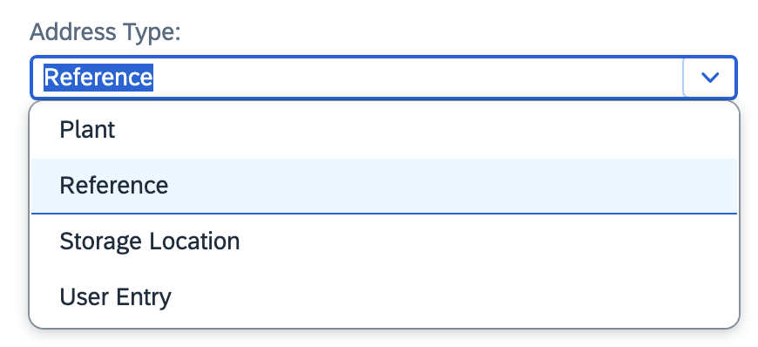
17. Click the Search Icon on the right side of Address Number field | 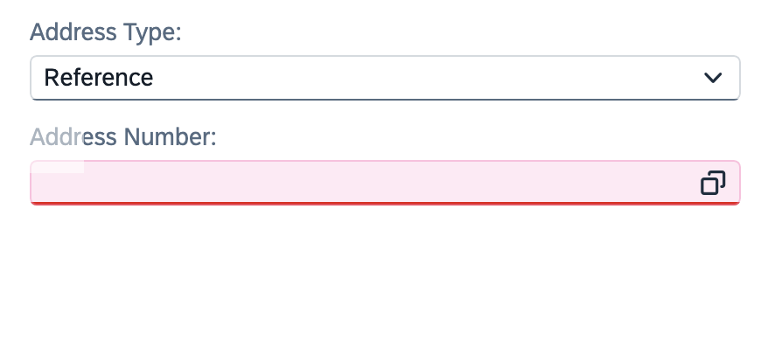
18. Expand to Show All Filters, if needed | 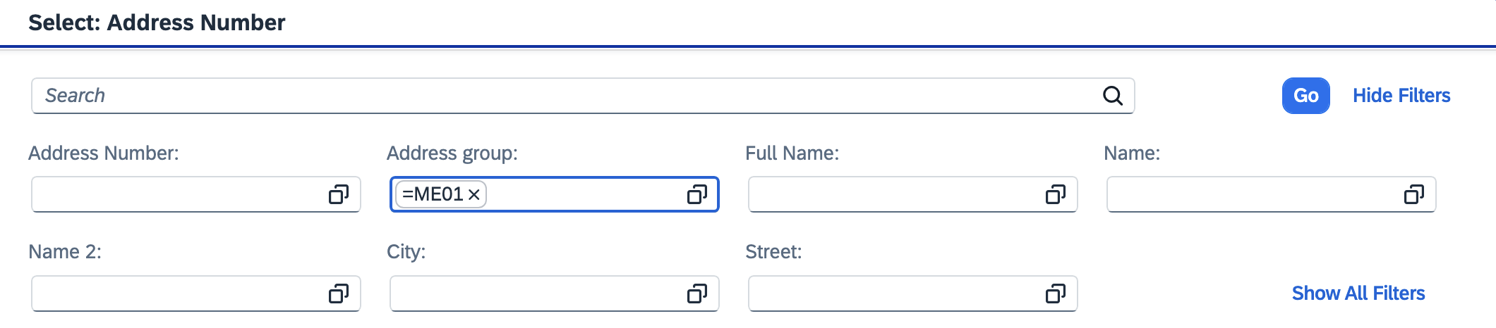
19. Ensure ME01 is selected for Address Group.  Enter your Delivery Building Location Code in the Search 2 field. For campus-based buildings, this is typically your postal speed-sort code. If needed, a full building listing is available on the Procurement Services website. Click Go. | 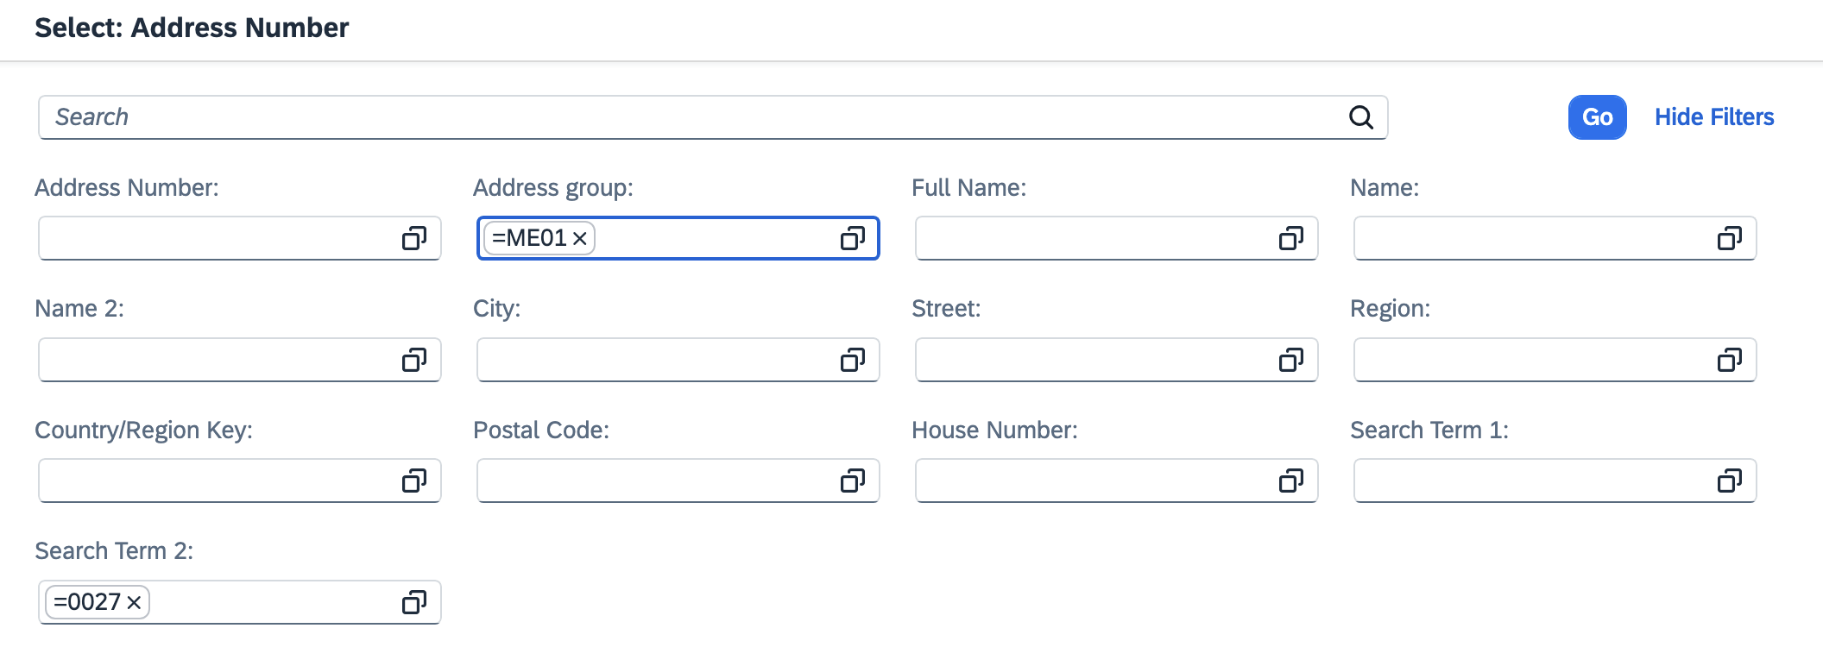
20. Select your delivery building from the search results | 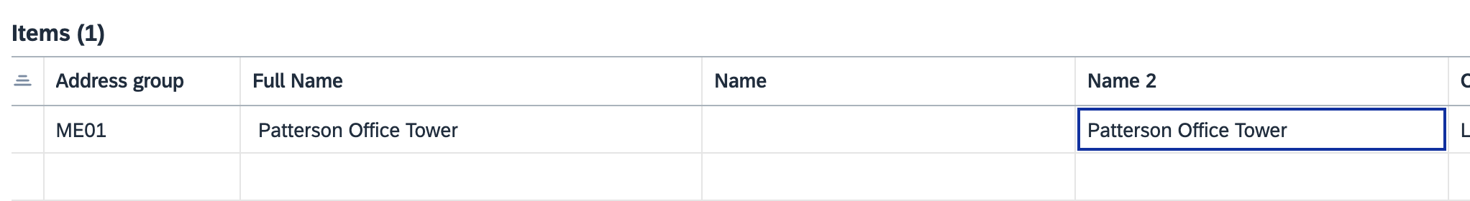
TIP: It is a good idea to record this number for convenient and quick usage on future orders. | 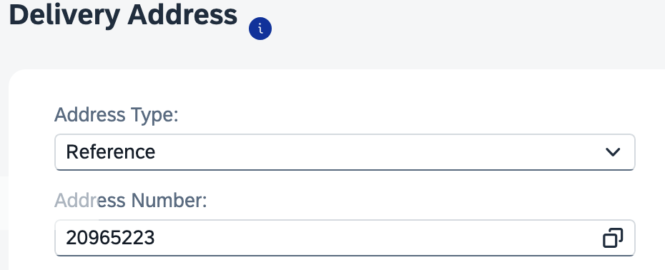
21. Select User Entry from the dropdown menu | 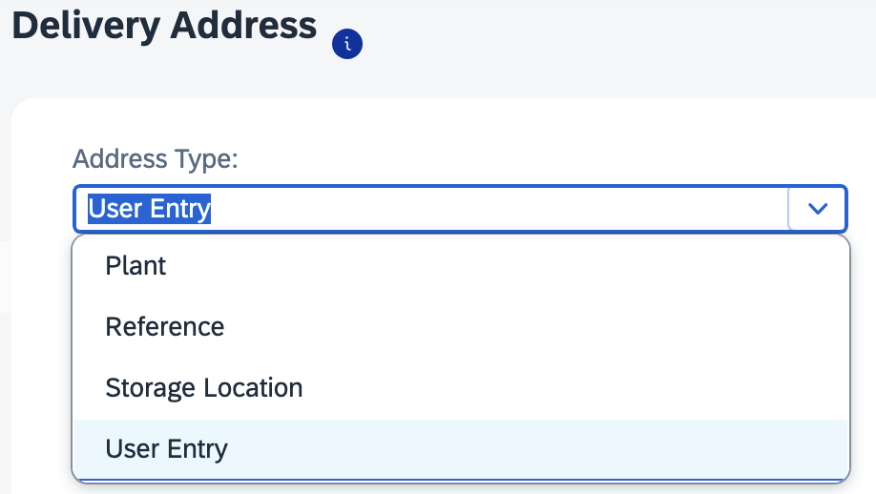
22. Add the following to the User Entry panel:  > Add the room number to the end of the street address  >Add the room number in the Room Number field  >Add the Floor  >Enter the c/o Deliver-to person’s name | 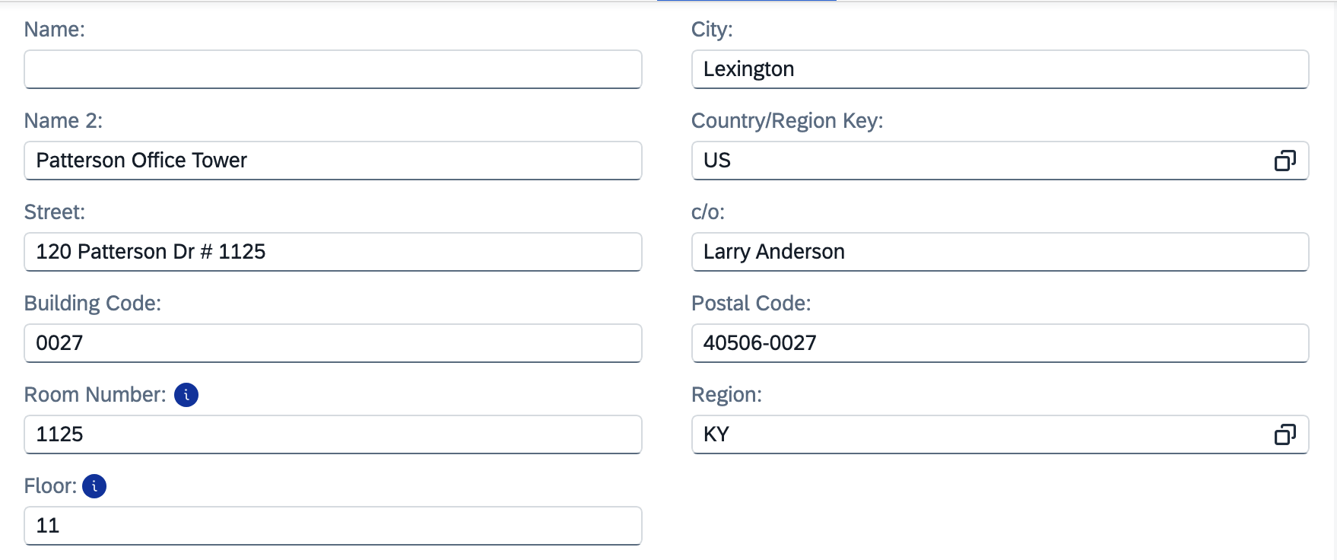
23. Click Apply to finish Line-Item Details | 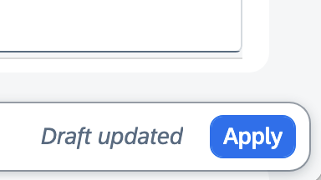
24. Repeat completion of Account Assignment and Delivery Address Details on each remaining line item(s) | 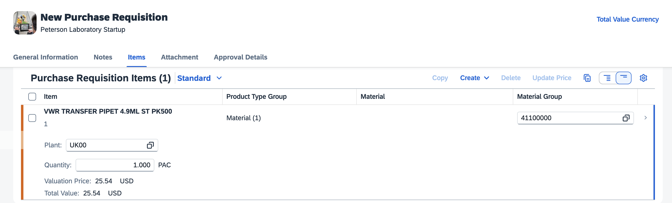
25. Click Create in bottom right to complete and submit Requisition for approval  Note: If needed, disregard any soft (orange) block messages. | 