Prior to using the Fiori Manage Purchase Requisition Professional app to create requisitions, default settings must be established per below steps.

Note: This app is prerequisite and complementary to the Fiori Manage Purchase Requisitions Professional app; it is not applicable to any other app or T-code.

Role: SAP S/4 Requisitioner | Frequency: As Needed

From the myUK Landing Page, Click the SAP Fiori Launchpad icon to begin. | 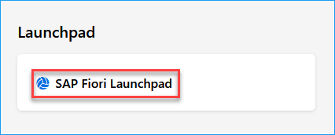
1. From the Add Apps icon, add Default Settings for Users app to your home page. | 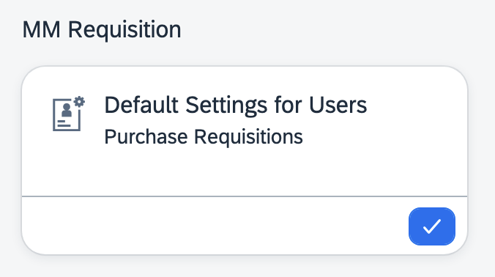
2. Enter your linkblue ID in the User ID box and press Enter | 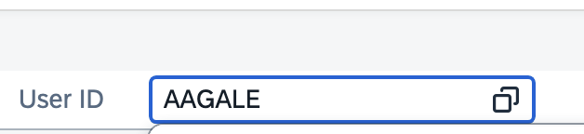
3. Click the Edit button at the top right | 
4. Under Basic Parameters section, ensure or enter the following settings:  >Plant = UK00  >Company Code = UK00  >Currency = USD  >Source Determination box is checked  >Purchasing Doc Type = NB  >Purch Organization = UK00 | 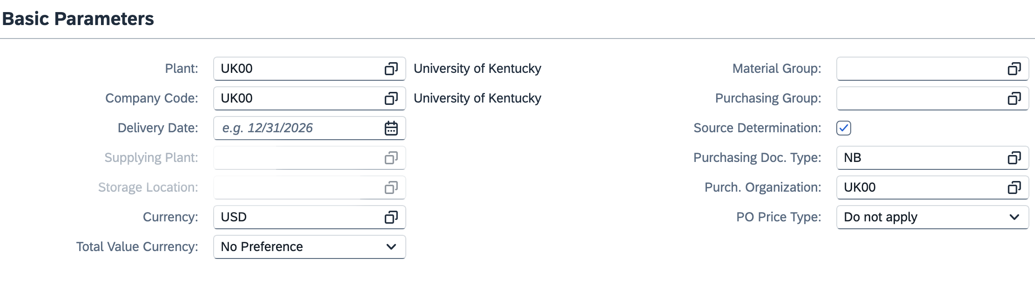
5. Under Account Assignment Category:  >Enter K if you most commonly use a cost center for requisitions  >Enter P if you most commonly use WBS Element-Grants for requisitions  Optional: If you always use a single cost center or a single WBS Element-Grant for every requisition, you may also enter either number to automatically populate on every requisition. | 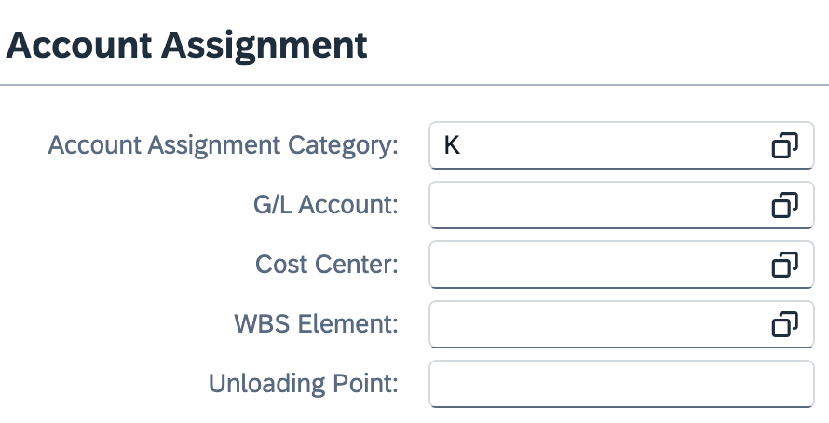
6. Under Assigned Catalogs, ensure UK Ariba Catalog is showing and check Default Indicator. If it is not showing, click the Add button on the right to add to view.  Click SAVE when finished with default settings. | 