Use the following steps to create an SAP S/4 Requisition using T-code ME51N (Create Purchase Requisition Advanced) to order needed items from Ariba Network e-catalogs.

Role: SAP S/4 Requisitioner | Frequency: As Needed

Prior to creating your first requisition using SAP T-code ME51N, you must set your default settings in four locations. This is a one-time requirement. After your default settings are established, you can immediately create requisitions as needed each time using steps in Section B.

A. Set Default Settings (Four Locations) on First Visit
From the myUK Landing Page, Click the SAP Fiori Launchpad icon to begin. | 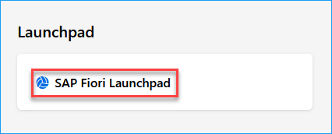
1. To access T-code ME51N within the SAP S/4 environment, select Add Apps from the upper right area of your home page. | 
2. Upon arriving to the Apps page, enter ME51N into the Search Catalog box at the top right. | 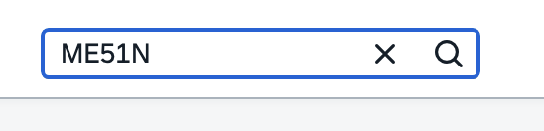
3. Once you locate the T-code for Create Purchase Requisition Advanced, click the plus (+) sign to add it to your home page as a favorite. | 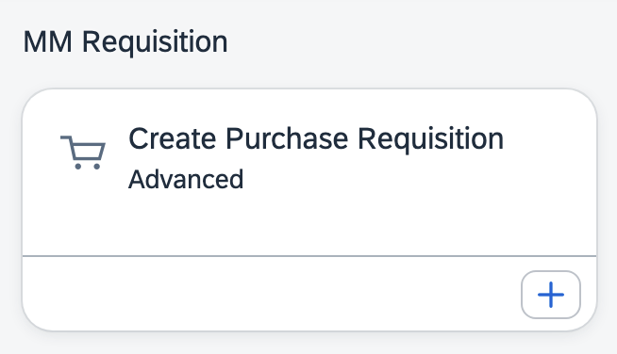
4. Click Create Purchase Requisition Advanced tile to open T-code | 
5. Setting One – Once the app starts, click the Menu button at the top left and select Settings.  (This is one-time only.) | 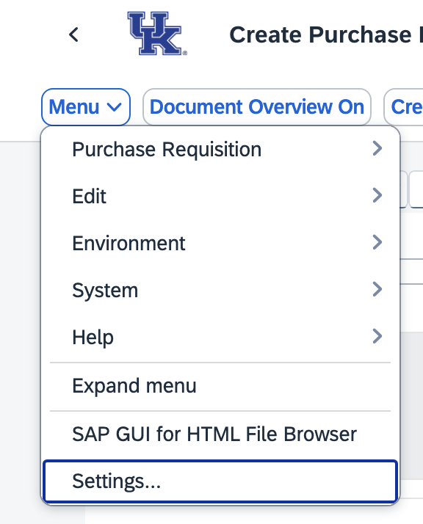
6. Select Visualization from the left menu. Ensure both selections under Dropdown List section are set to On.  Ensure both selections for Enhanced Search are set to on.  Click SAVE when complete. | 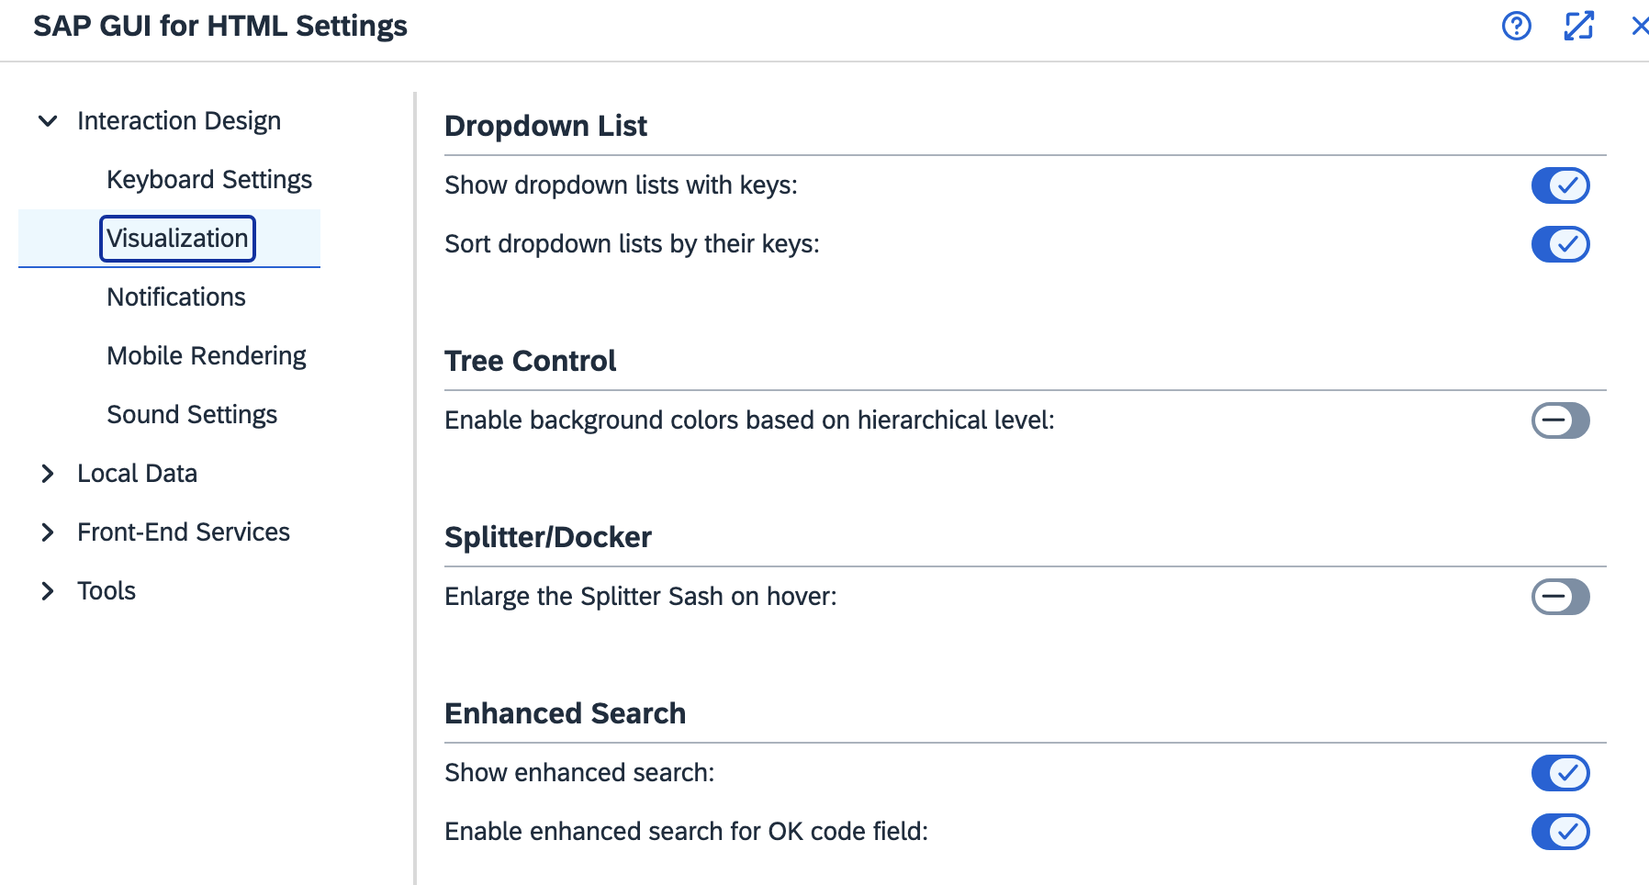
7. Setting Two - Select Personal Setting from the top menu.  (This is one-time only.) | 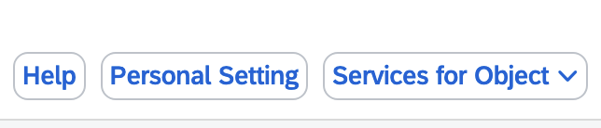
8. On Basic Settings tab, set Selection Period for My Docs to -9999 for No Restrictions. | 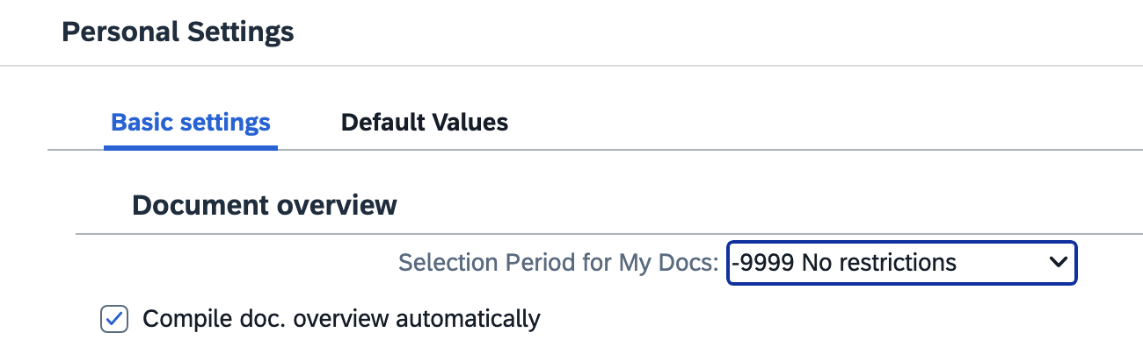
10. Setting 3 - Set Default Values on Requisition Line Item. The icon button is in the middle screen section.  (This is one-time only.)  Set the exact same settings and checkboxes here at the Line-Item level as you did for the header level in the previous step.  >Click Save | 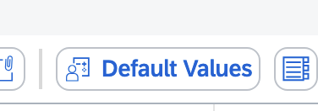  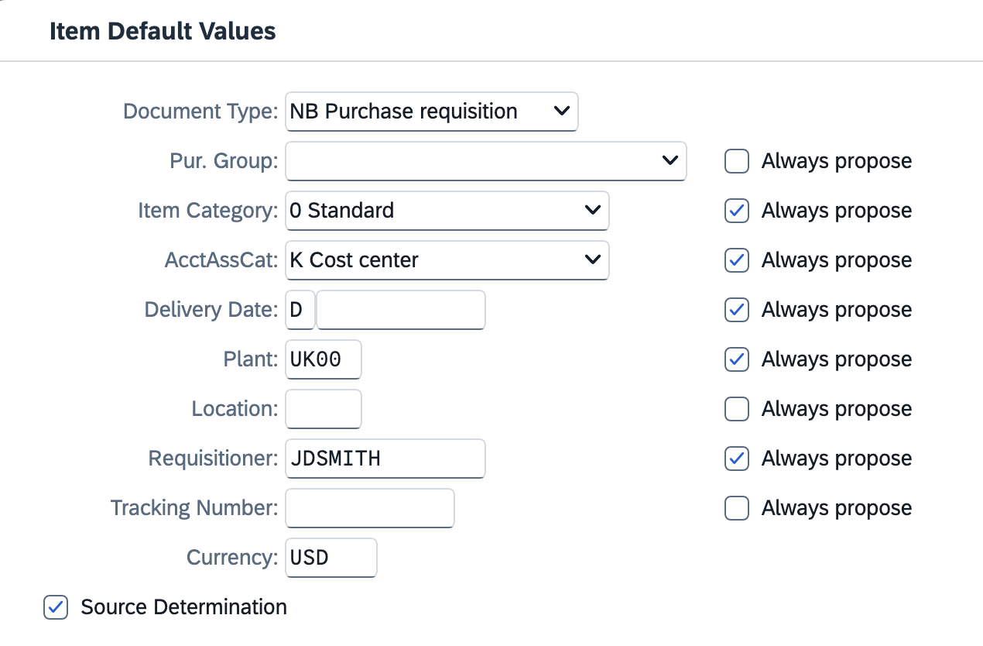
11. Setting 4 - Locate the Layout button in the middle of the requisition screen and click the black triangle on the right side.  (This is one-time only.)  >Click Choose Layout  >Select /CAMPUS_REQ as your layout type to bring into view | 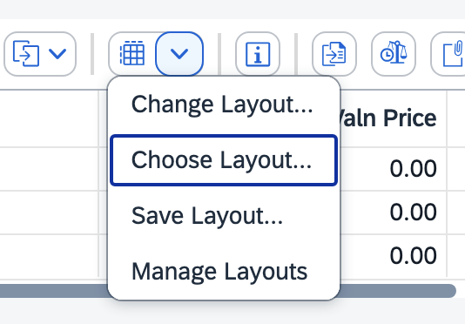  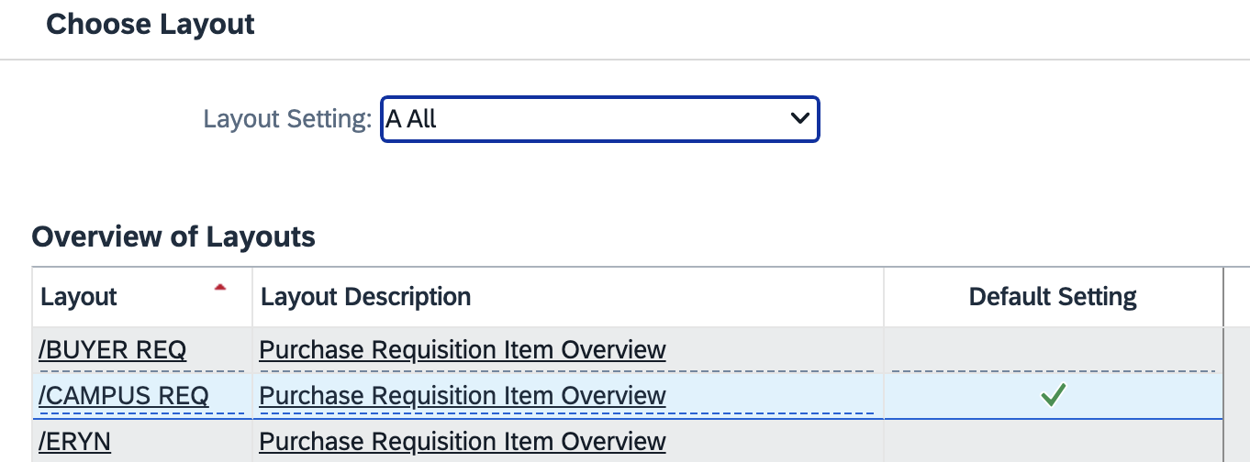
12. Click the right side of the Layout button a second time and select Save Layout from the dropdown menu.  >With /CAMPUS_REQ layout showing, place a checkmark on the Default box and click Adopt.  >Click Yes to Save Layout  Note: The same layout is used by every Requisitioner. Ensure not to make any other changes to the layout.  This completes all of your one-time settings for ME51N Create Purchase Requisition Advanced. | 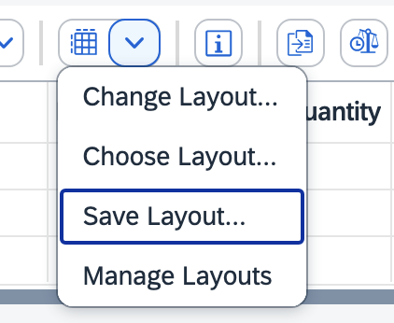  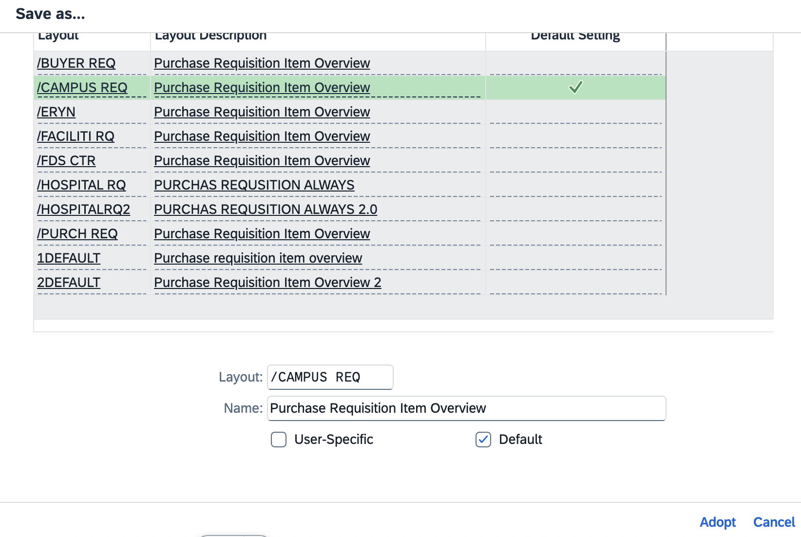  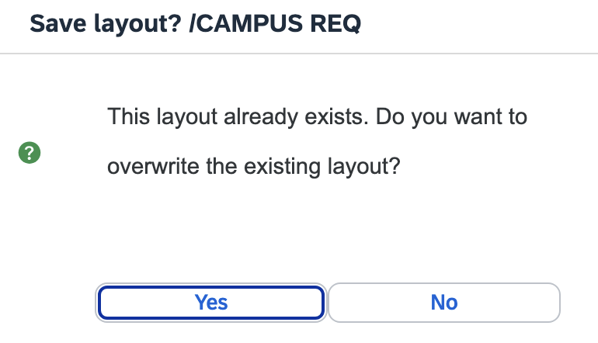

B. Create ME51N SAP S/4 Requisition for Ariba Network E-Catalog Order
1. Enter header and/or Business Purpose Notes | 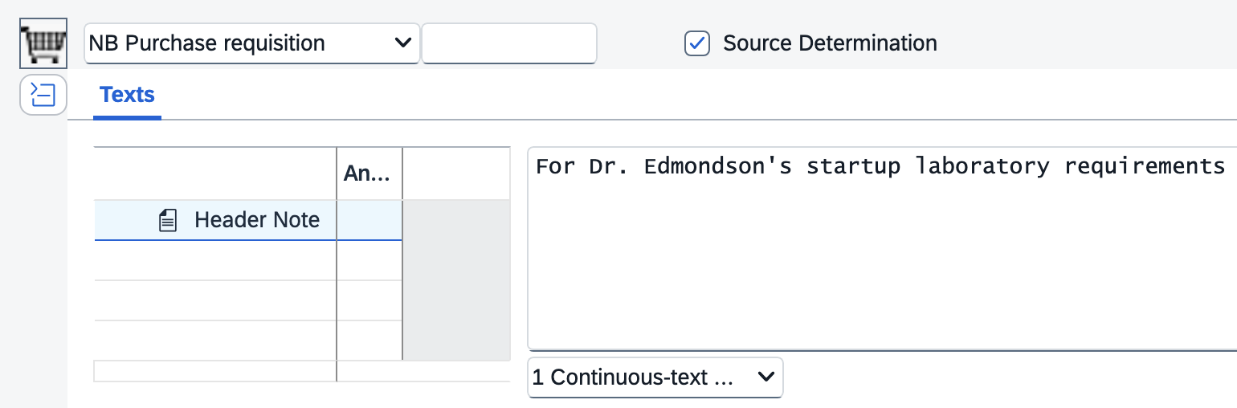
2. Click the punch-out catalog icon to access Ariba Network  e-catalogs  Note: Ensure you have pop-ups allowed on your first visit to the Ariba Network.  Note: When prompted always click to Accept Cookies on any e-catalog when visiting sites. | 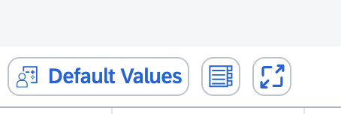
3. When navigating the Ariba Network landing page, hover over the > icon to the right of Supplier on the Shop By menu. Then click View All Suppliers. This will provide a listing of all e-catalogs on a single page for viewing and access. | 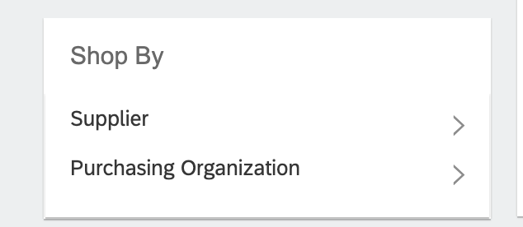
4. Select needed catalog from the available listing | 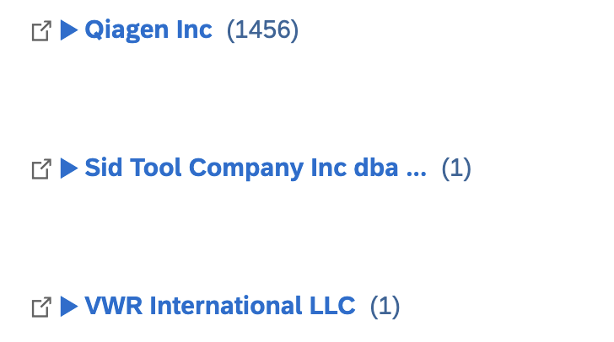
5. Shop for needed items from Ariba Network e-catalog supplier, place into Ariba Shopping Cart and check-out from Ariba Network.  Note: When punching out to the Ariba Network for the first time, ensure pop-ups are allowed for navigation purposes.  Note: Always Accept Cookies when prompted on any Ariba Network e-catalog | 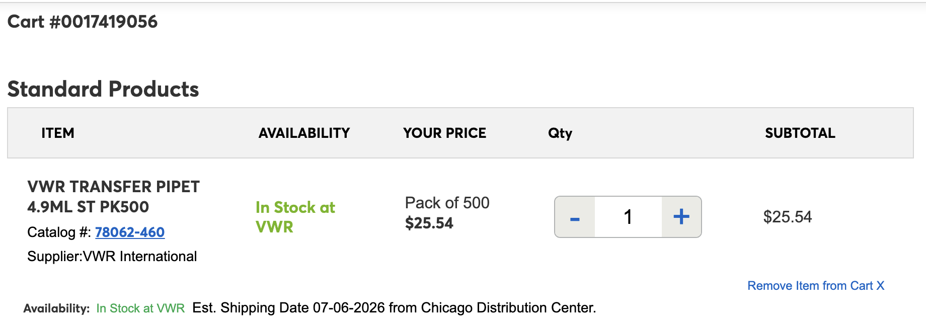
Product details for all line items will show on your requisition including description, quantity, price, UOM, catalog numbers, etc. The Desired Vendor number field will not populate and does not need completed. | 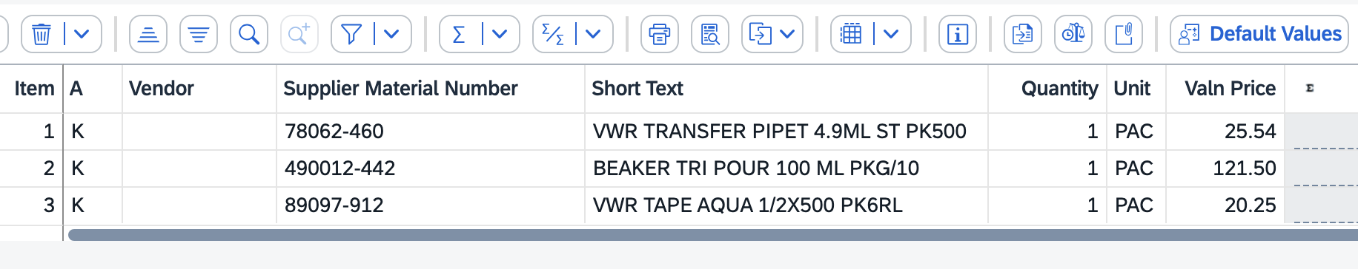
6. Navigate to the bottom Item Details section and click the Account Assignment tab. Establish and enter your accounting information for your Cost Center or WBS-Element.  If needed, toggle the AccAssCat selection between K-Cost Center and P-Project (WBS Element-Grant) to select/change the appropriate type.  If you need to assign split/multiple accounting, select X-All Other Aux Assignments from the AccAssCat selection to establish and complete the needed layout and distribution. You can also select the appropriate split distribution type. | 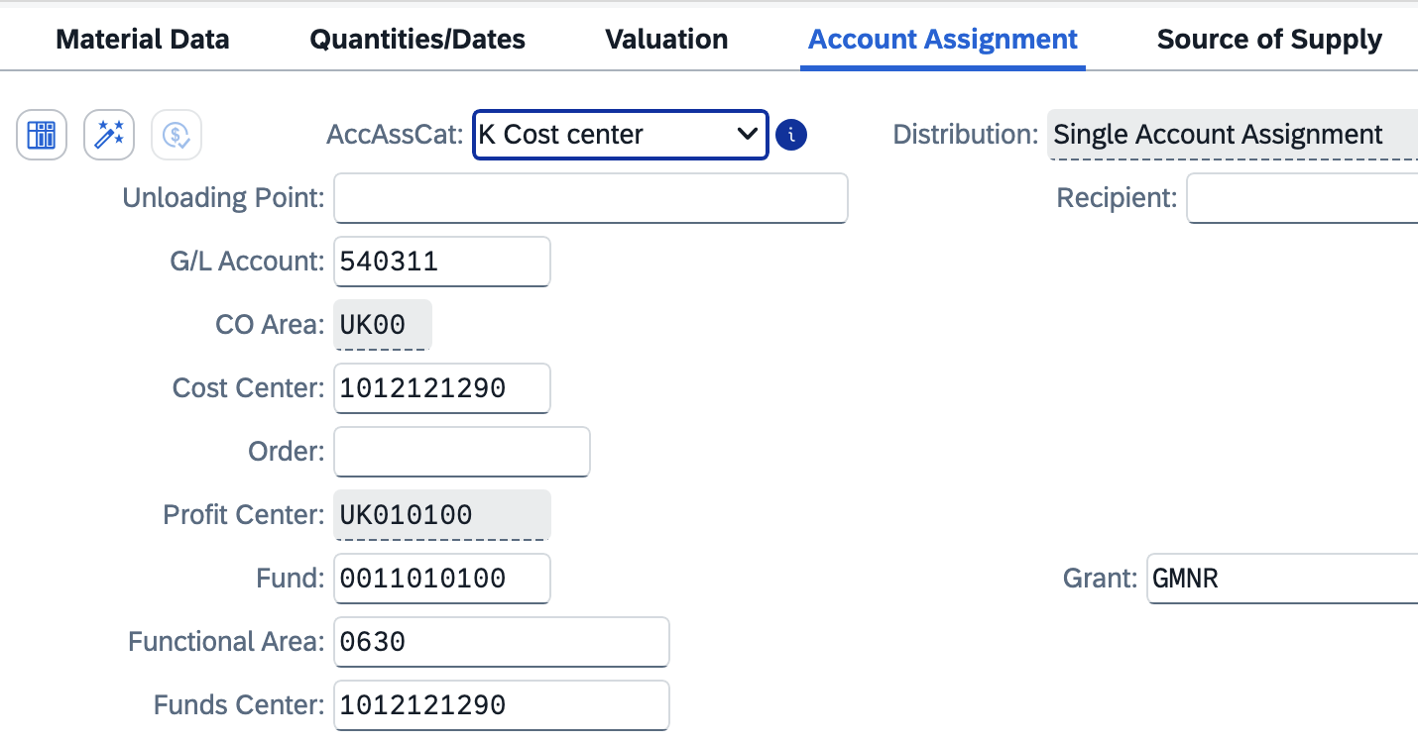
Note: If you have multiple lines, you can copy/paste the GL Account and Cost Center (or WBS Element-Grant). Use the up/down buttons to move among line items. | 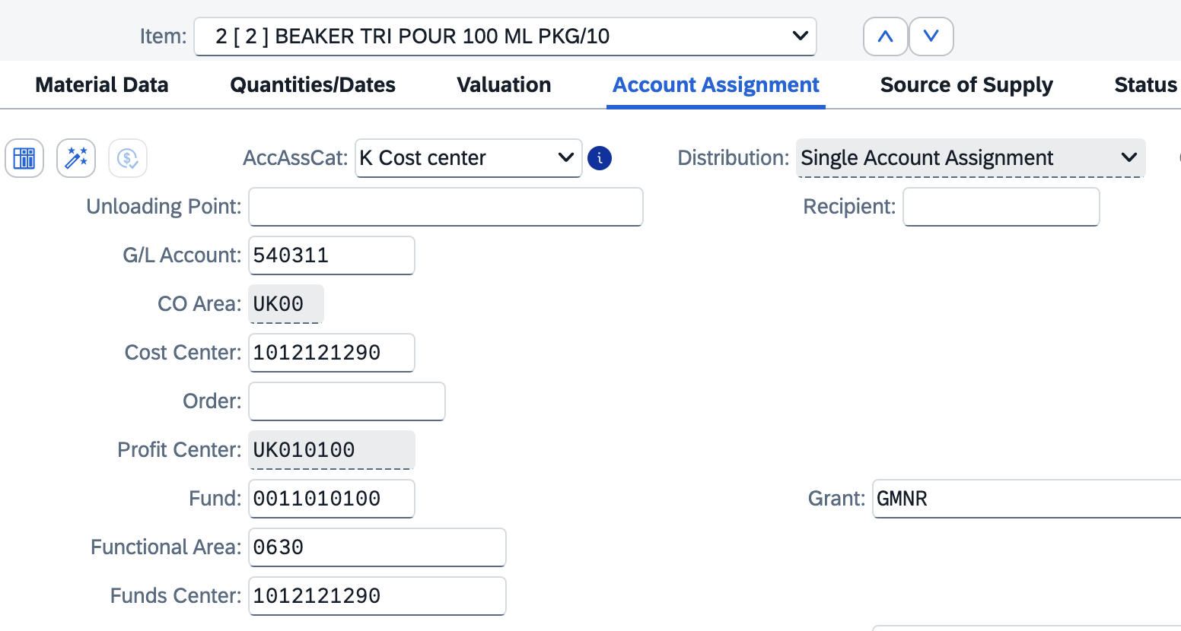
7. Navigate to Delivery Address Tab  Important: Integrated ordering systems utilize specific master data in specific cells for correct order placement and processing. It’s important to follow the exact steps below to enter your delivery address information correctly and not enter any building name or address components via free text entry.  >Failure to follow the delivery steps will cause an order to fail to process or deliver correctly. | 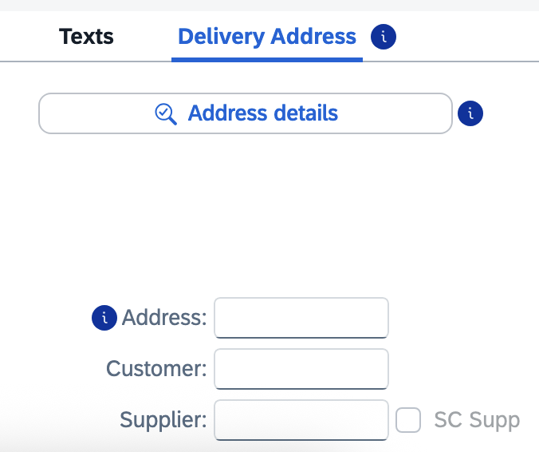
8. On line item 1 in the bottom Details section, click the Search icon on the right of the Address box to perform a search for your building location code. | 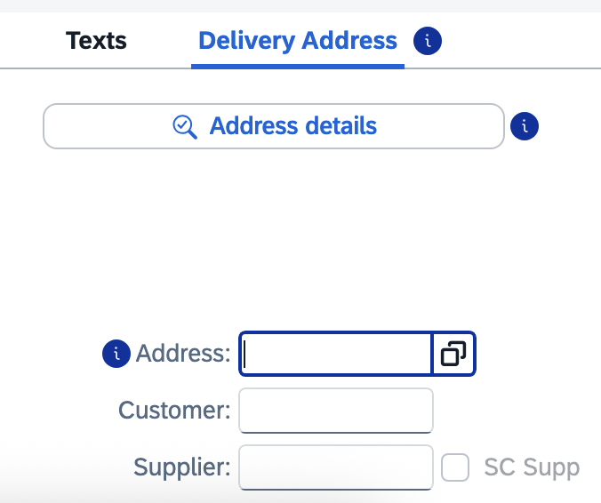
9. Ensure your Address group auto-populates ME01.  Enter your Building Location (Speed Sort) Code in the Search Term 2 field and click Go.  Note: If you encounter issues locating or using your Building Location code, contact eprocurement@uky.edu for assistance. A campus-wide delivery building listing is available on the Procurement Services website Learning and Training page. | 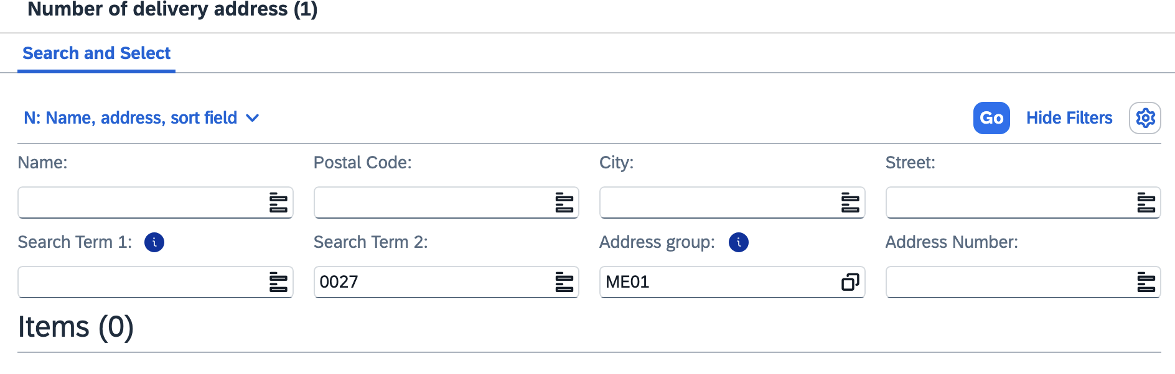
10. Select your building from the results list and click OK. | 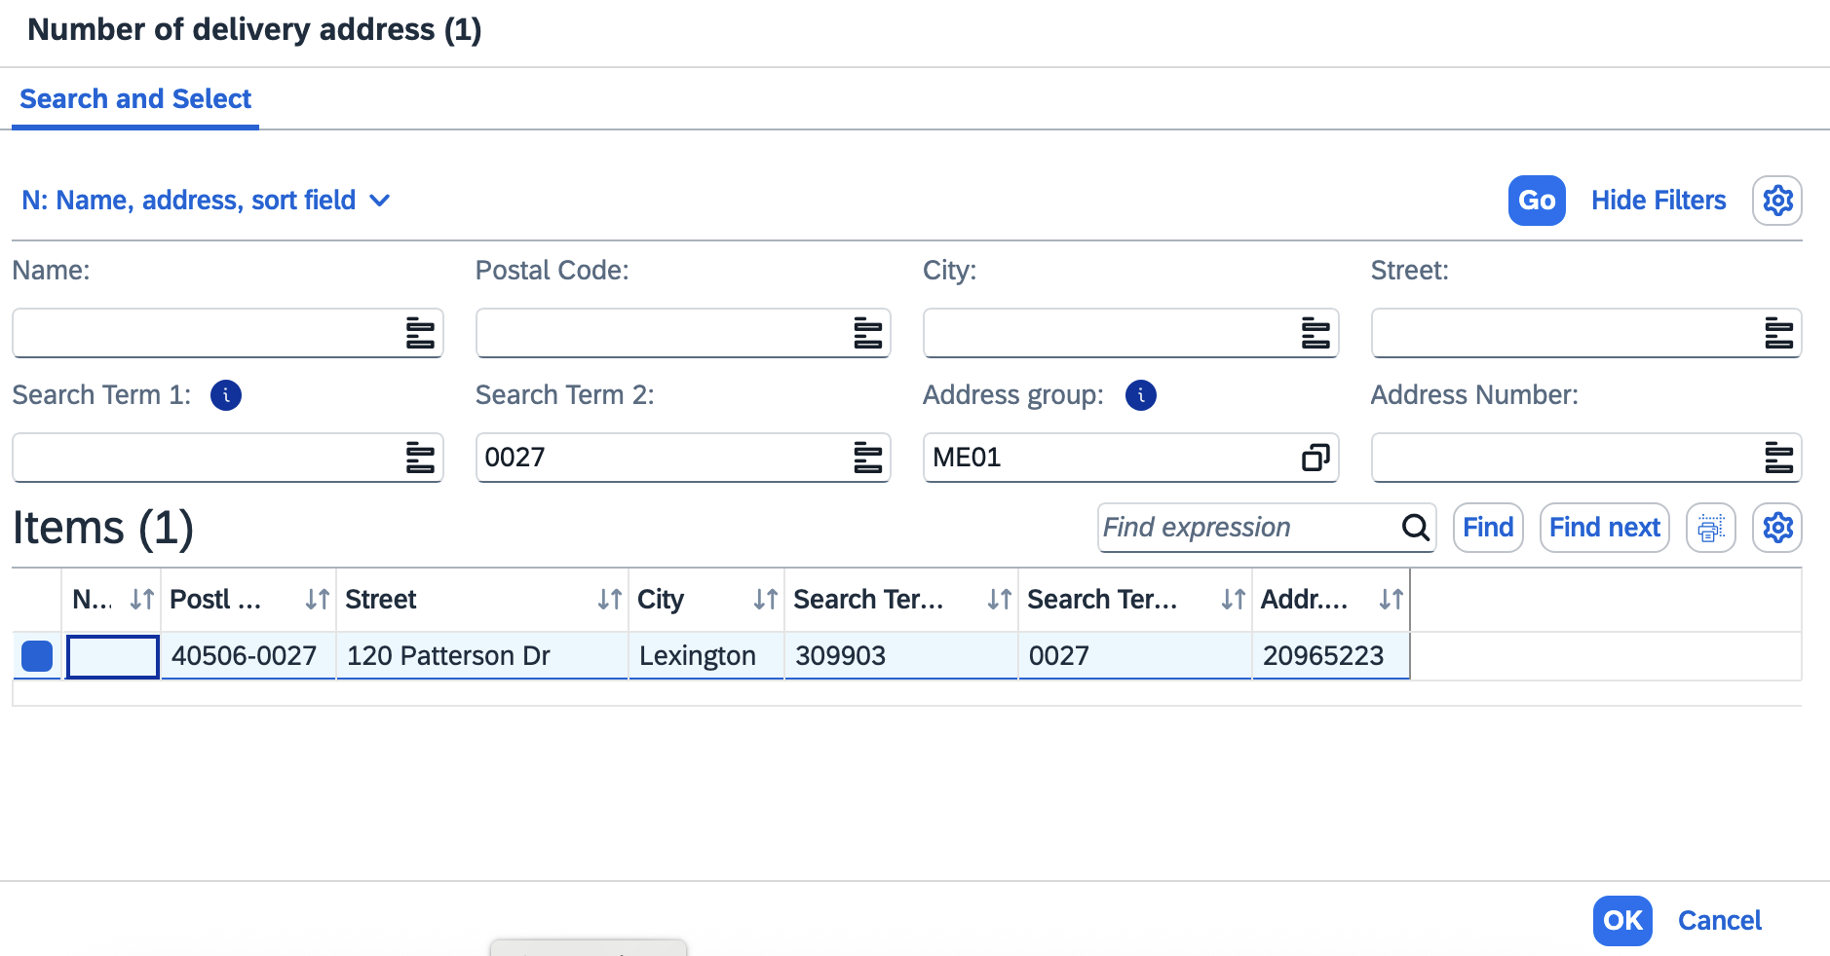
11. Press enter to populate your address into the Address field.  If you have multiple line items in your requisition, click Yes to apply the same building master data for each line item.  TIP: You may want to record your building address number for your delivery location for convenient entry on future requisitions. | 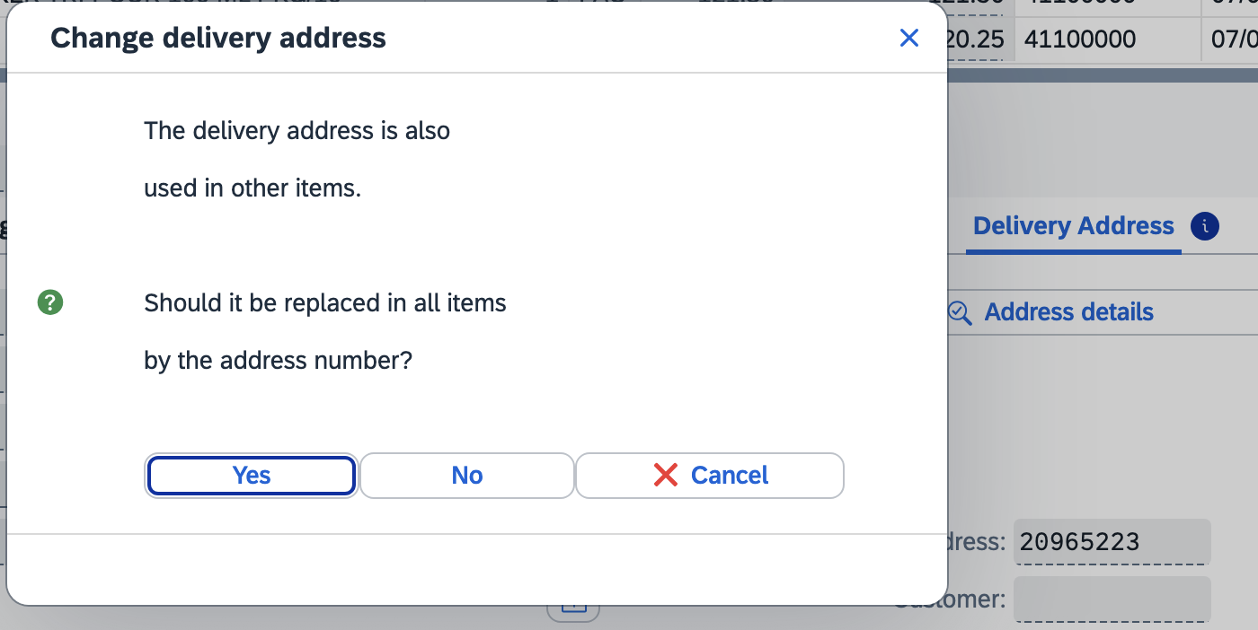
Important: You must hit the “Enter” key on your keyboard to ensure the address data loads into the req before going into Address Details.  12. Click the Address Details button | 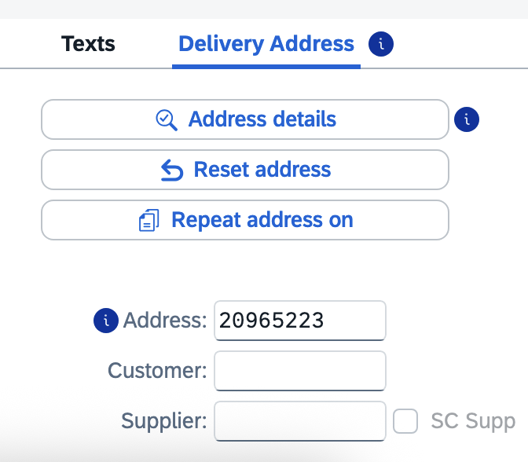
13. Within the Street Address section, click the Expand Section button at the bottom right of section. | 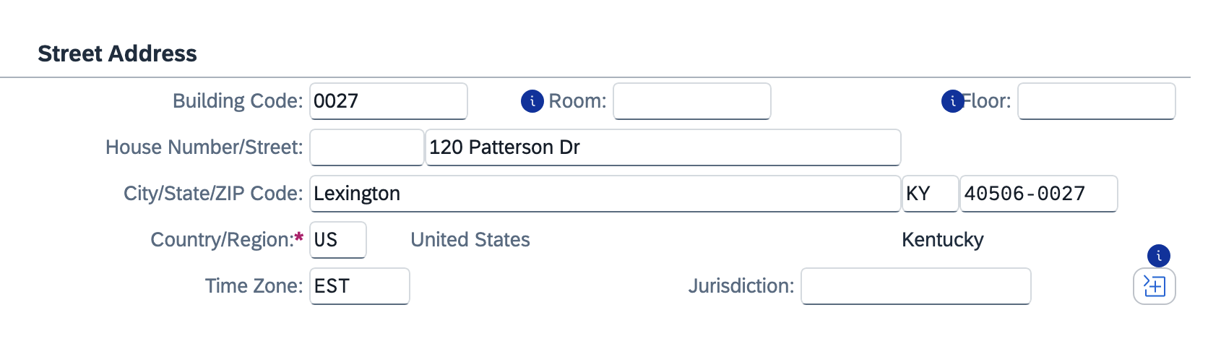
14. Perform the following edits:  >Add the Deliver-to room number to the Room field and at the end of the street address  >Add the floor number  >Add the c/o person delivery name  Click the Collapse section button | 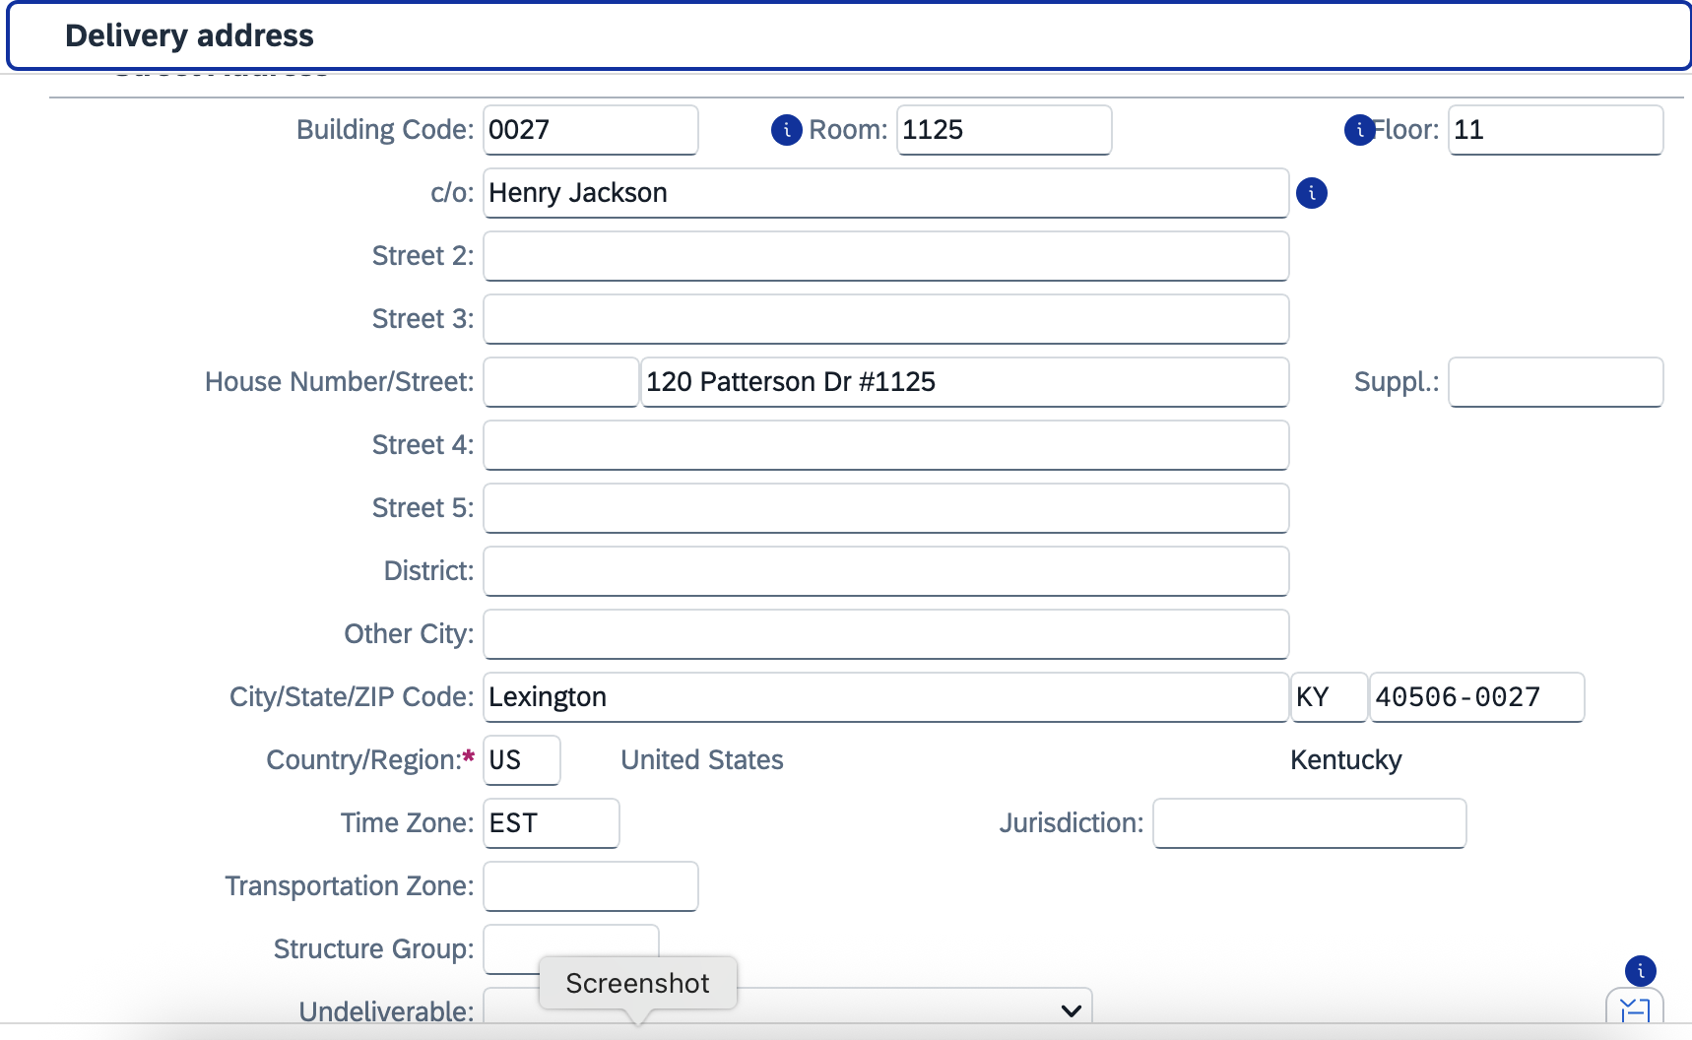
15. Add your phone number and email address | 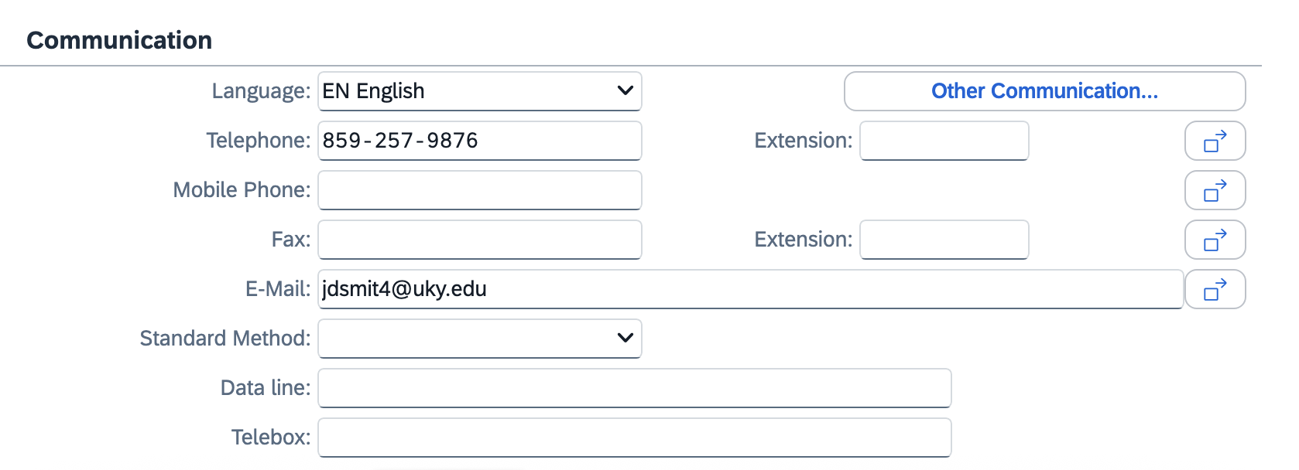
16. Click the checkmark at the bottom right corner | 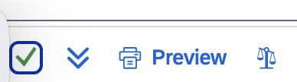
17. Click Yes to update address changes to all line items (if multiple) and finish | 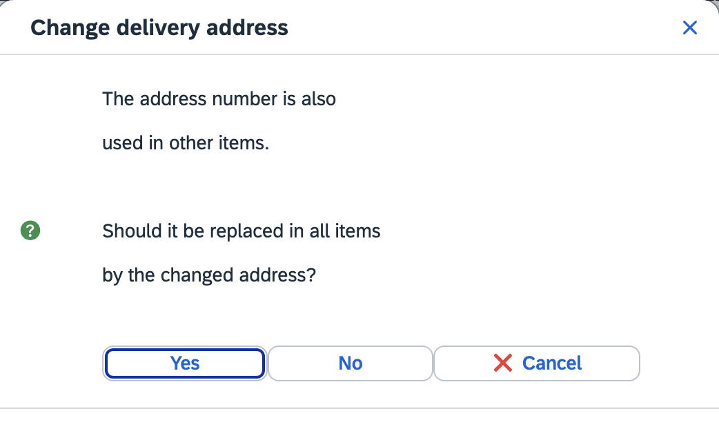
18. Review and check all line items for accuracy.  Click the Check button at the top to validate whether any errors exist.  Note: Disregard any orange (soft) warning messages. | 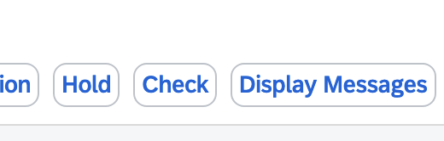
19. Click SAVE icon in the bottom right corner to complete requisition and move it forward to Approval | 