Use the following steps to cancel a Goods Receipt using SAP T-Code MIGO.
Role: SAP Goods Receiver | Frequency: As Needed

- Accessing SAP Fiori
From the myUK Landing Page, Click the SAP Fiori Launchpad icon to begin. | 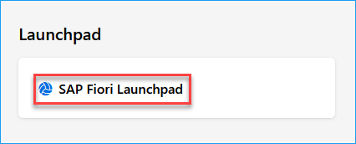
- Searching for the S/4 T-Code App
From the Fiori Home Screen, click the ‘Add Apps’ button from the far-right side. | 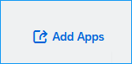
Using the catalog search bar on the right upper corner of your screen, search for “Post Goods Movement” or “MIGO” and hit enter on your keyboard. Click on the app to open it.  Optional: To save this app to your homepage, click the plus (+) sign. and then click on the app when ready. | 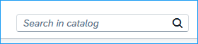  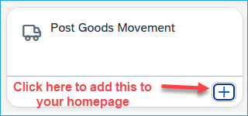
- Completing a Goods Receipt Cancellation
Ensure A03 Goods Cancellation is selected for the first field, R02 is selected for the second field, and the material document number is entered and hit “Enter” on your keyboard.  Note: The Material Document number listed in the Purchase Order History tab on the PO is what you need for the Goods Cancellation. | 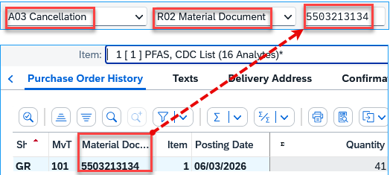
Note: If you have additional information to add to this goods cancellation, you can complete the optional Header Text field.  To cancel lines on the Goods Receipt, check the “Item OK” box on the bottom of the screen for the highlighted line. For other lines, you can select the “OK” box directly on the line item listing. Once complete, select ‘Post’ in the bottom right to submit the cancellation. | 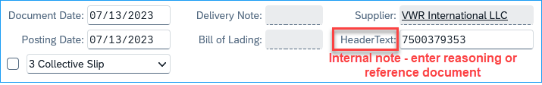  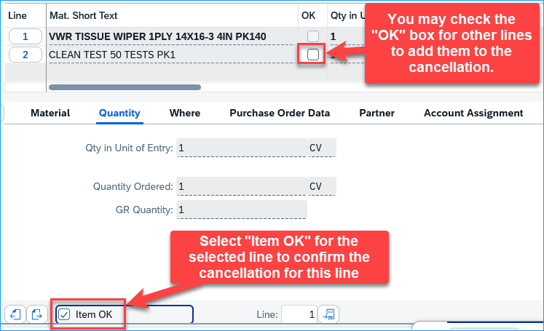
Tip: If you are unsure what your material document number is for the GR you need to cancel, a good starting point that may also help you locate it is by selecting the Show/Hide Overview button to see a document overview of the GRs you have entered. You can double-click on these numbers to view them and confirm which GR needs to be canceled. | 