Use the following steps to create a Goods Receipt using the Fiori app for applicable orders.
Role: SAP Goods Receiver | Frequency: As Needed

- Accessing SAP Fiori
From the myUK Landing Page, Click the SAP Fiori Launchpad icon to begin. | 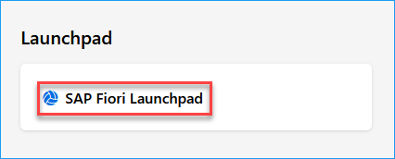
- Searching for the Fiori App
From the Fiori Home Screen, click the ‘Add Apps’ button from the far-right side. | 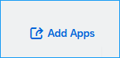
Using the catalog search bar on the right upper corner of your screen, search for “Post Goods Receipt for Purchasing Document” and hit enter on your keyboard.Click on the app to open it.  Optional: To save this app to your homepage, click the plus (+) sign. and then click on the app when ready. | 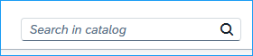  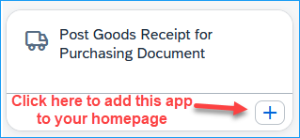
- Completing a Goods Receipt
Enter your PO number in the Purchasing Document Search bar and hit ‘Enter’ on your keyboard.  A list of lines from the PO will populate that still need a goods receipt entered. | 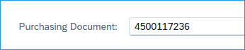
Note: If you have additional information to add to this goods receipt, you can complete the following optional fields:  To confirm the full quantity, check the box on the left edge for the line(s) and select ‘Post’ in the bottom right.  To confirm for a partial quantity, change the quantity to the correct amount and then check the box on the left edge for the line(s) and select ‘Post’ in the bottom right. | 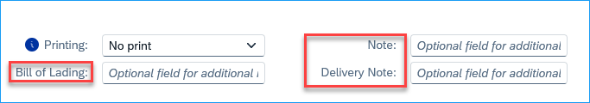  - Bill of Lading – not typical and usually does not apply  - Note & Delivery Note – internal notation (may enter an invoice number here if you have one)  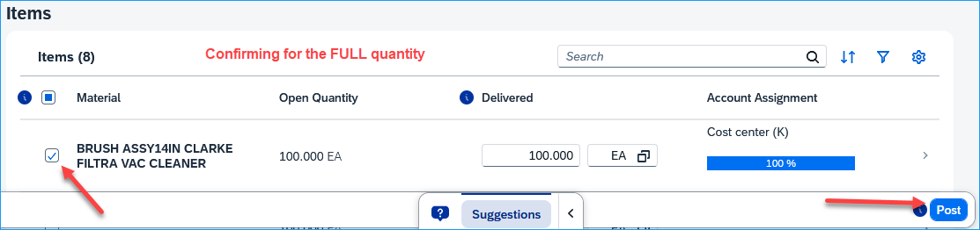  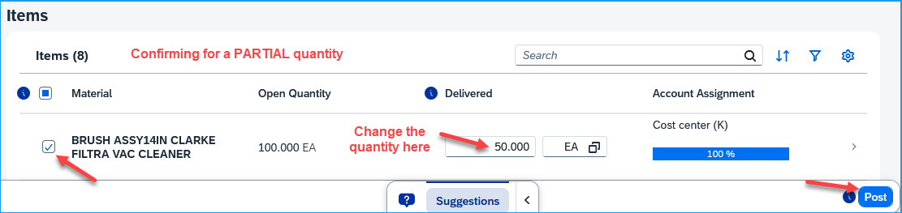
Note for Delivery Complete Indicator:  If you will not be receiving any more items for a line and want/need to mark this as Delivery Completed, click on the arrow on the right of the item and click on the checkbox for the Delivery Completed indicator. | 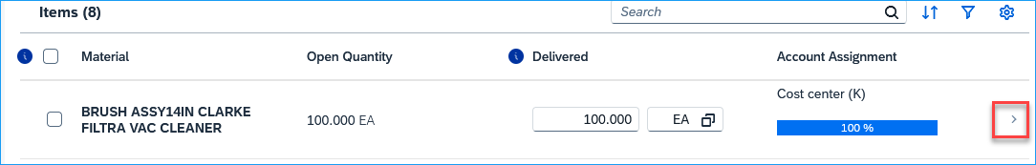  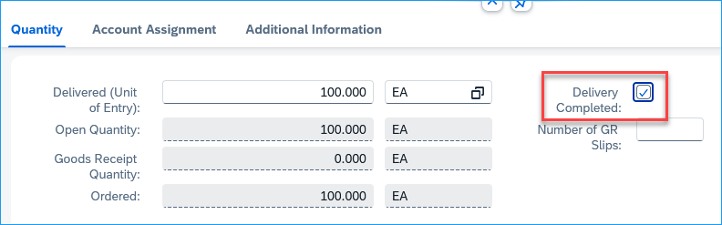
Canceling a Goods Receipt | Important:  Please note that if you need to cancel any Goods Receipts, you will need to use T-Code MIGO

