Use the following steps to create a Goods Receipt using SAP T-Code MIGO for applicable orders.
Role: SAP Goods Receiver | Frequency: As Needed

- Accessing SAP Fiori
From the myUK Landing Page, Click the SAP Fiori Launchpad icon to begin. | 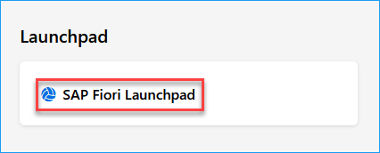
- Searching for the S/4 T-Code App
From the Fiori Home Screen, click the ‘Add Apps’ button from the far-right side. | 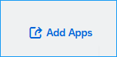
Using the catalog search bar on the right upper corner of your screen, search for “Post Goods Movement” or “MIGO” and hit enter on your keyboard. Click on the app to open it.  Optional: To save this app to your homepage, click the plus (+) sign. and then click on the app when ready. | 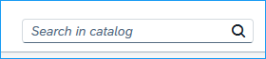  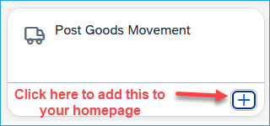
- Completing a Goods Receipt
Ensure A01 Goods Receipt is selected for the first field, R01 is selected for the second field, and the PO number and hit “Enter” on your keyboard.

Note: If you have additional information to add to this goods receipt, you can complete the following optional fields:  To confirm the full quantity, check the “Item OK” box on the bottom of the screen for the highlighted line. For other lines, you can select the “OK” box directly on the line item listing. Once complete, select ‘Post’ in the bottom right.  To confirm for a partial quantity, change the quantity to the correct amount and then check the “Item OK” box and select ‘Post’ in the bottom right. | 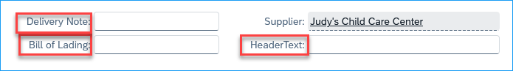  - Delivery Note – can include any delivery notes such as the person who received it.  - Bill of Lading – not typical and usually does not apply  - Header Text – internal notation (may enter an invoice number here if you have one)  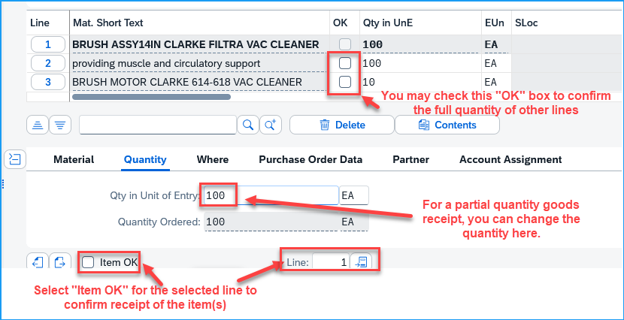
Note for Delivery Complete Indicator:  If you will not be receiving any more items for a line and want/need to mark this as Delivery Completed, click on the “Purchase Order Data” tab and change the indicator to “Set”. | 