Approvers receive requisitions and other documents (such as Payment Request Documents (PRDs)) to review for their areas into their SAP S/4 My Inbox. Available tasks include approve, reject, claim, and forward. Document routing is based on department number-driven workflows.

Approvers receive their roles based on their Business Officer completing and submitting an SAP Access Request Form on their behalf. The form submission should include the department number(s) required for workflow routing and the approval levels to be assigned to the Approver.

- Requisitions or PRD < $10K – Require one level of approval (L1)
- Requisitions or PRD => $10K – Require second level of approval (L2)

In addition, requisitions having specific GL accounts for purchase of vehicles, IT hardware, leases and high-risk items (e.g., drones, golf carts, firearms, security items) route to areas responsible for their oversite and approval.

Requisitions route to Procurement Services for Purchase Order processing once all approvals are complete.

Note: UK HealthCare and Facilities Management requisitions utilize line-item driven workflows with different value thresholds

Role: SAP S/4 Approver | Frequency: As Needed

1. If needed, use the Add Apps icon to add My Inbox to your home page | 
2. Click any requisition in the left Tasks bar to view in right panel | 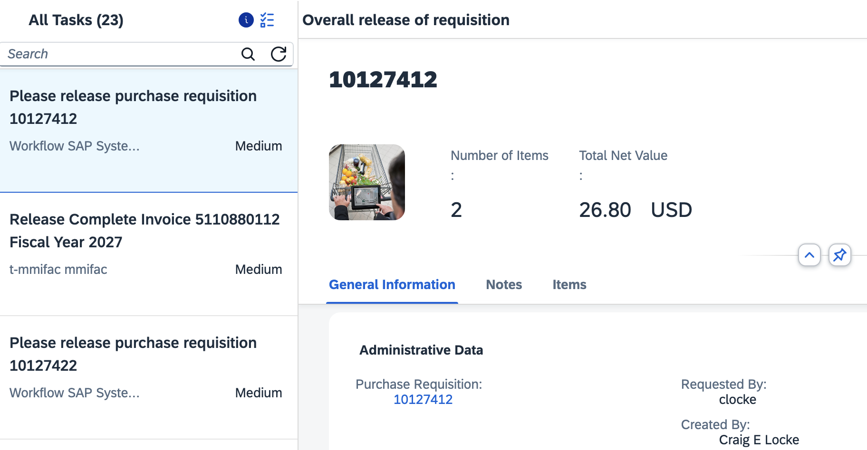
3. Review top General Information for overview | 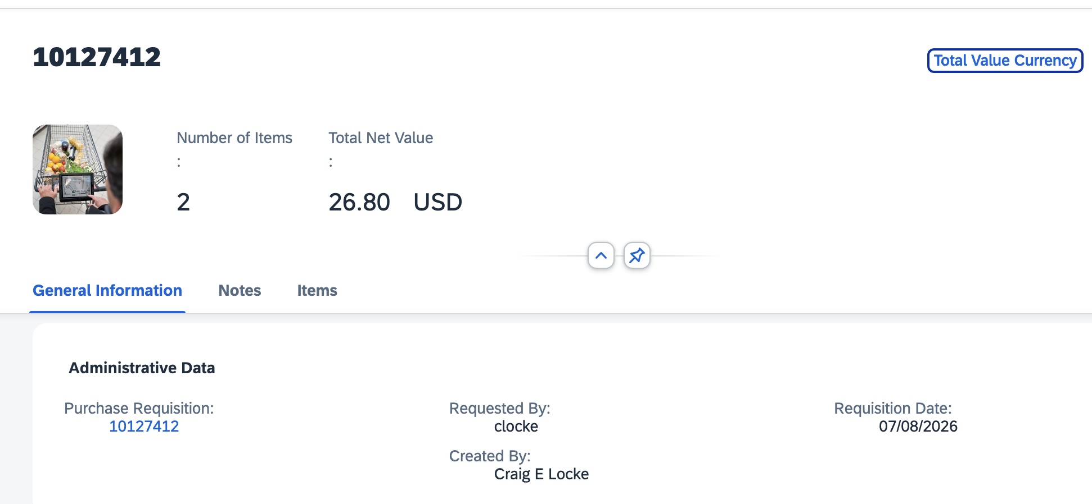
4. Scroll or select tab to review any items within Notes section | 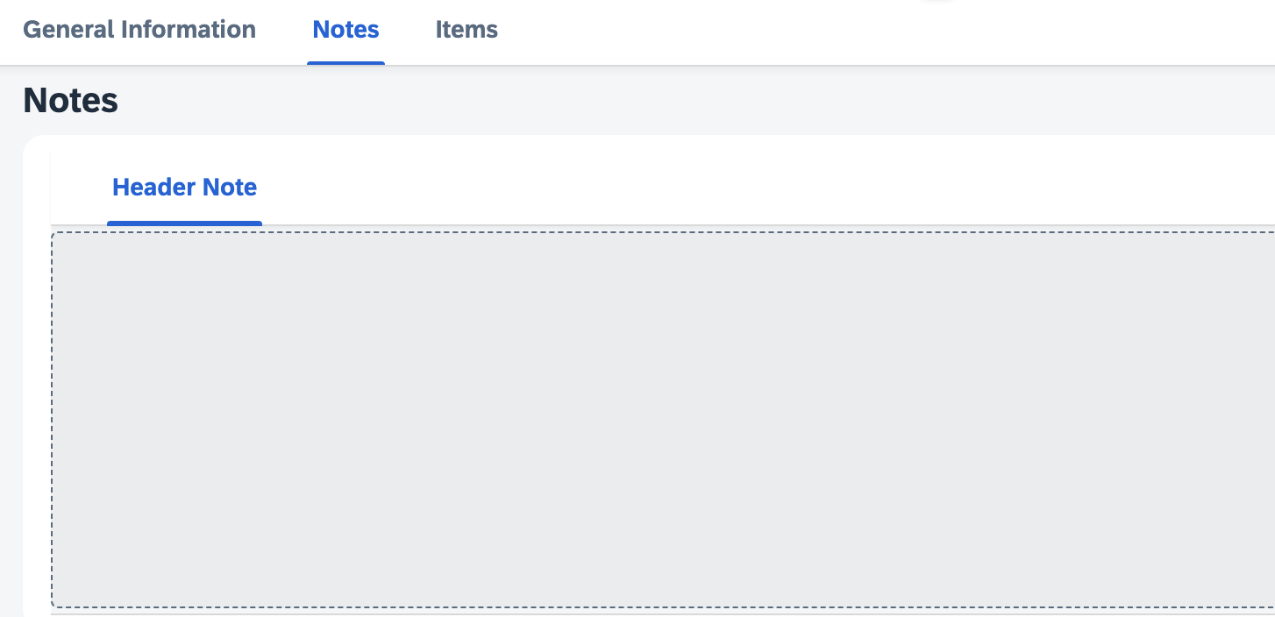
5. Scroll or select tab to review Items section.  Click the > icon on the right for line-item details | 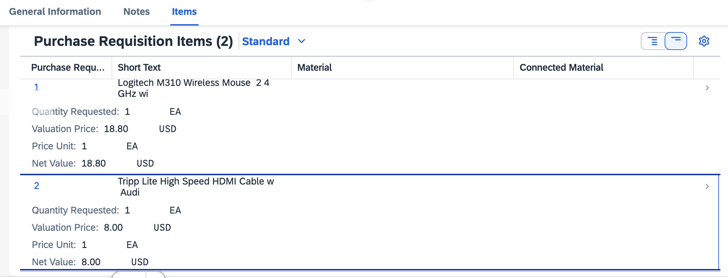
6. Line-item Details include extended description of goods or services purchased, delivery address, desired vendor, account assignment, additional notes, and attachment(s). | 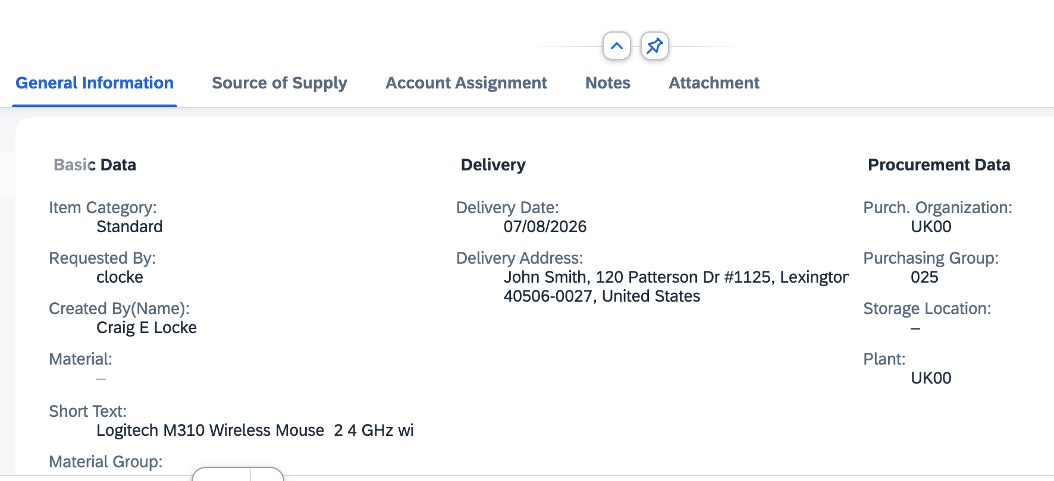
7. Approver options:  >Approve  >Reject (with note)  >Claim (removes from inboxes of peer approvers, when applicable)  >Forward to other approver to manage.  Note: Forwarded requisitions can only be approved by the recipient provided the person also has the Approver role. | 