Requisitions created using the ME51N T-Code Create Purchase Requisition can be displayed and potentially edited when needed.

Important: Requisitions can only be edited to the point of their first level of approval. If a change is needed to an order after it is approved, contact the Procurement Services buyer responsible for the resultant purchase order. The buyer name can be found on the requisition under Purchasing Group.

Role: SAP S/4 Requisitioner | Frequency: As Needed

1.Begin Create Purchase Requisition app (ME51N) | 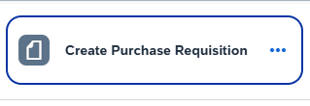
2.Click on the Menu Button | 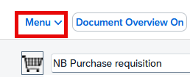
3.Follow the drop down menus and click on Other Requisition | 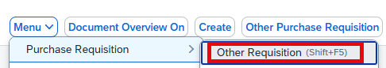
4.Enter the requisition number and then enter on your keyboard | 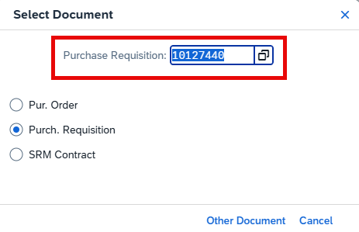
5.Click the Display/Change button at the top of the screen  Remember: Requisitions can only be edited to the point of their first level of approval. If a change is needed to an order after it is approved, contact the Procurement Services buyer responsible for the resultant purchase order. The buyer name can be found on the requisition under Purchasing Group. | 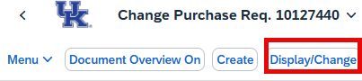
6.Highlight the line you want to edit by clicking on the box on the far left

7.Make the necessary changes such as Quantity, Value Price. Account Assignment, G/L, etc.

8.Click the Save button in the lower left corner when finished to retrigger Approval workflow | 

