Important: Integrated ordering systems utilize specific master data in specific cells for correct order placement and processing. It’s important to follow the exact steps below to enter your delivery address information correctly and not enter any building name or address components via free text entry.
Failure to follow the delivery steps will cause an order to fail to process or deliver correctly.

Completing the Delivery Address section is one of the last steps for completing either an e-catalog or Free Text requisition.

Role: SAP S/4 Requisitioner | Frequency: As Needed

Set Delivery Address on e-Catalog or Free Text Requisition
1. Navigate to Delivery Address Tab | 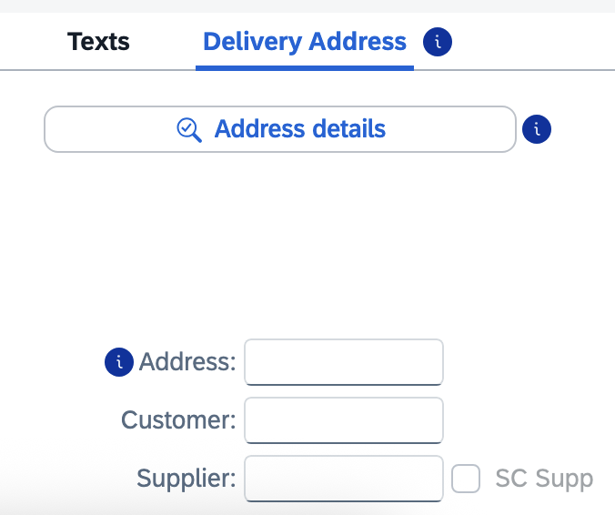
2. On line item 1 in the bottom Details section, click the Search icon on the right of the Address box to perform a search for your building location code. | 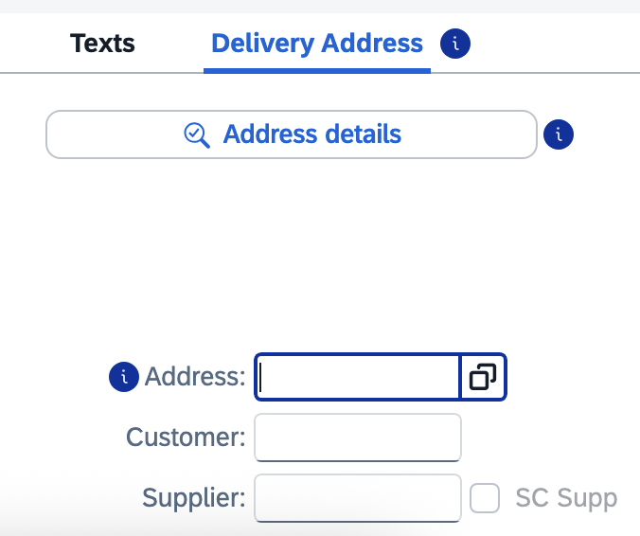
3. Ensure your Address group auto-populates ME01.  Enter your Building Location (Speed Sort) Code in the Search Term 2 field and click Go.  Note: If you encounter issues locating or using your Building Location code, contact eprocurement@uky.edu for assistance. A campus-wide delivery building listing is available on the Procurement Services website Learning and Training page. | 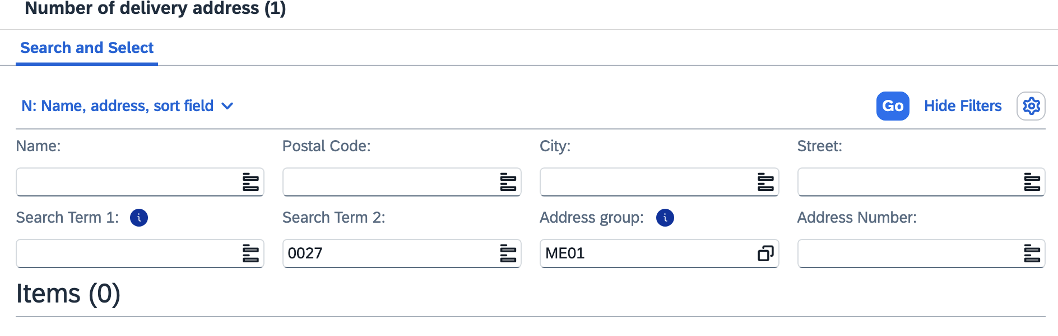
4. Select your building from the results list and click OK. | 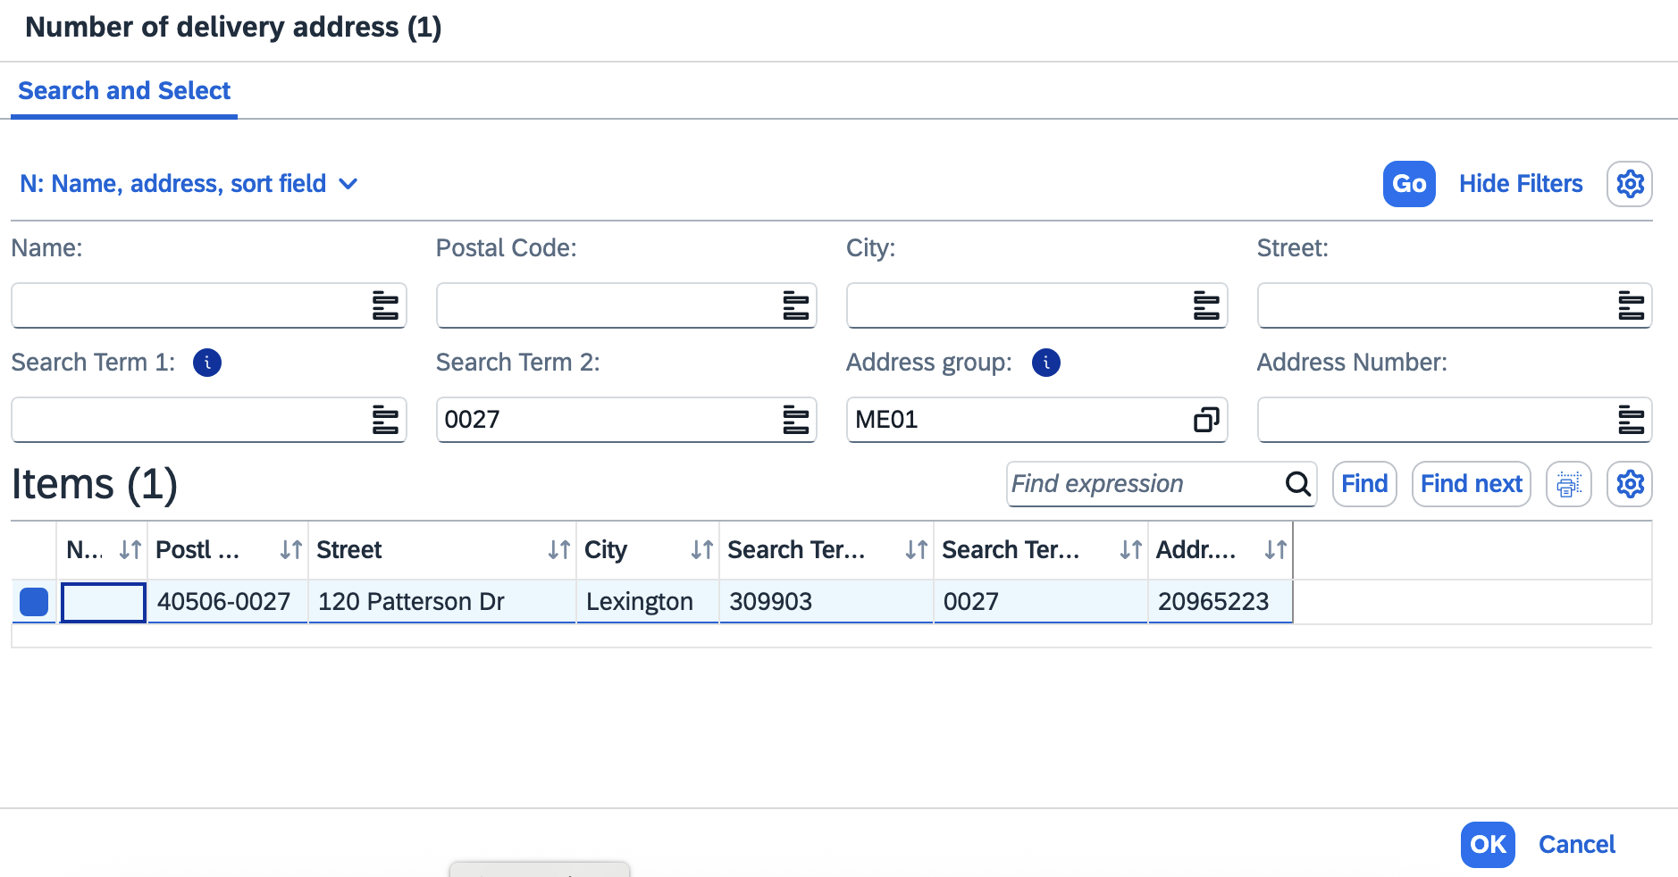
5. Press enter to populate your address into the Address field.  If you have multiple line items in your requisition, click Yes to apply the same building master data for each line item.  TIP: You may want to record your building address number for your delivery location for convenient entry on future requisitions. | 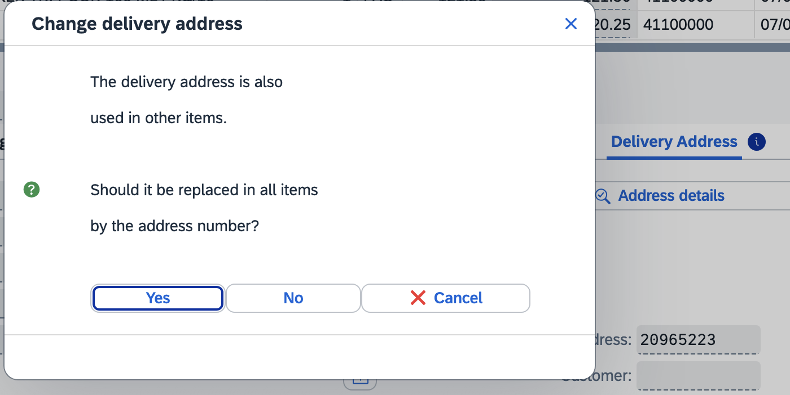  IMPORTANT: You must hit ‘Enter’ on your keyboard after this step to ensure the address is input into the requisition.
Important: Make sure you already hit ‘Enter’ so the address data loaded into the req before navigating to the Address Details section.  6. Click the Address Details button | 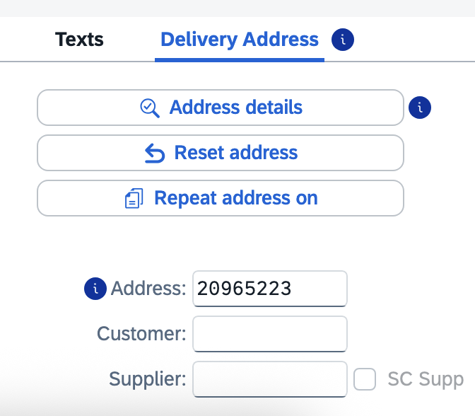
7. Within the Street Address section, click the Expand Section button at the bottom right of section. | 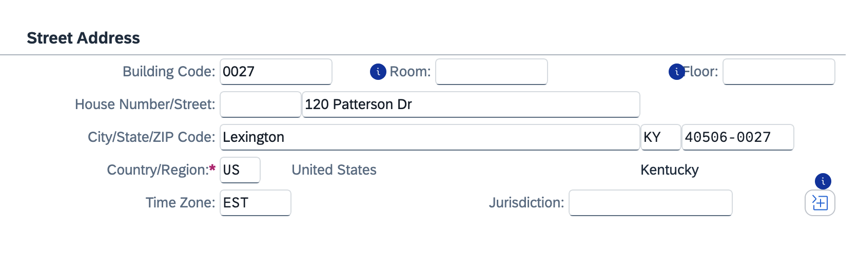
8. Perform the following edits:  >Add the Deliver-to room number to the Room field and at the end of the street address  >Add the floor number  >Add the c/o person delivery name  Click the Collapse section button | 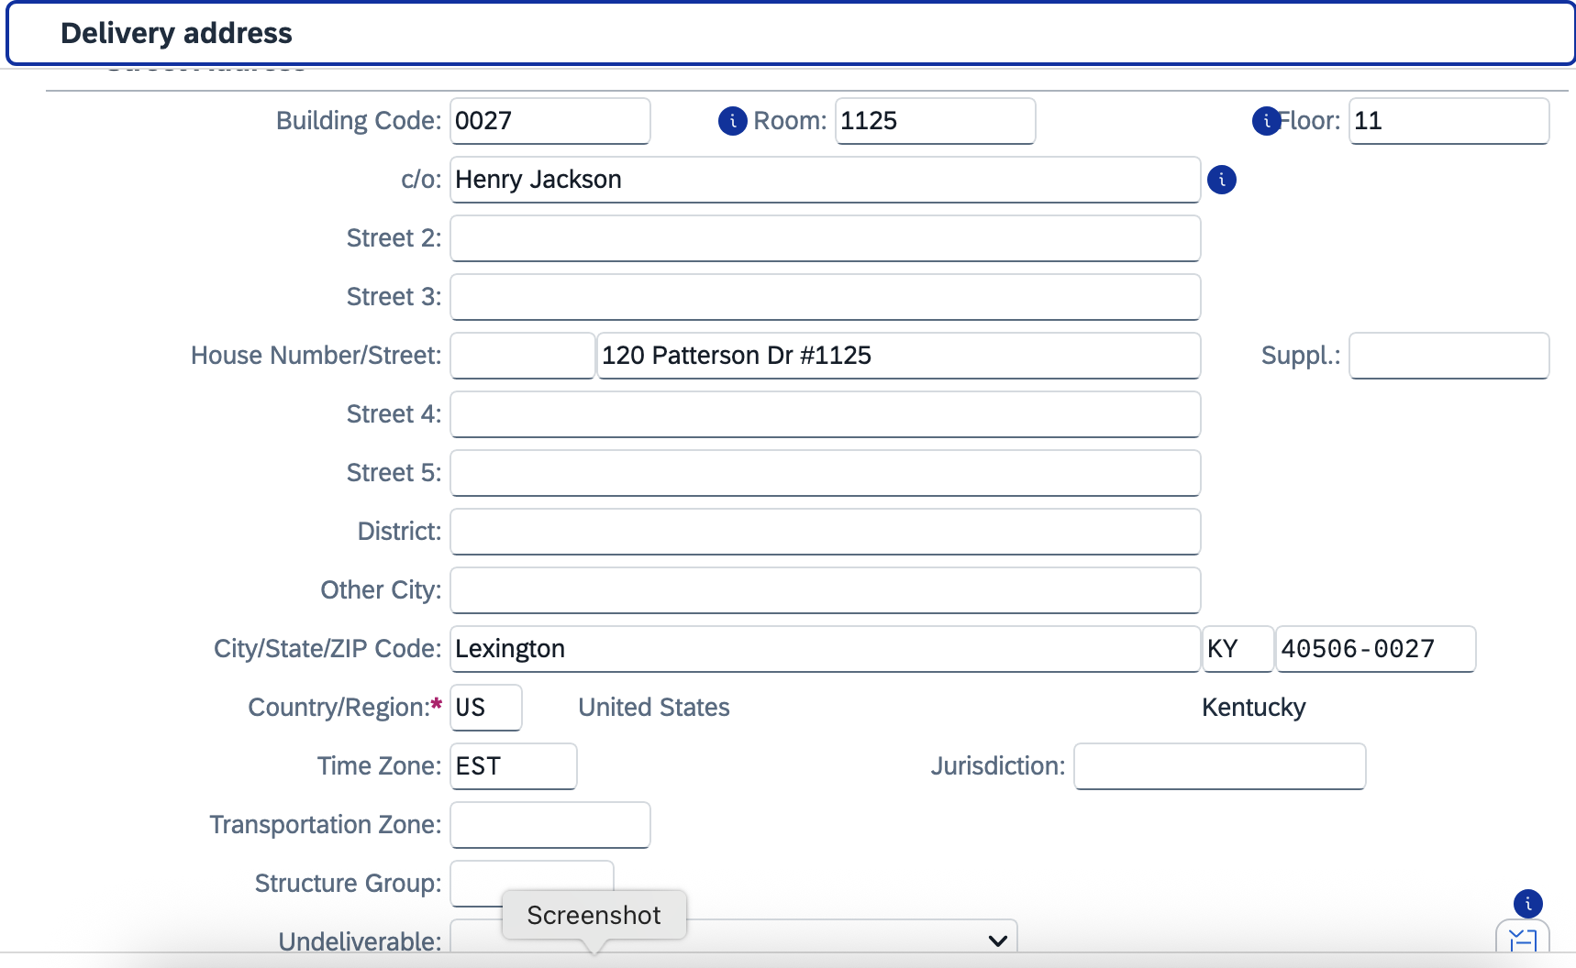
9. Add your phone number and email address | 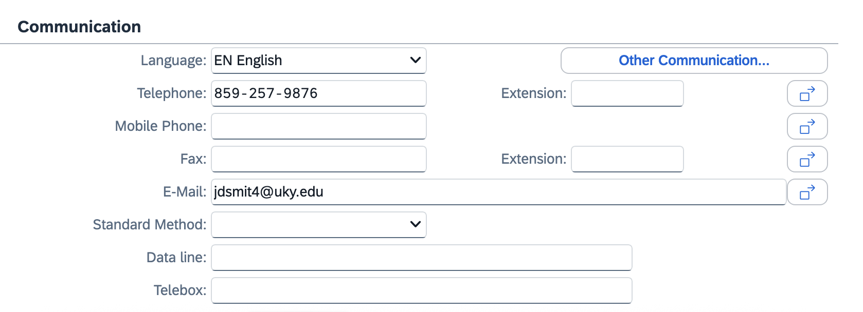
10. Click the checkmark at the bottom right corner | 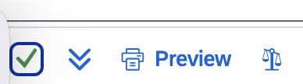
11. Click Yes to update address changes to all line items (if multiple) and finish | 