Use the following steps to create an SAP S/4 Free Text Requisition using T-code ME51N for Create Purchase Requisition Advanced to order needed goods and/or services from non-e-catalog suppliers using a supplier quote.

Note: For Requisitioners who may enter orders for Personal Service Contracts (PSCs), always use the ME51N Create Purchase Requisition Advanced for this type of order. Purchase Orders for PSCs cannot be submitted via the Fiori Manage Purchase Requisition Professional app.

Role: SAP S/4 Requisitioner | Frequency: As Needed

Prior to creating your first requisition using SAP T-code ME51N, you must set your default settings in four locations. This is a one-time requirement. After your default settings are established, you can immediately create requisitions as needed each time using steps in Section B.

A. Set Default Settings (Four Locations) on First Visit
From the myUK Landing Page, Click the SAP Fiori Launchpad icon to begin. | 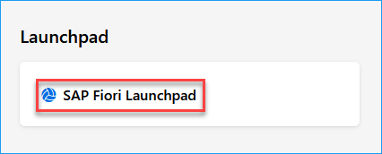
1. To access T-code ME51N within the SAP S/4 environment, select Add Apps from the upper right area of your home page. | 
2. Upon arriving to the Apps page, enter ME51N into the Search Catalog box at the top right. | 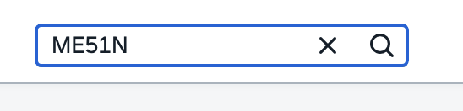
3. Once you locate the T-code for Create Purchase Requisition Advanced, click the plus (+) sign to add it to your home page as a favorite. | 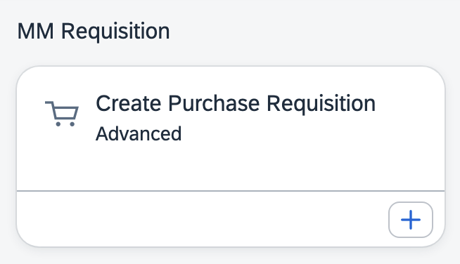
4. Click Create Purchase Requisition Advanced to open T-code | 
5. Setting One – Once the app starts, click the Menu button at the top left and select Settings.  (This is one-time only.) | 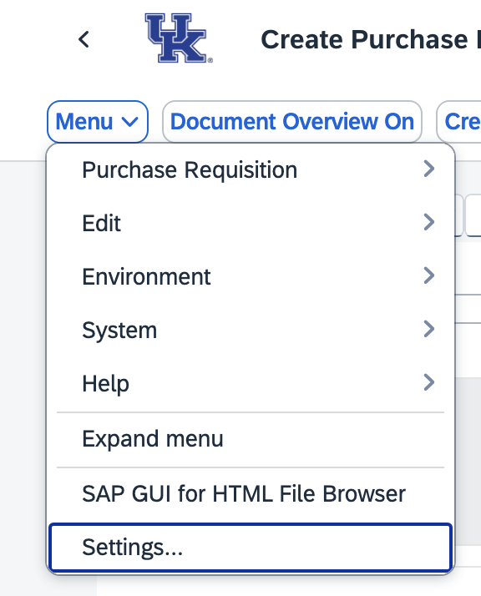
6. Select Visualization from the left menu. Ensure both selections under Dropdown List section are set to On.  Ensure both selections for Enhanced Search are set to on.  Click SAVE when complete. | 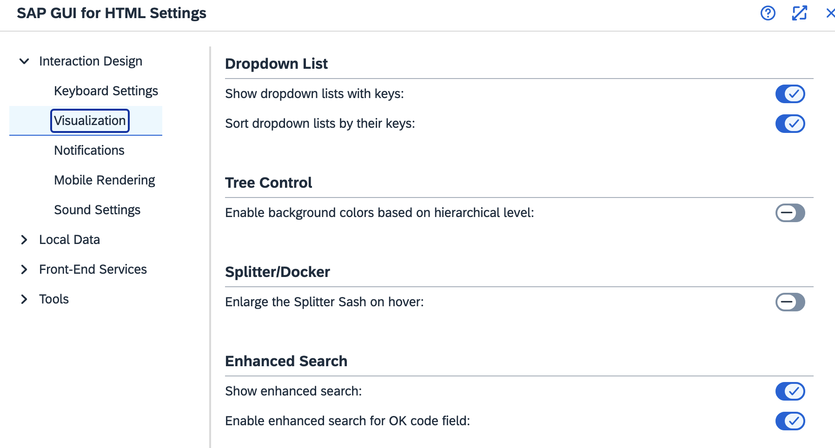
7. Setting Two - Select Personal Setting from the top menu.  (This is one-time only.) | 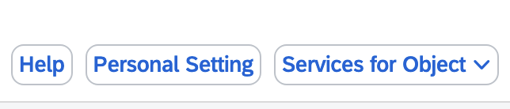
8. On Basic Settings tab, set Selection Period for My Docs to -9999 for No Restrictions. | 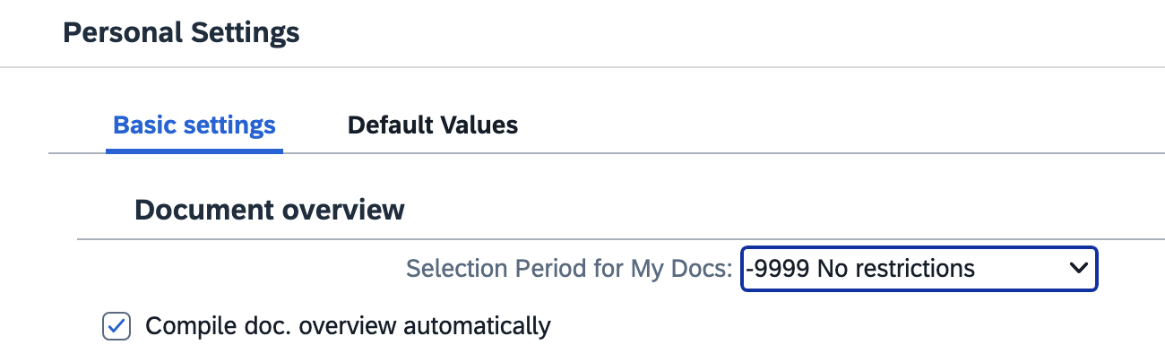
9. On the same selection set Default Values on Requisition Header as follows.  (This is one-time only.)  >Document type – NB Purchase Requisition  >Item Category – Select 0 Standard and check Always Propose  >AcctAssCat – Select K-Cost Center or P-Project (WBS Element-Grant) depending on the cost object type you most frequently use and check Always Propose  >Delivery Date – Enter D in first box only and check Always Propose  >Plant – Enter UK00 and check Always Propose  >Important: Requisitioner – Enter your Linkblue ID and check Always Propose  >Currency – Enter USD  >Check box for Source Determination  >Click Save | 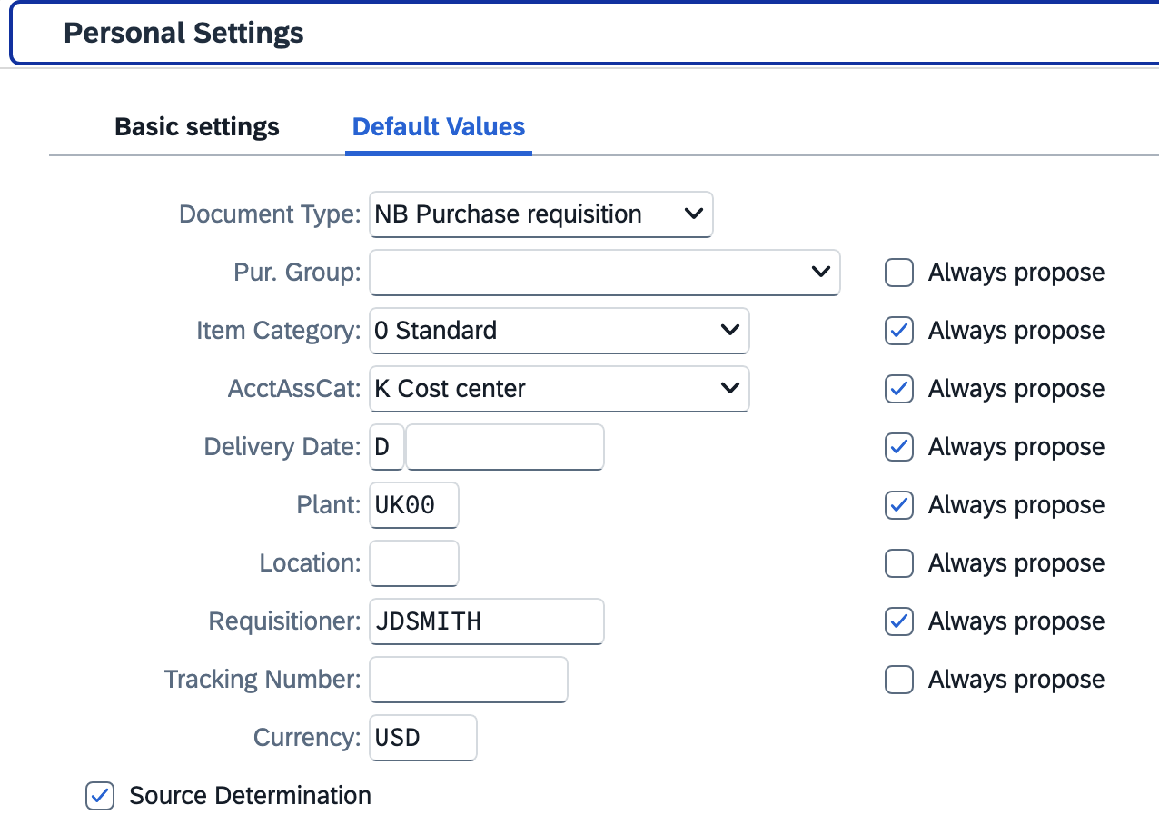  If some fields are missing, click the More Fields button to move needed ones into view.  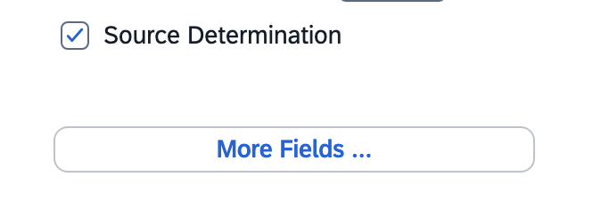
10. Setting 3 - Set Default Values on Requisition Line Item. The icon button is in the middle screen section.  (This is one-time only.)  Set the exact same settings and checkboxes here at the Line-Item level as you did for the header level in the previous step.  >Click Save | 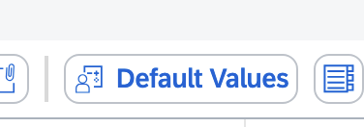  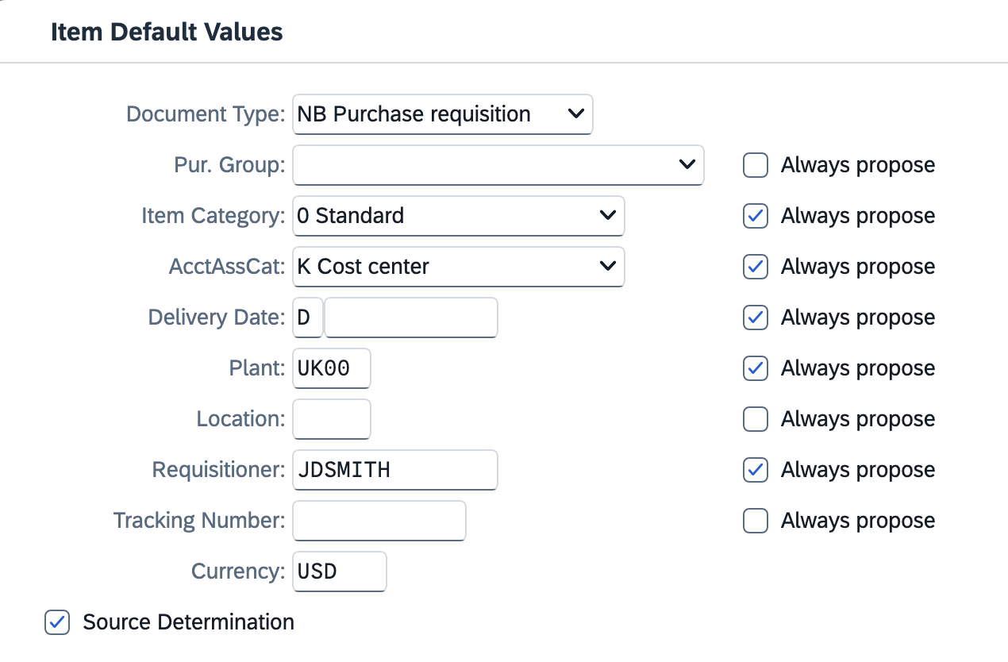
11. Setting 4 - Locate the Layout button in the middle of the requisition screen and click the black triangle on the right side.  (This is one-time only.)  >Click Choose Layout  >Select /CAMPUS_REQ as your layout type to bring into view | 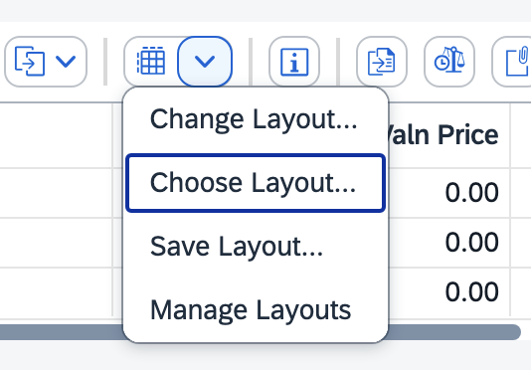  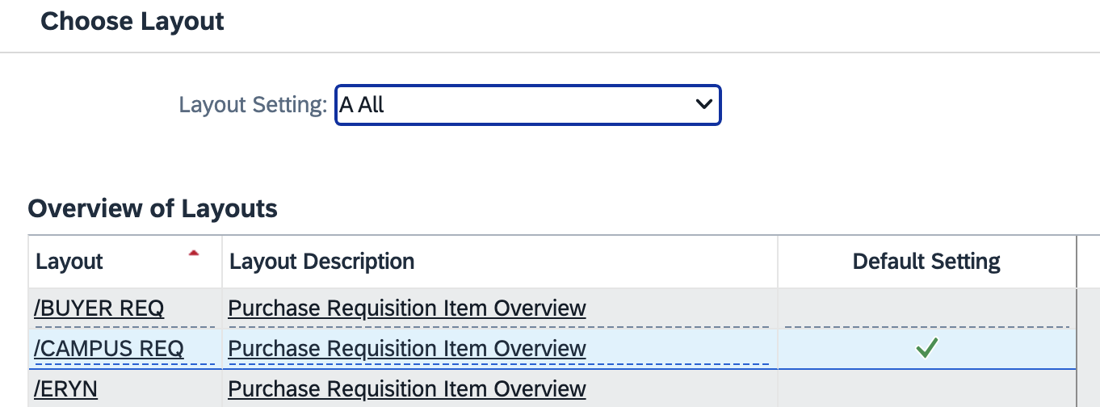
12. Click the right side of the Layout button a second time and select Save Layout from the dropdown menu.  >With /CAMPUS_REQ layout showing, place a checkmark on the Default box and click Adopt.  >Click Yes to Save Layout  Note: The same layout is used by every Requisitioner. Ensure not to make any other changes to the layout.  This completes all of your one-time settings for ME51N Create Purchase Requisition Advanced. | 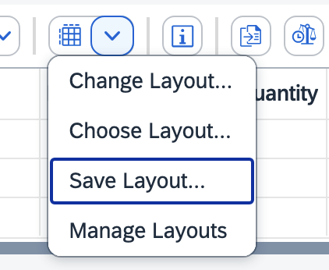  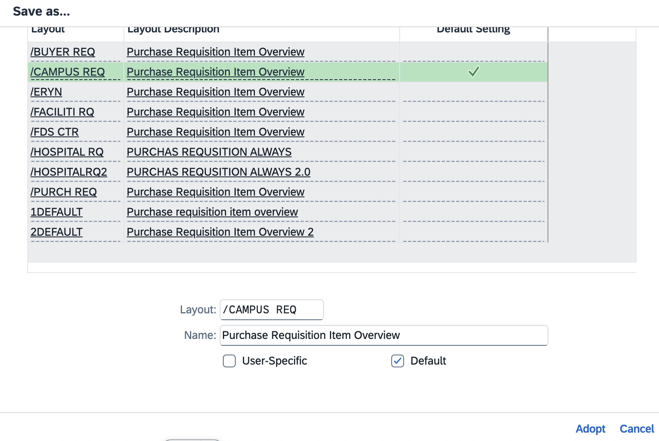  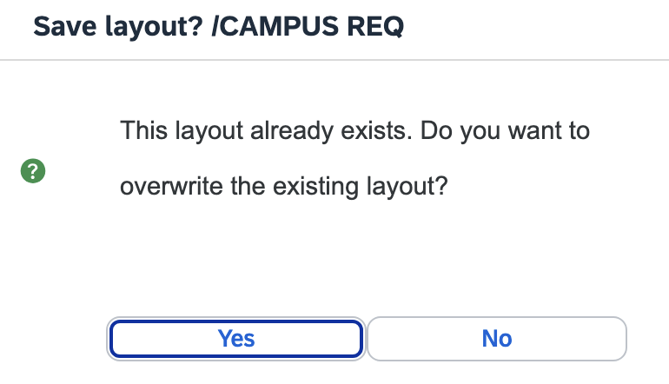

B. Create ME51N SAP Requisition for Free Text Order
1. Enter header and/or Business Purpose Notes | 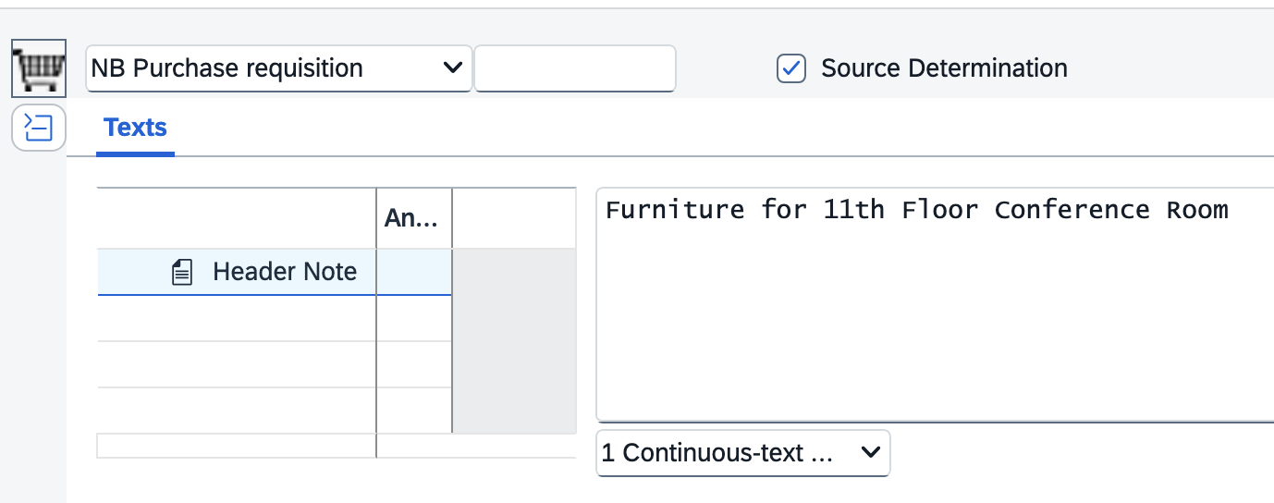
2. Enter needed information across the line items. Line-item numbers will auto-populate.  >Update Account Assignment Category (K, P, or X) if not previously entered or needs changed.  >Enter the Desired Vendor number. Click on the right side of the Desired Vendor box for a search option to locate the correct vendor number. Ensure to use only the UK Vendor Search selection menu and use *wildcard* search tools.  >Enter vendor material (catalog) number, description, quantity, unit of measure, etc.  >Enter/adjust the delivery date as needed. | 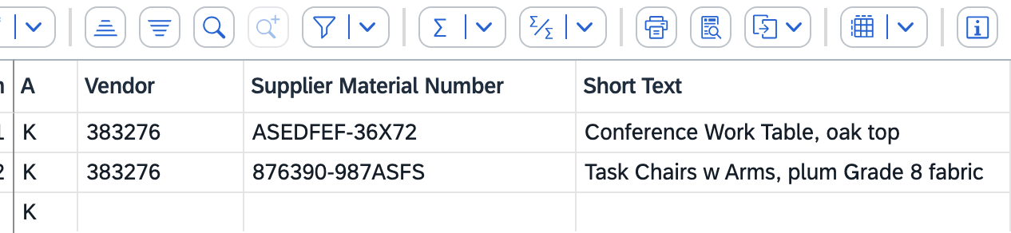  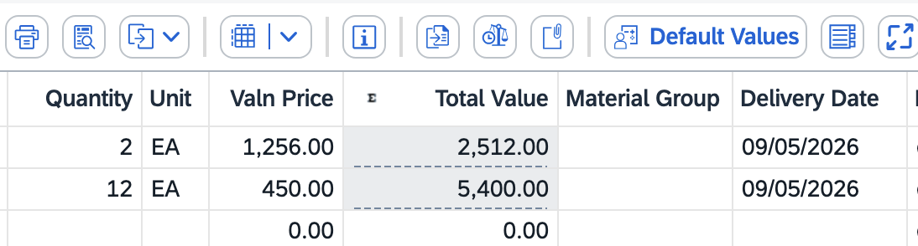
3. The Material Group must be selected for each line. Using the search icon on the right, select the Material Group that most closely aligns with the description of the commodity that you are ordering.  You may use the search bar for a keyword search or also click the column headers to sort in ascending or descending order for manual search.  >For campus users, use only Material Groups with an 8-digit number.  >For UKHC areas, use only Material Groups other than 8-digit.  *Important: Do not use material groups preceded with any alpha-characters (e.g., C).  *Important: Assign the same Material Group to every line-item on your requisition. It’s important not to intermingle multiple Material Groups on the same requisition. | 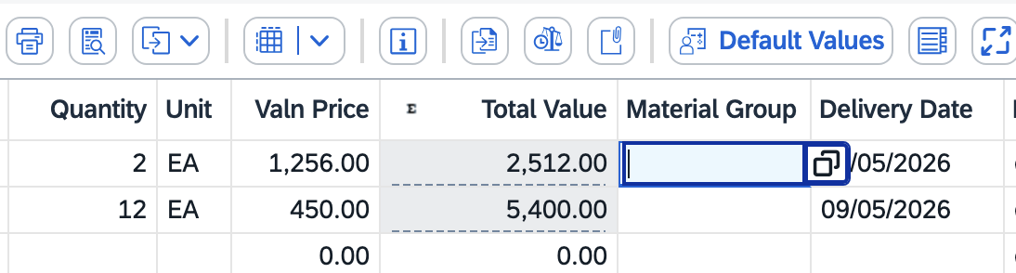  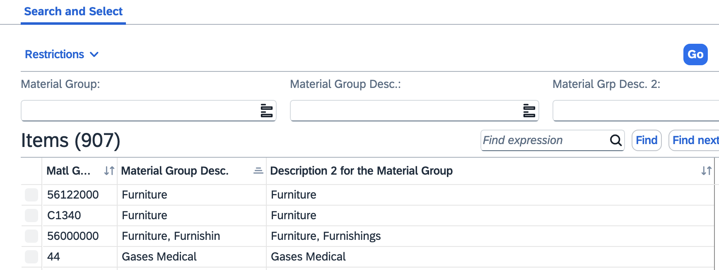  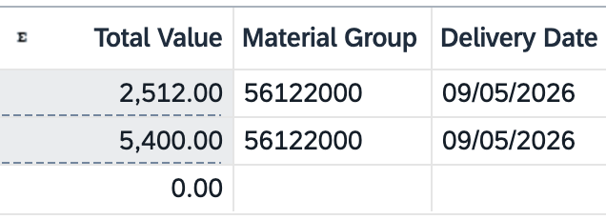
4. Navigate to the bottom Item Details section and click the Account Assignment tab. Establish and enter your accounting information for your Cost Center or WBS-Element.  If needed, toggle the AccAssCat selection between K-Cost Center and P-Project (WBS Element-Grant) to select/change the appropriate type.  If you need to assign split/multiple accounting, select X-All Other Aux Assignments from the AccAssCat selection to establish and complete the needed layout and distribution. You can also select the appropriate split distribution type. | 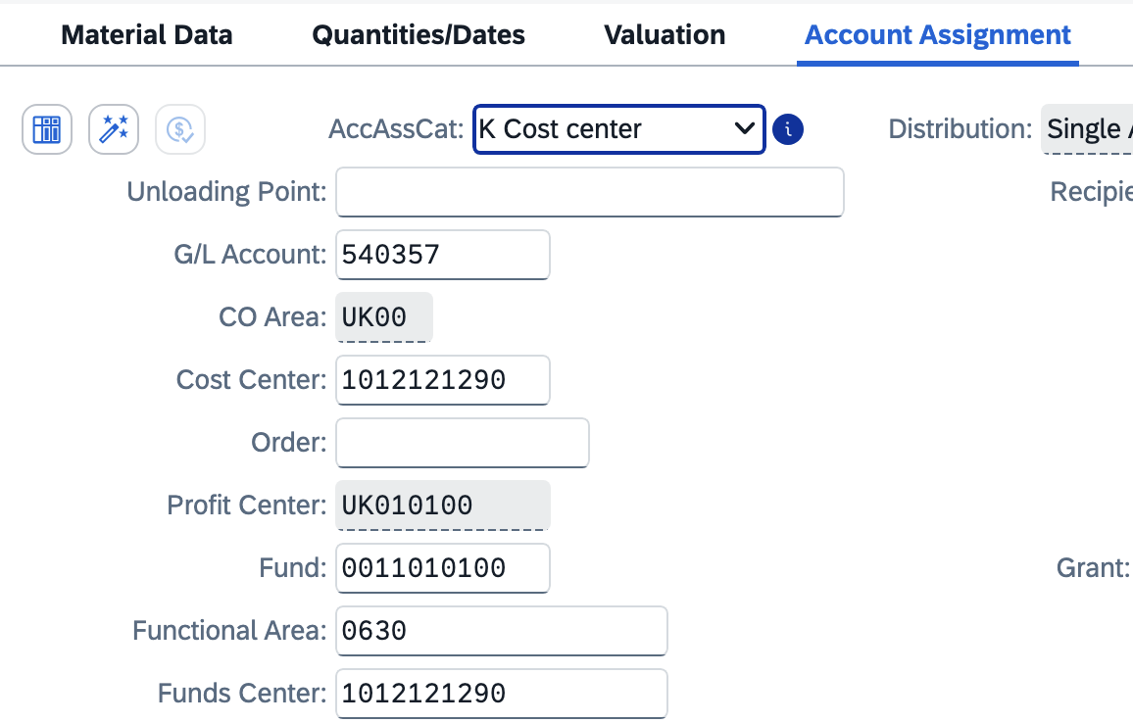
5. Press Enter

Note: If you have multiple line items, click the Repeat Account Assignment icon to repeat the same information automatically to your other line items.

Alternatively, you can copy/paste the GL Account and Cost Center (or WBS Element-Grant). Use the up/down buttons to move among line items.

6. Navigate to Delivery Address Tab  Important: Integrated ordering systems utilize specific master data in specific cells for correct order placement and processing. It’s important to follow the exact steps below to enter your delivery address information correctly and not enter any building name or address components via free text entry.  >Failure to follow the delivery steps will cause an order to fail to process or deliver correctly. | 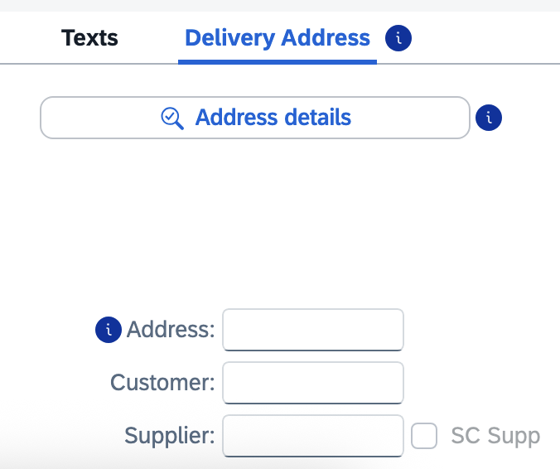
7. On line item 1 in the bottom Details section, click the Search icon on the right of the Address box to perform a search for your building location code. | 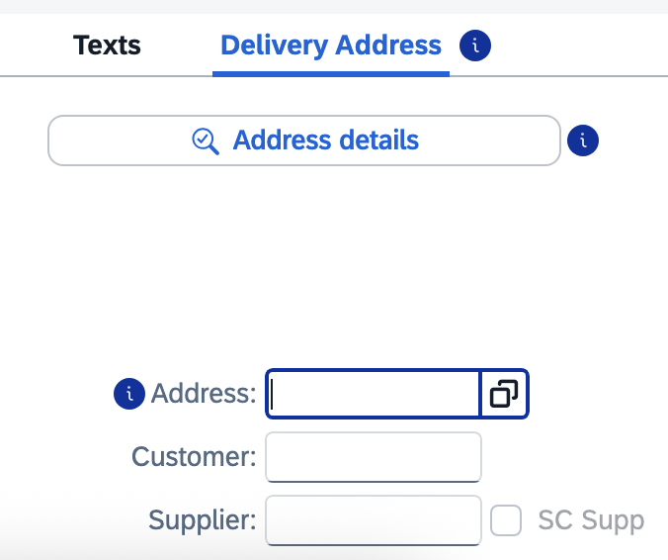
8. Ensure your Address group auto-populates ME01.  Enter your Building Location (Speed Sort) Code in the Search Term 2 field and click Go.  Note: If you encounter issues locating or using your Building Location code, contact eprocurement@uky.edu for assistance. A campus-wide delivery building listing is available on the Procurement Services website Learning and Training page. | 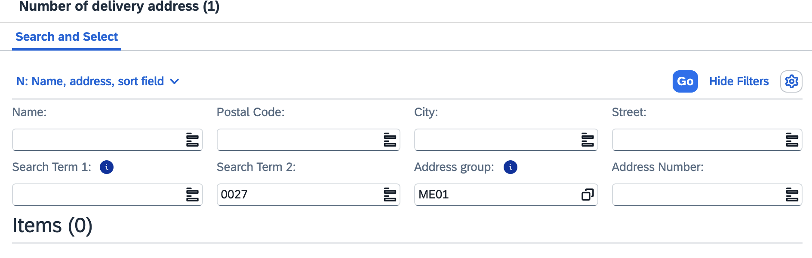
9. Select your building from the results list and click OK. | 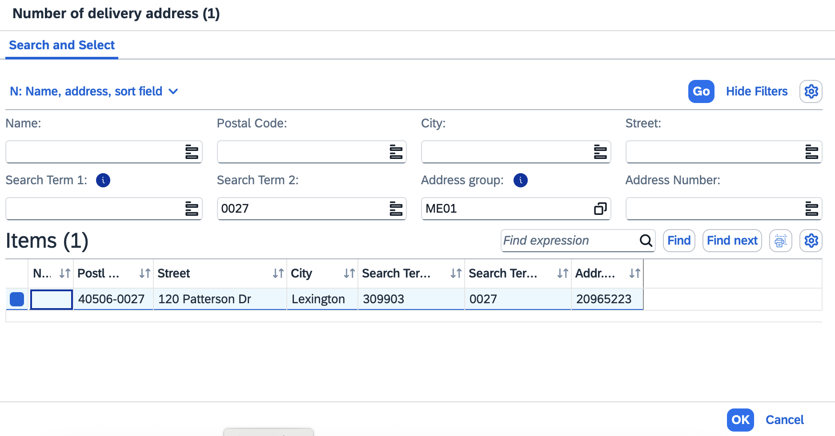
10. Press enter to populate your address into the Address field.  If you have multiple line items in your requisition, click Yes to apply the same building master data for each line item.  IMPORTANT: Make sure to hit the Enter key before moving on.  TIP: You may want to record your building address number for your delivery location for convenient entry on future requisitions. | 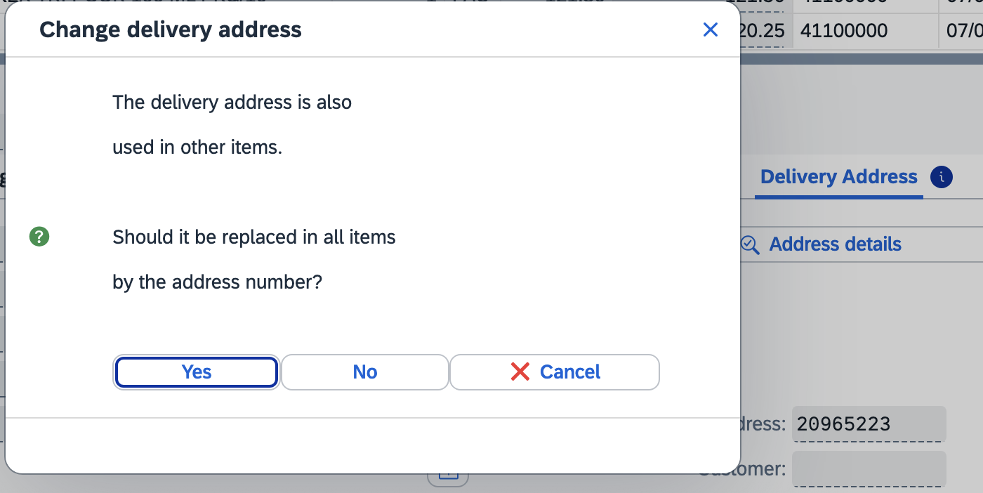
11. Click the Address Details button | 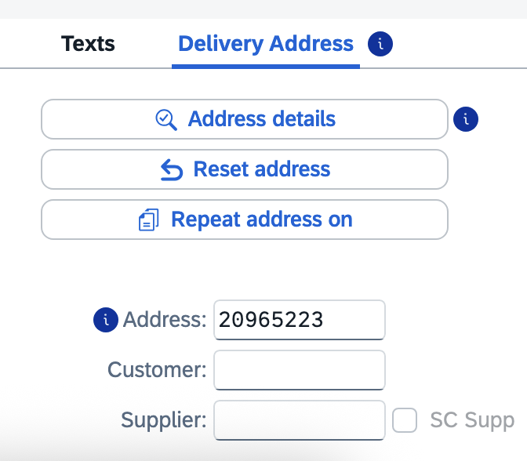
12. Within the Street Address section, click the Expand Section button at the bottom right of section. | 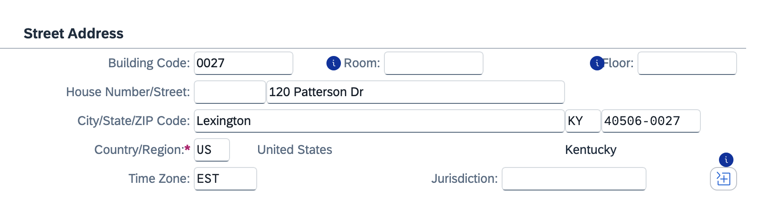
13. Perform the following edits:  >Add the Deliver-to room number to the Room field and at the end of the street address  >Add the floor number  >Add the c/o person delivery name  Click the Collapse section button | 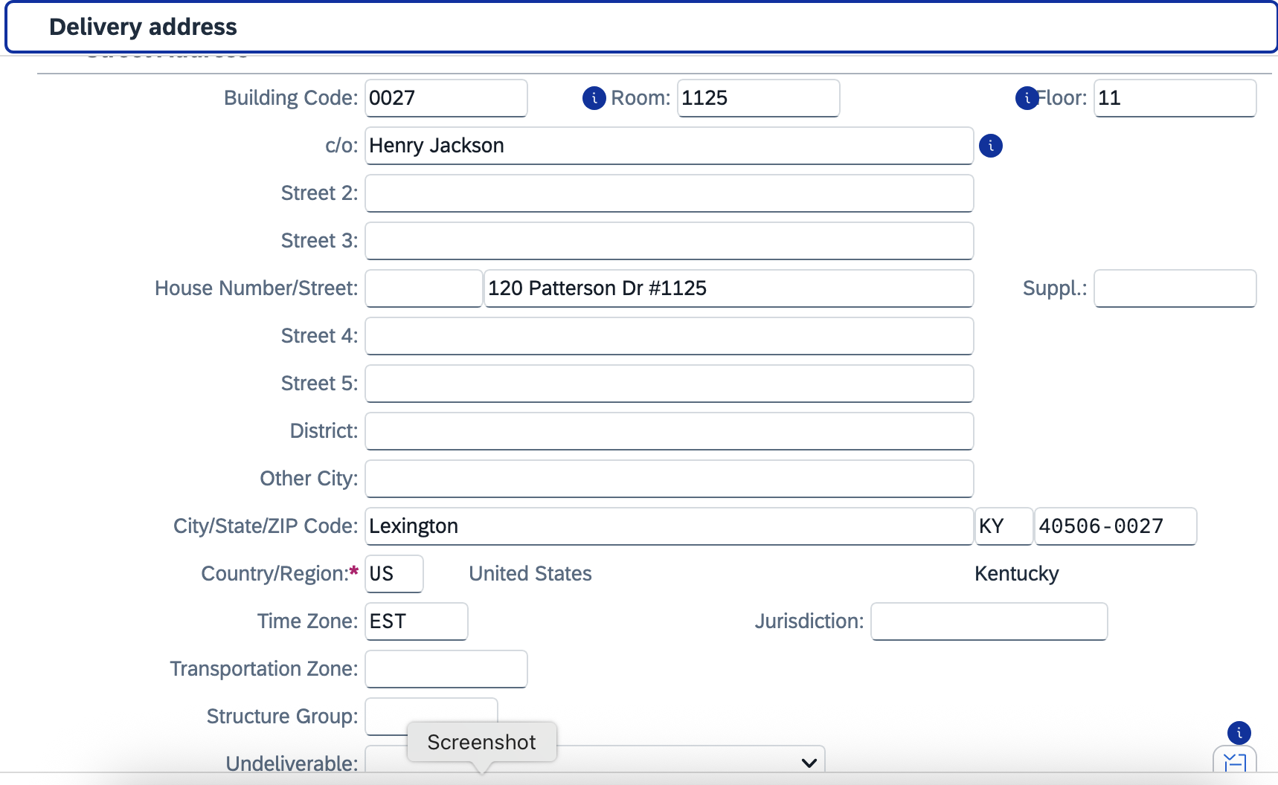
14. Add your phone number and email address | 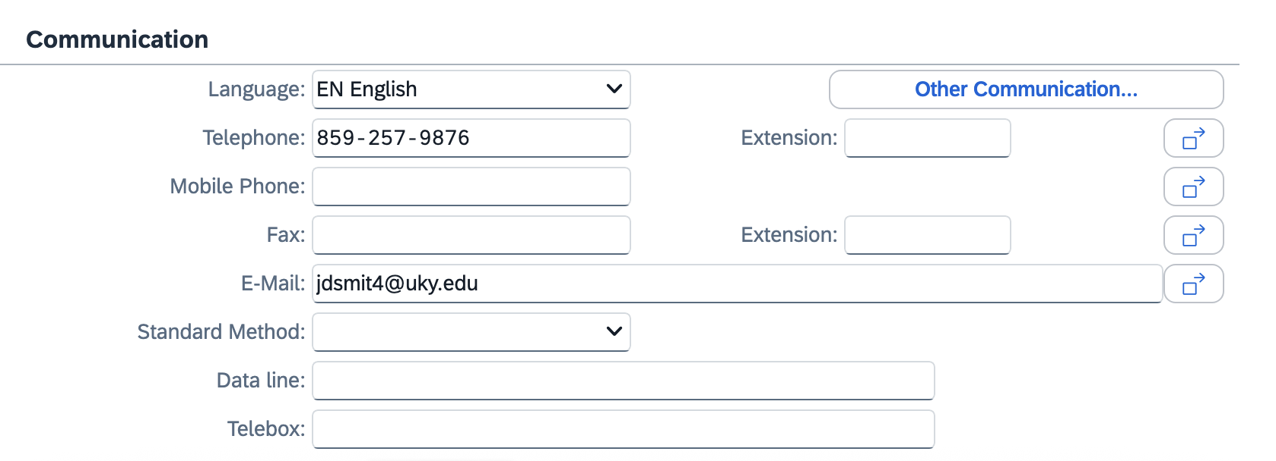
15. Click the checkmark at the bottom right corner | 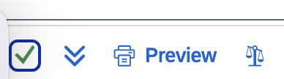
16. Click Yes to update address changes to all line items (if multiple) and finish | 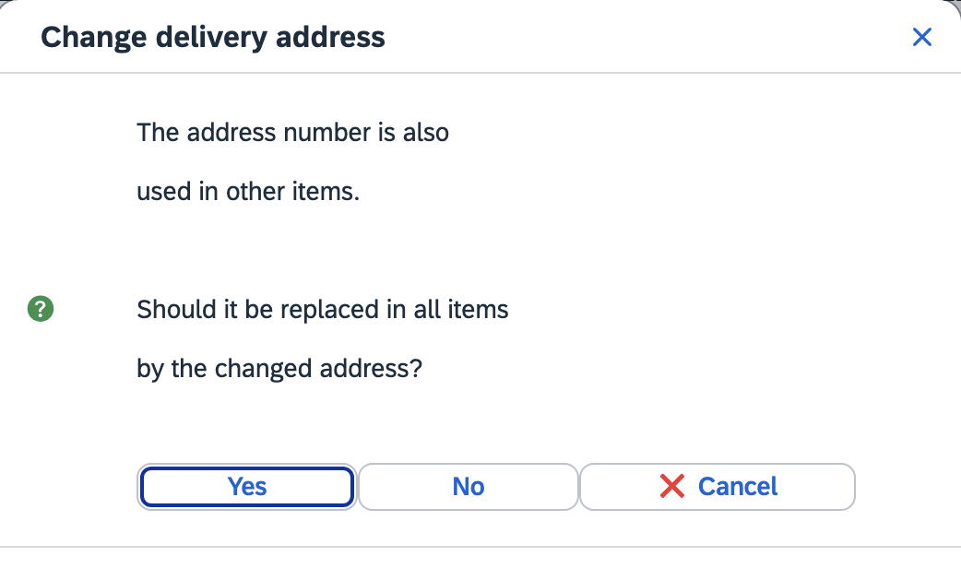
17. Attach your quote and any other needed files under the Services for Object icon/menu at the top right. | 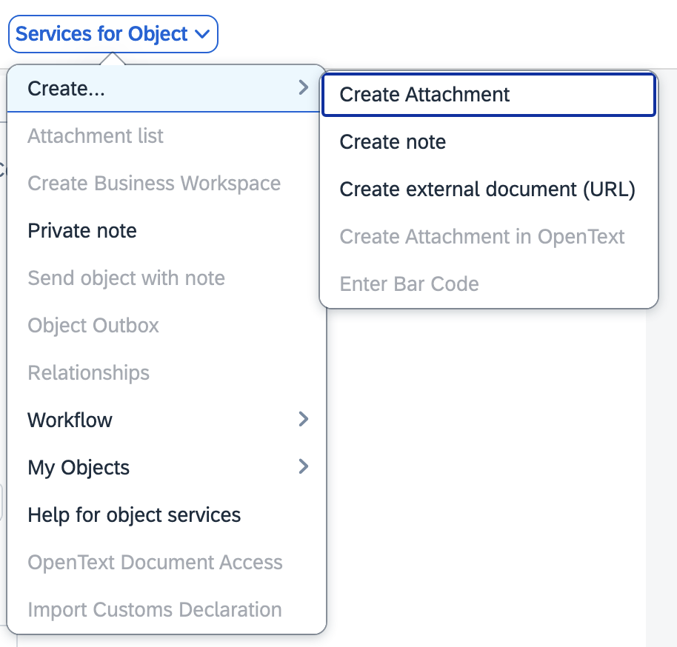
18. Review and check all line items for accuracy.  Click the Check button at the top to validate whether any errors exist.  Note: Disregard any yellow (soft) warning messages. | 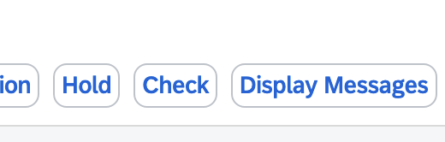
19. Click SAVE icon to complete requisition and move it forward to Approval | 