Prior to creating your first requisition using SAP T-code ME51N, you must set your default settings in four locations. This is a one-time requirement. After your default settings are established, you can immediately create e-catalog or free text requisitions.

Role: SAP S/4 Requisitioner | Frequency: As Needed

Set Default Settings (Four Locations) on First Visit
From the myUK Landing Page, Click the SAP Fiori Launchpad icon to begin. | 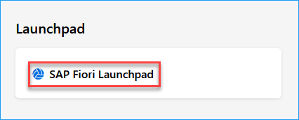
1. To access T-code ME51N within the SAP S/4 environment, select Add Apps from the upper right area of your home page. | 
2. Upon arriving to the Apps page, enter ME51N into the Search Catalog box at the top right. | 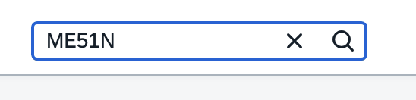
3. Once you locate the T-code for Create Purchase Requisition Advanced, click the plus (+) sign to add it to your home page as a favorite. | 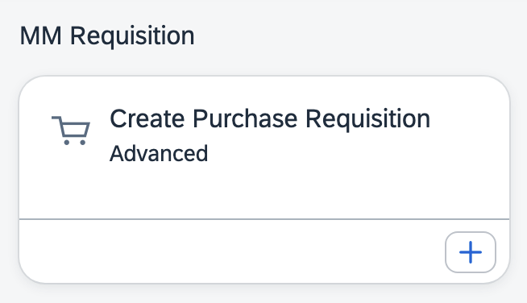
4. Click Create Purchase Requisition Advanced tile to open T-code | 
5. Setting One – Once the app starts, click the Menu button at the top left and select Settings.  (This is one-time only.) | 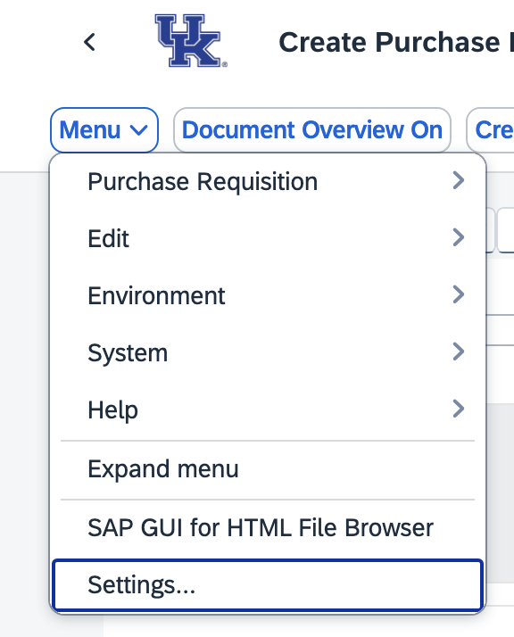
6. Select Visualization from the left menu. Ensure both selections under Dropdown List section are set to On.  Ensure both selections for Enhanced Search are set to on.  Click SAVE when complete. | 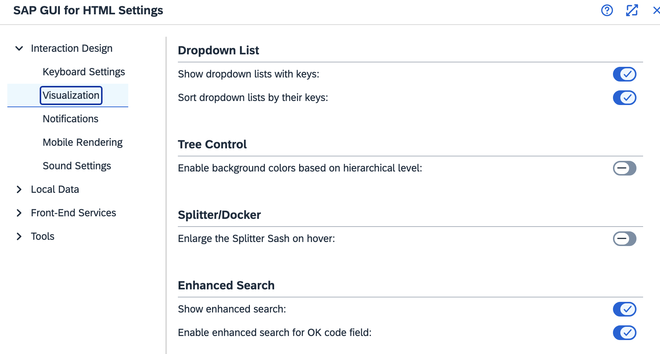
7. Setting Two - Select Personal Setting from the top menu.  (This is one-time only.) | 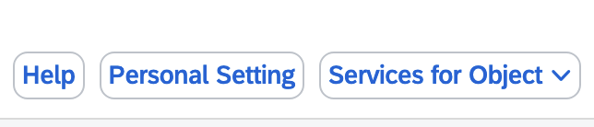
8. On Basic Settings tab, set Selection Period for My Docs to -9999 for No Restrictions. | 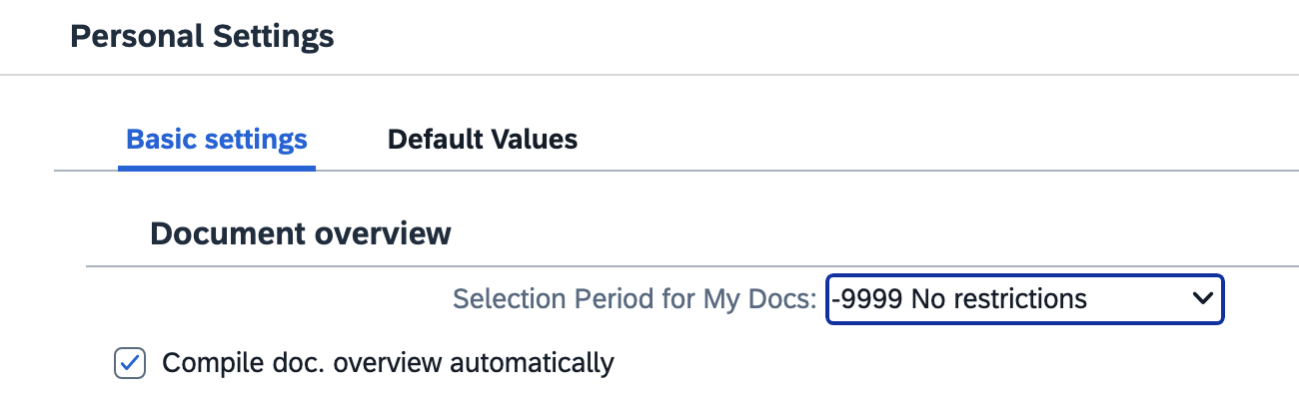
9. On the same selection set Default Values on Requisition Header as follows.  (This is one-time only.)  >Document type – NB Purchase Requisition  >Item Category – Select 0 Standard and check Always Propose  >AcctAssCat – Select K-Cost Center or P-Project (WBS Element-Grant) depending on the cost object type you most frequently use and check Always Propose  >Delivery Date – Enter D in first box only and check Always Propose  >Plant – Enter UK00 and check Always Propose  >Important: Requisitioner – Enter your Linkblue ID and check Always Propose  >Currency – Enter USD  >Check box for Source Determination  >Click Save | 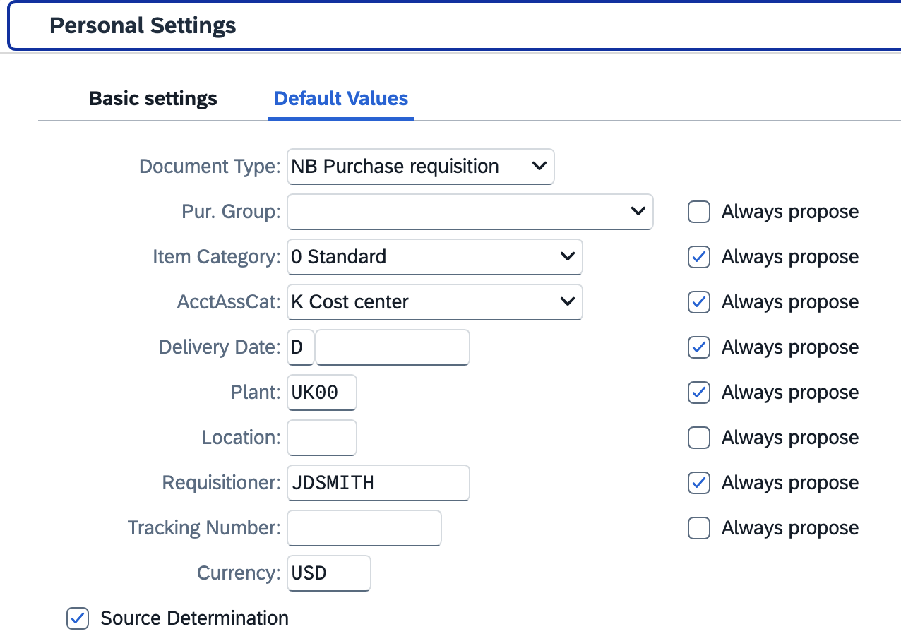  If some fields are missing, click the More Fields button to move needed ones into view.  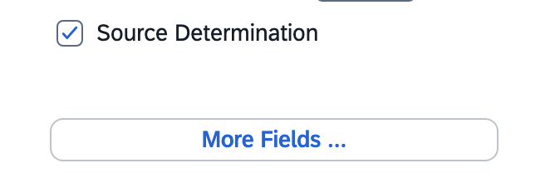
10. Setting 3 - Set Default Values on Requisition Line Item. The icon button is in the middle screen section.  (This is one-time only.)  Set the exact same settings and checkboxes here at the Line-Item level as you did for the header level in the previous step.  >Click Save | 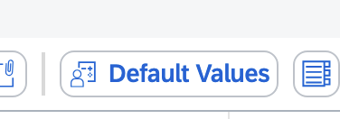  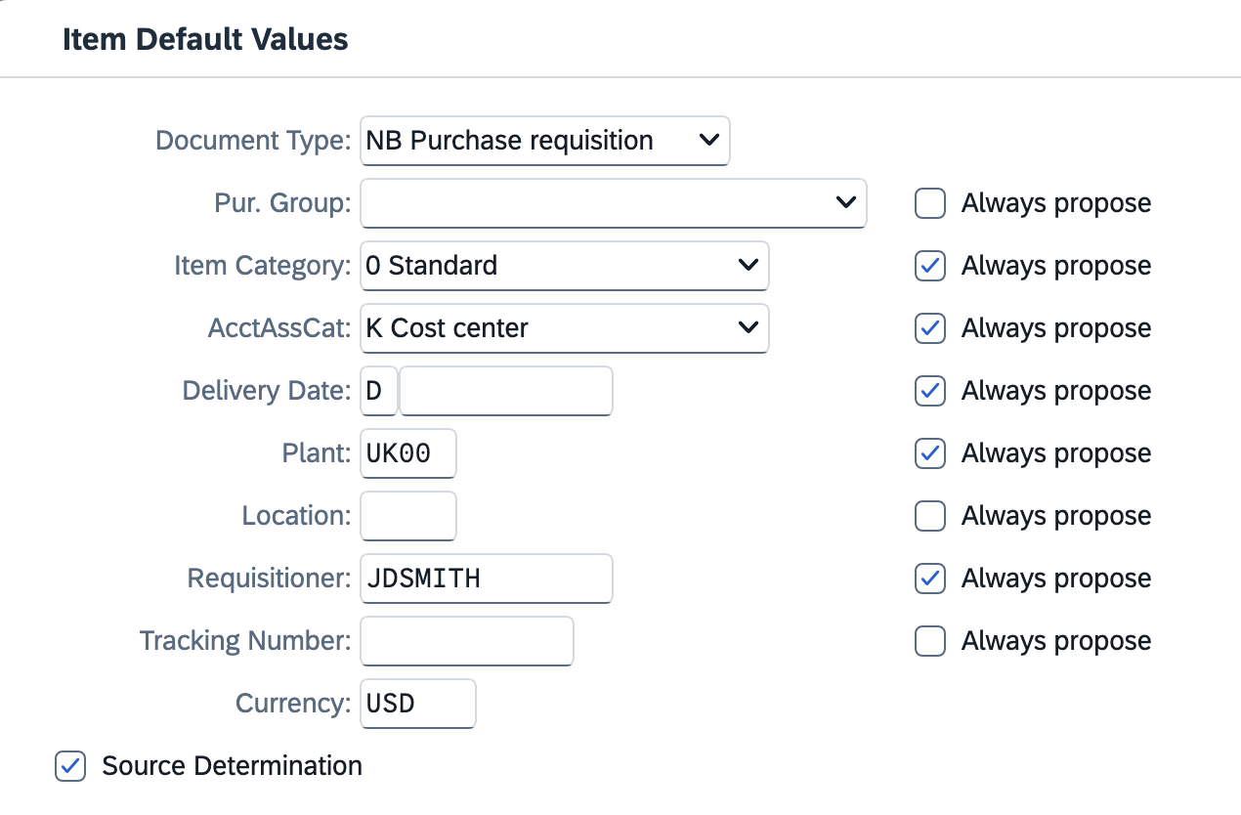
11. Setting 4 - Locate the Layout button in the middle of the requisition screen and click the black triangle on the right side.  (This is one-time only.)  >Click Choose Layout  >Select /CAMPUS_REQ as your layout type to bring into view | 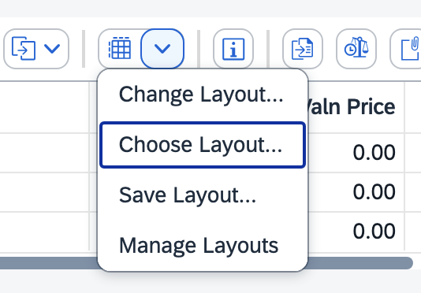  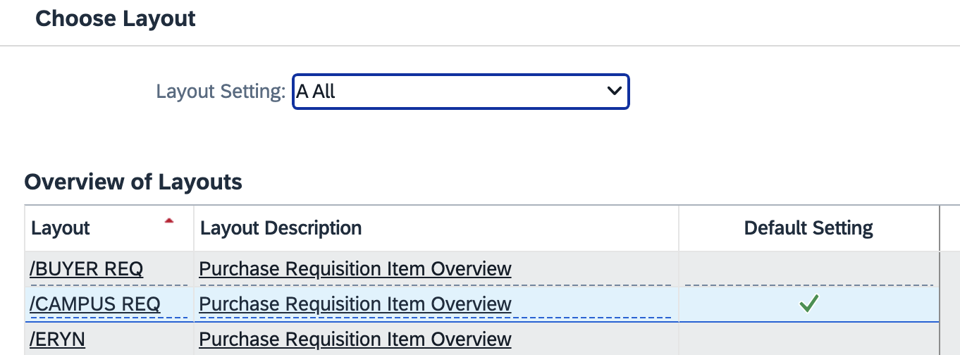
12. Click the right side of the Layout button a second time and select Save Layout from the dropdown menu.  >With /CAMPUS_REQ layout showing, place a checkmark on the Default box and click Adopt.  >Click Yes to Save Layout  Note: The same layout is used by every Requisitioner. Ensure not to make any other changes to the layout.  This completes all of your one-time settings for ME51N Create Purchase Requisition Advanced. | 