Procurement users must complete key tasks upon your first time visiting SAP S/4 and prior to utilizing Procurement applications. Listed below are required tasks, tips, and best practices to maximize your experience and productivity.

Role: Staff | Frequency: As Needed

From the myUK Landing Page, Click the SAP Fiori Launchpad icon to begin. | 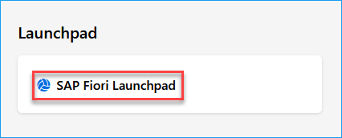
1. Use the Add Apps icon in the upper right area of your home page to locate and bookmark needed applications | 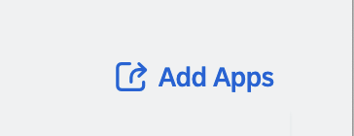
2. Use the Search in catalog feature in the top right of the following screen to enter and search for needed Procurement applications. | 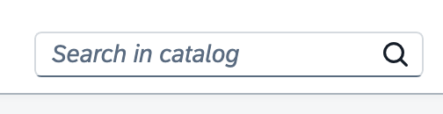
3. As you locate apps, click the plus (+) sign to add them to your home page. You may see the same app within multiple role sets which is standard. | 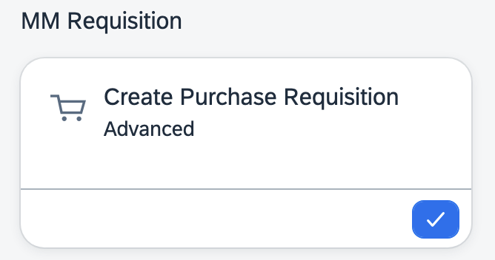
4. Most departmental Procurement users may utilize at a minimum of the apps to the right. You may want to locate and bookmark all or a portion of these to your home page.  Access to certain apps is dependent upon roles that may be assigned to you. Some roles and apps are only available when approved by your Business Officer via an SAP Access Request Form and upon your receiving and completing required training.  If you cannot load certain apps, you may not have the associated role(s). Contact your business officer regarding role assignments appropriate for your position and duties. | - ME51N Create Purchase Requisition Advanced  - MIGO Goods Receipts  - Manage Purchase Requisition Professional  - Default Settings for Users (Accompanies above app only)  - Post Goods Receipts for Purchasing Documents  - My Inbox  - Maintain Business Partner  - ZMM_BA_RPT PO Business Analysis Report  - ZMM_PA_RPT Purchase Order Analysis Report
5. If utilizing a requisition for creating orders, Default User settings must be established prior to creation of your first order | Both the standard T-code ME51N Requisition and the Fiori Manage Purchase Requisition Professional apps require setup of Default Settings prior to the initial usage of either.  - For ME51N, the default settings are completed inside of the T-code itself.  - For the Fiori Manage Purchase Requisition Professional app, the Default Settings are established via a complementary app identified as Default Settings for Users.  For both setup processes, Quick Reference Cards (QRCs) are available on the Procurement Services website, Learning and Training Resources page.
6. For Requisitioners utilizing and shopping from e-catalogs, you may encounter a pop-up blocker the first time you punch-out from a requisition to visit the Ariba Network. Set your pop-up blocker to always allow pop-ups for Ariba Network. | 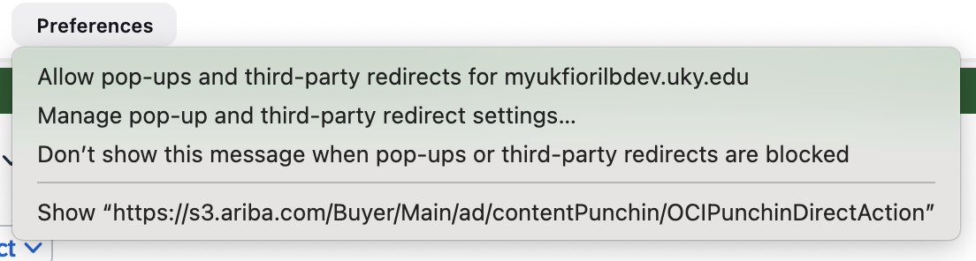
7. When visiting any e-catalogs on the Ariba Network for the first time, if you are presented with cookies options, always select Accept Cookies for all e-catalogs. | 
8. When navigating the Ariba Network landing page, hover over the > icon to the right of Supplier on the Shop By menu. Then click View All Suppliers. This will provide a listing of all e-catalogs on a single page for easy viewing and access. | 