Use the following steps to display or edit SAP Requisitions which you previously created. SAP T-codes ME52N and ME53N also edit and display, respectively, previously created requisitions. T-code ME51N has integrated toggle functionality allowing for all actions to be performed within a single screen.

Important: You may edit a requisition only if it has not yet been approved by your unit/division/college approvers. Once it is approved at any level, it may no longer be edited. If it is approval stage, please contact your Approver for guidance. If it has been processed to a Purchase Order or is in a Procurement Services buyer’s queue for processing, please contact the respective buyer for guidance.

Role: SAP Requisitioner | Frequency: As Needed

1. From myUK Landing Page, Click the SAP (top) icon to start | 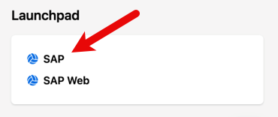
2. Enter the Transaction Code  (T-code) into the top left entry box – ME51N | 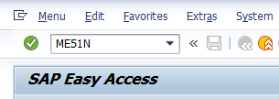

3. Click Document Overview On button | 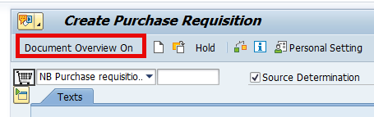
4. The Documents Overview panel will display on the left. Click the black arrow on the right of the multi-color icon to display document menu. | 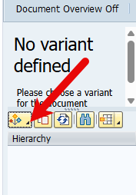
5. Select My Purchase Requisitions | 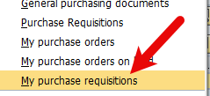
6. The overview panel will display all requisitions you have created. | 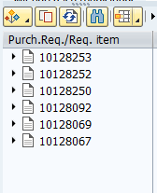
6. Double-click any requisition to display the document in the main window. | 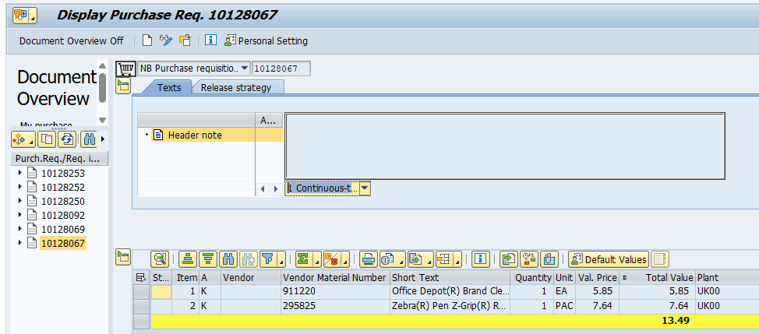
7. If you need to edit a requisition to make changes, click the eyeglasses/pencil icon to toggle between display/edit. | 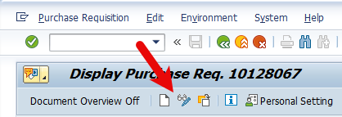
8. Make needed changes. Common requisition edits include addition/deletion of line-items, price or quantity changes, account assignment or delivery address changes, add / delete / change attachments, etc.  Reminder: You may edit a requisition only if it has not yet been approved by your unit/division/college approvers. Click the Release Strategy tab to view approval status. | 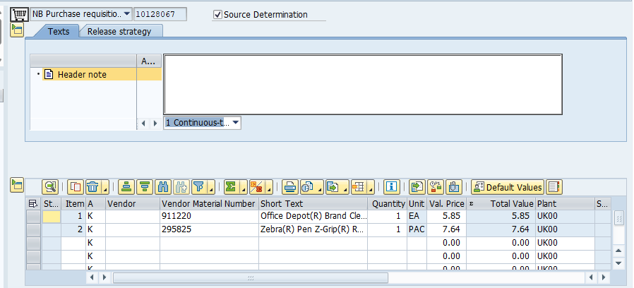
8. Click the Check icon to check for errors.  Click the Save icon to finish and return to Approver’s workflow.  Note: Disregard yellow/soft stop error messages. | 