Use the following steps to create an SAP Requisition using T-code ME51N to order needed items from Ariba Network e-catalogs.

Role: SAP Requisitioner | Frequency: As Needed

A. Accessing SAP
From myUK Landing Page, Click the SAP (top) icon to start | 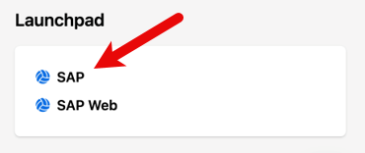

Important Note: The SAP GUI (Graphical User Interface) is the most common method to access and use SAP. It requires the SAP GUI (window) for usage. If you encounter errors opening or using the SAP GUI, please submit an IT Service Request via myUK Enterprise Services tab to request the SAP GUI be installed on your device. You may need to reboot your device after installation.

You may also choose to use the SAP Web version as an option which utilizes a web-browser version of SAP without need for installation of the GUI.

Please note that instructions and graphics within this help guide are designed for use with the SAP GUI which is available via the IT Service Request, if needed. Instructions and process steps are the same although navigation and menu options may vary slightly between the two applications.

Prior to creating your first requisition using SAP T-code ME51N, you must set your default settings in four locations. This is a one-time requirement. After your default settings are established, you can immediately create requisitions as needed each time using steps in Section C.

B. Set Default Settings (Four Locations) on First Visit
Setting 1 - From the SAP main window, access Menu > Extras >Settings  (One-time only)  >Check Display Technical Names  >Click Checkmark | 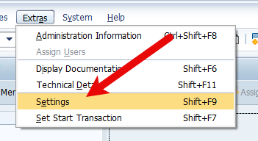  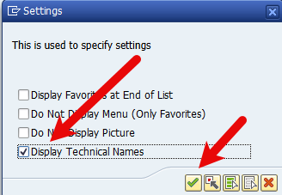
Setting 2 - From the SAP main window, click the multi-colored icon on the right and select Options.  (One-time only)  >Under Visualization 1 > Controls, check the box for Show keys within dropdown list.  >Click Apply and then Click OK | 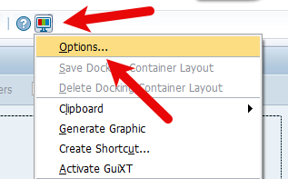  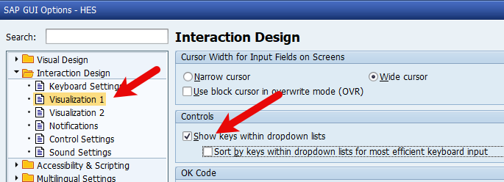  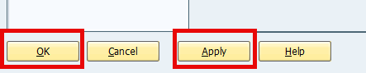
Enter the Transaction Code (T-code) into the top left entry box – ME51N | 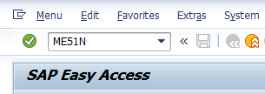
Setting 3 - Set Default Values on Requisition as follows. The icon button is in the middle screen section: (One-time only)  >Document type – NB Purchase Requisition  >Item Category – Select 0 Standard and check Always Propose  >AcctAssCat – Select K-Cost Center or P-Project (WBS Element-Grant) depending on the cost object type you most frequently use and check Always Propose  >Delivery Date – Enter D in first box only and check Always Propose  >Plant – Enter UK00 and check Always Propose  >Requisitioner – Enter your Linkblue ID and check Always Propose  >Currency – Enter USD  >Check box for Source Determination  >Click Save | 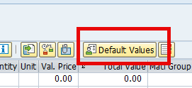  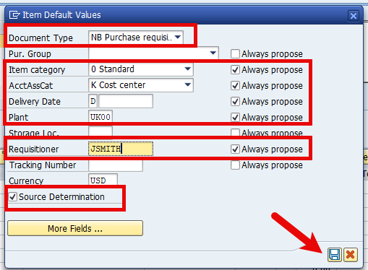
Setting 4 – Locate the Layout button in the middle of the requisition screen and click the black triangle on the right side: (One-time only)  >Click Choose Layout  >Select /CAMPUS_REQ as your layout type  >Click Save | 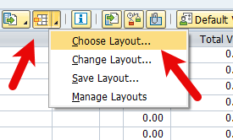  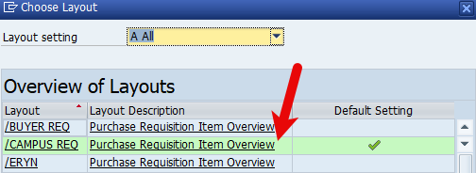

C. Create ME51N SAP Requisition for Ariba Network E-Catalog Order
1. Enter header and/or Business Purpose Notes | 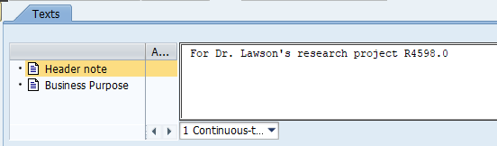
2. Click the punch-out catalog icon to access Ariba Network  e-catalogs | 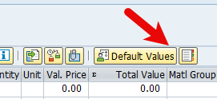
3. Shop for needed items from Ariba Network e-catalog supplier, place into Ariba Shopping Cart and check-out from Ariba Network. | 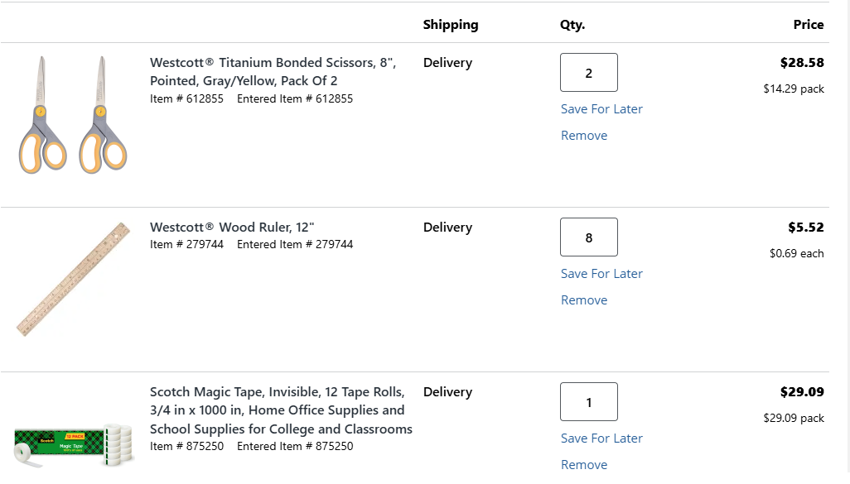
Product details for all line items will show on your requisition including description, quantity, price, UOM, catalog numbers, etc. The Desired Vendor number field will not populate and does not need completed. | 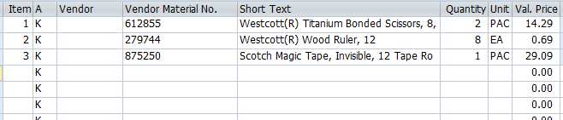
4. Navigate to the bottom Item Details section and click the Account Assignment tab. Establish and enter your accounting information for your Cost Center or WBS-Project (WBS-Element Grant).  If needed, toggle the AccAssCat selection between K-Cost Center and P-Project (WBS Element-Grant) to select/change the appropriate type.  If you need to assign split/multiple accounting, select X-All Other Aux Assignments from the AccAssCat selection to establish and complete the needed layout. You can also select the appropriate split distribution type. | 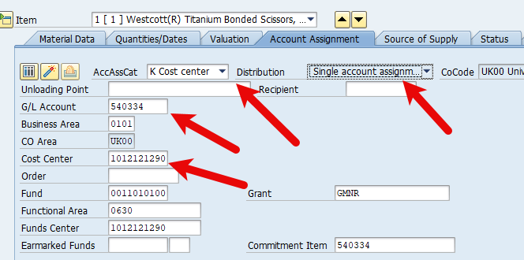
If you have multiple lines, you can copy/paste the GL Account and Cost Center (or WBS Element-Grant). Use the up/down buttons to move among line items. | 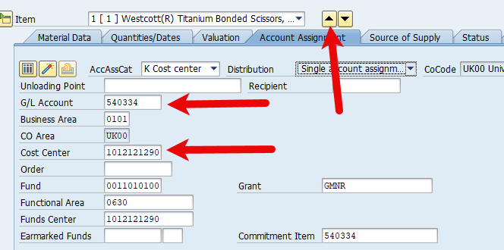
6. Navigate to Delivery Address Tab  Important: Integrated ordering systems utilize specific master data in specific cells for correct order placement and processing. It’s important to follow the steps below to enter your delivery address information correctly and not enter any building name or address components via free text entry.  >Failure to follow the delivery steps will cause an order to fail to process or deliver correctly. | 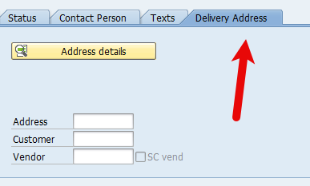
7. On line item 1 in the bottom Details section, click the Search icon on the right of the Address box to perform a search for your building location code. | 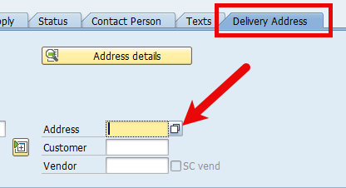
8. Ensure your Address group auto-populates ME01.  Enter your Building Location (Speed Sort) Code in the Search Term 2 field and click the checkmark.  Note: If you encounter issues locating or using your Building Location code, contact eprocurement@uky.edu for assistance. A campus-wide delivery building listing is available on the Procurement Services website Learning and Training page. | 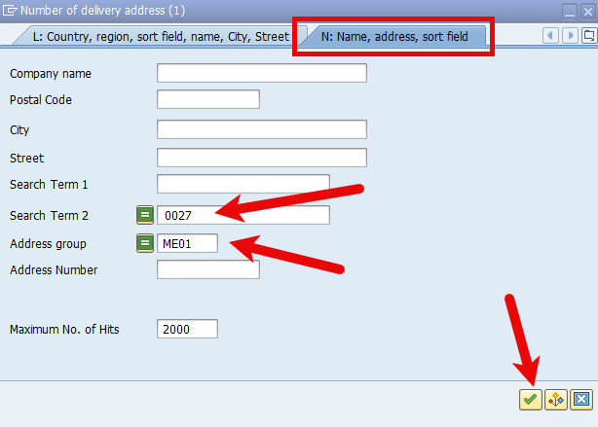
9. Select your building from the results list | 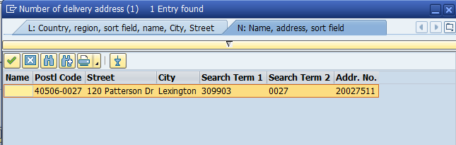
10. Press enter to populate your address into the Address field. If you have multiple line items in your requisition, click Yes to apply the same building master data for each line item.  TIP: You may want to record your building address number for your delivery location for convenient entry on future requisitions. | 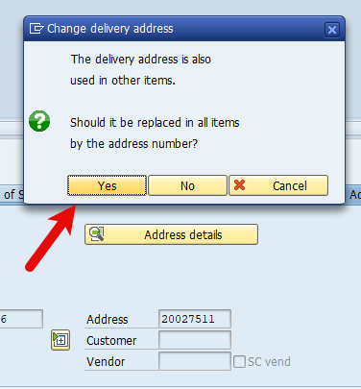
11. Click the Address Details button | 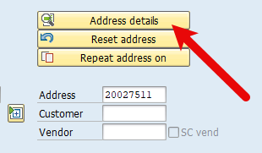
12. Within the Street Address section, click the Expand Section button. | 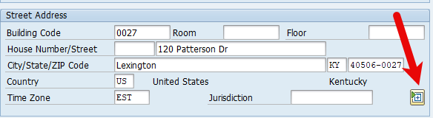
13. Perform the following edits:  >Add the Deliver-to room number to the Room field and at the end of the street address  >Add the floor number  >Add the c/o person delivery name  Click the Collapse section button | 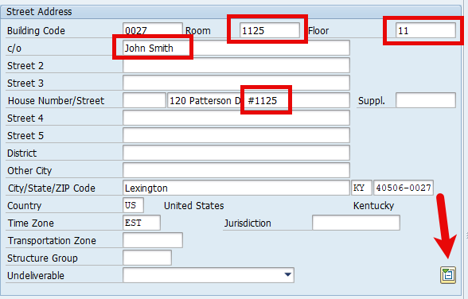
14. Add your email address | 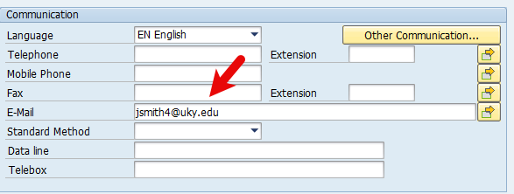
15. Click the checkmark | 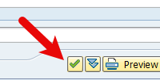
16. Click Yes to update address changes to all line items (if multiple) and finish | 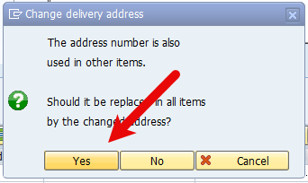
17. Review and check all line items for accuracy.  Click the Check button at the top to validate whether any errors exist.  Note: Disregard any yellow (soft) warning messages. | 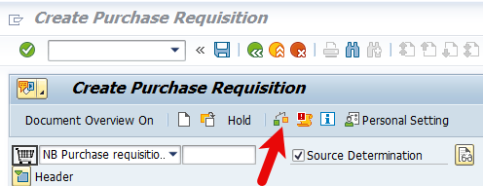
18. Click SAVE icon to complete requisition and move it forward to Approval | 