**Instructions:**

Use the learning modules and Excel templates provided by Huron to prepare, research, and build the Business Case for a Bid or Simple Solicitation. If needed, there is also an Excel worksheet in the network folder developed in-house that contains three Business Case dashboards that can be completed and integrated into this Business Case document. All materials are located on the network drive; click here to quickly access the materials. When using the Excel templates, be sure to make a copy to your work file and refrain from placing content into the master templates since they are shared among the entire division.

**Delete all content in blue font when this document is complete. The remaining content will be solely your Business Case.**

|  |  |
| --- | --- |
| **1. Bid Title:** |  |
| **2. Who are the key stakeholders for this initiative and what are their roles?** |  |
| **3. What do you identify as the key cost drivers and savings levers for the contract purchases?** |  |
| **4. What are some of the industry leading best practices for this commodity?** |  |
| **5. What opportunities do you see for process improvement that would benefit the customer experience and create value?** |  |
| **6. If there are current contract(s) for this initiative, describe the relevant details: effective date, expiration date, termination clauses, current financial incentives, etc.** |  |
| **7. If this relates to rebid of an existing contract, what aspects of the current contract or supplier performance can be improved?** |  |
| **8. Are there any opportunities at hand to improve the technology approach for purchase of these goods or services?** |  |

**Business Case Dashboard(s)**

Listed below find dashboard(s) relating to the Business Case:

If Applicable: Using the available Business Case dashboards on the network drive, complete and embed at least one or more below to help visualize and convey the potential savings, key observations, data analyses, etc. You can copy and paste the completed dashboard from Excel directly below or use Snag-it to make a graphic to embed. Remember to resize so it is easy to read (hold down shift key + grab graphic corners and move in or out.

Example: (Remove the below when inserting your graphic(s).)

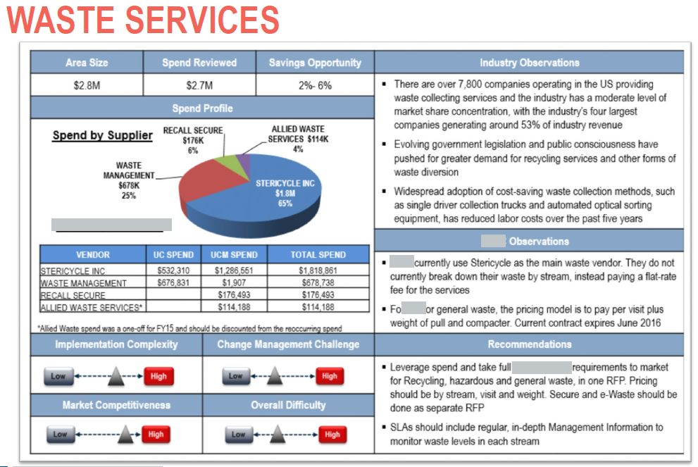

**Delete all content in blue font when this document is complete. The remaining content will be solely your Business Case.**