**Instructions:**

Use the learning modules and Excel templates provided by Huron to prepare, research, and build the Business Case. There is also an Excel worksheet in the network folder developed in-house that contains three Business Case dashboards that can be completed and integrated into this Business Case document. All materials are located on the network drive; click here to quickly access the materials. When using the Excel templates, be sure to make a copy to your work file and refrain from placing content into the master templates since they are shared among the entire division.

**Delete all content in blue font when this document is complete. The remaining content will be solely your Business Case for presentation to leadership.**

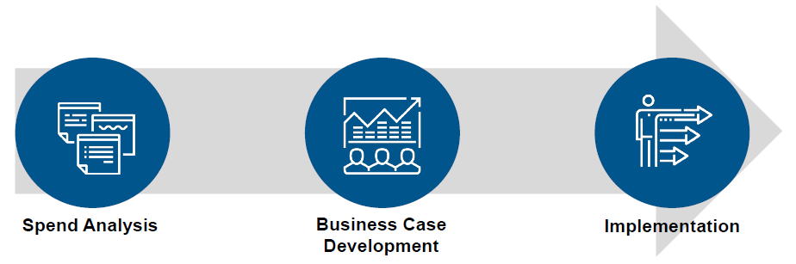

Since the Business Case contains a quantitative element, reflect on what data may be available for analysis and is most appropriate for the initiative at hand. You may consider using some of the suggestions within the Huron documents and Excel templates to analyze and measure potential savings. The data sources could include purchase orders, invoices, p-card, PRD, supplier reporting, etc.

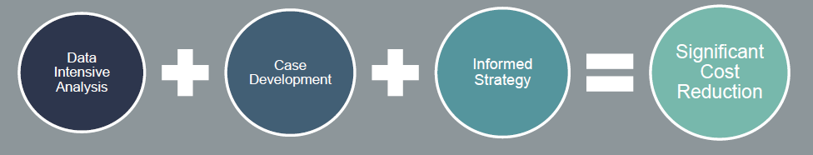

Reminder: Guiding Principles for Strategic Sourcing:

1. Deliver total cost reduction
2. Conduct fact-based analyses
3. Maintain or enhance quality of goods, services, and relationships
4. Facilitate behavior change
5. Strengthen relationships (customer and supplier)

Reminder: Business Case Goals

1. Present a case for action
2. Document and evaluate findings
3. Obtain buy-in and support of key stakeholders
4. Determine strategy and next steps

|  |  |
| --- | --- |
| **1. Strategic Sourcing Initiative Title:** |  |
| **2. What is the current case for action, i.e., what matters are at hand that support the initiative and reason(s) for change?** |  |
| **3. What approach did you use to document and evaluate your Business Case research findings?** |  |
| **4. Who are the key stakeholders for this initiative and what are their roles?** |  |
| **5. As part of the case preparation, what steps did you take to obtain buy-in and support of key stakeholders?** |  |
| **6. What market research efforts did you perform from what sources and how did you arrive at the market research data?** |  |
| **7. From your analysis, describe the competitive space for this initiative. Who are the competing/alternate suppliers for these goods/services?** |  |
| **8. As you reviewed the spend and product mix, what facts did you learn that may be relevant to the initiative?** |  |
| **9. What do you identify as the key cost drivers for current purchases?** |  |
| **10. What do you identify as the key savings levers for this initiative?** |  |
| **11. What benchmarking efforts were undertaken as part of the Business Case and how do you propose we use benchmarking to benefit the initiative?** |  |
| **12. What are some of the industry leading best practices for this commodity?** |  |
| **13. What data analysis approach did you use to prepare the Business Case and to identify savings?** |  |
| **14. What spend data was analyzed and for what periods?** |  |
| **15. What facts were learned during the spend analysis phase that may be relevant to the Business Case and potential savings?** |  |
| **16. What are the key findings from stakeholder communications / feedback relating this initiative or the current supplier or process (if a rebid)?** |  |
| **17. What do you see as the primary opportunities on behalf of stakeholders for this initiative?** |  |
| **18. What opportunities do you see for process improvement that would benefit the customer experience and create value?** |  |
| **19. If there are current contract(s) for this initiative, describe the relevant details: effective date, expiration date, termination clauses, current financial incentives, etc.** |  |
| **20. If this relates to rebid of an existing contract, what aspects of the current contract or supplier performance can be improved?** |  |
| **21. Are there any opportunities at hand to improve the technology approach for purchase of these goods or services?** |  |
| **22. Describe the proposed Action Plan and Strategy Considerations for this initiative.** |  |

**Business Case Dashboard(s)**

Listed below find dashboard(s) relating to the Business Case:

Using the available Business Case dashboards on the network drive, complete and embed at least one or more below to help visualize and convey the potential savings, key observations, data analyses, etc. You can copy and paste the completed dashboard from Excel directly below or use Snag-it to make a graphic to embed. Remember to resize so it is easy to read (hold down shift key + grab graphic corners and move in or out). Remove the below example when inserting your graphic(s).

Example:

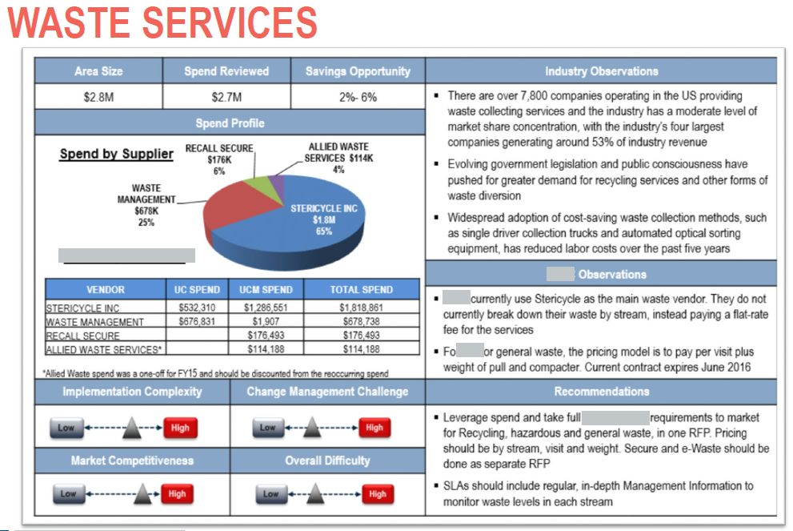

**Additional Exhibits**

If desired, you can use worksheets from the Huron templates on the network drive to complete and copy/paste below. This could potentially include:

Huron Template 1:

* Tab 2 – Industry Research Notes
* Tab 3 – Interview Notes
* Tab 4 – Contract Summary
* Any of the green or blue tabs if used to show spend analysis or savings calculations

Huron Template 2:

* Tab 2 – Savings Calculations
* Tab 3 – Weighted Average Discounts

If you choose to use any of the additional templates, remember to create headings and introductory statements as needed when embedding the table/data.

If no additional exhibits are planned, delete this entire section in blue text.