With the new two-way match system in place, more emails relating to the status of orders will be coming to Shoppers and Approvers. This guide will help you set up Outlook rules to automatically direct emails to a newly created folder.

Role: Employee performing Approver or Shopper Role | Frequency: when desired

Setting up outlook rules to reduce email clutter
In outlook, click “File” in the top left corner. | 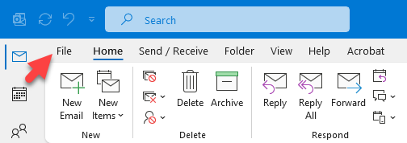
Click “Manage Rules and Alerts”. | 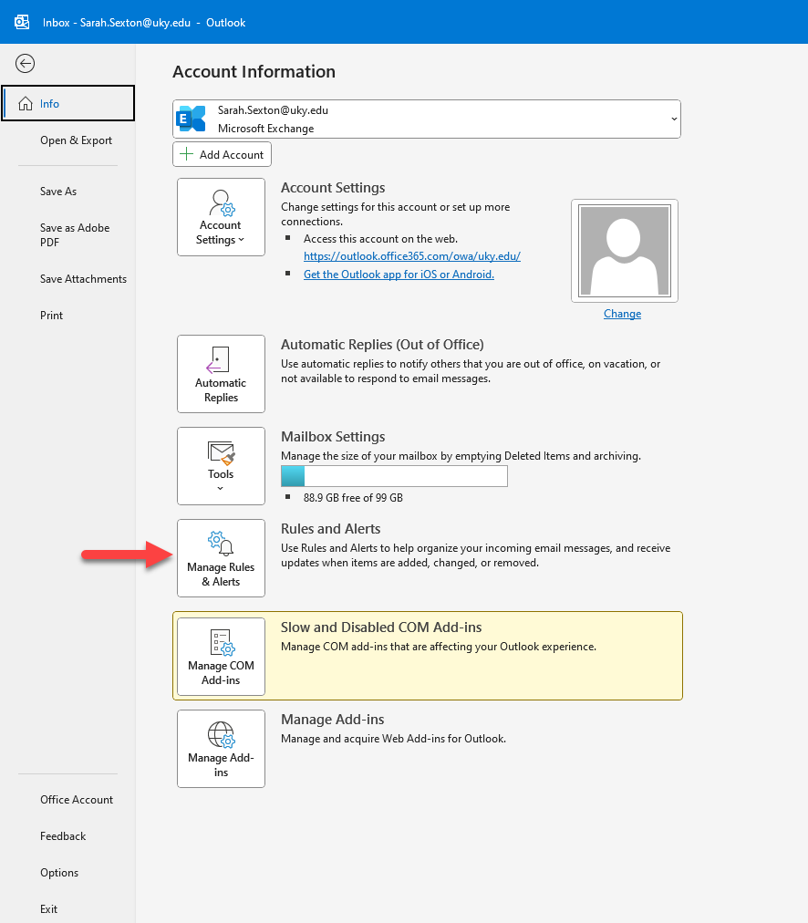
Click “New Rule”.  This will pull up the “Rules Wizard”.  Select “Apply rule on messages I receive” and click next | 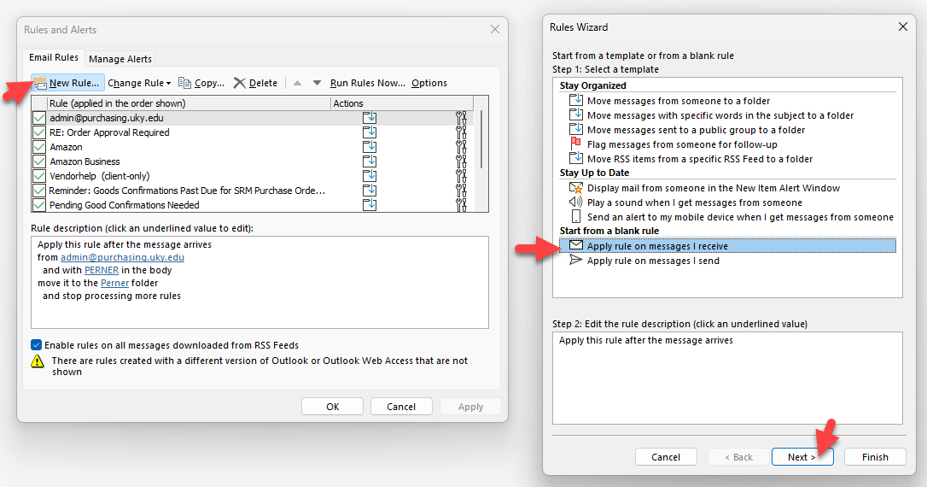
In step 1: select the condition “from people or public group”  In step 2: click on underlined value “people or public group” | 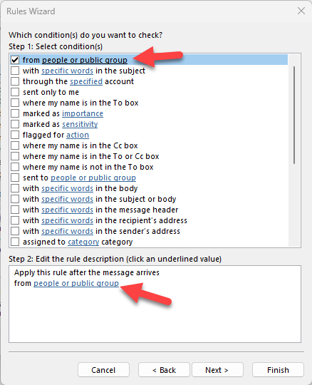
Type wfbatch@uky.edu and click OK | 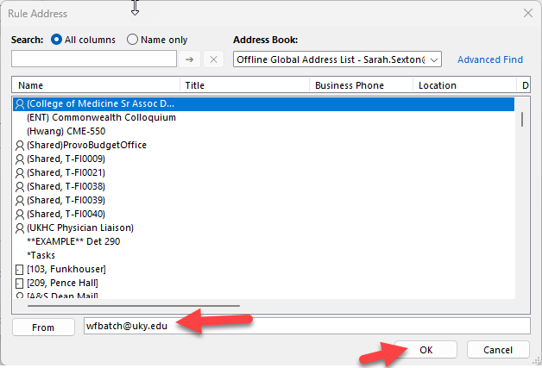
In step 1: select condition “with specific words in the subject”  In step 2: click underlined value “specific words”  A “Search Text” window will pop up.  Type in “Invoice” and click Add.  Ensure “Invoice” is in the search list and click OK | 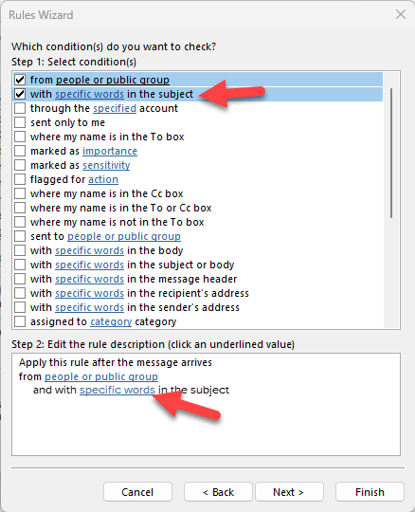  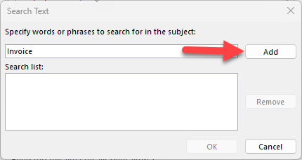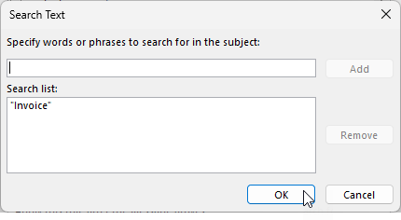
If your step 2 box looks like the image, proceed to next screen by clicking next.  Select the action “move it to the specified folder”  Click into the underlined rule description “specified” | 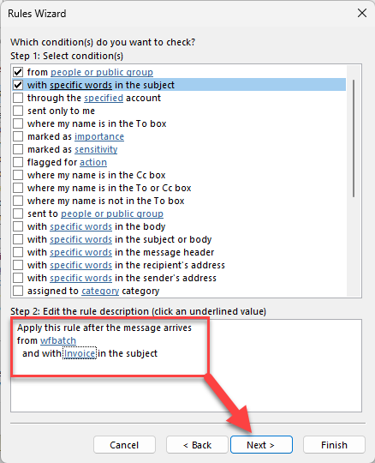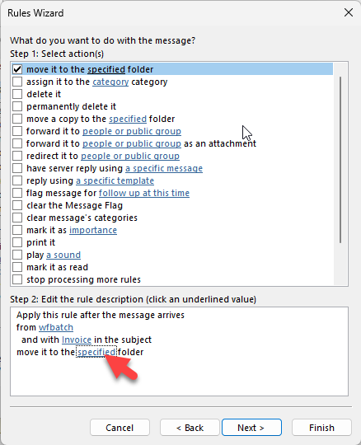
You will be prompted to select a folder to send emails to.  If you need to set up a new folder, click “New…”  In “Create New Folder” name the new folder  Example: “Invoices”  Click OK | 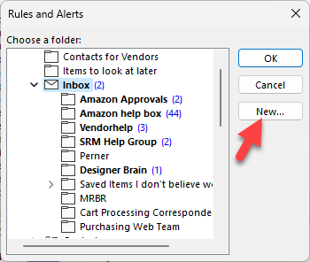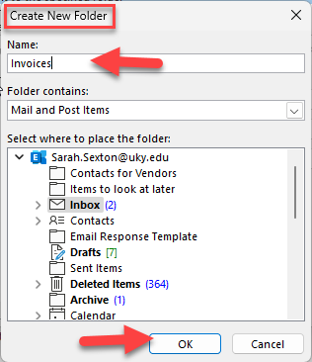
Select folder that was just created and click OK | 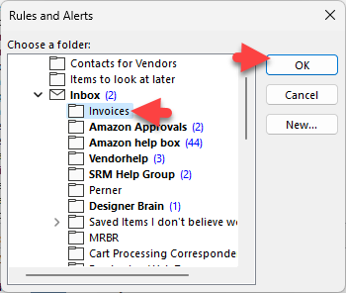
You may rename the rule if you want. Make sure the check box is on for “Turn on this rule”.  If Step 3 looks like image, click Finish. | 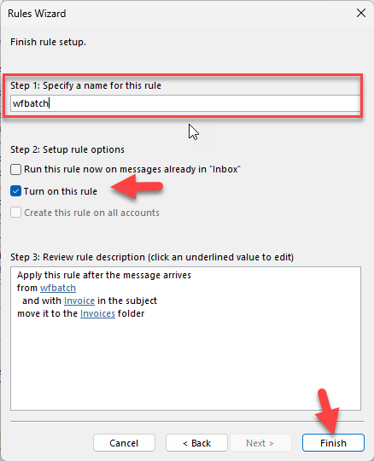
Click OK | 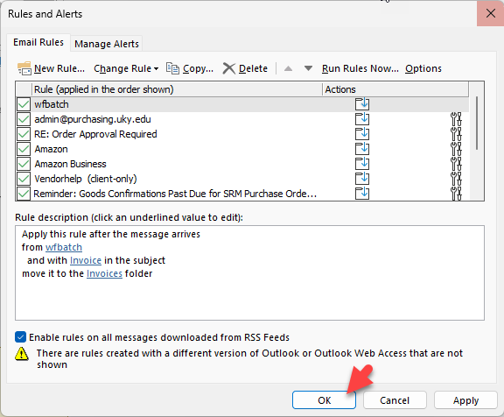
If set up correctly, all invoice emails from wfbatch will automatically move to the Invoices Folder.  The invoices received will look similar to the sample provided. | 