Suppliers on the Ariba Network occasionally will receive an Invoice Rejection message if an invoice is not submitted correctly based on network rules. This Quick Reference Guide (QRC) shows how Ariba Network Suppliers can set up or update their Ariba Network Account setting to get these notifications.

This QRC specifically shows Suppliers how to Update their Account Settings to ensure Purchase Orders and Rejection Notifications are sent to the correct/current email address.

Note: All suppliers on the Ariba Network are able to upload and/or resubmit an invoice manually on the Ariba Network from their web-based online login portal. Ask your B2B or e-Commerce team for access if you do not have access to your company’s Ariba Network online login portal. Additionally, an invoice that is resubmitted must have a new, unique invoice number from the original invoice. This can be easily accommodated by adding a new letter (A, B, C, etc.) to the end of the original invoice number.

Note: Please be sure not to use any Ariba Network selections that generate a Non–PO Invoice. Every invoice created or resubmitted must generate from a PO number previously existing on their supplier login portal. “Non-PO” invoices will automatically fail to transmit on Ariba Network.

Role: Ariba Network Supplier | Frequency: As Needed

1. Access the supplier portal on the Ariba Network.  Direct Link | 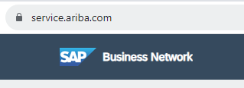
2. Login to the Supplier portal using your Ariba Network Username and Password. If you don’t have access, contact your company B2B or e-Commerce team to assign you as a company user. | 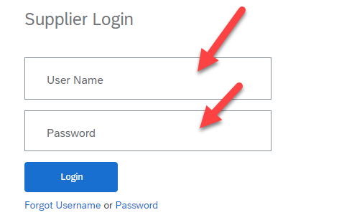
3. To access your User Profile settings, click on your initials in the top right corner of the page –  Click User Profile –  You must have Administrator authority to add a new Email Address to it. | 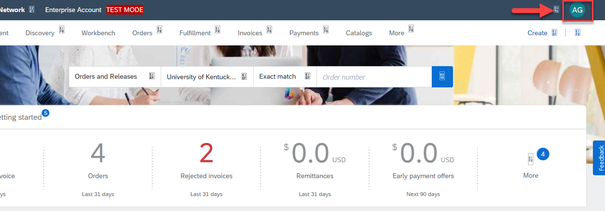  OR  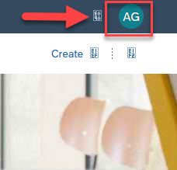
4. On User Profile –  Click Setting - | 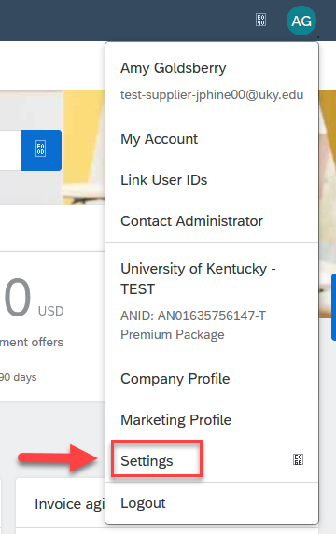
5. Once in User Profile  Click Notification | 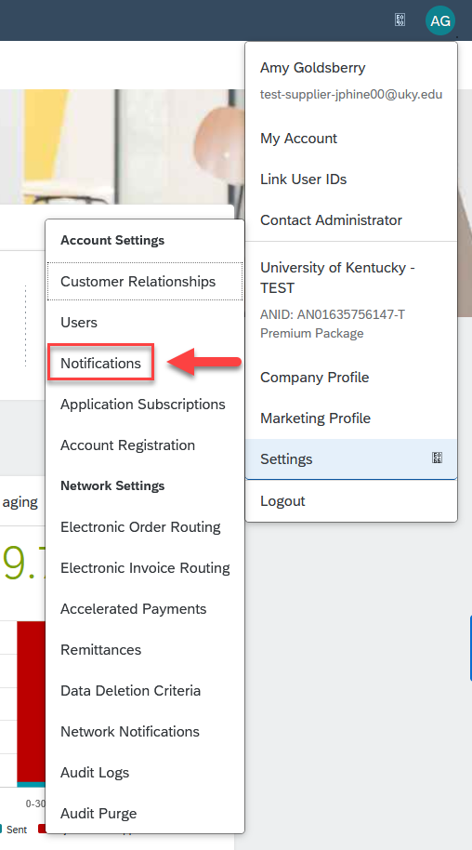
6. New Window will open.  Click Notification  Click Network | 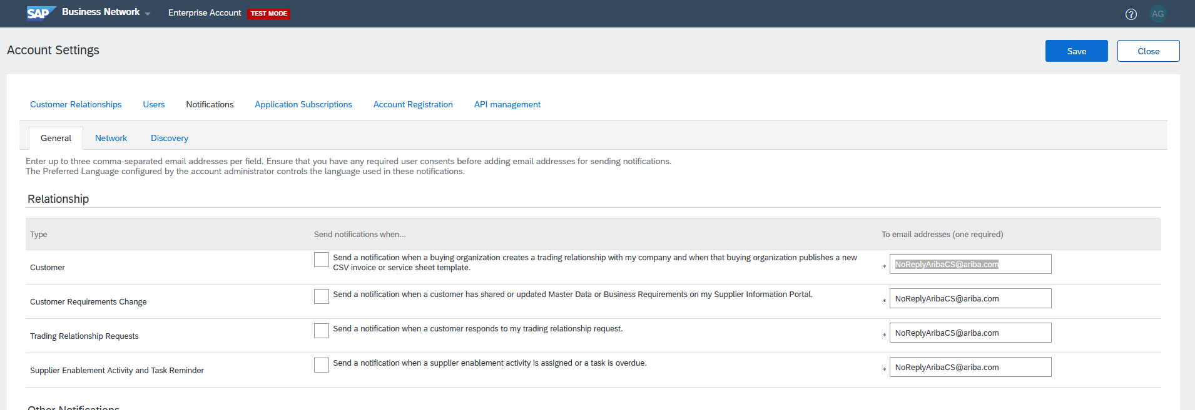  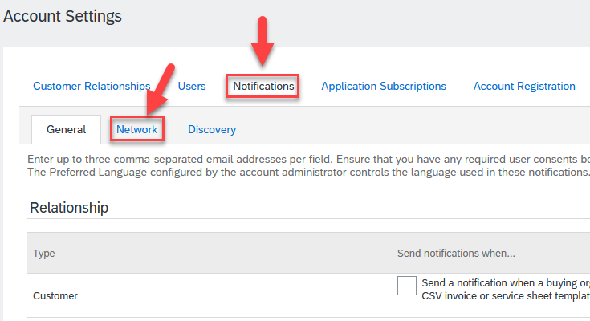
7. Network Tab will open.  See Tab Network  Look for Electronic Order Routing | 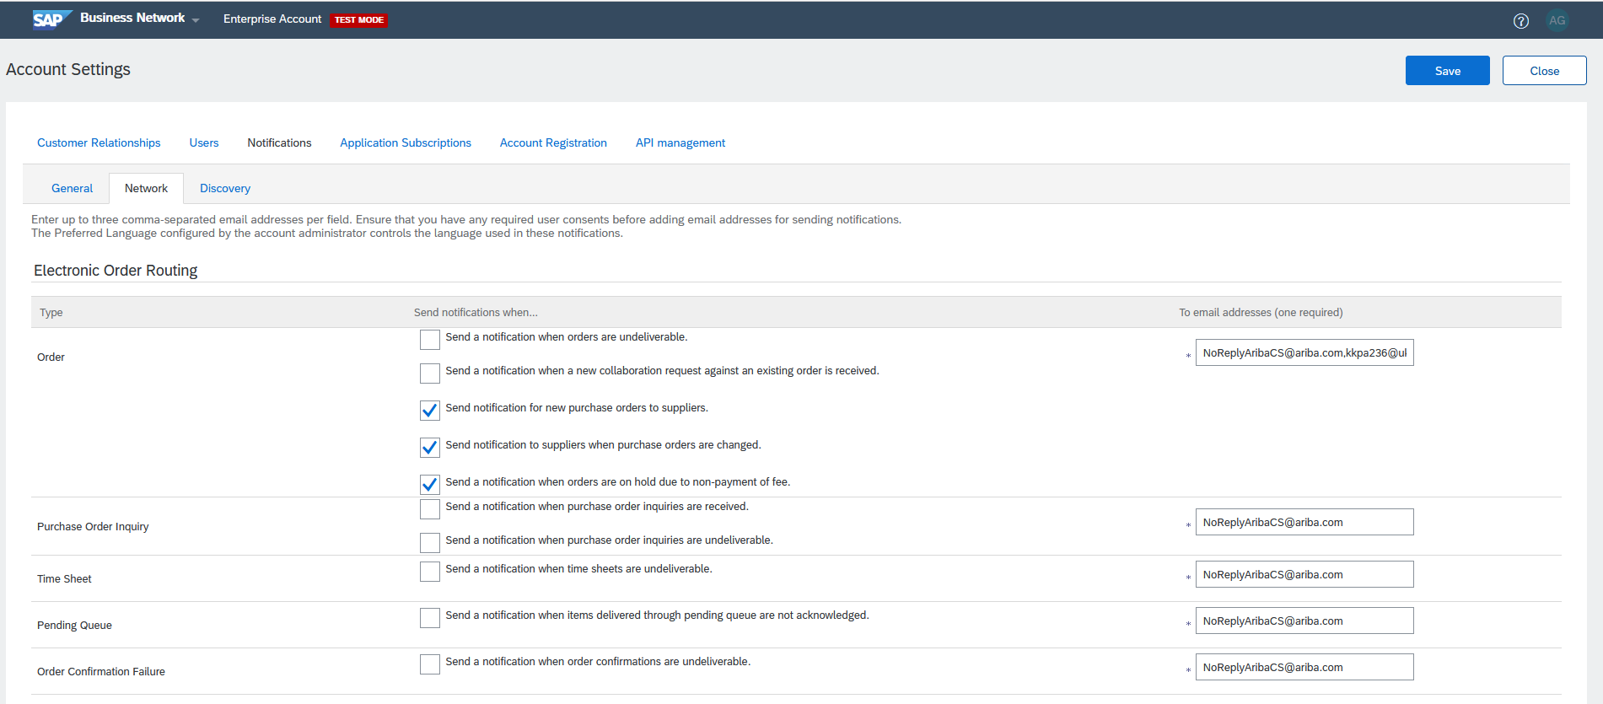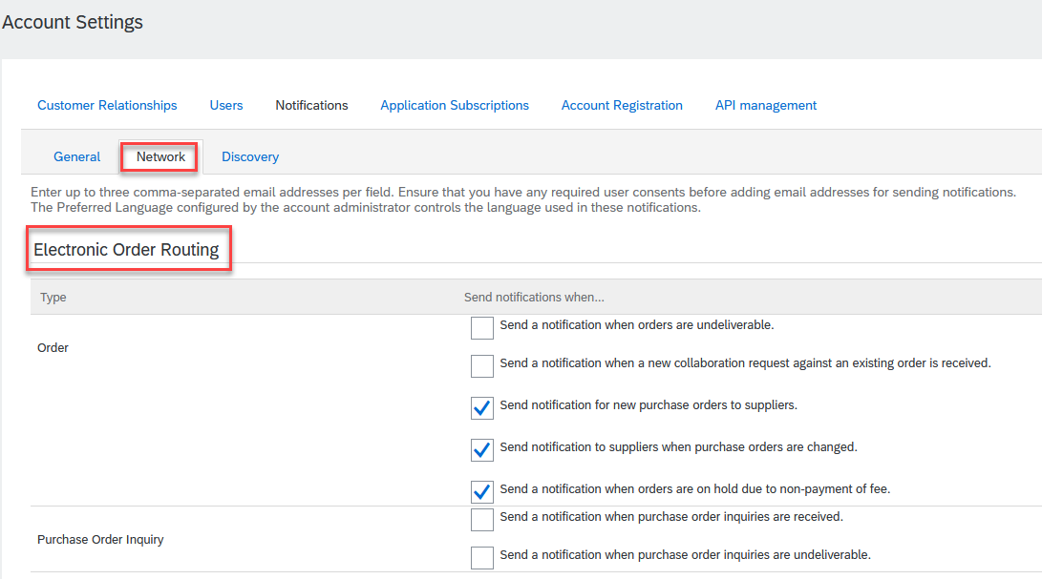
8. To Send Purchase Order to New Email:  Find “Order” under Electronic Order Routing | 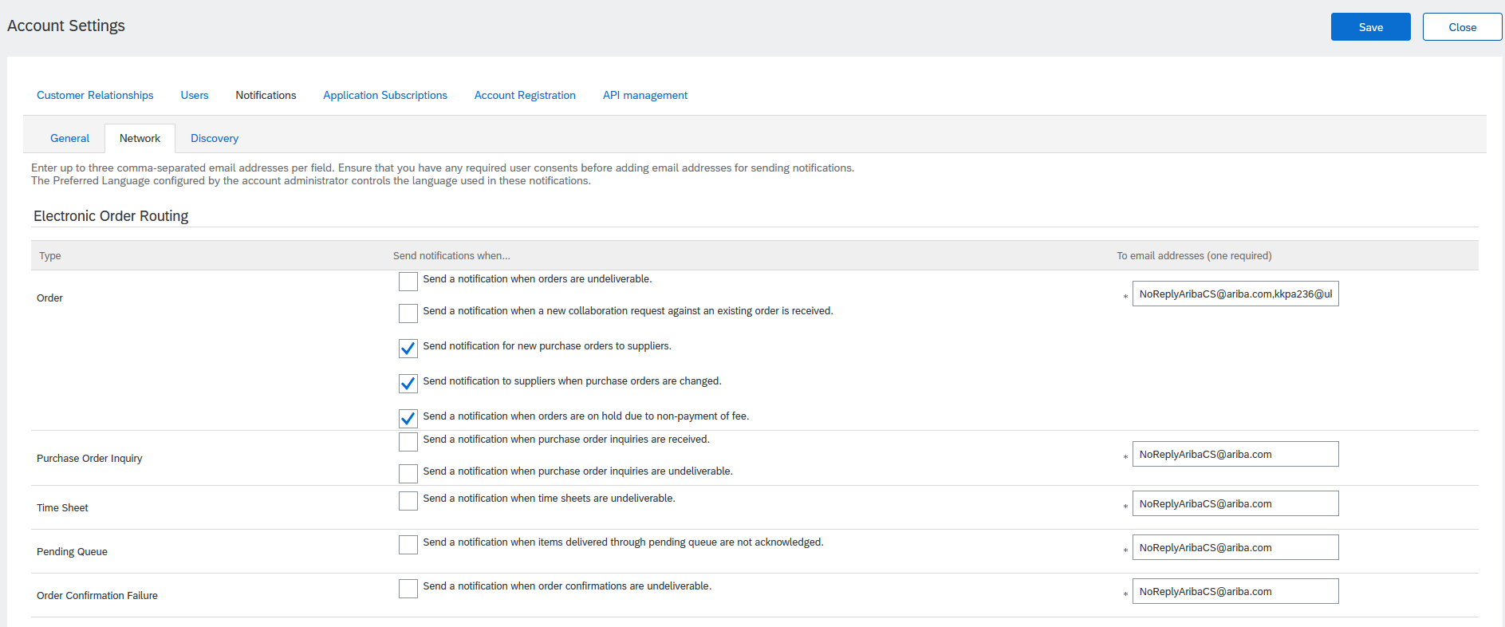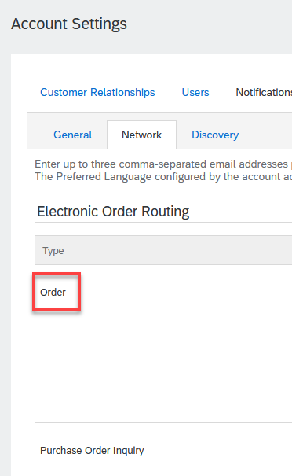
Check Mark all the check boxes shown/needed under “Send notifications when…”  Specify Email Address you want all future Purchase Orders to be sent to.  (You can input up to 3 emails by separating them with a comma) | 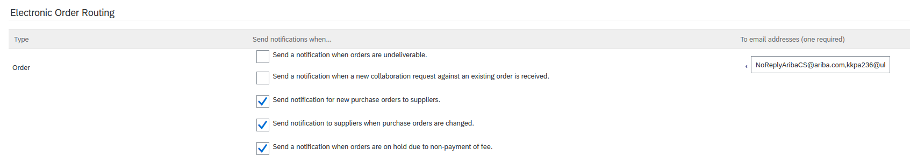  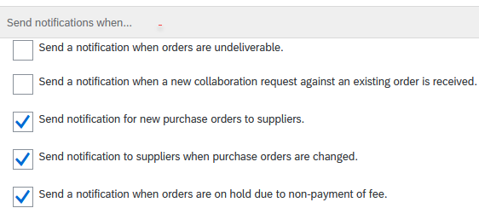  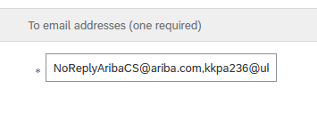
10. To Receive Notification of Invoice Failures:  Find “Invoice Failure” under Electronic Invoice Routing  Click Send Notification if invoice fails.  Ensure Email is set to correct/current Email Address  If needed, update email address. | 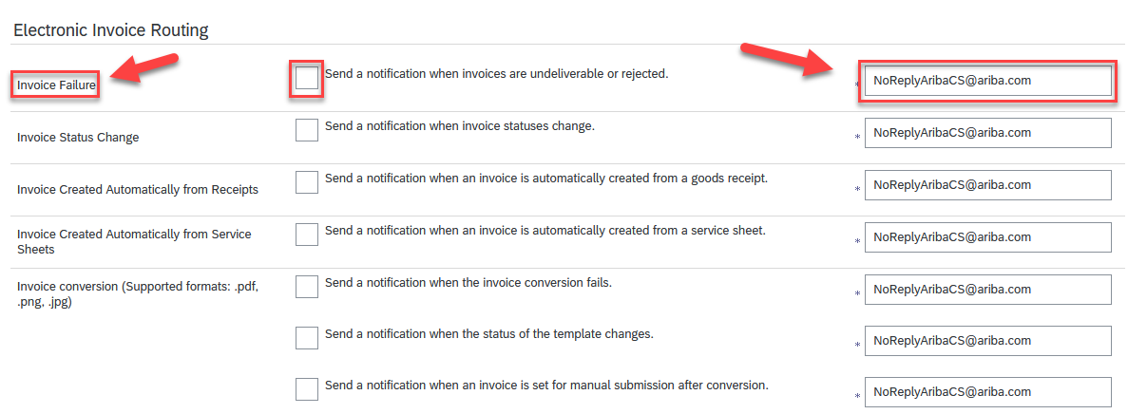  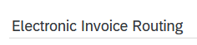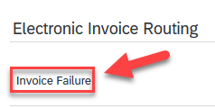  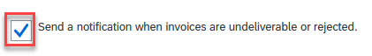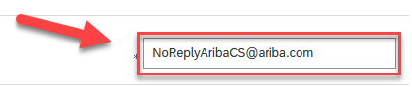
10. Make sure you Save and Close to keep these settings.  The Save and Close buttons are on the Top Right corner of the page. | 