Suppliers on the Ariba Network occasionally will receive an Invoice Rejection message if an invoice is not submitted correctly based on network rules. This Quick Reference Guide (QRC) shows a supplier on the Ariba Network how to resubmit an invoice correcting the error.

This QRC shows specifically how to Resubmit an Ariba Invoice that was rejected due to a Tax Code error.

Note: All suppliers on the Ariba Network have the ability to upload and/or resubmit an invoice manually on the Ariba Network from their web-based online login portal. Ask your B2B or e-Commerce team for access if you do not have access to your company’s Ariba Network online login portal. Additionally, an invoice that is resubmitted must have a new, unique invoice number from the original invoice. This can be easily accommodated by adding a new letter (A, B, C, etc.) to the end of the original invoice number.

Note: Please be sure not to use any Ariba Network selections that generate a Non–PO Invoice. Every invoice created or resubmitted must generate from a PO number previously existing on their supplier login portal. “Non-PO” invoices will automatically fail to transmit on Ariba Network.

Role: Ariba Network Supplier | Frequency: As Needed

1. Access the supplier portal on the Ariba Network.  Direct Link | 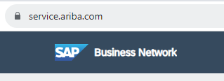
2. Login to the Supplier portal using your Ariba Network Username and password. If you don’t have access, contact your company B2B or e-Commerce team to assign you as a company user. | 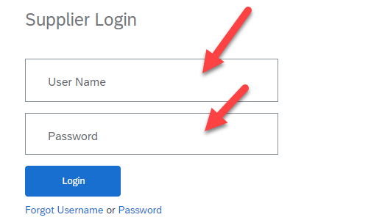
3. To locate the appropriate invoice to resubmit, look up the PO number to display as the initial reference.  Click Order –  Purchase Orders.  OR  Click Create –  PO Invoice  Select Customer  Enter Order Number.  Select Creation Date  Click Apply.  Ariba will search for that order Number.  And  Order Number will get displayed and click that order. | 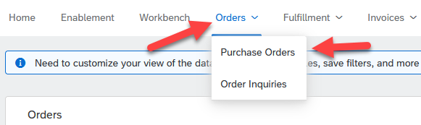  OR  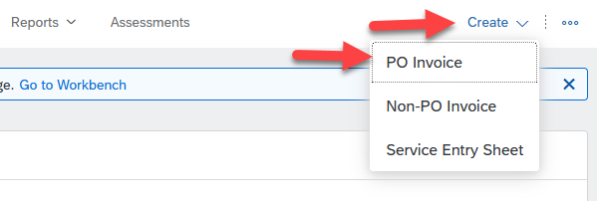  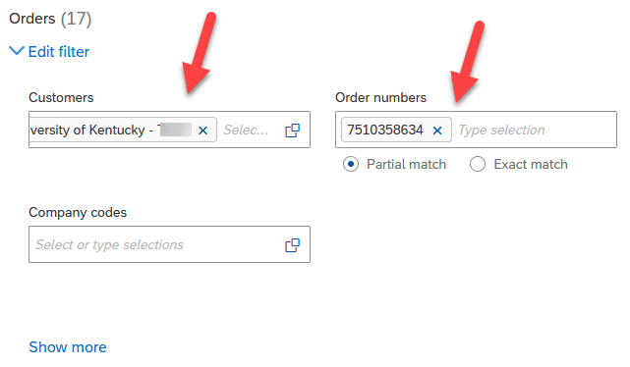  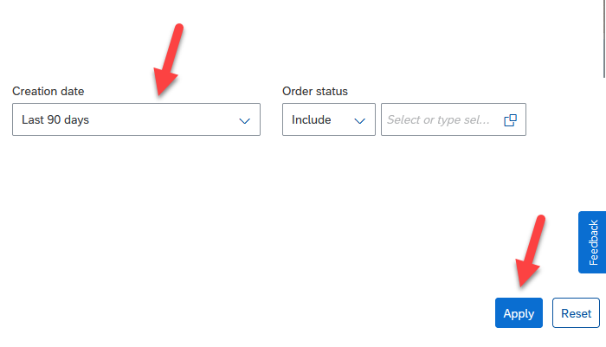  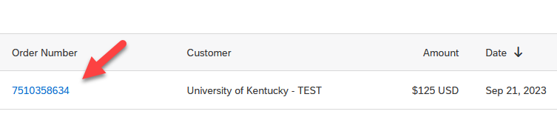
4. Upon finding the PO number, drill into it to display.  Purchase Order will get Displayed. | 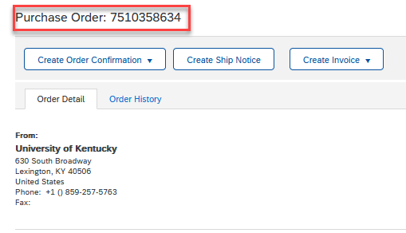
5. Once the PO displays, navigate to the right to see the invoice list affiliated with the PO.  Click Create Invoice.  Click Standard Invoice. | 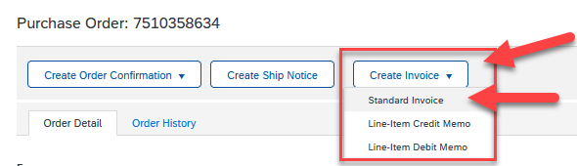
6. Once you locate the invoice on the display. Enter Unique Invoice Number.  Invoice will be displayed.  Enter Unique Invoice Number. For Example – UK12345. | 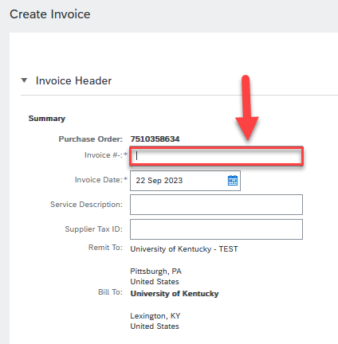
7. By default Sales Tax category tab is present while creating invoice. don’t remove it.  Sales Tax Category Tab is present by default. Please don’t Remove it. | 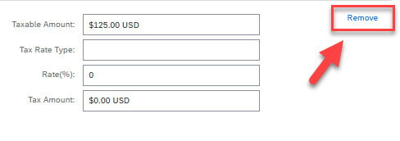  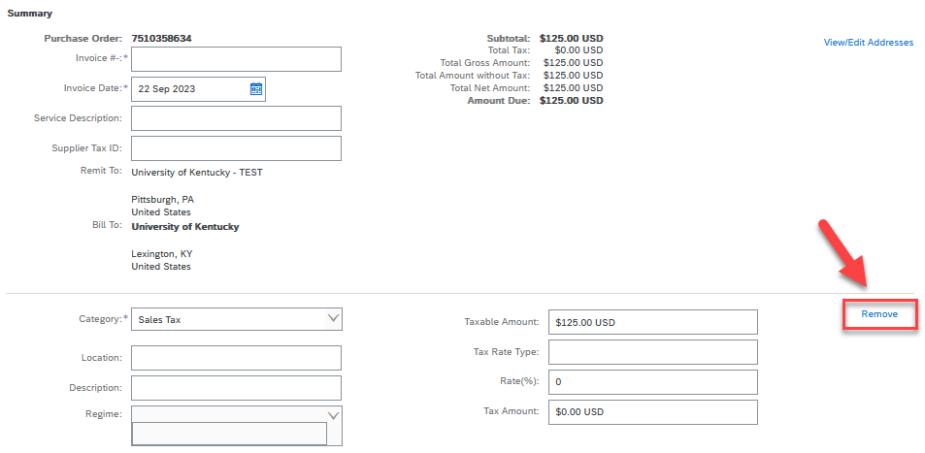
8. If by Mistake Sales Tax Category Tab is removed.  If you click remove button present on top screen - Sales Tax Category Tab is removed. | 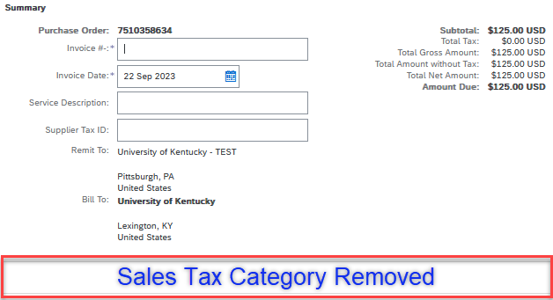
9. Add Sales Tax Category Tab back as its mandatory else it will give tax code error and invoice will not get posted.  To Add Back the Sales Tax Category Tab -  Click Add to Header.  Click Tax  Sales Tax Category Tab will get added back. | 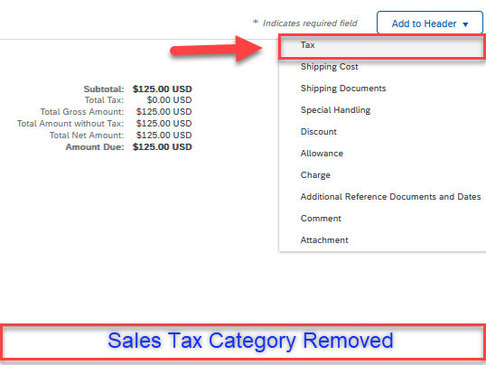  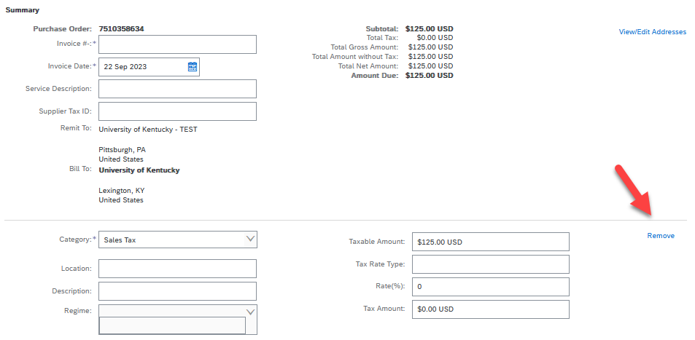
10. Scroll Down to Check Line Items material with Price. Don’t change anything here.  Put Check Mark in Small box present at Line No.1.  Check Material Part # & Description.  Check Quantity, Unit of Measurement, Unit Price, Subtotal | 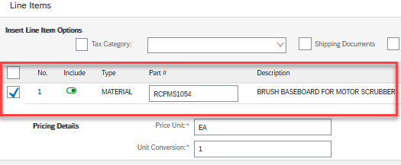  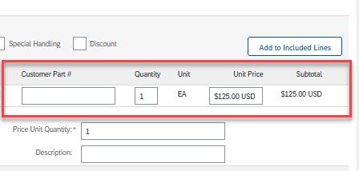
11. Click Next to Submit Invoice. | 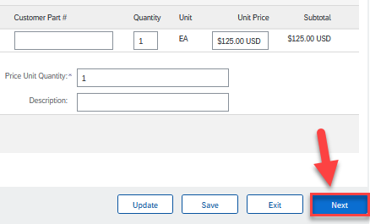
12. Submit the Invoice.  Submit the Invoice.  Invoice will get posted in Ariba | 