Suppliers on the Ariba Network occasionally will receive an Invoice Rejection message if an invoice is not submitted correctly based on network rules. This Quick Reference Guide (QRC) shows a supplier on the Ariba Network how to resubmit an invoice correcting the error.

This QRC shows specifically how to Resubmit an Ariba Invoice that was rejected due to a Freight Code Error.

Note: All suppliers on the Ariba Network have the ability to upload and/or resubmit an invoice manually on the Ariba Network from their web-based online login portal. Ask your B2B or e-Commerce team for access if you do not have access to your company’s Ariba Network online login portal. Additionally, an invoice that is resubmitted must have a new, unique invoice number from the original invoice. This can be easily accommodated by adding a new letter (A, B, C, etc.) to the end of the original invoice number.

Note: Please be sure not to use any Ariba Network selections that generate a Non–PO Invoice. Every invoice created or resubmitted must generate from a PO number previously existing on their supplier login portal. “Non-PO” invoices will automatically fail to transmit on Ariba Network.

Role: Ariba Network Supplier | Frequency: As Needed

1. Access the supplier portal on the Ariba Network.  Direct Link | 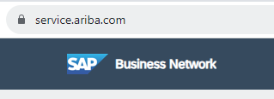
2. Login to the Supplier portal using your Ariba Network Username and password. If you don’t have access, contact your company B2B or e-Commerce team to assign you as a company user. | 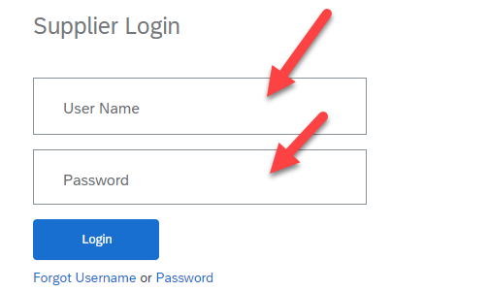
3. To locate the appropriate invoice to resubmit, look up the PO number to display as the initial reference.  Click Order –  Purchase Orders.  OR  Click Create –  PO Invoice  Select Customer  Enter Order Number.  Select Creation Date  Click Apply.  Ariba will search for that order Number.  Order Number will get displayed and click that order. | 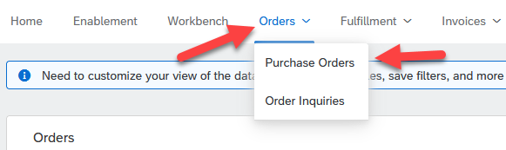  OR  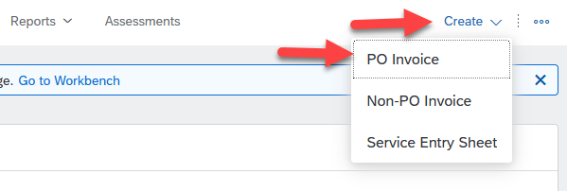  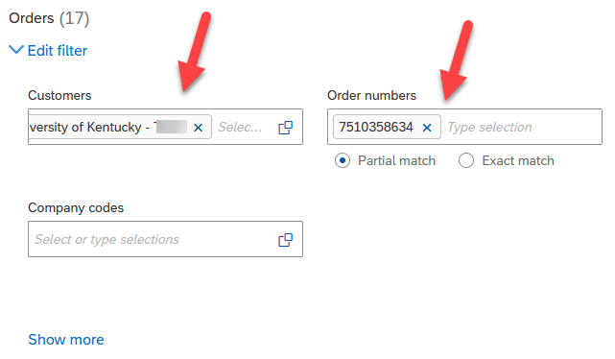  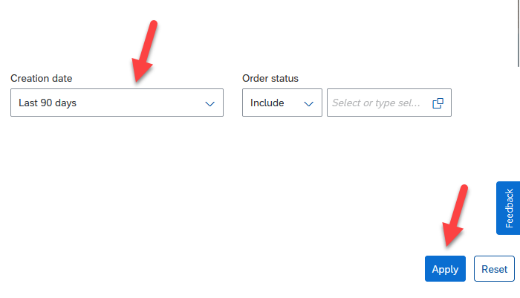  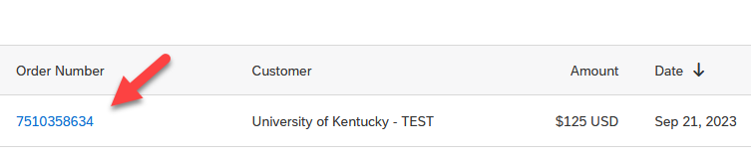
4. Upon finding the PO number, drill into it to display.  Purchase Order will get Displayed. | 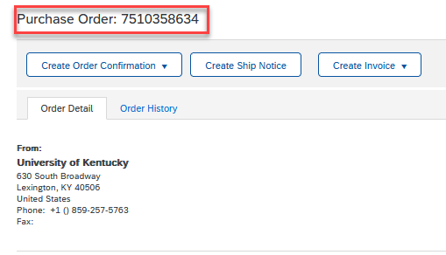
5. Once the PO displays, navigate to the right to see the invoice list affiliated with the PO.  Click Create Invoice.  Click Standard Invoice. | 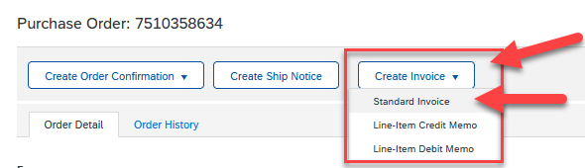
6. Once you locate the invoice on the display. Enter Unique Invoice Number.  Invoice will be displayed.  Enter Unique Invoice Number. For Example – UK12345. | 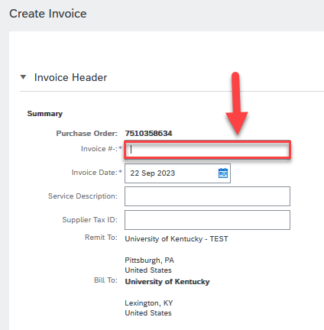
7. By default the Shipping tab is present while creating invoice.  The Shipping Category Tab is present by default.  By Default, Header Level Shipping is clicked.  Don’t Click Line Level Shipping. If Clicked Freight will get added to Line level and Freight Code error will be generated. | 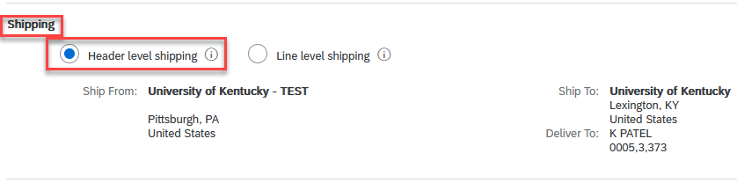  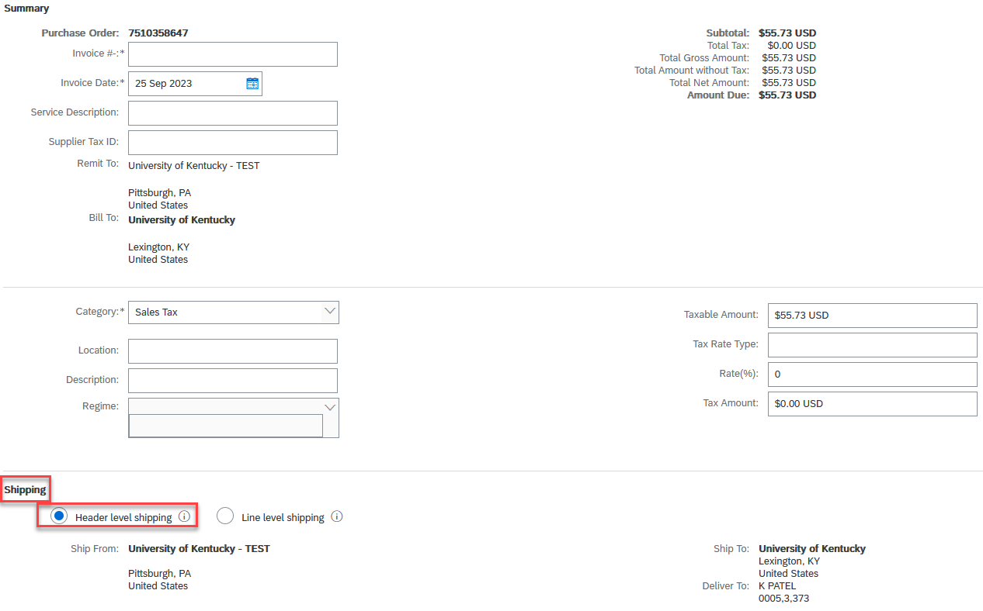
8. To Add Shipping Cost to Header Level.  Click Add to Header.  Click Shipping Cost. | 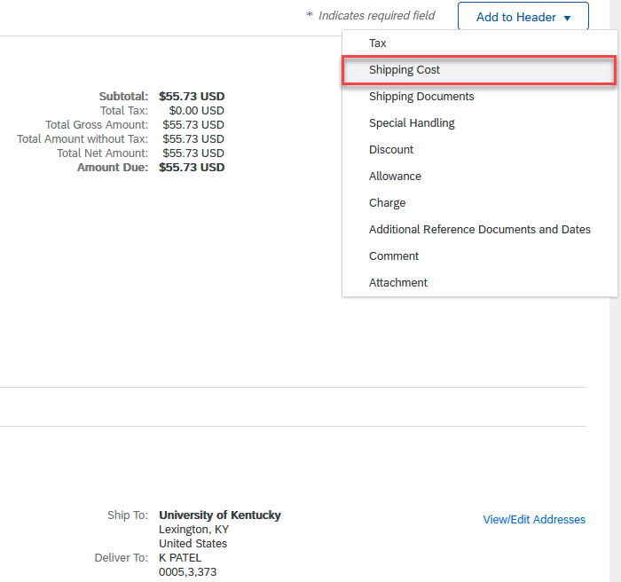  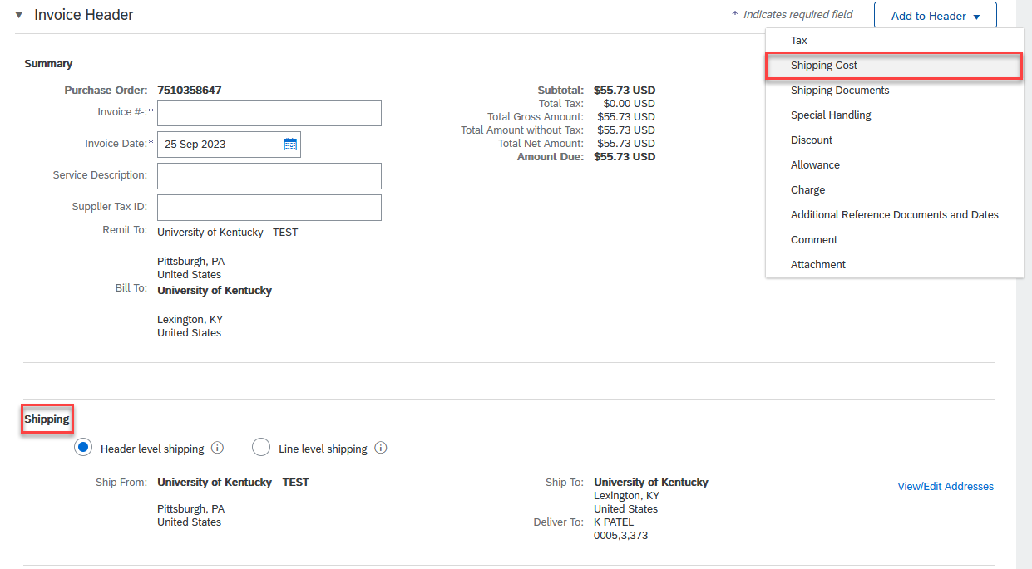
9. Added Shipping Cost to Header Level. | 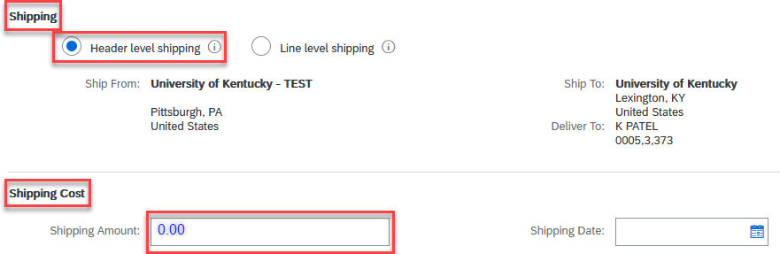  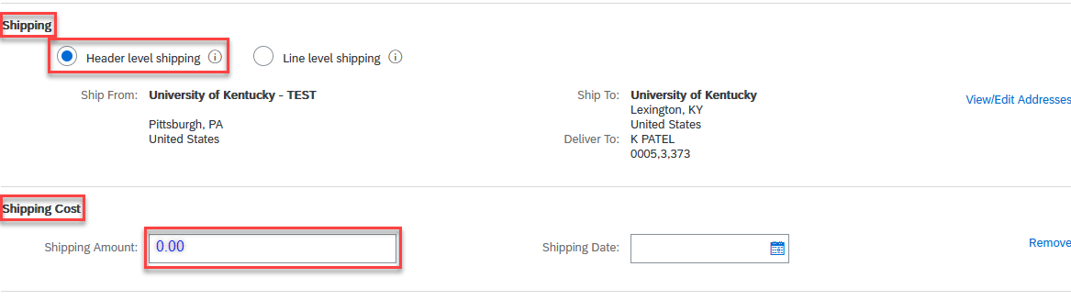
10. By Mistake, if you click Line level Shipping | 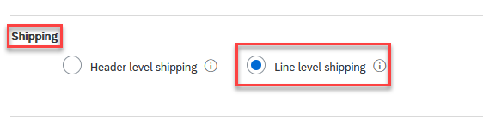  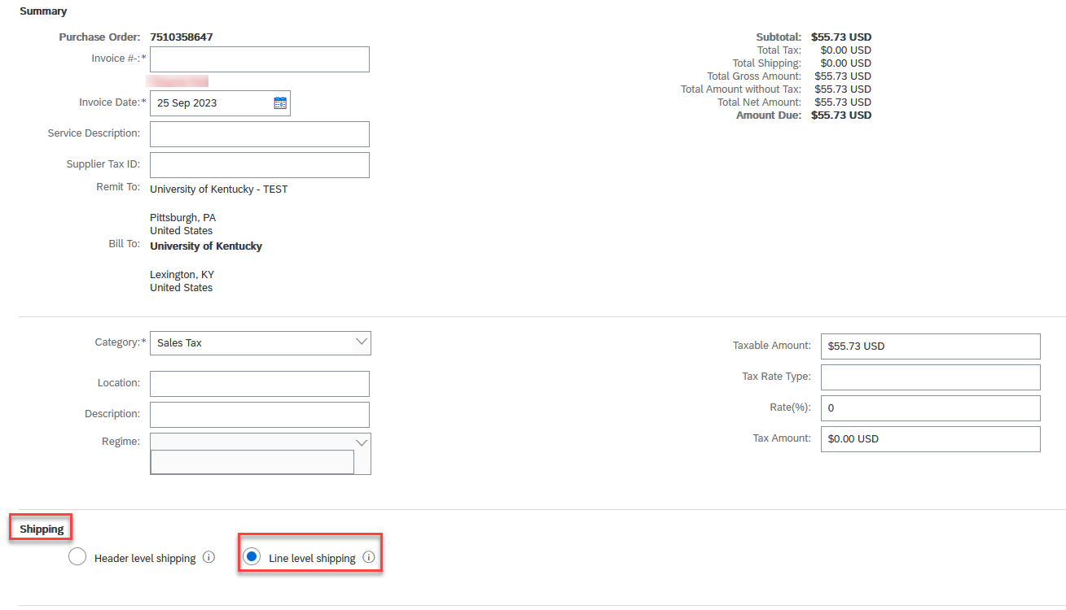
11. Line Level Shipping will get added.  Please Avoid this to do.  Please don’t submit invoices by adding freight charges to line level.  Invoice will not get posted and Freight Error will get displayed. | 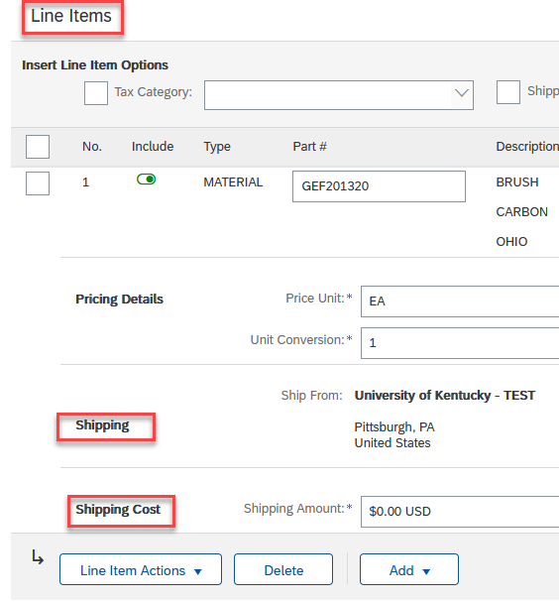  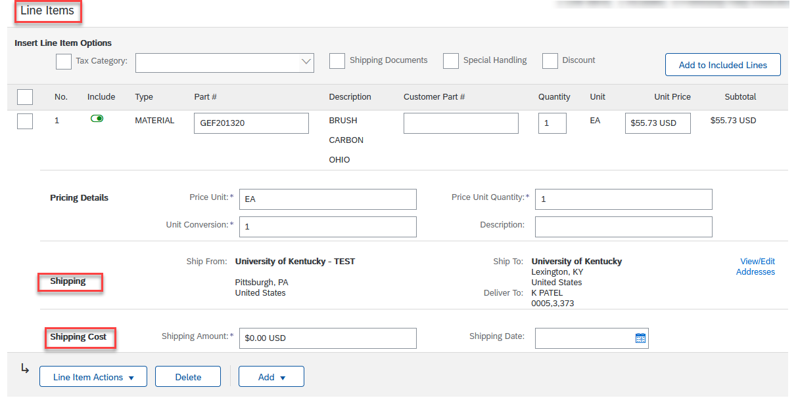
10. Scroll Down to Check Line Items material with Price. Don’t change anything here.  Put Check Mark in Small box present at Line No.1.  Check Material Part # & Description.  Check Quantity, Unit of Measurement, Unit Price, Subtotal | 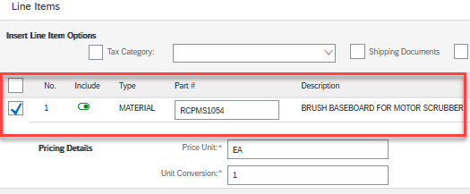  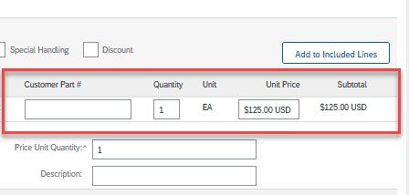
11. Click Next to Submit Invoice. | 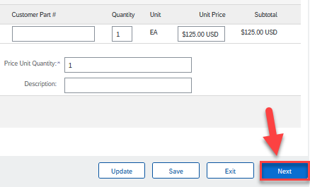
12. Submit the Invoice.  Submit the Invoice.  Invoice will get posted in Ariba | 