Substitute Shoppers are persons allowed to set-up, view, and respond on behalf of another Shopper.

Role: Staff | Frequency: As Needed

Designate Substitute Shoppers
1.From the dashboard click Settings. | 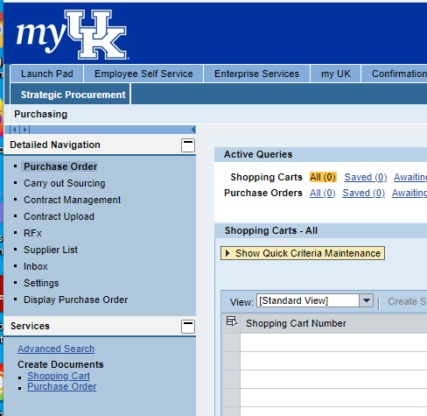
2. Select the User Account tab.  3. Click the Possible Entries icon to locate and add a Substitute Shopper. | 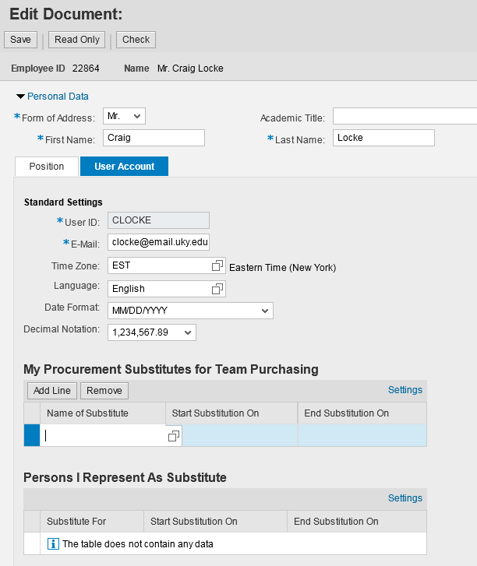
4. To conduct a search, enter last and first name of Substitute Shopper  5. Click Search | 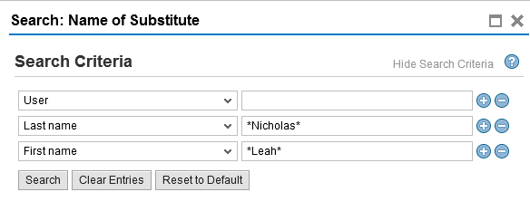
6. Highlight correct selection from search results. | 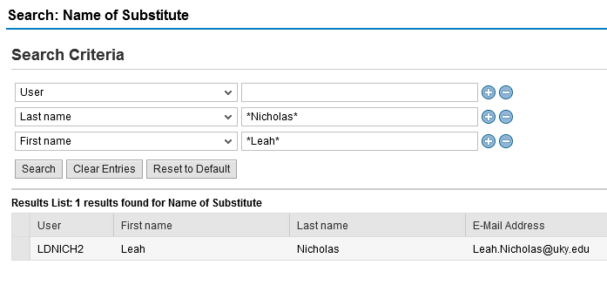
Designating your Substitute Shoppers within Personal Settings sets permissions for you to participate in “Team Shopping”.  With Team Shopping, two or more shoppers can have access to each other’s carts. A Substitute Shopper can view, edit, or delete a Shopping Cart created by a team member.  For more information a Quick Reference Card entitled “Substitute Shoppers and Manage Team Carts” is available from the Purchasing SRM website at: http://www.uky.edu/Purchasing/. | Once you set up Substitute Shoppers for each other, on every cart from that point on, you will see a new check box at the top of each Shopping Cart for “Team Cart”. You must check that checkbox also on each cart for the other person to have access to it.  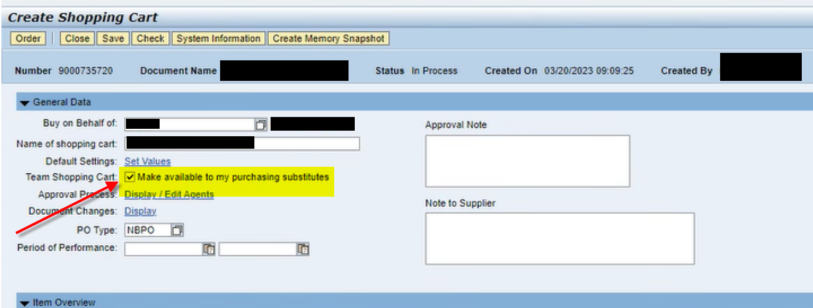  When looking in your POWL Dashboard also, your Team carts will show in your Team Shopping Cart queues, not your individual queues, when looking for them.  