Below are the top tips related to SAP Vendor Master Data, Vendor Searches, and the roles executed by PaymentWorks, the University’s third-party Vendor Onboarding Partner in the vendor management process. This help guide has three sections:

- Vendor Help Quick Tips
- PaymentWorks Console Status Definitions
- How to Conduct General Search for Vendors Using SAP T-code XK03

- Definitions: SAP Vendor Master Data vs Payment Works - SAP Vendor Master Data is the official repository and single point of truth for all Vendor Master Data. PaymentWorks is a contracted third-party platform, external to the University, that is used for vendor new registrations, updates, and onboarding into the SAP Vendor Master Data. PaymentWorks does not act as the administrator or custodian for the University’s Vendor Master Data.

- To determine whether a vendor is fully onboarded into the SAP Vendor Master Data, use T-code XK03 to perform a vendor search in SAP. Be sure to only use the UK Vendor Search tab when conducting the search; searches from other tabs will show incorrect results. Use wildcard searches utilizing the * symbol to receive the best results. If needed, a help guide and other resources are available on the Purchasing Learning and Training Resources page in the PaymentWorks/Vendor Management section.

- Before sending a PaymentWorks invitation, remember first to check the SAP Vendor Master Data to determine whether the vendor is already listed and available to use. Only send a PaymentWorks invitation if the vendor record is not found in the SAP Vendor Master Data.

- Remember to monitor your PaymentWorks console status bar for progress during the onboarding process and use it as your primary information tool. A help guide describing status messages is available on the Learning and Training Resources page in the PaymentWorks section. Both the Purchasing Division and PaymentWorks have continual access to status bar progress for all vendors being onboarded University-wide.

- PaymentWorks provides a console status bar for each vendor and will show the term Approved once that vendor fully completes the onboarding process. It may take up to one business day for the vendor to load into the SAP Vendor Master Data. Based on a number of factors, PaymentWorks may or may not reflect the SAP vendor number in its console status bar. If a vendor shows a status of Approved, be sure to check the SAP Vendor Master Data to determine the vendor number if needed.

- A status of Submitted – Pending Internal Review indicates the vendor has submitted their registration and is currently under further validation. This continues until all validations are completed by PaymentWorks and Purchasing. Vendors in this phase are continuously and actively monitored by both PaymentWorks and Purchasing; there is no need to follow up to check status on vendors while they are under Submitted – Pending Internal Review.

- Please send only one PaymentWorks invitation to a vendor to complete a registration unless there is a valid reason to resend to a different email address. Sending multiple invitations for the same vendor setup creates confusion in the onboarding process and typically extends the time required for onboarding.

- Please send questions related to vendor onboarding and PaymentWorks issues to vendorhelp@l.uky.edu. Purchasing provides support and assistance for all vendor updates, questions, etc. and works internally to resolve vendor questions or challenges during the onboarding process. In cases where needed to support vendors during onboarding, Purchasing will request PaymentWorks to directly assist the vendor with the onboarding process.

- Please keep in mind that all vendor onboarding and updating tasks are reviewed and processed on an ongoing basis each business day by both PaymentWorks and the Purchasing Division. Some registrations may require a longer period to validate dependent on unique situations. While the vendorhelp@l.uky.edu email is available for situations that require support, please remember to use the PaymentWorks console status bar as the primary tool to monitor onboarding progress.

Key TIPS Summary:

- Check the SAP Vendor Master Data to verify whether the vendor is previously onboarded and available.
- Use the PaymentWorks console status bar as your primary tool for monitoring onboarding progress of your vendors.
- Vendor onboardings with status of Submitted-Pending Internal Review simply means the vendor has submitted their registration and is being reviewed and validated by PaymentWorks and Purchasing; this phase is actively monitored and progresses depending on the unique nature of each vendor; there is no need to follow up on vendors while they are within this status.
- Send only one PaymentWorks registration to a vendor unless there is a valid reason otherwise
- Use the vendorhelp@l.uky.edu as your help resource when needed and there is valid need for support that is not provided by the PaymentWorks console status bar.

PaymentWorks Console Status Definitions:

PaymentWorks users have dedicated dashboards that show status of each vendor in process for onboarding. The status will change as the vendor progresses from the Invitation stage through Approved.

University departments only complete Step 1. Steps 3 through Step 8 are completed by the vendor.

For assistance and support for onboarding or other vendor questions, email vendorhelp@l.uky.edu.

Role: Departmental Staff or Faculty | Frequency: As needed

1. Invitation has been sent (performed by the department)

2. Invitation not deliverable (possibly incorrect email address used)

3. Invitation was delivered to vendor’s mail inbox, but not yet opened

4. Invitation email opened by vendor within their mail inbox

5. Vendor clicked PaymentWorks link within their email invitation but has not completed initial account setup.

6. Vendor initially created account on PaymentWorks

7. Vendor’s email and initial account setup validated, but they have not begun the registration. PaymentWorks vendor registration is a two-step process. The vendor first creates an account as directed by PaymentWorks email instructions. They then receive a second email from PaymentWorks to log into their account and complete the actual registration form. (Vendor Step 1 of 2)

8. Vendor has begun process of completing registration form. Registration is not complete until they complete the entire form and click the Submit button. When this is completed by the vendor, the registration will change to a status of Submitted.

9. Vendor completed and submitted PaymentWorks registration (Vendor Step 2 of 2)

10. Submitted – Pending Internal Review indicates the vendor has submitted their registration and is it is currently under further validation. This continues until all validations are completed by PaymentWorks and Purchasing. Vendors in this phase are continuously and actively monitored by both PaymentWorks and Purchasing; there is no need to follow up on vendors while they are pending internal review.

Or

11. Vendor registration reviewed by Purchasing administrator and returned to vendor (possibly incorrect information provided, duplicate submission, more information needed, etc.). Vendor receives email notification indicating required actions, etc.

12. Vendor registration approved for SAP number assignment. It may take up to one business day for the vendor to load into the SAP Vendor Master Data. Based on a number of factors, PaymentWorks may or may not reflect the SAP vendor number in its console. Be sure to use the SAP Vendor Master Data to determine the vendor number if it shows as Approved in PaymentWorks.

13. Vendor registration fully complete and SAP vendor number assigned. This will show status “Connected” in the user’s dashboard. Note: This may occur later in the process or for some vendors, the above term “Approved” is the final step; be sure to check the SAP Vendor Master Data to determine the vendor number rather than wait for it to populate in PaymentWorks.

How to Conduct General Search for Vendors Using SAP T-code XK03

Usage: Perform before creating any procurement document to confirm whether the desired vendor is currently listed in the SAP Vendor Master Data.

Users: Creators of any type of procurement document

1. Click the IRIS icon from within the myUK Launch pad tab | 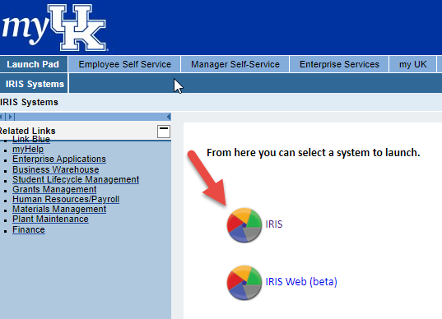
2. Enter T-code XK03 from the SAP Easy Access menu | 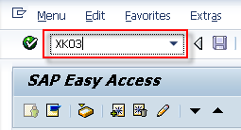
3. From the Display Vendor Initial Screen, click the possible entries icon to the right. | 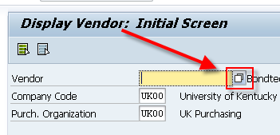
4. From the search criteria box, enter all or part of the vendor’s name into the Name field. Place an asterisk at the ends of the search term, and between search terms if more than one word.  Click the check button to start the search.  *Important: There are multiple tabs here. Be sure to use only the tab labeled as UK Vendor Search; all other tabs will display incorrect results. | 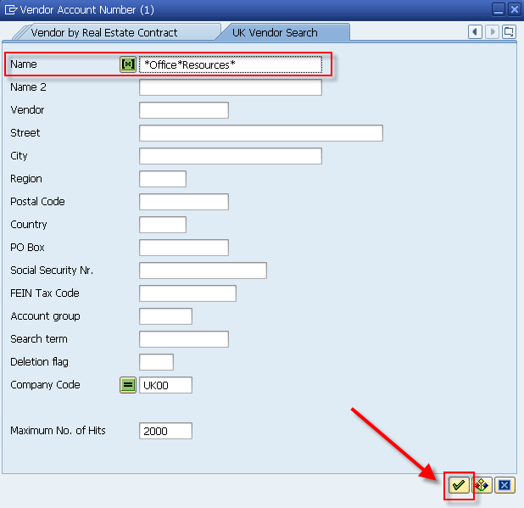
5. Review the list of search results to determine whether your vendor currently exists within the database. If not listed, send the vendor an invitation through PaymentWorks to register. | 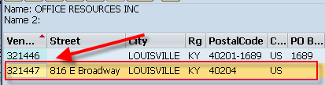
Search TIP:  Remember you can search on other data if known, for example: portions of the street address, PO box, city, ZIP code, etc. The search results will show all vendors meeting the search criteria; identify and select the correct entry. If available, the search data most unique in nature (e.g., tax ID number) will return the most accurate results. | 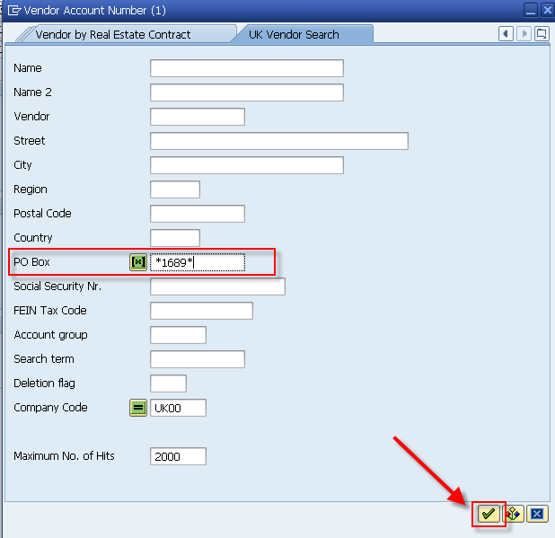  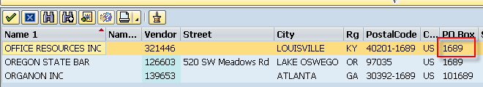

Vendor Search Tips

Departments may find the following TIPS useful when conducting vendor searches:

- If you are having problems locating a vendor, remember to use alternate search terms such as street address, city, ZIP code, etc. Manipulating wildcard (*) searches may also return better results, e.g., *123*Main* or 123*Main or *Main*.
- If you have a remittance address that needs added to the vendor database in addition to a vendor’s ordering address, send an invitation through PaymentWorks to the vendor as normal for them to submit and provide their remittance address information.

