Process: Items from Fisher Scientific can be ordered two ways within the Supplier Relationship Management (SRM) e-procurement system:

1. The Fisher Scientific e-catalog is available for those holding the Shopper role. It is accessible via the Add-Item dropdown menu along with other e-catalogs. It contains products that are exclusive to Fisher Scientific (e.g., Fisherbrand, Thermo Scientific, Invitrogen, Life Technologies, etc.) and not available from VWR International. Quotes are not needed for e-catalog orders; Shoppers simply locate Fisher exclusive items from within the catalog, place into their Shopping Cart, and checkout/order.

2. If needed, departments may purchase products from Fisher Scientific beyond the exclusive items in the e-catalog by using the SRM Free Text Shopping Cart option. A quote must be acquired from a Fisher sales rep or other source. The shopper manually enters the line item information into the Free Text Cart. As a refresher, the below steps reflect the Free Text Cart entry process specifically for Fisher Scientific. If needed, additional help materials are available on the Purchasing website at: http://www.uky.edu/Purchasing/SRM.htm.

When working with a Fisher prepared quote, please ensure the items cannot be ordered from within the e-catalog prior to creating a Free Text cart. The e-catalog should be utilized for ordering items whenever possible.

Please create Free Text Shopping Carts separately from items ordered through an e-catalog Shopping Cart.

Role: SRM Shoppers | Frequency: As needed

Refresher/Quick Reference:
How to Create Free Text Shopping Cart

Reminder: This is for Free Text Shopping Carts only, for items that are not available from the Fisher Scientific e-catalog.  1. The department obtains quote from a Fisher sales representative. | 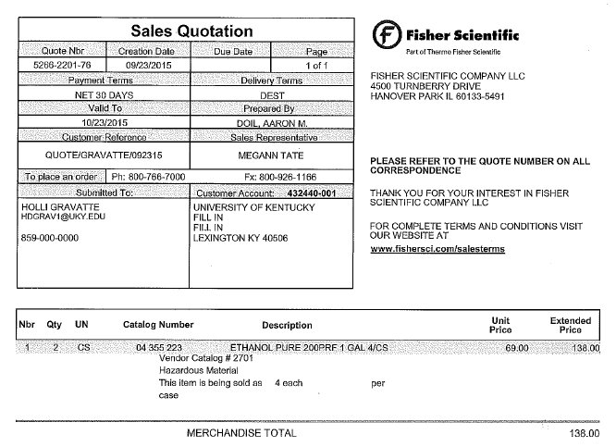
2. Access the Shopper tab within myUK | 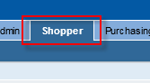
3. Click Shopping Cart under the Navigation panel on the left side | 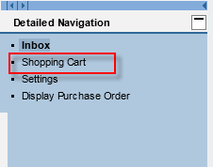
4. Click Create Documents – Shopping Cart | 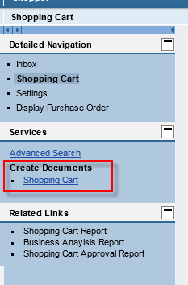
5. Click Set Values under Default Settings in the header section of the cart | 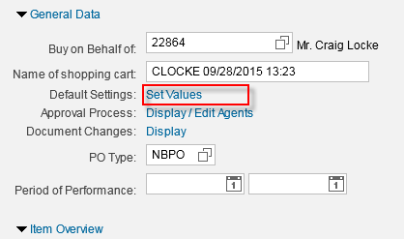
6. Select the correct Account Assignment Category and set the corresponding number.  - Select Cost Center as category if account number begins with 1  - Select WBS Element as category if account number begins with 2 or 3 | 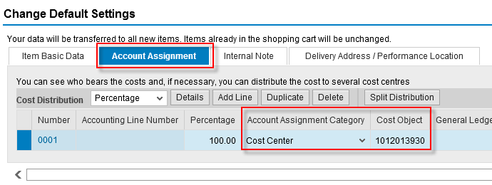
7. Select Delivery Address tab. Enter c/o name, room, and floor number for person receiving delivery of items.  Click OK | 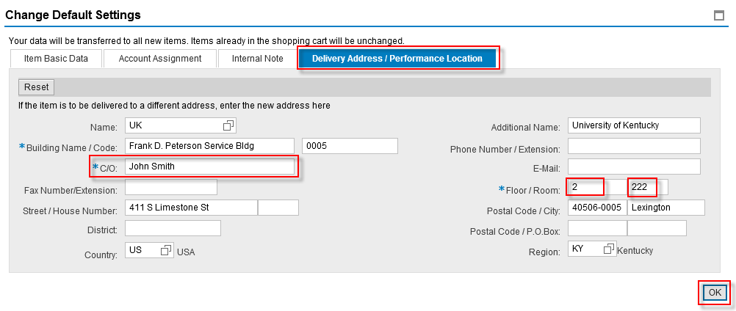
8. Place quote number in the Note to Supplier text box | 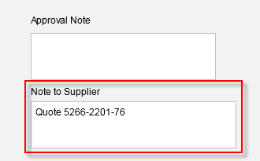
9. Items for Free Text orders are entered via freehand. They are not selected from an e-catalog within the Add Item menu.  Enter the item description, quantity, unit, and per each price from the quote, and required delivery date. | 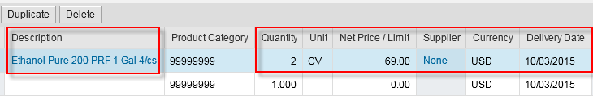
10. For laboratory/scientific purchases only, enter product category 41100000. | 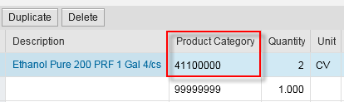
11. If multiple items are being ordered, repeat steps for other line items.  When finished, click Details button to open the bottom section. | 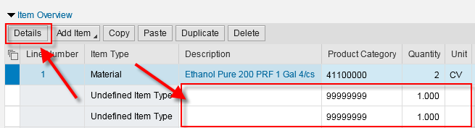
12. On the Item Data tab, enter the Supplier Product Number (i.e., catalog number) for each line item | 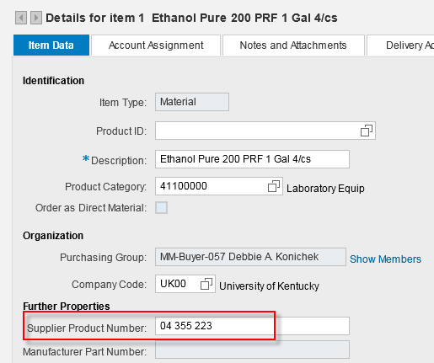
13. Review and check the Account Assignment tab on the line item level. Shopper can overwrite the GL Account as needed.  Reminder: If a piece of equipment is over $5000, it requires a capital GL. 550030 is the most common capital GL for laboratory equipment. | 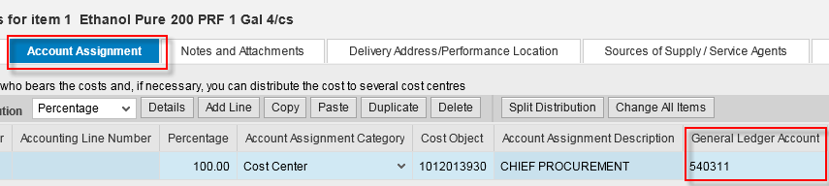
14. The quote must be attached to the Shopping Cart.  Click Notes and Attachments tab in bottom Details section  Click Add Attachment | 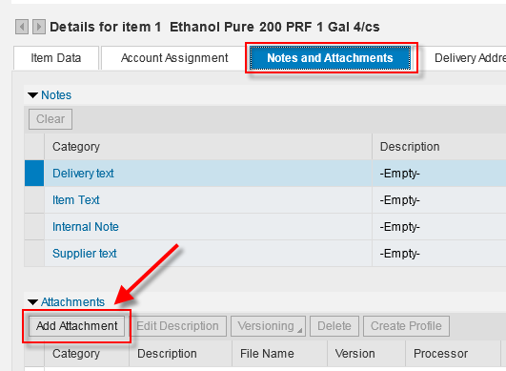
15. Click Browse | 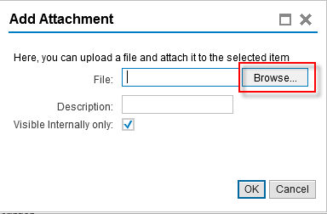
16. Locate and select the quote attachment to add.  Click Open | 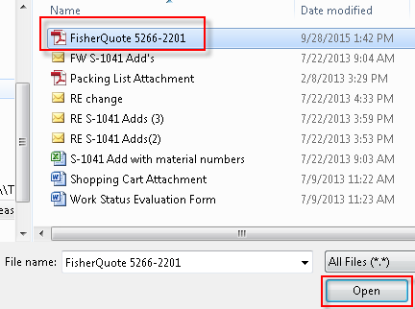
17. Name the attachment  Click OK | 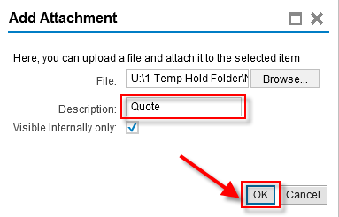
18. Click the Sources of Supply Tab to set the supplier number.  For Fisher Scientific only, enter 119652 into the Preferred Supplier box.  Reminder: If there are multiple line items, the supplier number must be replicated on each line. | 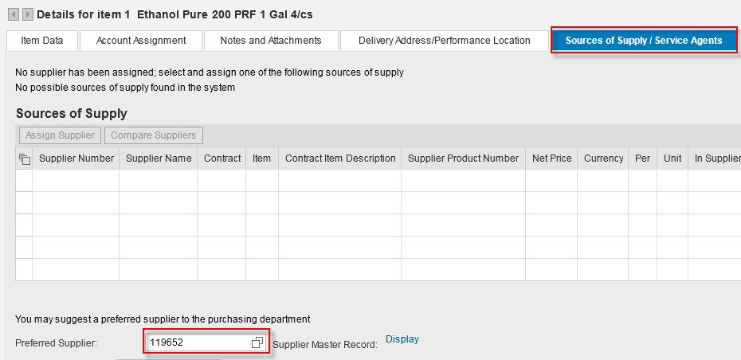
19. Click Order to finish the Shopping Cart. All Free Text carts move to departmental approver(s) and onto Purchasing for processing. | 