Setting Attributes

Role: Staff | Frequency: As Needed

Beginning Steps to Set the Attributes
Attributes are default components which populate into every Shopping Cart to facilitate a more efficient shopping experience. | The following attributes can be set as defaults:  - Account Assignment Category  - Cost Center  - WBS Element
- To set the attributes click on Settings under the Shopper tab within MyUK. | 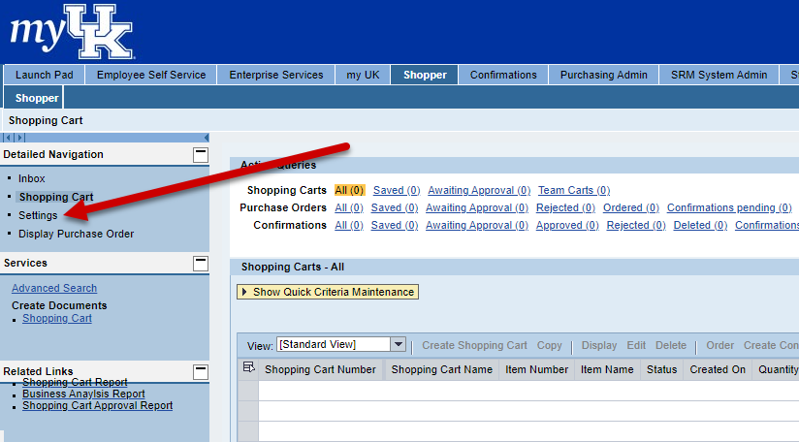
- Under the Position tab select the Account Assignment Category. | 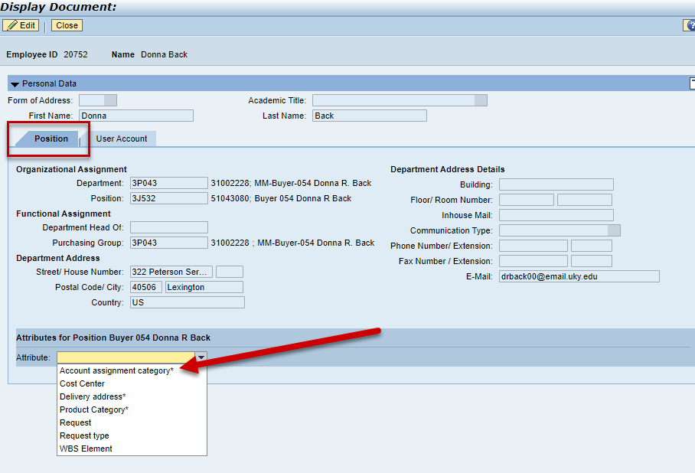
- Click the Edit button at the top left | 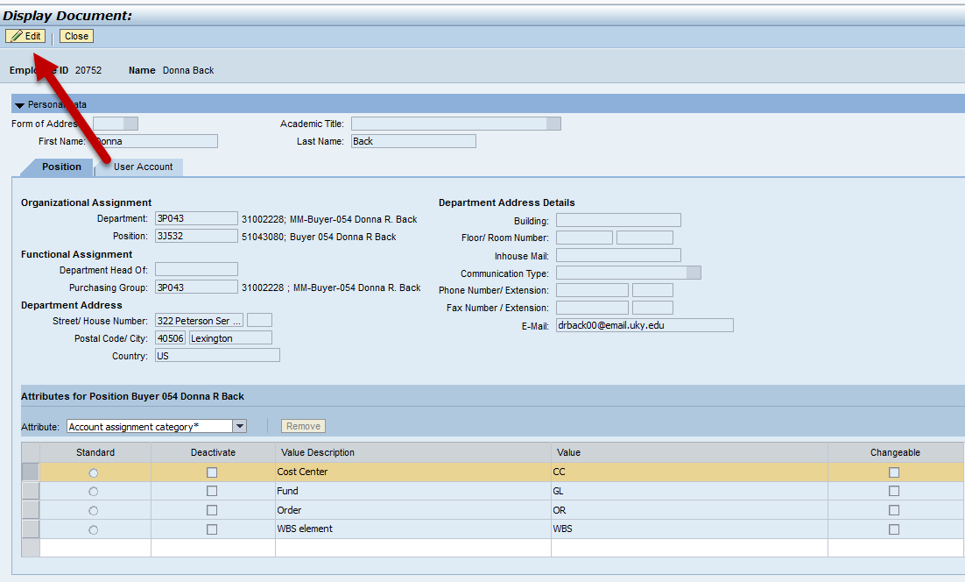
- Determine which type of Cost Assignment Category you most frequently use and click the Standard radio button. Cost Center will be the most common selection for most Shoppers. | 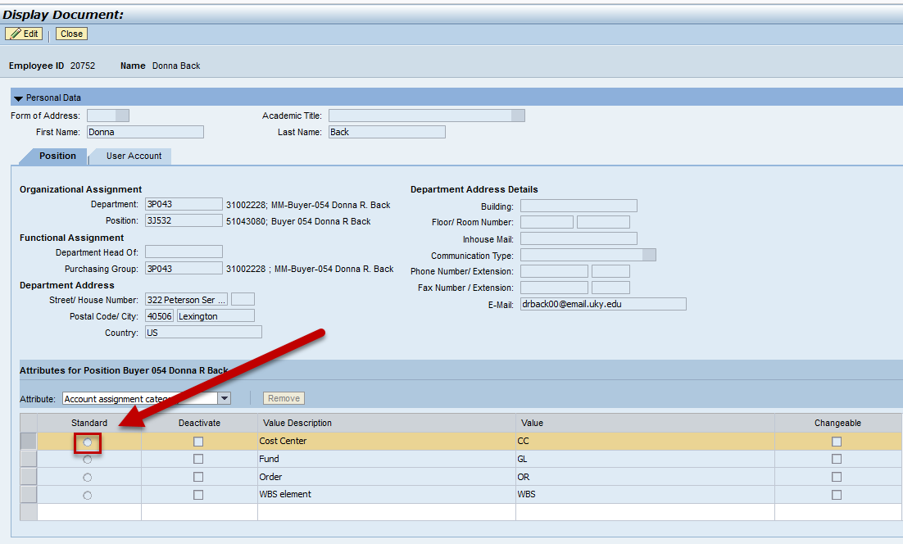
Important: Be sure not to check Deactivate for any selections. | 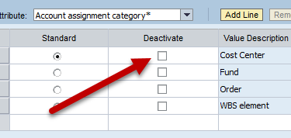
Setting Cost Center Attribute
- Select Cost Center from the drop down menu to assign a default Cost Center number | 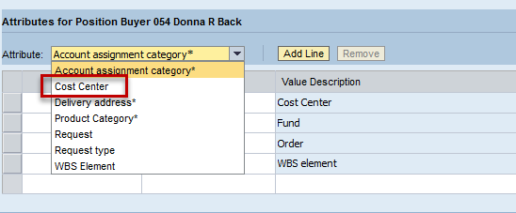
- Select Logical System  (there is only one selection)  - Click Add Line | 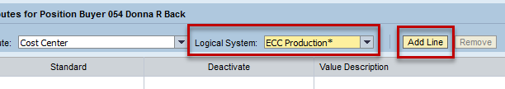
- Click the Standard Radio Button  - Enter the Cost Center number that you will use for most purchases | 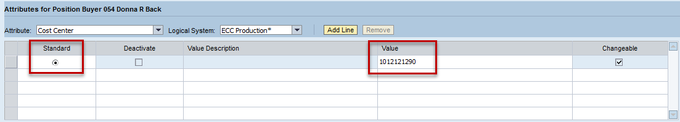
Setting WBS Element Attribute
- Select WBS Element from the drop down menu to assign a default WBS Element number. | 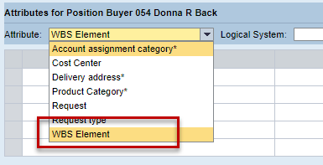
- Select Logical System  (there is only one selection)  - Click Add Line | 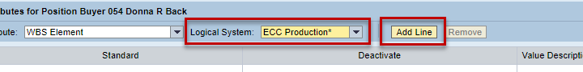
- Click the Standard Radio Button  - Enter the Cost Center number that you will use for most purchases  - If needed a search feature is available through the Possible Entries icon | 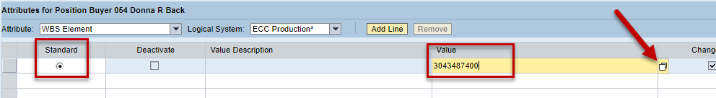
- Remember to click Save after changing or entering new attributes | 