A number of suppliers on the SAP Ariba Network offer Quote-To-Shopping-Cart capability as part of their e-catalog functionality. Departmental Shoppers can request a supplier (via the University-established Customer Service Representative) to write one or more customized quotes and place onto their respective e-catalog. The Shopper can navigate to the supplier’s e-catalog through SAP Ariba and utilize their quote-to-cart tool to transfer all line items to their Shopping Cart for easy and convenient ordering. Customized quotes are frequently used for orders that may qualify for special pricing, have many line items, or have other content of a customized nature.

Role: Shopper | Frequency: As Needed

Load Quote-To-Shopping Cart for VWR
1. Begin from your Shopper tab | 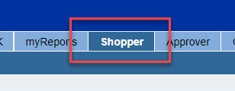
2. From the left Detailed Navigation menu, Click Shopping Cart.  Click Create Shopping Cart | 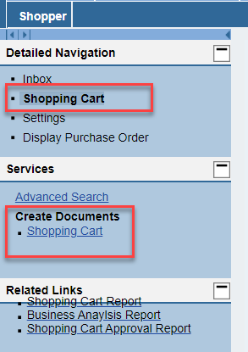
3. Select and Set Default Values as normal. This includes entering your cost object (cost center or WBS Element-Grant) and completing the c/o Delivery Person, room, and floor on the Delivery Address tab.  Remember, your Default Delivery Building should previously have been set in your Shopper Settings from your dashboard. That default building information and address will flow in automatically. | 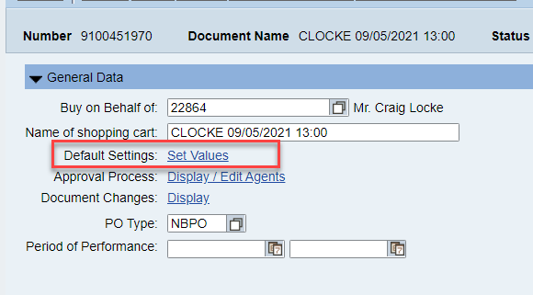  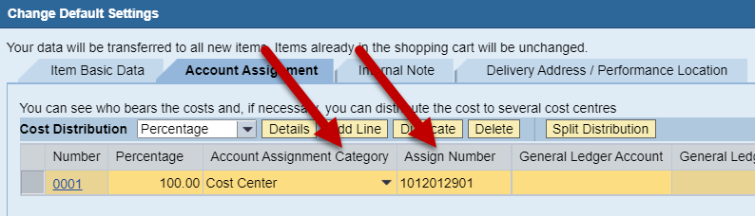  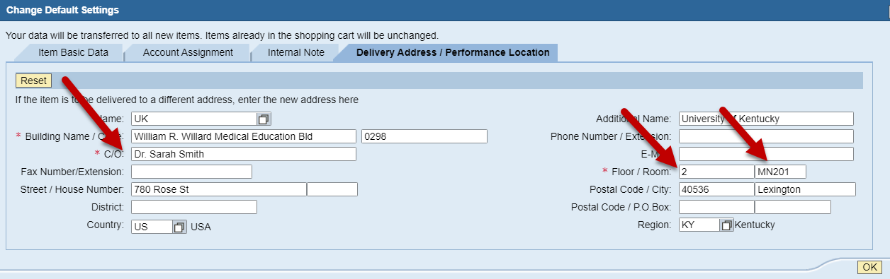
4. Select the Ariba Catalog from the Add Item menu | 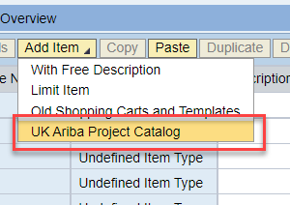
5. From the Ariba catalog home page, Search on the term “laboratory supplies VWR” (including quotes) to display the punchout catalog option. | 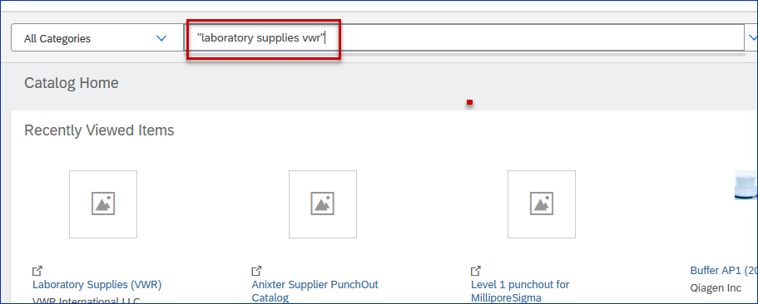
6.  Click on Buy from Supplier | 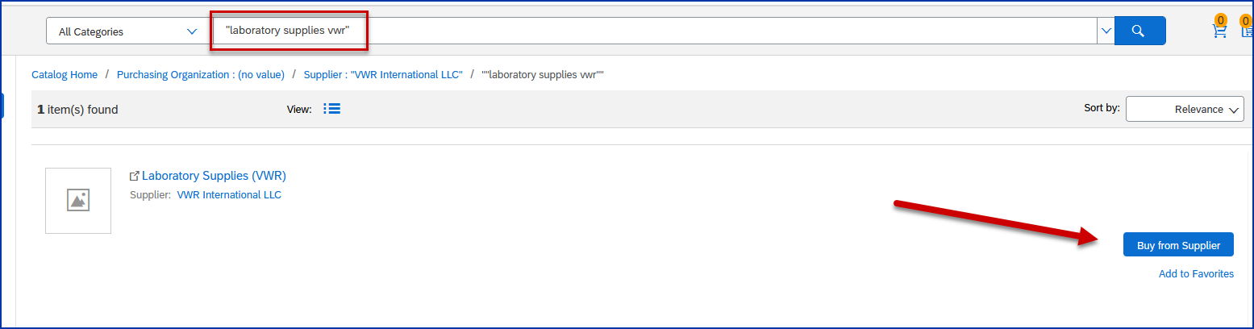
7. You will be taken to the VWR punchout catalog. | 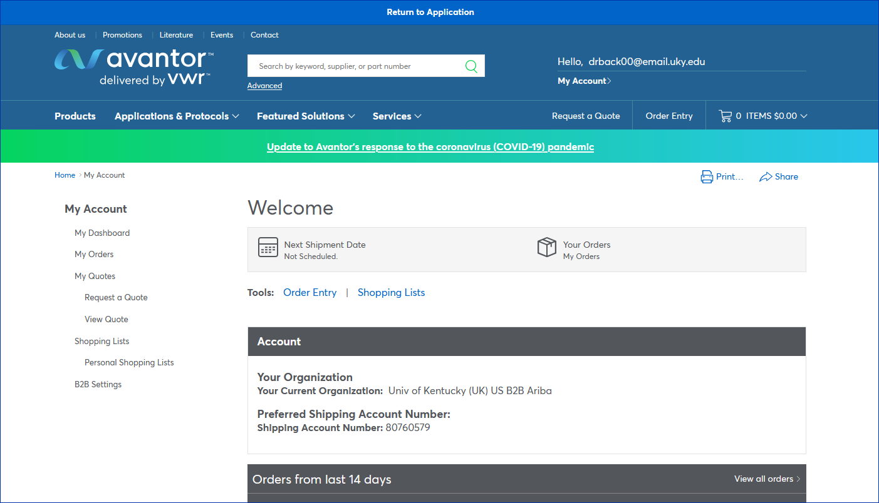
8. Under My Account on the left side, click on View Quote | 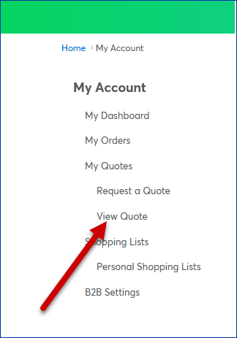
9. This will bring you to the Quote Center. You can search for your quote by entering the number in the search field or look for your quote in the list of available quotes. | 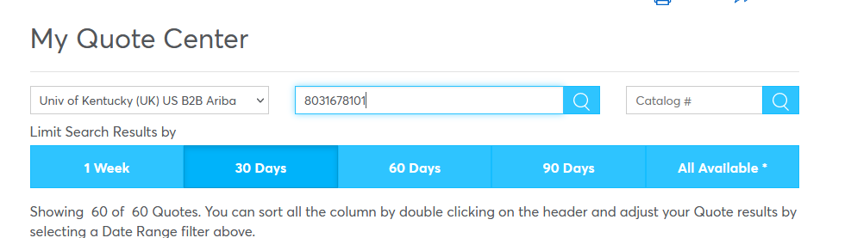  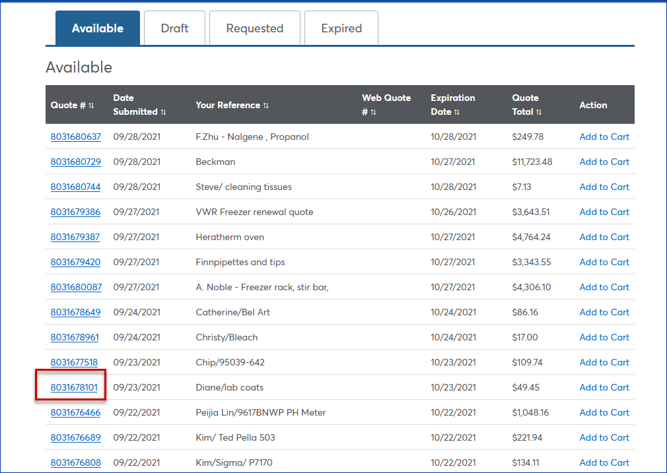
10. Click on the quote to bring up the quote details. Edit if desired and click Add to Cart. | 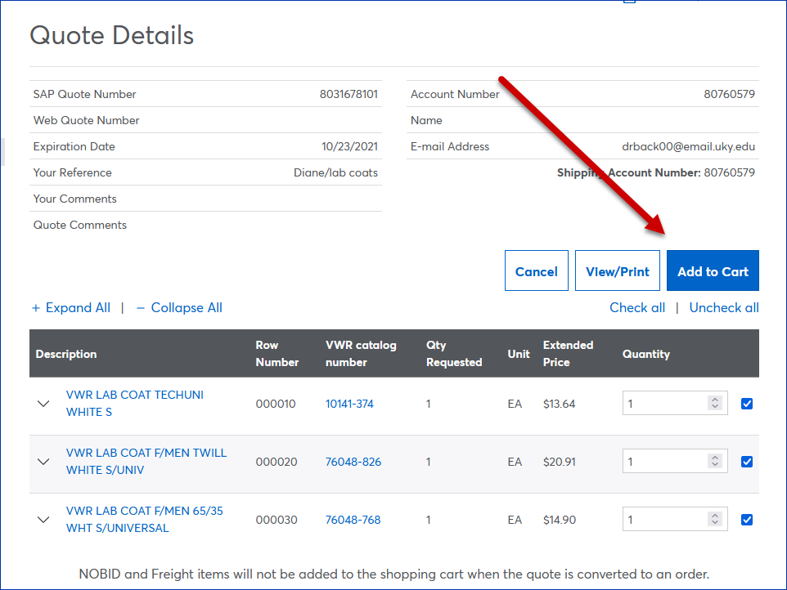
11. Click Checkout | 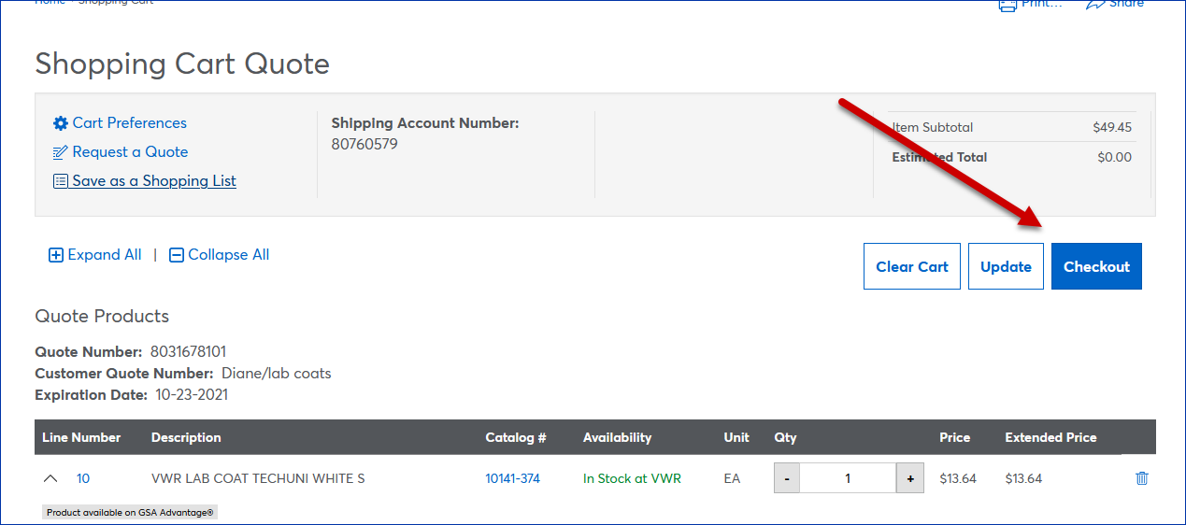
12. Your items will be brought into the Ariba cart for you to review. | 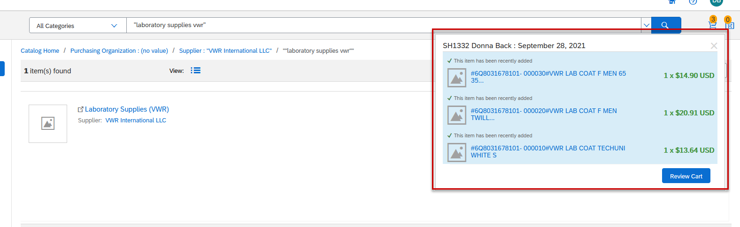
13 You will have the option to edit your Ariba cart, continue shopping or check out. | 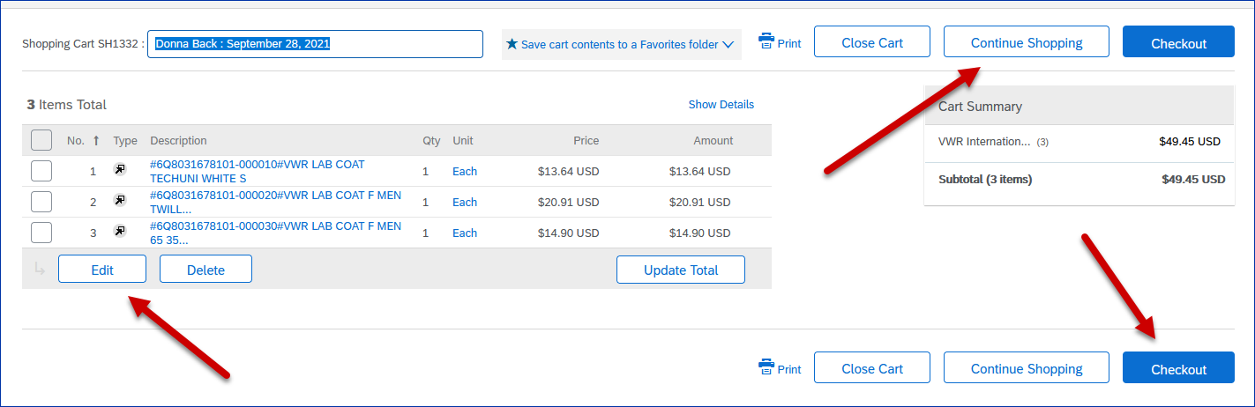
14. By clicking Checkout you will be returned to SRM where you will finalize your order. | 