A number of suppliers on the SAP Ariba Network offer Quote-To-Shopping-Cart capability as part of their e-catalog functionality. Departmental Shoppers can request a supplier (via the University-established Customer Service Representative) to write one or more customized quotes and place onto their respective e-catalog. The Shopper can navigate to the supplier’s e-catalog through SAP Ariba and utilize their quote-to-cart tool to transfer all line items to their Shopping Cart for easy and convenient ordering. Customized quotes are frequently used for orders that may qualify for special pricing, have many line items, or have other content of a customized nature.

Role: Shopper | Frequency: As Needed

Load Quote-To-Shopping Cart for Sigma-Aldrich
1. Begin from your Shopper tab | 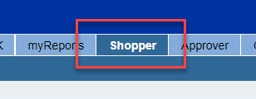
2. From the left Detailed Navigation menu, Click Shopping Cart.  Click Create Shopping Cart | 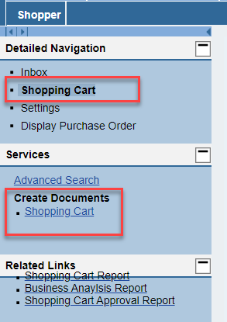
3. Select and Set Default Values as normal. This includes entering your cost object (cost center or WBS Element-Grant) and completing the c/o Delivery Person, room, and floor on the Delivery Address tab.  Remember, your Default Delivery Building should previously have been set in your Shopper Settings from your dashboard. That default building information and address will flow in automatically. | 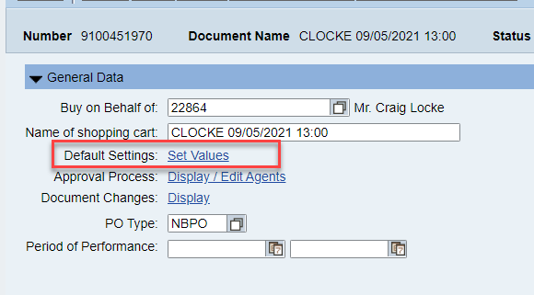  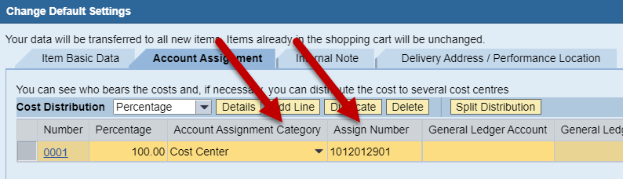  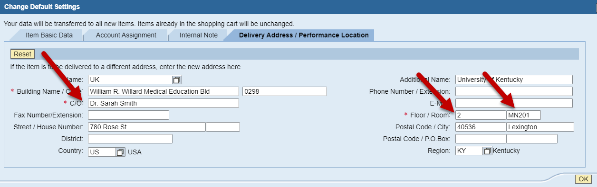
4. Select the Ariba Catalog from the Add Item menu | 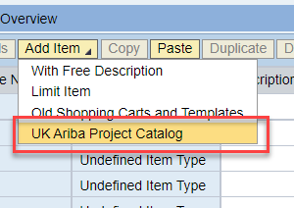
5. From the Ariba landing page, click View All Suppliers from the Supplier menu | 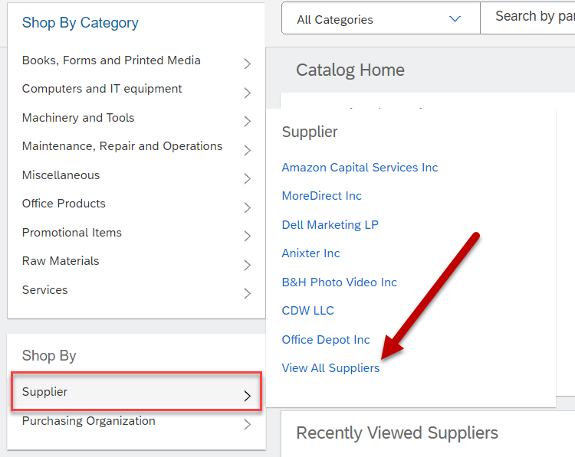
6. You will be presented with a list of vendors available in the Ariba system. Click on the Sigma Aldrich Inc link. | 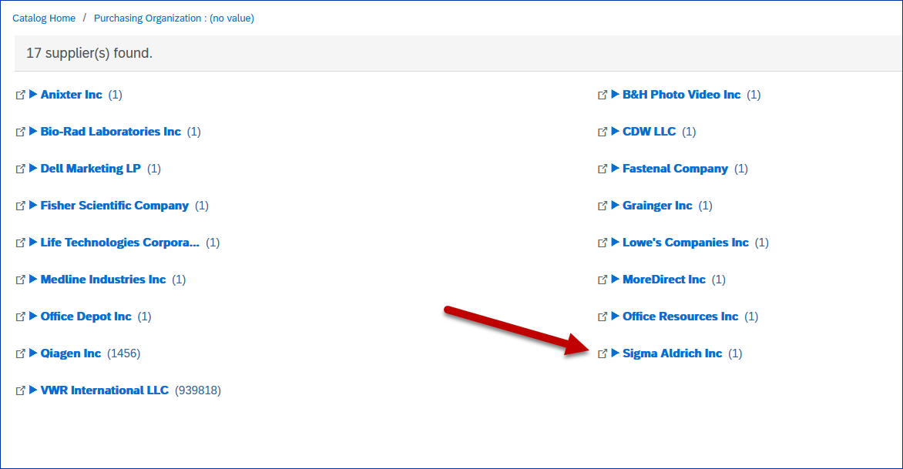
7. Click the Buy from Supplier button. | 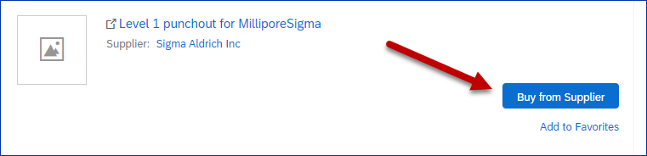
8. The landing page for the Sigma-Aldrich punchout is a Quick Order page. From this page there are two paths you can use to retrieve a quote. The first is to click on Account and then orders. | 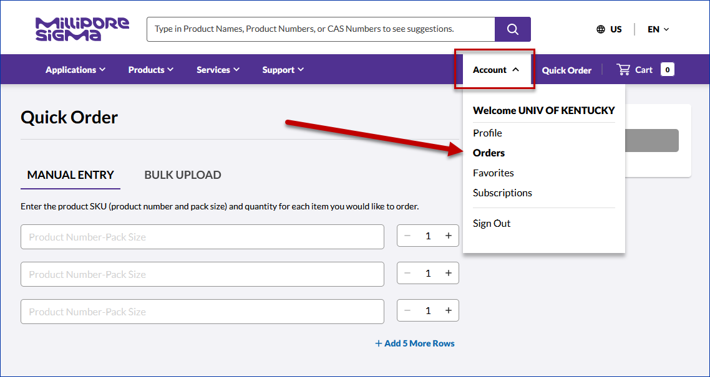
9.You can also reach the quotes search page by clicking on the Millipore Sigma logo in the upper left corner. | 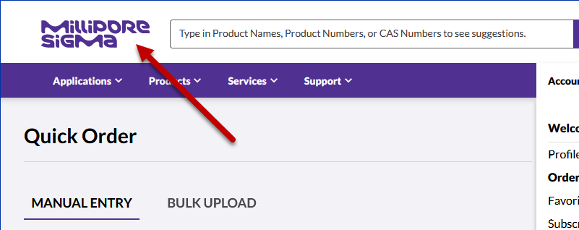
10. Click on the Quotes icon | 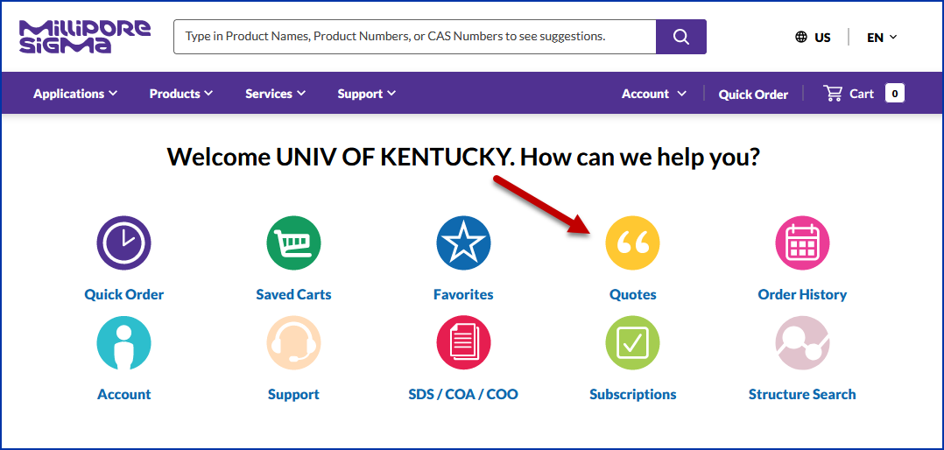
11. Click on Quote Search | 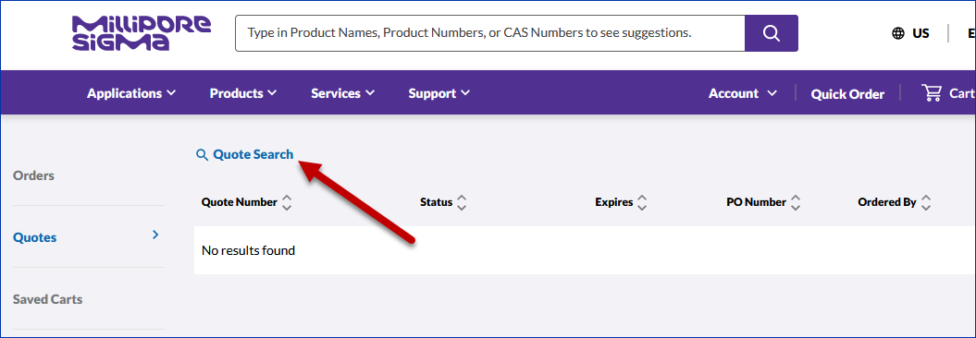
12. Enter your quote number in the quote number field and then click the eyeglass icon to retrieve the quote.  If found, the quote will appear below. | 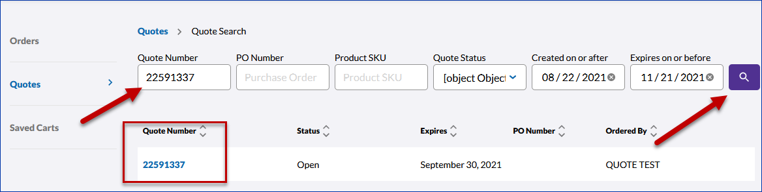
13. Click the quote to open it. | 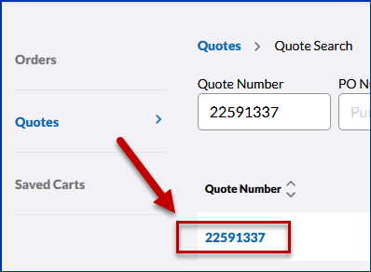
14. Your quote will be displayed. | 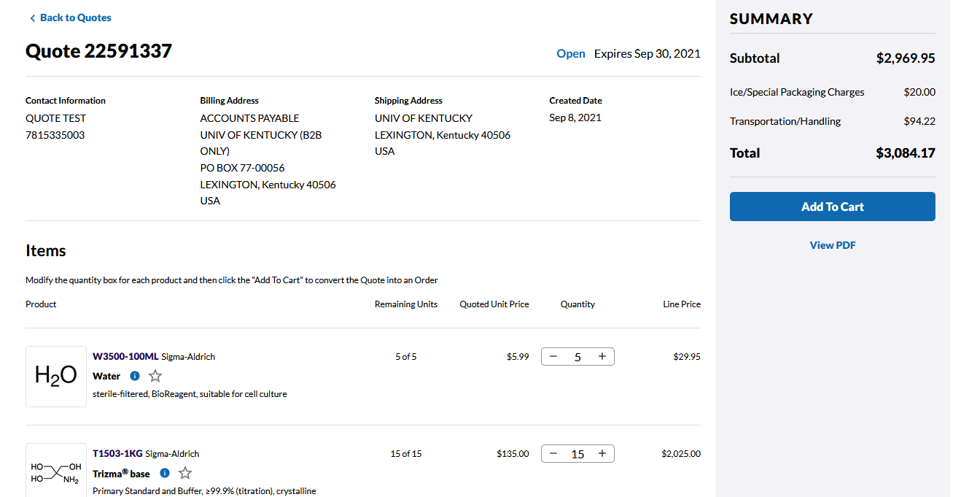
15. Review and when ready, click Add to Cart to move the item(s) into your cart for checkout. | 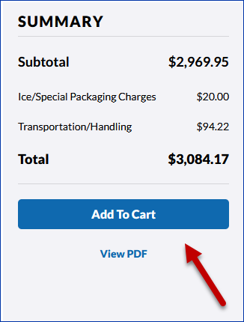
16. Click Agree | 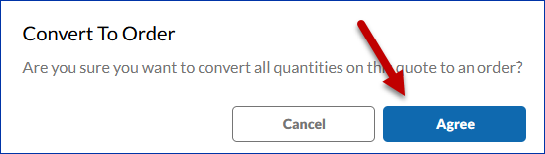
17. Review the items and when ready, click the Transfer Cart button. | 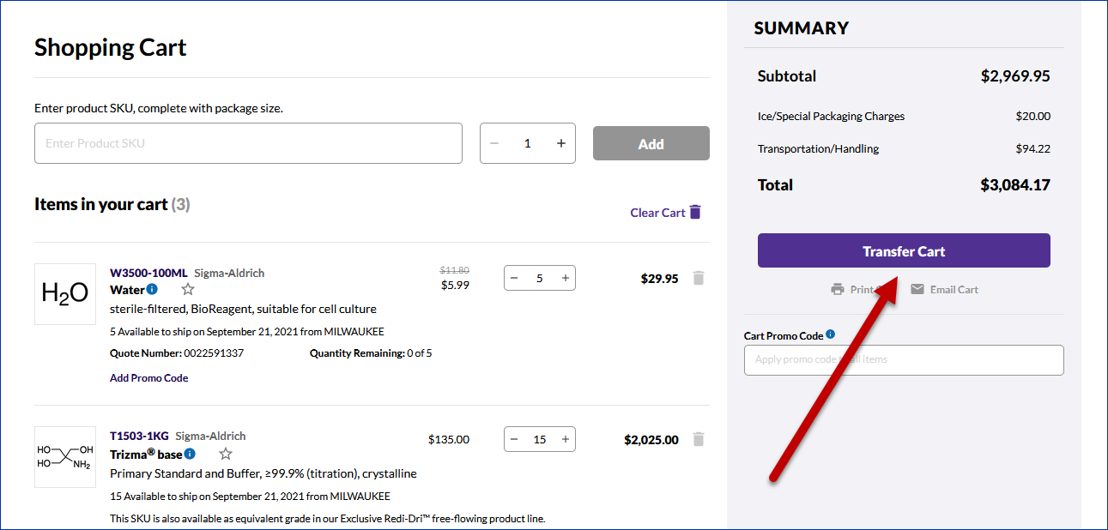
18. Your items will be brought into the Ariba cart for you to review. | 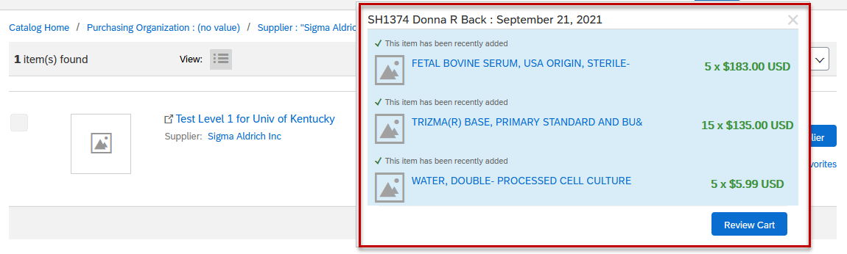
19. You will have the option to edit your cart, continue shopping or check out. | 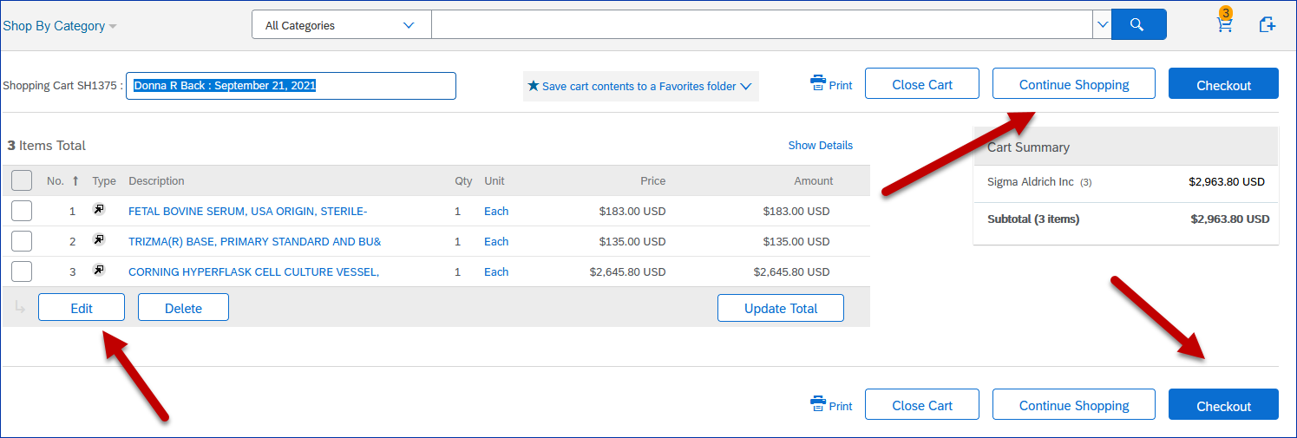
20. By clicking checkout you will be returned to SRM where you will finalize your order. | 