A number of suppliers on the SAP Ariba Network offer Quote-To-Shopping-Cart capability as part of their e-catalog functionality. Departmental Shoppers can request a supplier (via the University-established Customer Service Representative) to write one or more customized quotes and place onto their respective e-catalog. The Shopper can navigate to the supplier’s e-catalog through SAP Ariba and utilize their quote-to-cart tool to transfer all line items to their Shopping Cart for easy and convenient ordering. Customized quotes are frequently used for orders that may qualify for special pricing, have many line items, or have other content of a customized nature.

Role: Shopper | Frequency: As Needed

Load Quote-To-Shopping Cart for Life Tech
1. Begin from your Shopper tab | 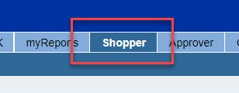
2. From the left Detailed Navigation menu, Click Shopping Cart.  Click Create Shopping Cart | 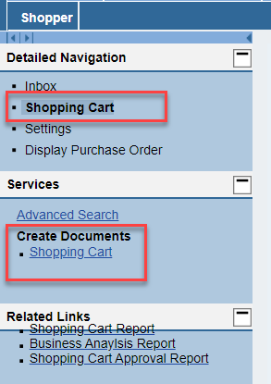
3. Select and Set Default Values as normal. This includes entering your cost object (cost center or WBS Element-Grant) and completing the c/o Delivery Person, room, and floor on the Delivery Address tab.  Remember, your Default Delivery Building should previously have been set in your Shopper Settings from your dashboard. That default building information and address will flow in automatically. | 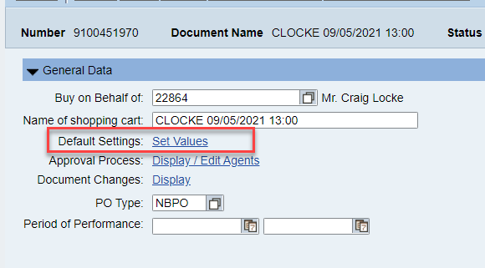  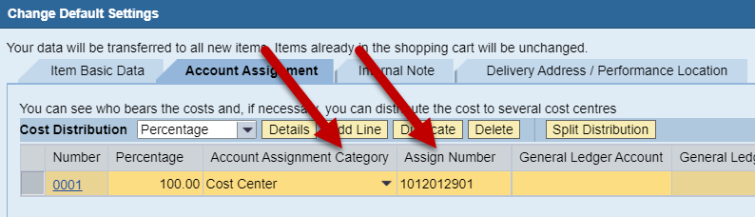  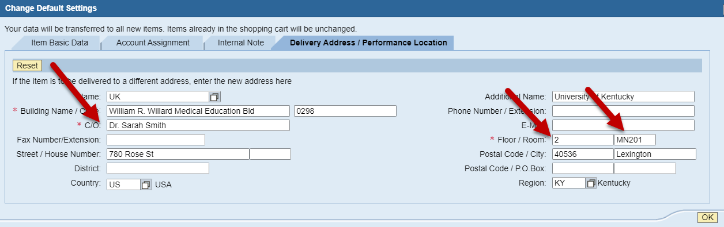
4. Select the Ariba Catalog from the Add Item menu | 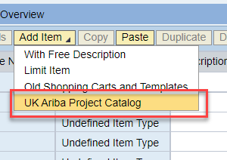
5. From the Ariba landing page, click View All Suppliers from the Supplier menu | 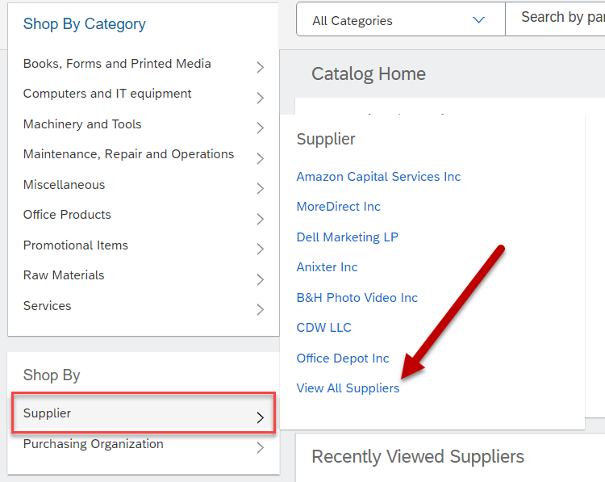
6. You will be presented with a list of vendors available in the Ariba system. Click the link for Life Technologies Corporation. | 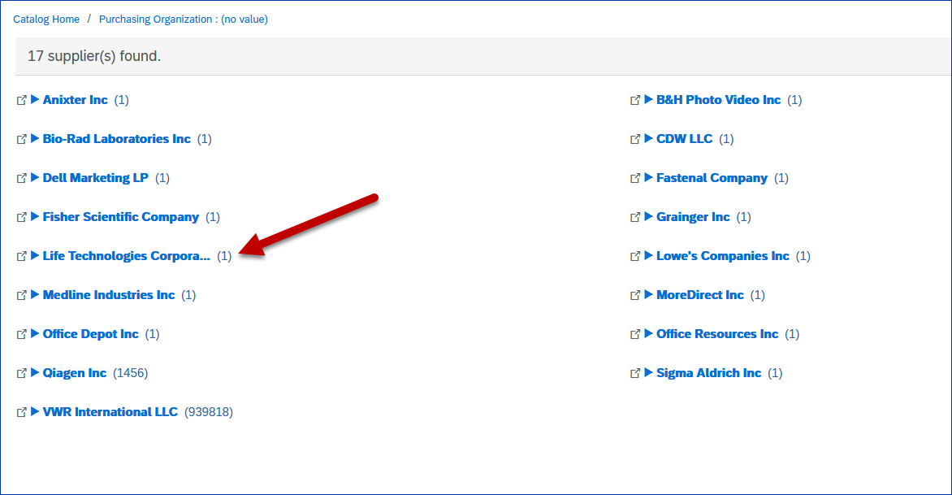
7. Click the Buy from Supplier button. | 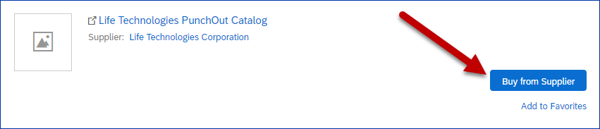
8. Use information on the quote to add items to your cart. | 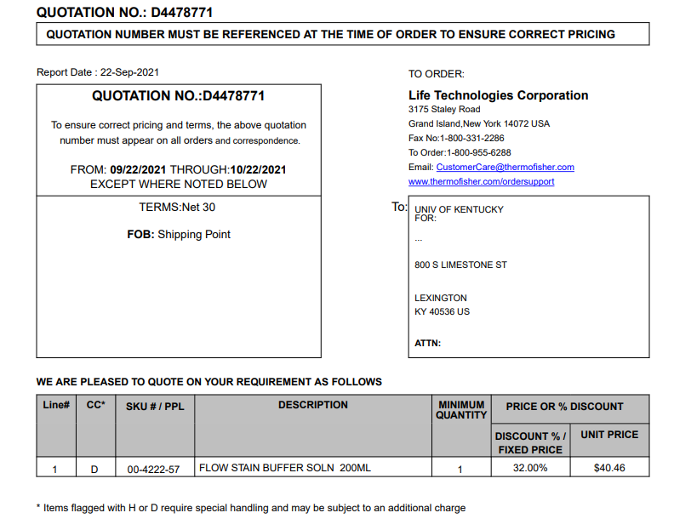
9. Search for the quoted items. | 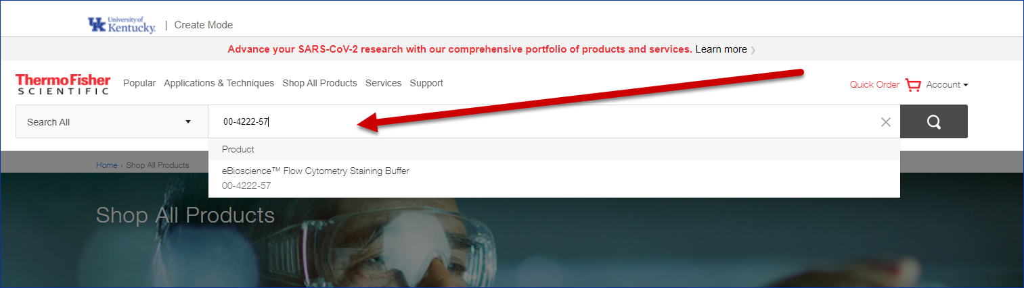
10. Add item(s) to your cart. | 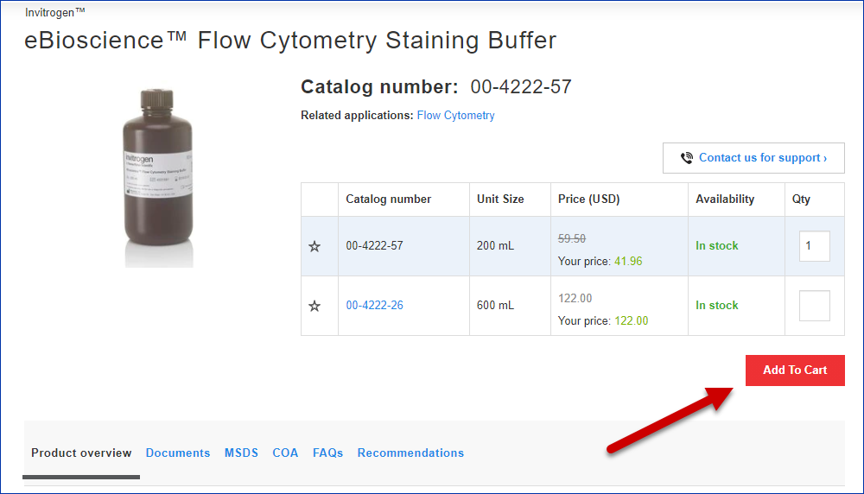
12. View Cart and Checkout | 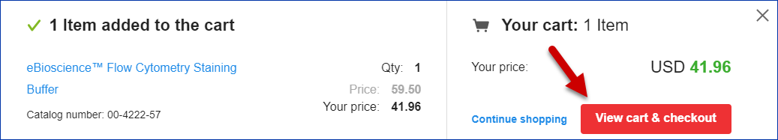
13. Enter the quote or promotion number in the appropriate field and click Apply. The discount will be applied and displayed. Note: quote numbers are single use. | 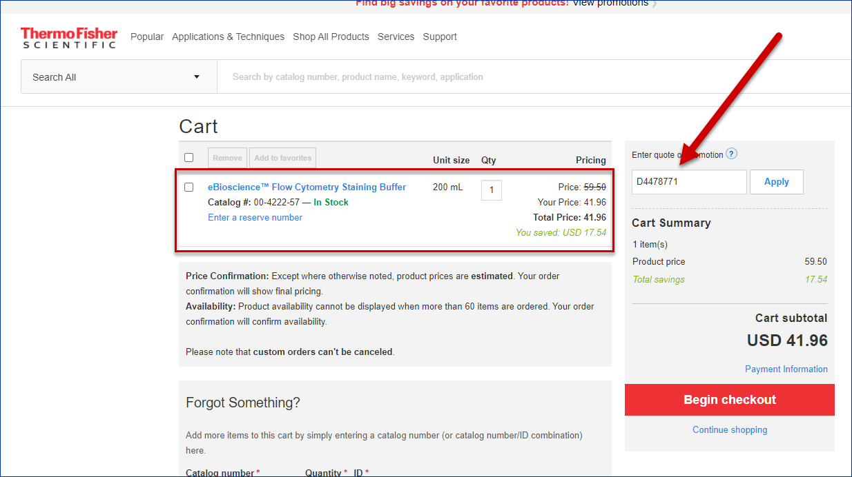
14. Click the Begin Checkout button. | 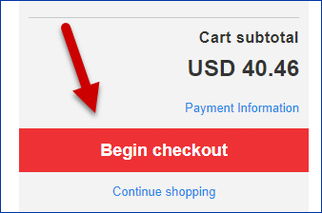
15. Click Return Cart for Checkout. | 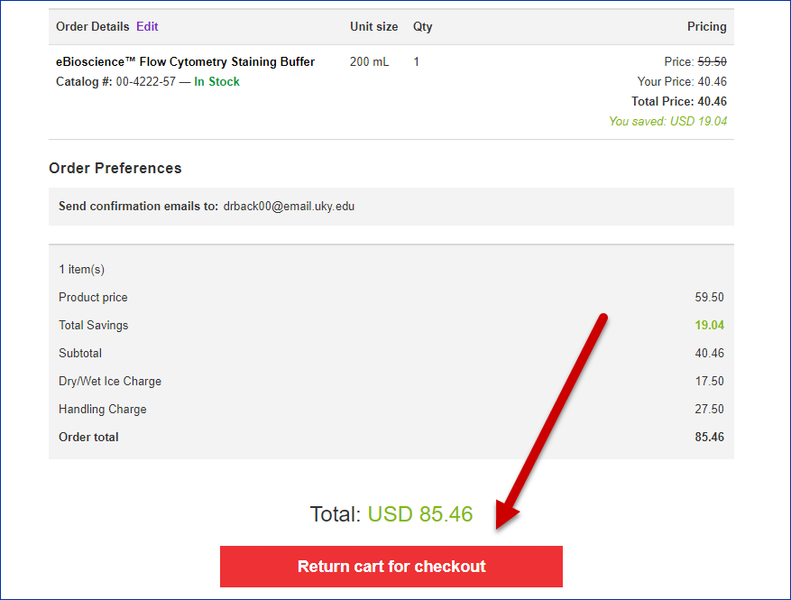
16. Your items will be brought into the Ariba cart for you to review. | 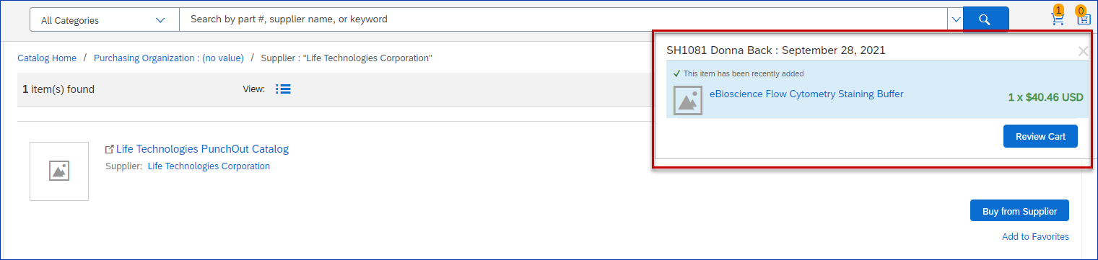
17. You will have the option to edit your Ariba cart, continue shopping or check out. | 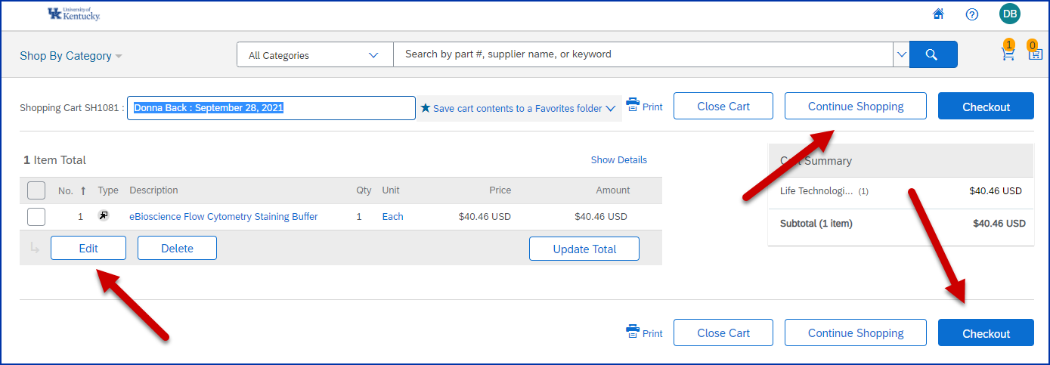
18. By clicking Checkout you will be returned to SRM where you will finalize your order. | 