Overview

The Purchasing Division manages the University’s vendor master data. With the exception of procurement card purchases, a vendor must be established within the University’s vendor database for all companies, individuals, and other entities from whom the University procures goods and services. This includes any vendor entity that will be used on an SRM Shopping Cart, SAP/ECC Requisition, Payment Request Document (PRD), subcontract, or employee reimbursement for out-of-pocket expenses.

The University utilizes PaymentWorks, a cloud-based solution, for onboarding vendors. The application is integrated with the myUK environment allowing departmental users to access it using Single Sign-On (SSO) functionality via the Enterprise Services tab. PaymentWorks supports the entire application platform, including vendors requiring registration support. With this automated onboarding functionality, the University no longer processes paper vendor applications. PaymentWorks is utilized to onboard all vendors including US-based companies and individuals, foreign companies and individuals, UK student organizations, UK imprest (petty cash) custodians, etc. In some cases, registering entities can also submit their banking information indicating their preferred payment method.

University employees seeking an 8XXXXX number will not complete an application within PaymentWorks. A customized Employee PERNER Form is available from the Purchasing website for employees to complete and submit to receive an 8XXXXX vendor number for a reimbursement.

Important: A departmental end-user cannot complete an application through PaymentWorks on behalf of a vendor or individual; the registration can only be completed and submitted by the vendor.

Internal support for onboarding or other vendor questions is available as needed to departments at vendorhelp@l.uky.edu.

Vendor Basics

Prior to starting any of the above transaction types, check to see if the desired vendor currently exists within the database.

If the vendor or individual is listed within SAP, and their information is current, the employee can move forward with completing the procurement document.

If the vendor or individual is not listed within the SAP database, send them an invitation to register via PaymentWorks from within the myUK Enterprise Services tab. Please remember to perform an exhaustive search in SAP for the vendor name before sending the invitation.

Change requests for a current vendor (e. g., address change) are also conducted via PaymentWorks. A previously registered vendor can update their own address within PaymentWorks which will transition into the SAP vendor database once approved.

DBA Vendors:

At their requests, small businesses or individuals are commonly setup as a “Doing Business As” (DBA) structure. This means their business is owned and operated under a primary legal name but is presented to the public or conducted under a different trade name. Vendors operating under a DBA structure can be found within the vendor database by either a search for their legal primary name under the Name 1 field or a search for their DBA name under the Name 2 field. For instance, using T-code XK-03 (Vendor Display) to conduct a search for Stuart*Holt* in the Name 1 field will return the same vendor record as a search for “DBA*Stuart*Holt*Painting*” on the Name 2 field (both tie to vendor number 128914). If you have problems locating a vendor and believe they may have a
DBA structure, try searching on the Name2 field using their DBA name. Be sure to use asterisks with the search terms.

How to Conduct General Search for Vendors Using SAP T-code XK-03

Usage: Perform before creating any procurement document to confirm whether the desired vendor is currently listed in the database.

Users: Creators of any type of procurement document

1. Execute T-code XK03 from the SAP Easy Access menu | 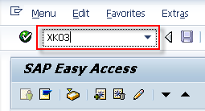
2. From the Display Vendor Initial Screen, click the possible entries icon to the right. | 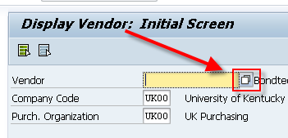
3. From the search criteria box, enter all or part of the vendor’s name into the Name field. Place an asterisk at the ends of the search term, and between search terms if more than one word.  Click the check button to start the search. | 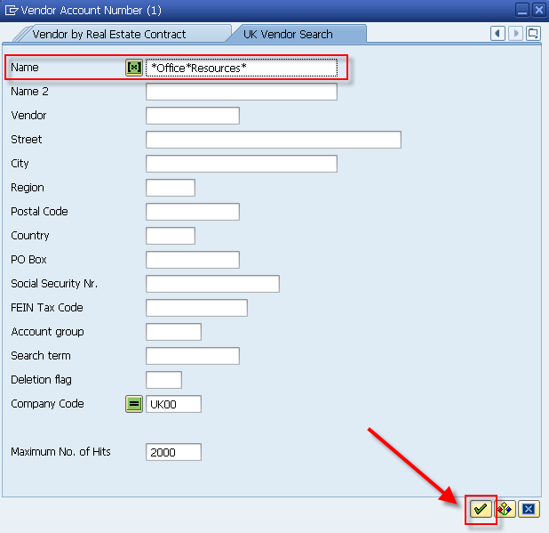
4. Review the list of search results to determine whether your vendor currently exists within the database. If not listed, send the vendor an invitation through PaymentWorks to register. | 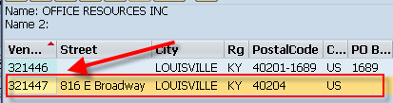
Search TIP:  Remember you can search on other data if known, for example: portions of the street address, PO box, city, ZIP code, etc. The search results will show all vendors meeting the search criteria; identify and select the correct entry. If available, the search data most unique in nature (e. g., tax ID number) will return the most accurate results. | 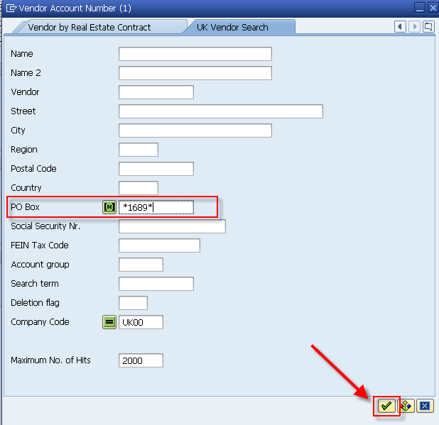  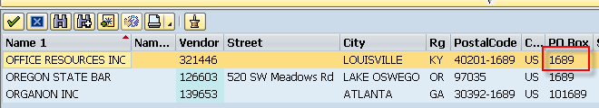

Vendor Search Tips

Departments may find the following TIPS useful when conducting vendor searches:

- If you are having problems locating a vendor, remember to use alternate search terms such as street address, city, ZIP code, etc. Manipulating wildcard (*) searches may also return better results, e.g., *123*Main* or 123*Main or *Main*.
- Vendors identified with ZPRO, ZEMP, or 0003 groups can be used on any procurement document.
- If you have a remittance address that needs added to the vendor database in addition to a vendor’s ordering address, send an invitation through PaymentWorks to the vendor as normal for them to submit and provide their remittance address information.
- Remember to use only vendor-based Transaction Codes (T-codes) when searching for vendor information in SAP. XK-03 is the correct T-code to Display Vendor information (T-codes with the XK prefix are vendor-oriented). T-codes outside the XK-prefix format (e.g., FBL1N, etc.) are not vendor-oriented and may not display full vendor record information.

Inactive Vendors

On an occasional (yearly or less frequent) basis, Enterprise Applications Group (EAG) may review the database and invalidate vendors that are inactive. When this occurs, any inactive vendors will no longer be displayed during a vendor search. “Inactive” means any vendor marked as such or has not been used on a procurement document for the previous two years and/or other criteria apply. To use an inactive vendor, send a new invitation through PaymentWorks to them to re-register.

What constitutes a vendor to be marked inactive?

- Vendor has not had activity for the previous two years
- Address is no longer valid
- Company or individual has had a name change, merger, combined acquisition, etc.
- FEIN/SSN data is incorrect
- Duplicate of another vendor record

Foreign Vendors

Foreign Businesses: Representatives for companies located outside the US should complete the PaymentWorks application via invitation as normal.

Foreign Individuals: Vendor entries for Non-Resident Alien (NRA) individuals also require a registration action within PaymentWorks. The person(s) can also provide/upload their W8-BEN form onto the platform as required.

In summary, send invitations via PaymentWorks (from the myUK/Enterprise Services tab) to both foreign companies and foreign individuals the same as would be done for US-based companies and individuals.

- How to Search for and Assign Vendor within an
Open SRM Shopping Cart
(Users: SRM Shoppers, i.e., general academic campus)

1. Complete the Header and Item Overview sections of the Shopping Cart. After completing the Account Assignment, Notes/Attachments, etc. tabs in the bottom Details section, select the Sources of Supply/Service Agents tab. Click the possible entries icon to the right of Preferred Supplier. | 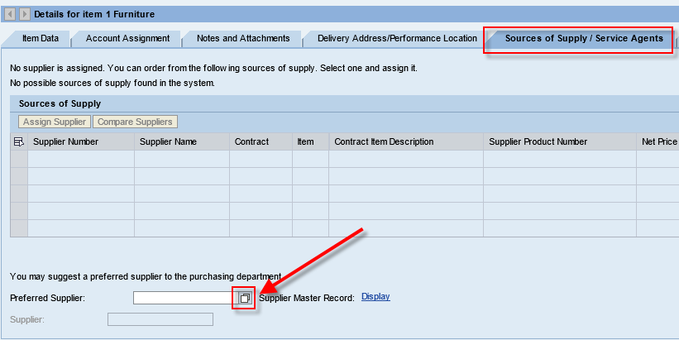
2. From the search criteria box, enter all or part of the vendor’s name into the Name 1 field. Place an asterisk at the ends of the search term, and between search terms if more than one word.  Click the Start Search button. | 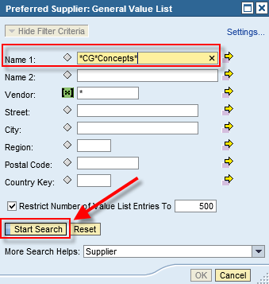
3. Locate and highlight the correct vendor to insert into Shopping Cart and click OK.  If needed, click column headings to sort in ascending or descending order. | 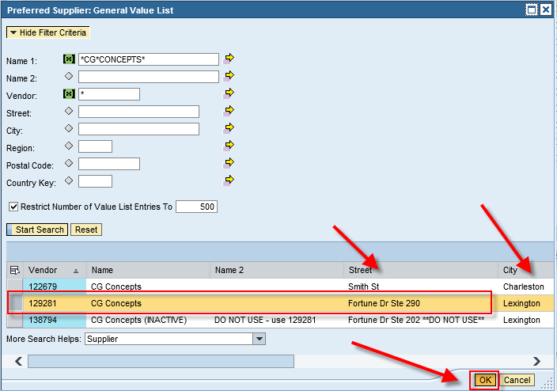
Search TIP:  Remember you can search on other data if known, for example: portions of the street address, PO box, city, ZIP code, etc. The search results will show all vendors meeting the search criteria; identify and select the correct entry. | 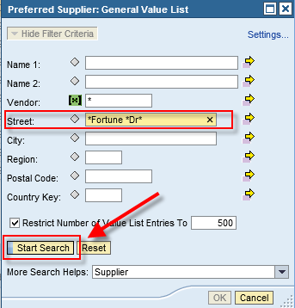  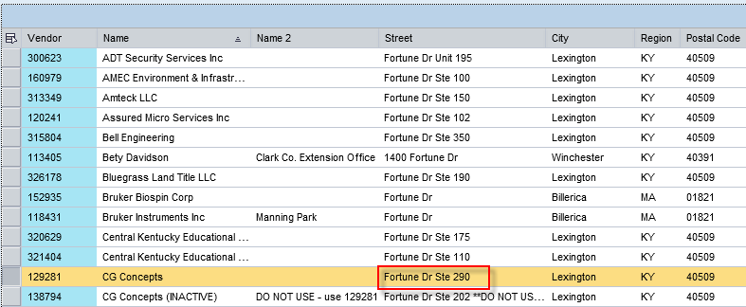

- How to Search for and Assign Vendor within an
Open SAP/ECC Requisition
(Users: ECC Requisitioners (i.e., hospital, Plant Maintenance areas)

1. After entering the line item number and Account Assignment Category, tab to the Desired Vendor field. Click the possible entries icon to the right to start a search. | 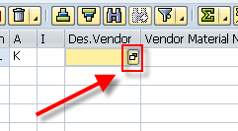
2. From the search criteria box, enter all or part of the vendor’s name into the Name field. Place an asterisk at the ends of the search term, and between search terms if more than one word.  Click the check button to conduct the search. | 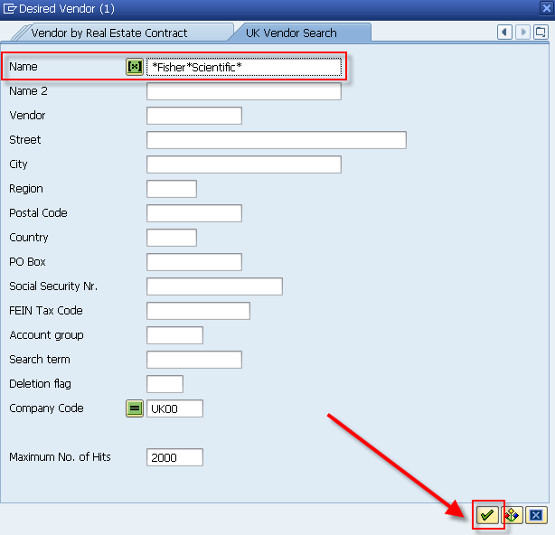
3. Locate and double click on the correct vendor to insert into the requisition.  If needed, click the column headings to sort in ascending or descending order. | 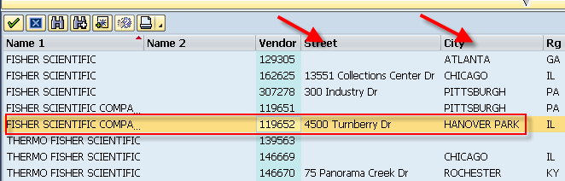
Search TIP:  Remember you can search on other data if known, for example: portions of the street address, PO Box city, ZIP code, etc. The search results will show all vendors meeting the search criteria; identify and select the correct entry. | 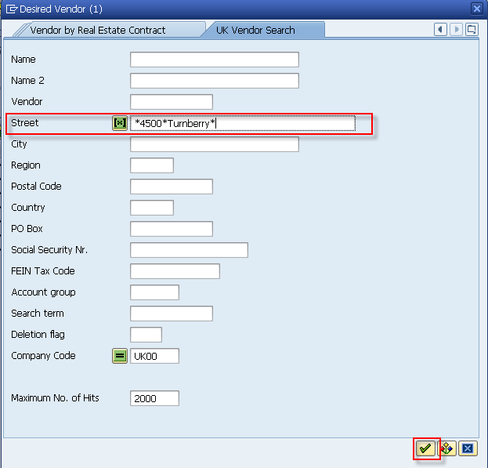  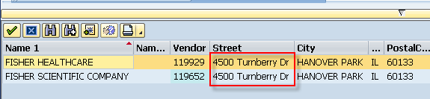

- How to Search for and Assign Vendor within Open
Payment Request Document (PRD)
(Users: PRD Creators, i.e., all departments, divisions, and areas)

1. From the Overview tab, click on the possible entries icon to the right of Payment To: box | 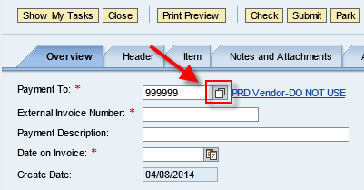
2. From the search criteria box, enter all or part of the vendor’s name into the Name 1 field. Place an asterisk at the ends of the search term, and between search terms if more than one word.  Click the Start Search button. | 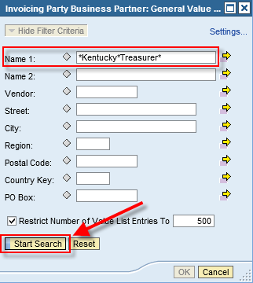
3. Locate the correct vendor to insert into the PRD and click OK.  If needed, click the column heading to sort in ascending or descending order. | 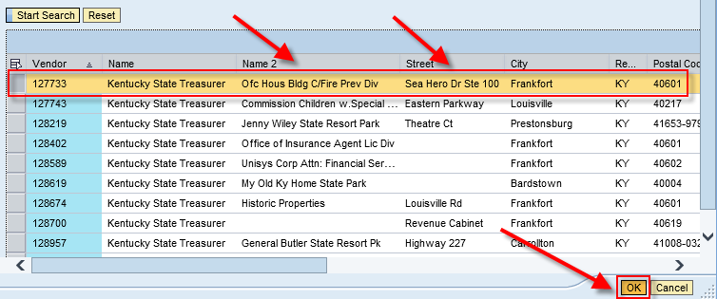
Search TIP:  Remember you can search on other data if known, for example: portions of the street address, PO box, city, ZIP code, etc. The search results will show all vendors meeting the search criteria; identify and select the correct entry. | 