Substitute Shoppers are persons allowed to set-up, view, and respond on behalf of another Shopper.

Role: Staff | Frequency: As Needed

Designate Substitute Shoppers
1.From the dashboard click Settings. | 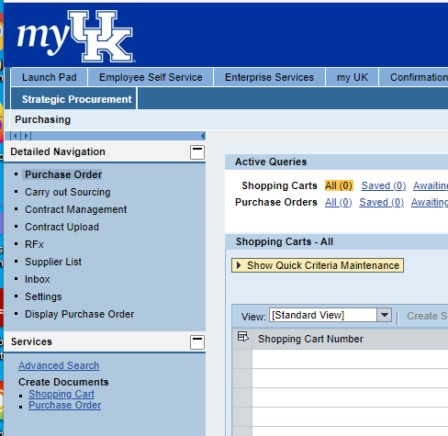
2. Select the User Account tab.  3. Click the Possible Entries icon to locate and add a Substitute Shopper. | 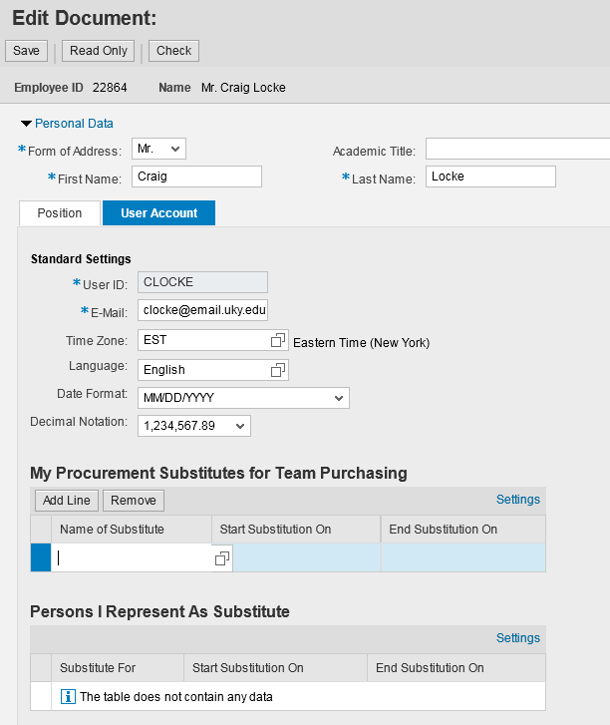
4. To conduct a search, enter last and first name of Substitute Shopper  5. Click Search | 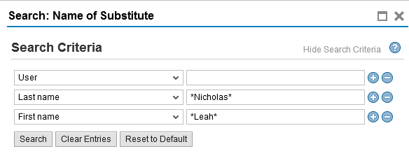
6. Highlight correct selection from search results. | 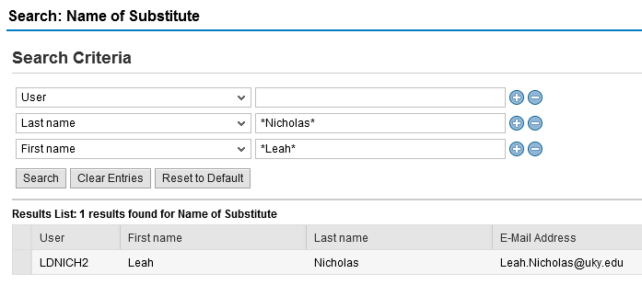
Designating your Substitute Shoppers within Personal Settings sets permissions for you to participate in “Team Shopping”.

With Team Shopping, two or more shoppers can have access to each other’s carts. A Substitute Shopper can view, edit, or delete a Shopping Cart created by a team member.

For more information a Quick Reference Card entitled “Substitute Shoppers and Manage Team Carts” is available from the Purchasing SRM website at: http://www.uky.edu/Purchasing/.

