Account Assignment for any line item can be distributed across multiple Cost Centers and/or WBS Elements

Role: Staff | Frequency: As Needed

Assigning Cost to Multiple Accounts
1. From the Account Assignment tab, select whether the split will be by percentage or quantity. | 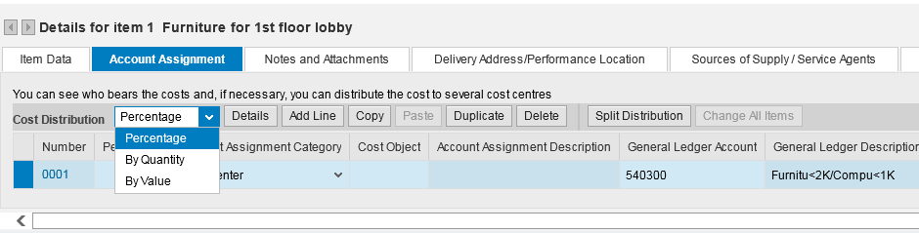
2. Click Add Line to create a new line for each account that will be used. | 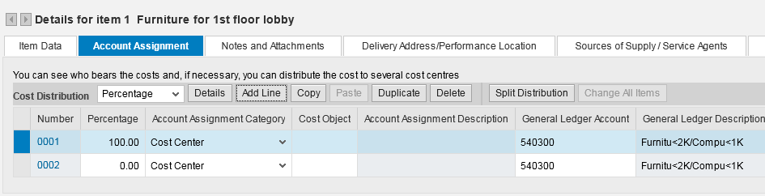
3. Enter the percentage or quantity to be assigned to each cost object.  4. Select the Account Assignment Categories for each.  5. Enter the cost object and applicable GL numbers. | 