Some types of Free Text orders perform better in “reverse” format. Reverse orders are entered as one line item with a lump sum dollar amount for the entire order, regardless whether the quote has multiple lines. Reverse format is usually used for complex orders such as furniture, printing, etc. it may also be used for orders that span a length of time and require monthly payments, e.g., Personal Service Contracts or equipment rental.

Role: Staff | Frequency: As Needed

Working with “Reverse” Shopping Carts
Reverse Shopping Carts are entered as one line for the entire order.  1.Enter the total dollar amount in the Quantity field.  2.Enter LOT as the unit of measure.  3. Enter 1.00 in the Net Price/Limit field. | 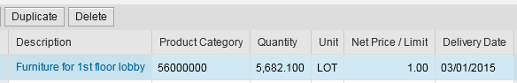
Examples of “Reverse” Shopping Carts
Larger complex orders with multiple lines of components or extended descriptions. | 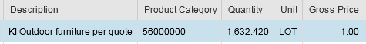
Personal Service or other lump sum contracts that may be partially confirmed over a period of time. | 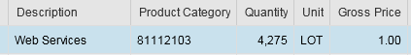
Employee reimbursements completed in lump sum amounts. | 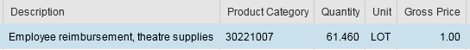
Contact the responsible buyer in Purchasing if you are unsure whether a specific Shopping Cart you plan to enter may work best in reverse format.

