An Approver may reject a Shopping Cart for various reasons.

Role: Staff | Frequency: As Needed

Viewing Details of a Rejected Shopping Cart
Notification of the rejected cart appears in the Shopper’s inbox for disposition. | 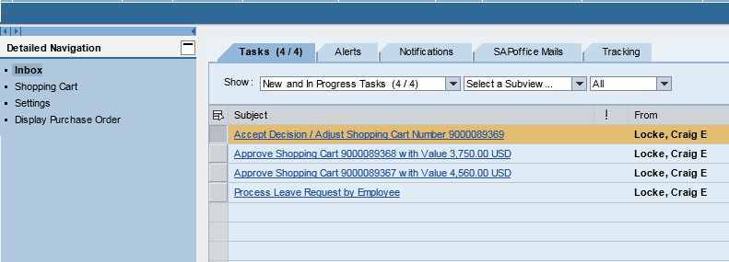
Click on the notification for more information.
Notes from the Approver, if applicable, will display in a pop-up box. | 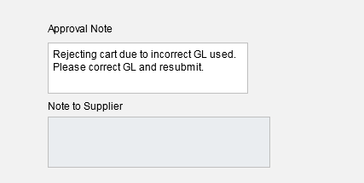
Steps to Resolve a Rejected Cart
The Shopper must choose one of three options to manage a rejected cart.  1. Edit  2. Accept  3. Delete | 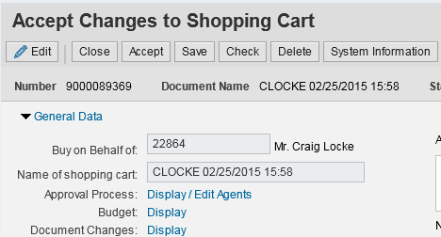
If Edit is selected, make needed changes and click Proceed to send notification to the Approver’s inbox. | 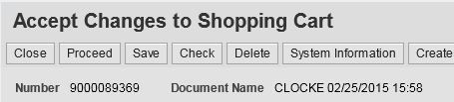
Click Accept to accept the rejection. The Shopping Cart will be available to copy to another cart in the future.
Click Delete to remove the Shopping Cart from workflow and terminate.

