Quick criteria maintenance allows a shopper to specify criteria for search results of their documents. For example, it can be used to bring up a specific shopping cart, or it can filter to bring up only carts awaiting approval.

Role: Staff | Frequency: As Needed

MODIFYING QUICK CRITERIA
1. From your dashboard, highlight the query to be searched.  Shopping Carts (All) is the query most commonly used. | 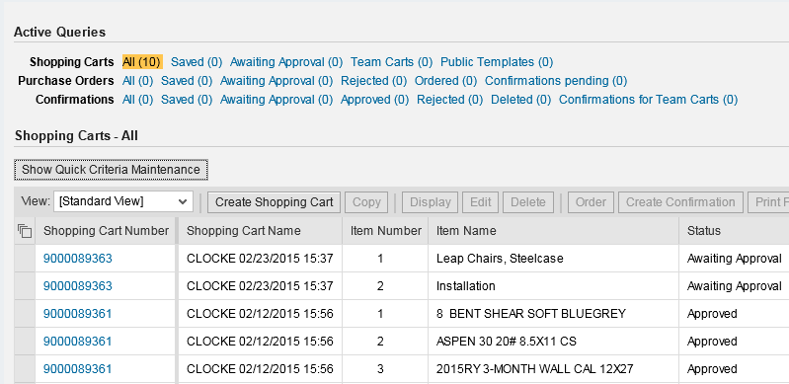
2. After the query loads, click Show Quick Criteria Maintenance.

A Shopper can enter one or more criteria to search for specific document(s).  For example:  Click Including Completed Shopping Carts to return an entire listing of all carts you have created. Not checking this selection will return only your carts that are in process.  Only check Show my Team Carts if you serve in a substitute relationship with other Shopper(s). | 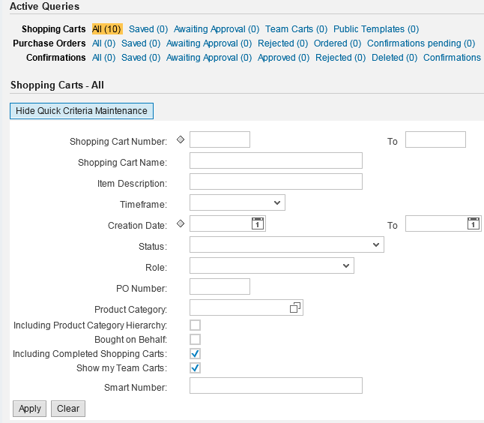
3. Click Apply after entering search criteria. | 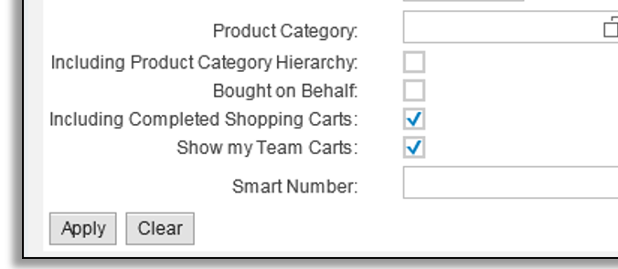
QUICK CRITERIA EXAMPLES
Search Example 1  Enter specific cart by number  and click Apply.  The shopping cart displays in the lower section. Click into the Cart Number to display details. | 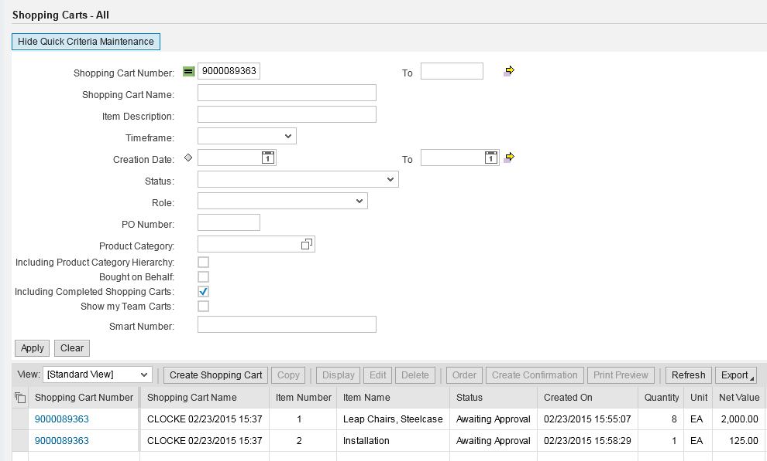
Search Example 2  Enter Awaiting Approval from the Status field drop down menu.  Click Apply.  Only Shopping Cart(s) awaiting approval will display in lower section.  Tip: If a query returns erroneous results, open Quick Criteria Maintenance and confirm whether invalid criteria may be entered. | 