Process: Perform this procedure to edit a shopping cart up to the point of approval. Carts cannot be edited after they are approved. Shoppers or Approvers can change, add, or delete line items; change cost assignment information or add attachments etc.

Role: Shopper or Approver | Frequency: As Needed

BEGIN SHOPPING CART EDIT
1. Select the Shopping Carts (All) query from the dashboard.  2. Click Refresh to see an updated view of your Shopping Carts and their status. | 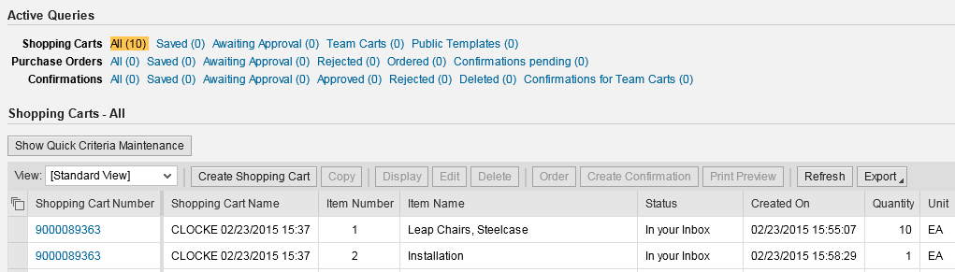
3. Select a Shopping Cart to be edited.
Depending on the status of the Shopping Cart, you will be able to either edit the cart immediately or be asked to view your tasks.  4a. If you receive an Edit button, click to begin editing the cart, or | 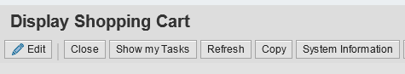
4b. Click the Show My Tasks button if you receive it instead. | 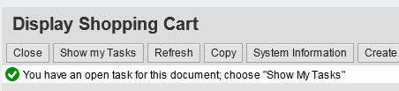
5. Select Revise Shopping Cart.  6. Click Process Now. | 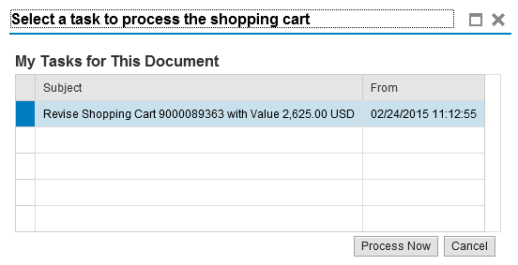
7. Make changes as needed.  Most components of a Shopping Cart can be edited. This includes notes, quantity changes, addition or deletion of items, descriptions, etc. | 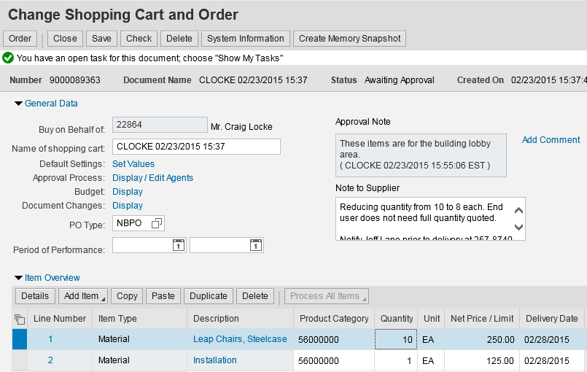
A Shopper can also change items in the bottom details section if needed, including Account Assignment information, Notes, Delivery Address, and Source of Supply.  8. Make additional changes as needed to specific sections. | 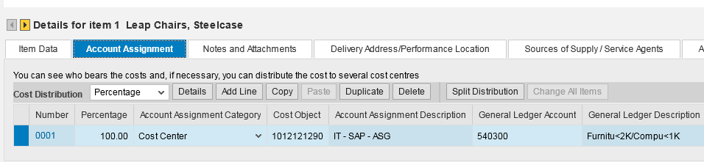
COMPLETE SHOPPING CART EDIT AND RE-ORDER
9. Click Check to check for errors.  10. Click Order to complete. | 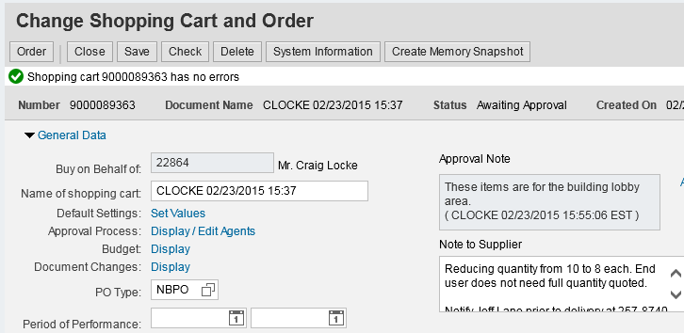
Shopper receives confirmation that edited cart re-ordered successfully. | 