The Approval Process Overview tab contains the approval status of a shopping cart.

Role: Staff | Frequency: As Needed

Viewing Approval Status
1. Click on the Approval Process Overview tab. | 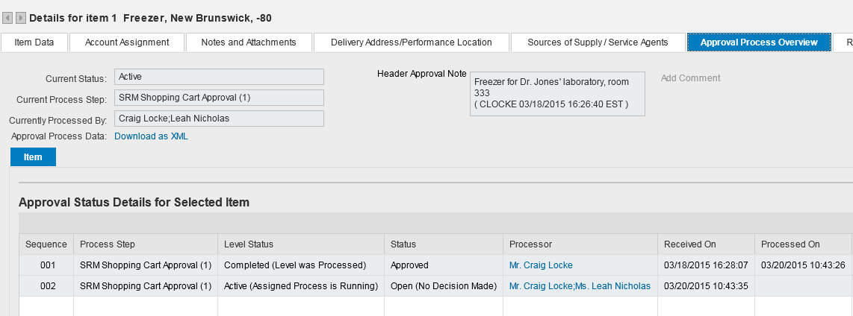
Approver information can be viewed on the bottom Details Section.

Information reflects full history including Approver(s) and dates/times of approval(s).

Note: If cart has not been approved, the tab will reflect the Approver’s mailboxes in which it resides.

