Process: Substitute Shoppers are persons allowed to access carts of other Shoppers. Only Shoppers may designate, within their Personal Settings, their own Substitute persons. Substitutes must have the Shopper role before they can be designated. In addition to viewing another Shopper’s carts, a Substitute can “Take Over” a Saved cart, if needed, and move it forward.

Carts created within a Substitute Shopper structure are termed “Team Carts”.
Role: Shopper | Frequency: As needed

BEGINNING STEPS
I. Establish Substitute Shopper within Personal Settings
Select Settings from within the Shopper tab | 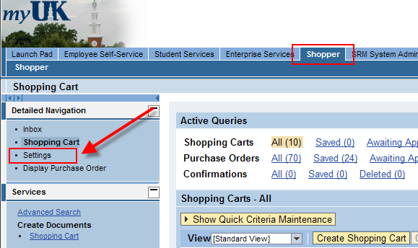
Click Edit and click User Account tab | 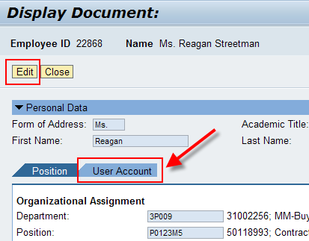
Within the My Procurement Substitutes section, click Possible Entries icon on the right side | 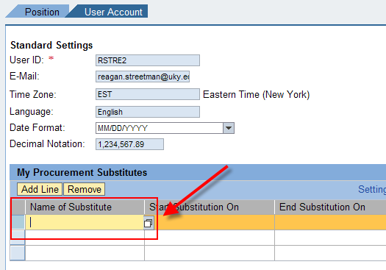
Enter the Substitute’s last and first name and click Start Search | 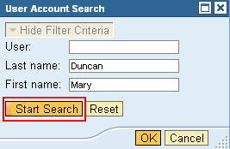
Highlight the person’s name from within the search results and click OK | 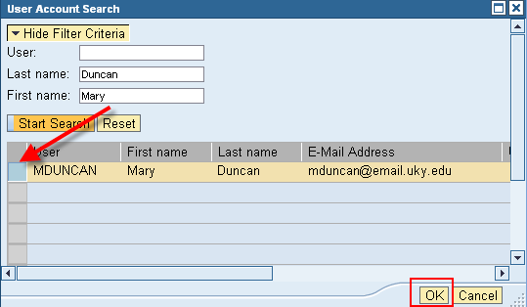
Enter the Start and End dates for the Substitute  For indefinite assignment enter 12/31/9999 for the end date | 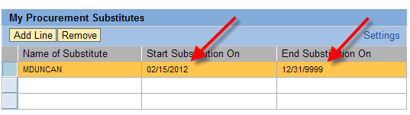
Note: To function correctly, each Substitute Shopper must reciprocally establish the other person as a  Substitute also.  In short, your Substitute should also have you listed as their Substitute. If configured correctly their name will appear in the “Persons I Represent as Substitute” section. | 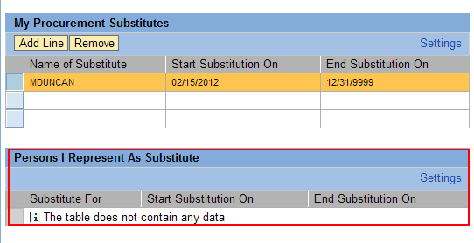
Click Save to finish Substitute Shopper settings | 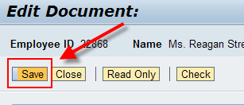
II. Identify Team Carts
Shopping Carts created under a Substitute Shopper structure are termed “Team Carts”.  Once you identify Substitutes in your personal settings, your Shopping Carts will reflect an option relating to this.  Check the box on any Shopping Cart you want to be available to your Substitute Shoppers | 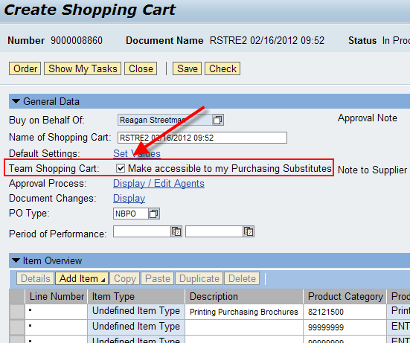
Substitute Shoppers can view all Shopping Carts created by team member(s) within a group context.  To move a Saved cart forward from another Shopper, locate the cart within the Team Carts query. Highlight and click Take Over button.  Note: A Substitute Shopper can only Take Over a cart that is in Saved status. | 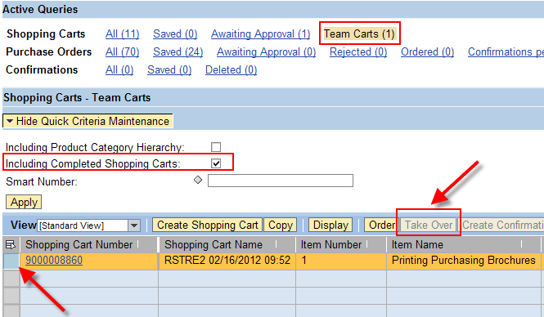
A Shopper can also see which carts they personally created that were setup with a team structure. From within the Shopper’s personal Carts query, set Show My Team Carts and click Apply. | 