Process: Depending on the commodity and nature of the order, some Shopping Carts (and their resulting Purchase Orders) are setup in a “reverse” format. Reverse orders are essentially “lump-sum” or “blanket” orders and are written with one-line for the total dollar amount of the order. They are usually used for orders which are more complex in nature, have a quote with extensive items or product numbers, or in which multiple payments are to be made over a period of time. Examples of commodities for which reverse orders are commonly used are printing, furniture, computing items, copier rentals, and personal service contracts.

Authority for determining whether a particular purchase might best be done with a reverse order format lies with the respective Purchasing Buyer. If needed check the Purchasing buyer for the commodity for guidance.

Reverse orders are formatted with the total dollar amount of the order entered in the Quantity box of line 1. The cost each should be entered as $1.00 and the unit of measure should be LOT. Goods confirmations and invoices, as they are due, are also posted in dollars. Below are examples of orders setup in reverse format.
Role: Shopper | Frequency: As needed

Message Definition
Example 1: Furniture order consisting of multiple components and product numbers | 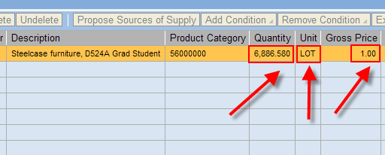
Example 2: Computing order which contains multiple items  In both cases, the order was written for the total dollar amount. This is entered into the Quantity box. | 