Process: Depending on the commodity and nature of the order, some Shopping Carts (and their resulting Purchase Orders) are setup in a “reverse” format. Reverse orders are essentially “lump-sum” or “blanket” orders and are written with one-line for the total order dollar amount. In short, a reverse order is written for the dollar amount of the order rather than line item units.

Reverse orders are formatted with the total dollar amount of the order entered in the Quantity box of line 1. Goods confirmations and invoices, as they are due, are also posted in dollars.

In order for business processes to flow and payments to release smoothly, Goods Confirmations for reverse orders must be created against the dollar amount of the order rather than individual order units. If the PO, Goods Confirmation, and Invoice postings do not create a 3-way match, check payment will not release.

TIP: A reverse order can be identified if the PO quantity is in dollars and/or the unit of measure is LOT.

Role: Goods Confirmer | Frequency: As needed

Message Definition
Scenario I – Creating a Goods Confirmation for confirming a complete order in reverse format  To confirm on the full amount of a reverse order, enter the full Confirm Quantity that matches the Outstanding Quantity. | 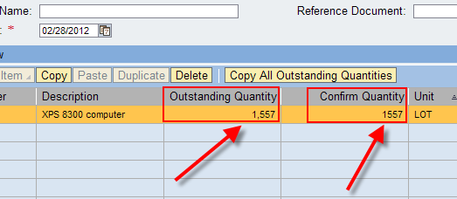
Scenario II – Creating a Goods Confirmation for confirming a partial order in reverse format  To confirm on a partial amount of a reverse order, enter only the Confirm Quantity that matches the Outstanding Quantity, i.e. the dollar amount of the partial invoice. | 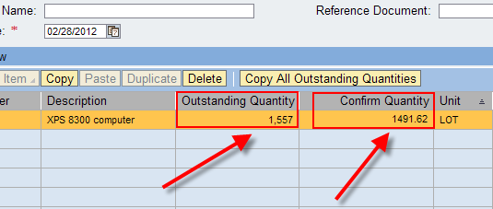
How do I know the amount to receive on a partial quantity?  If a partial confirmation is required for a reverse order, it must match the associated invoice. To find the invoice amount, click Display Purchase Order within Site Navigation.  Click Purchase Order from the top menu bar and enter the PO number.  The Purchase Order History tab in the bottom Details section will show all related invoices and the amount of each. | 