Process: Setting the Delivery Address is integral to successfully completing a Shopping Cart. If the address is not set correctly, items may be delivered to the incorrect person or building.

There are two components to utilizing the Delivery Address feature successfully:

A. Setting your default delivery building within Personal Settings –This is done once only before you create your first Shopping Cart.

B. Completing the contact person, room, and floor number on each cart as created.

An appendix is included at the end of the help guide for selecting alternate delivery building as needed on a cart-by-cart basis.

Role: SRM Shoppers | Frequency: As needed

A. Setting Default Delivery Building – This must be done before creating your first Shopping Cart. This is the building to which you most frequently will have items delivered. Failure to set the default building will result in incorrect delivery.  1. Click Shopper tab | 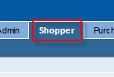
2. From the Shopper navigation panel on the left, click Settings | 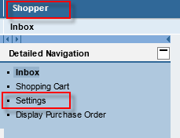
3. When Settings screen appears, click Edit | 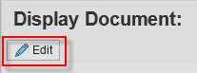
4. The Attributes section can be found in the lower portion of the screen. Click the dropdown menu and select Delivery Address. | 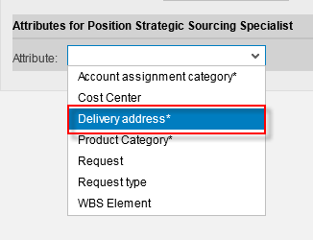
5. Highlight the 322 Peterson Service Building selection and click Remove  Note: If the line does not delete using the Remove button, simply move onto step 6. Step 6 will overwrite and remove any pre-existing building line. | 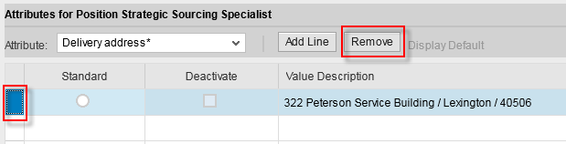
6. Click Add Line | 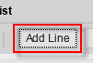
7. On the right side of the Value cell, click the search icon. | 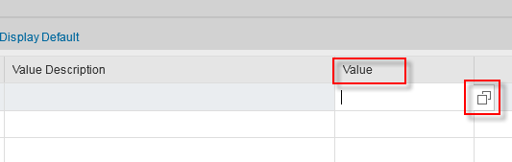
8. Locate your delivery building by speed sort code and click to select.  Note: If you do not see your building, you can also select the Show Search Criteria link to increase the number of results (usually an upper limit of 5000). | 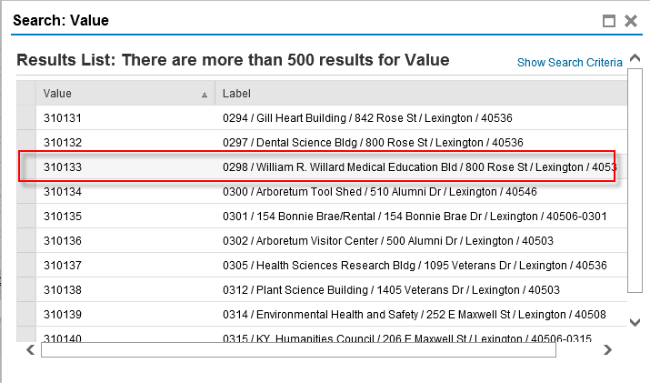
9. Click the radio button for Standard | 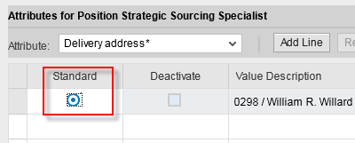
10. Click Save to finish  Once set, the default delivery building does not need to be reselected within Settings. | 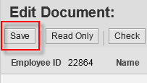

B. Completing the contact person, room, and floor – As each Shopping Cart is created, the default delivery building address loads automatically. The Shopper completes the information with entry of contact person, room, and floor number.  1. From the Shopper navigation panel on the left, click Create Documents – Shopping Cart | 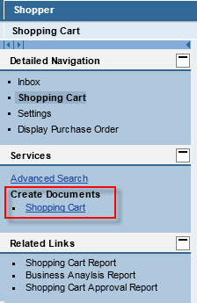
2. Click Set Values within the General Data (header) section of the cart | 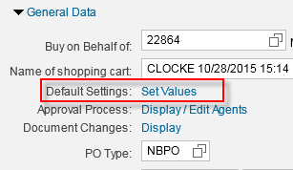
3. If the Delivery Address/Performance Location tab does not show, click the icon on right to bring it into view. | 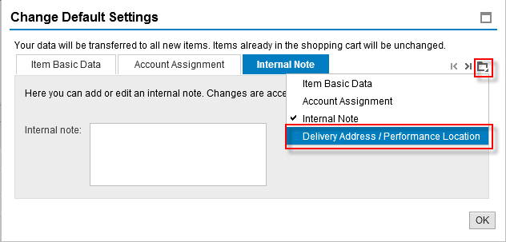
4. Complete the delivery contact person’s name, room, and floor number | 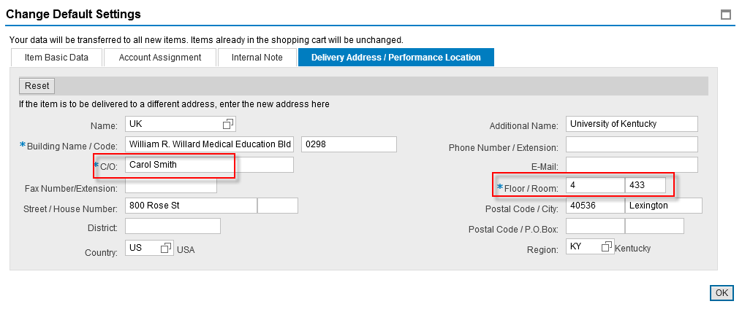
5. Complete the account assignment tab with cost center or WBS Element. Click OK to finish Delivery Settings.  Continue with Shopping tasks as needed and complete Cart. | 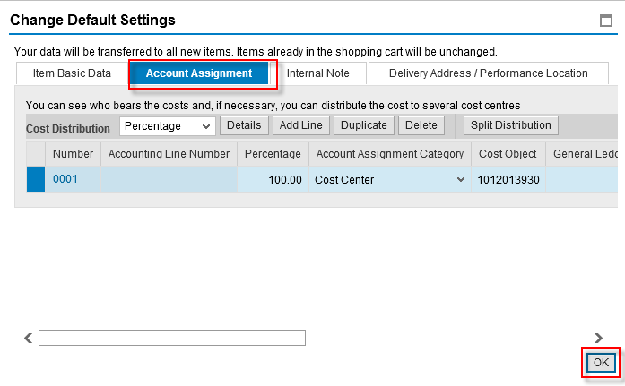

Appendix: Setting Alternate Delivery Information on a Cart-by-Cart Basis

From time to time, the Shopper may need to have an order shipped to a different building. The Shopper can select an alternate delivery building on a cart-by-cart basis as needed.

1. To change address to another building, from within the Delivery Address/Performance Location tab, select the search icon to right of Name box. | 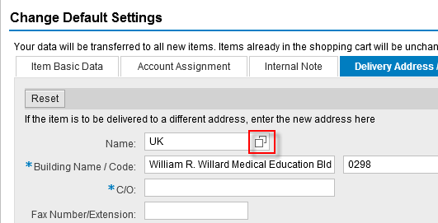
2. From within the Search term 1 dropdown menu, select Building code. | 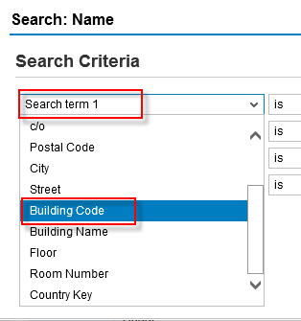
3. Enter Building/Speed Sort code for alternate building.  Click Search  Select the building from the search results | 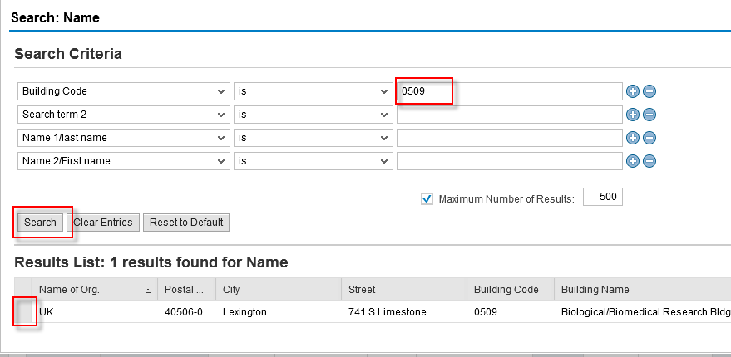
4. Complete with delivery contact person’s name, floor, and room number  Continue with completing Account Assignment and Shopping as needed.  Important: Be sure to select the alternate building through the process above. Do not freehand address information for an alternate building. | 