Process: Shipping status for VWR International Shopping Carts is available from within the e-catalog. It contains shipment and tracking information along with a link for UPS/FedEx real-time delivery information.

Role: Shopper | Frequency: As needed

To obtain shipping information, the Shopper needs either the VWR order number or the purchase order number. These are located on the email confirmation sent to the Shopper for each order placed. | 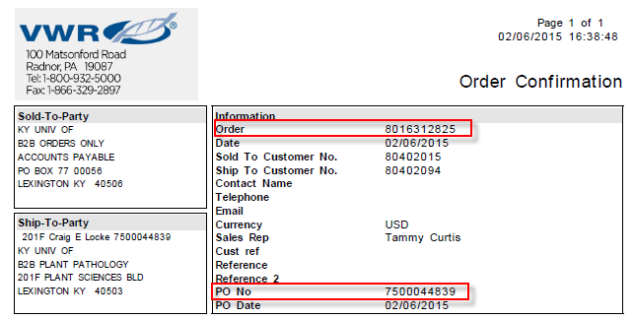
If no other information is available, the PO number can be found on the Related Documents tab of the original Shopping Cart. | 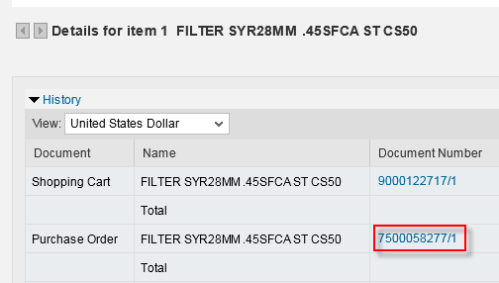
1. Open a new Shopping Cart. If you are only checking shipment status, you do not need to provide account assignment or Delivery Address entries. Simply proceed to the e-catalog via the Add Item menu. | 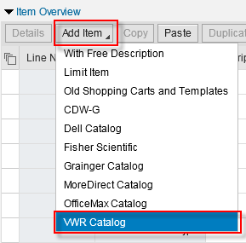
2. Upon arrival at the catalog landing page, click MyAccount in the upper right corner and select Order Status. | 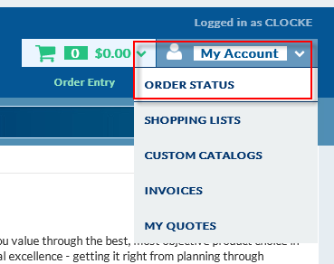
3. Enter one or more of the primary search criteria and click Search | 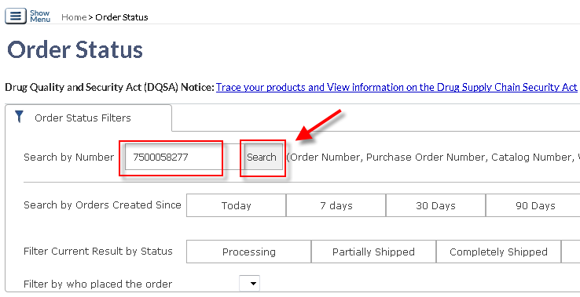
4. Search results show summary information for order. Drill into the Order Number for more information | 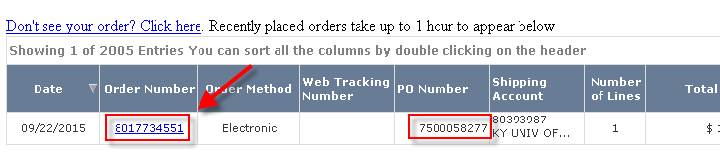
5. Details screen provides summary information about the shipment, including a link for UPS/FedEx tracking information. | 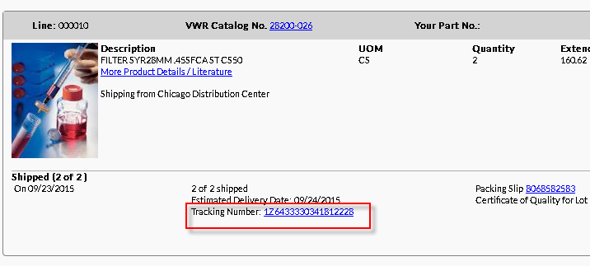
Tracking information includes name of person taking receipt of the delivery. | 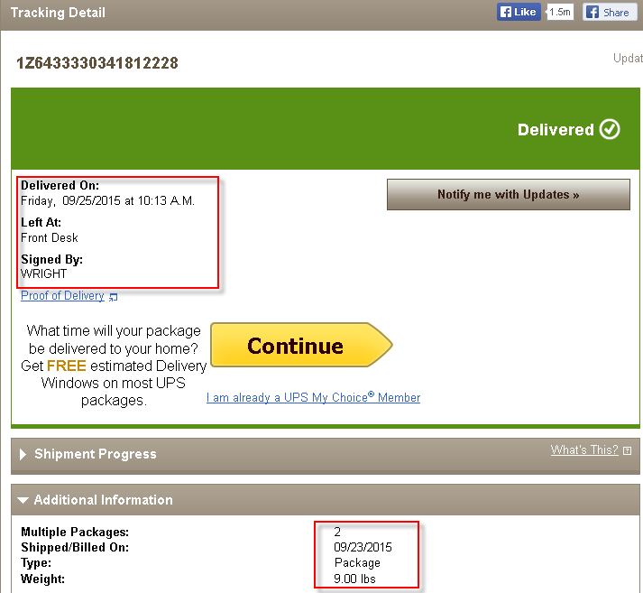
When finished, click the Back button from the VWR landing page to exit the e-catalog and close the Shopping Cart window. | 