STATISTICAL INTERNAL ORDER NUMBERS on SRM Shopping Carts
(Single Account Assignment)
Always begin an SRM Shopping cart at:
General Data TAB > Default Settings – Set Values section
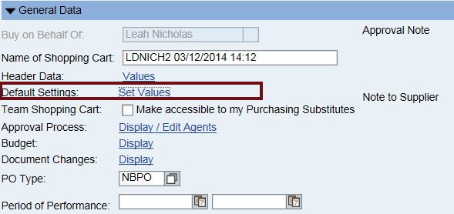
Choose the Account Assignment TAB > Details
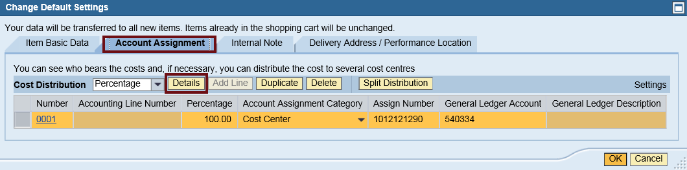
Account details will expand and if any default values they will display.
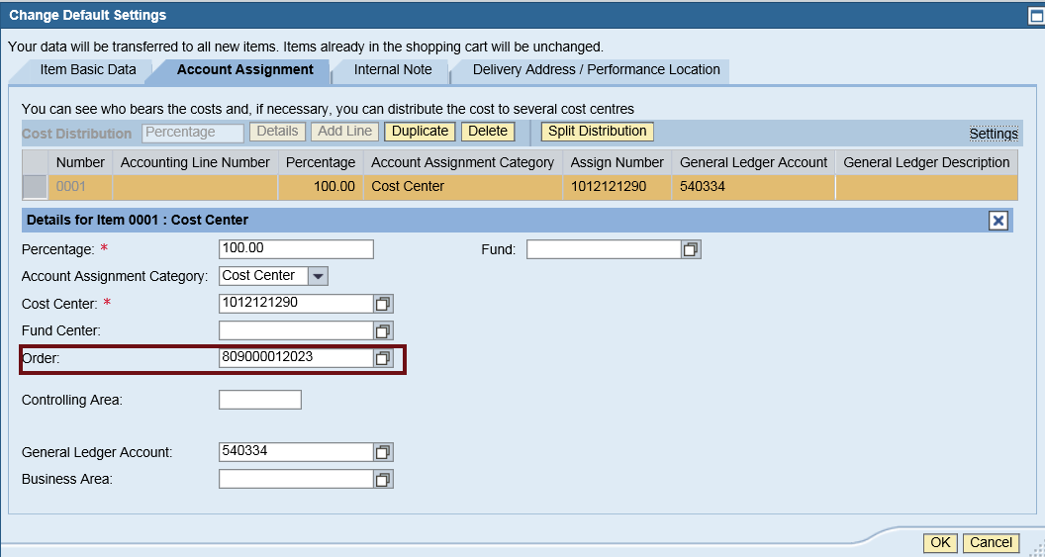
Add the Statistical Internal Order number in the “ORDER” field and press enter key.

NOTE: if not default values populate, very important to add Cost Object, press enter to derive details, then add the Order number and press enter and “OK” to proceed.

Complete your line item entries, go to the Details for Item, choose Account Assignment TAB to view, adjust any account assignment for each line as required.
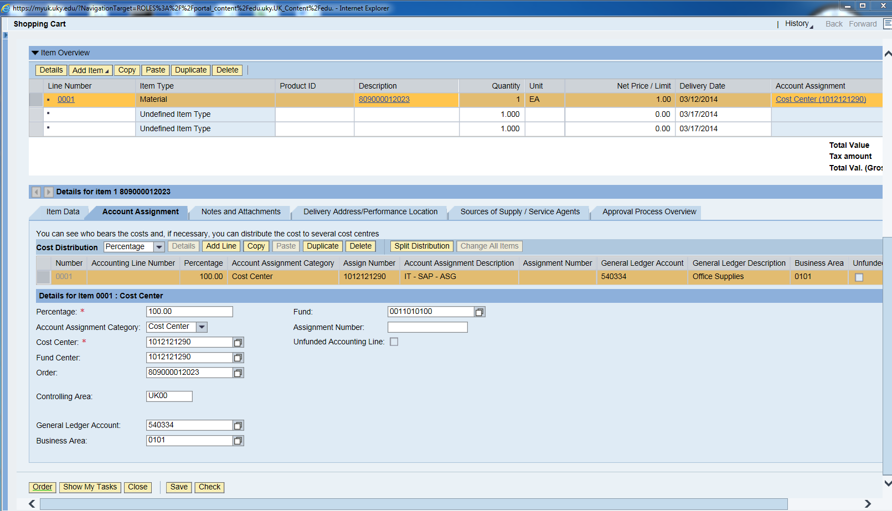

STATISTICAL INTERNAL ORDER NUMBERS on SRM Shopping Carts
(Multiple-Split Account Assignment)
Always begin an SRM Shopping cart at:
General Data TAB > Default Settings – Set Values section
Choose the Account Assignment TAB > Details
DELETE ANY VALUE by pressing the DELETE Button
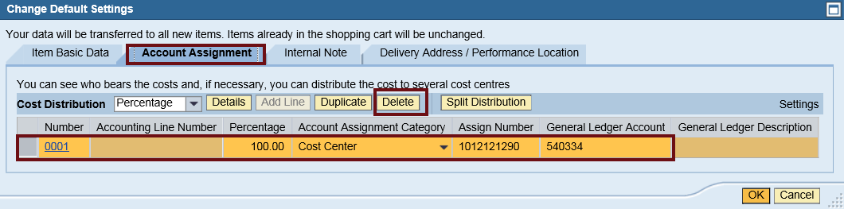
Choose “OK” to proceed
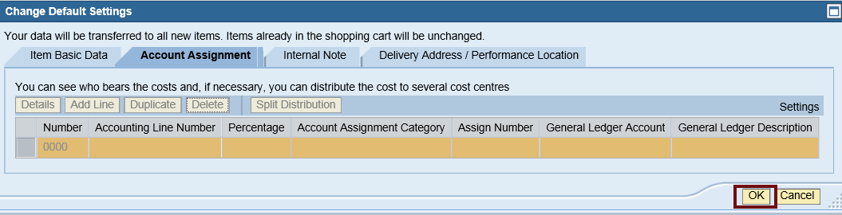

Complete your first line item entry and press ENTER key. Then select DETAILS button to expand view
Choose Account Assignment TAB to view, select “ADD LINE”
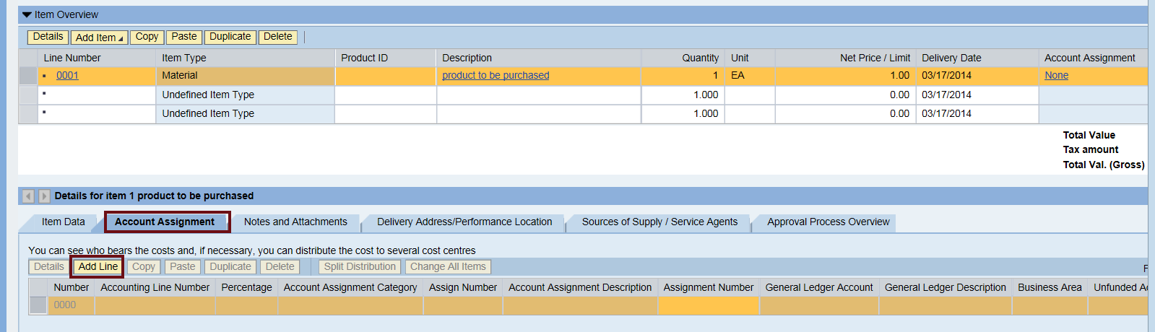
Choose DETAILS button to expand account assignment
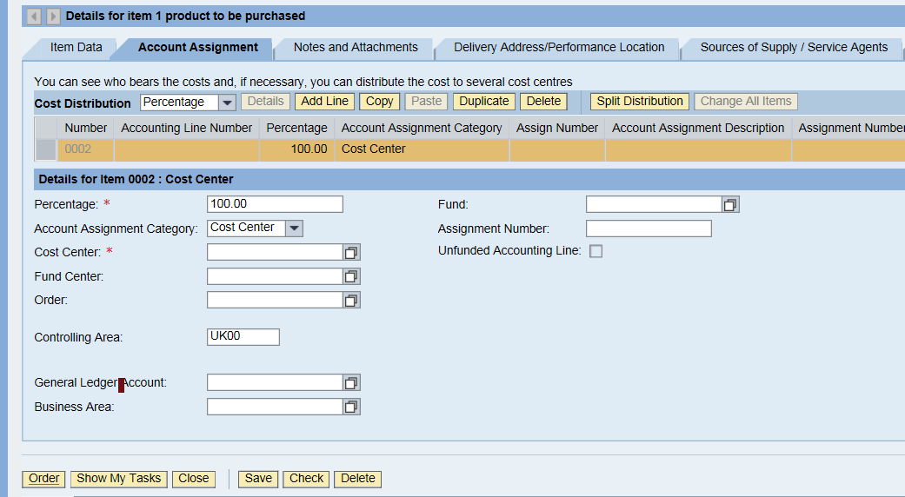
1st address cost distribution, determine if by percent, quantity or by value. Make sure your line item detail is correct for any of the above distribution options.
NOTE: Contact Purchasing Department for instructions on the split assignment if necessary

PERCENT DISTRIBUTION
Change the Percentage: to desired amount and add the cost object and PRESS ENTER KEY
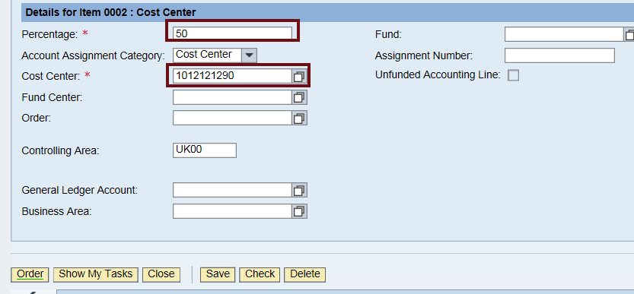
NOTE: Accounting will derive the appropriate Fund Center, Business Area and FUND
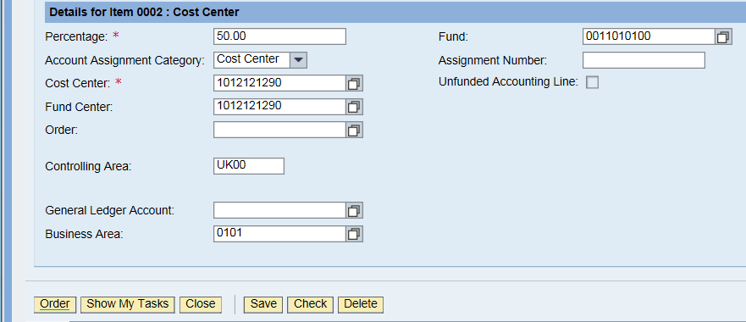
NOW, add the STATISTICAL INTERNAL ORDER NUMBER in the ORDER FIELD and PRESS ENTER KEY
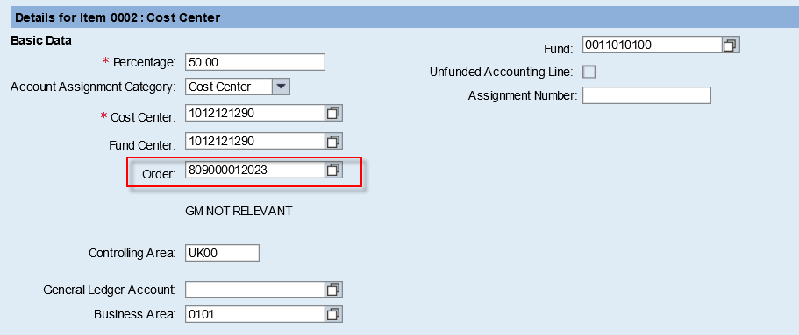
REMEMBER PRESS ENTER KEY after your entry.
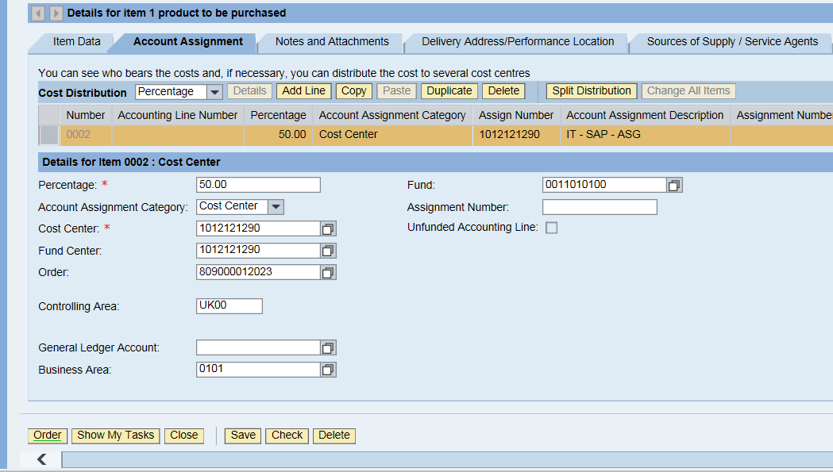
Add the g/l code and PRESS ENTER KEY. Time to begin next accounting line to split.
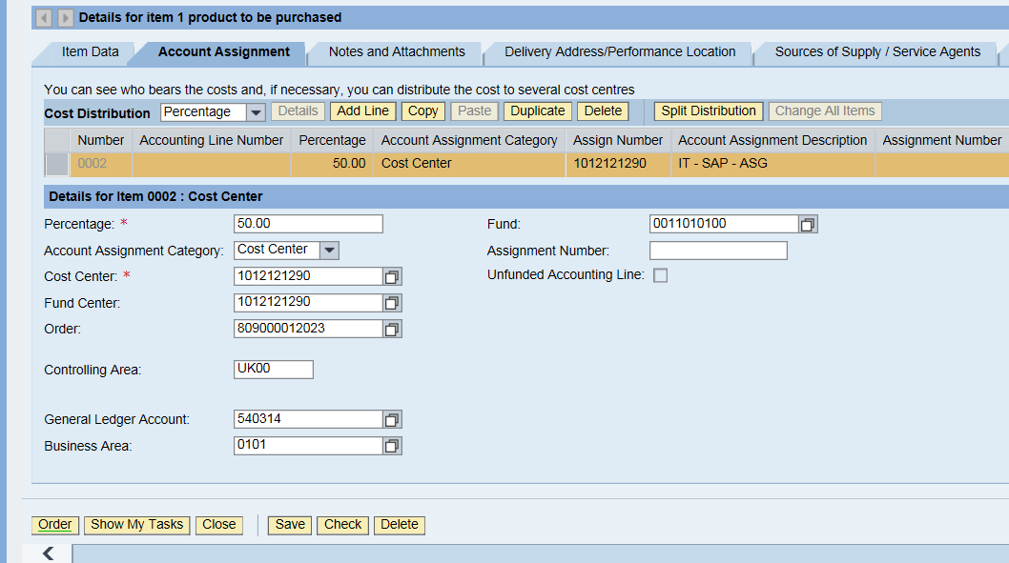
CHOOSE ADD LINE BUTTON, notice new line added is not highlight”….press box to change lines.
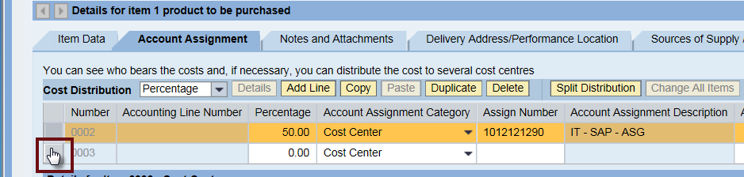
Complete the desired information on the 2nd line of the account assignment distribution and PRESS ENTER KEY then “CHECK” button for any messages.
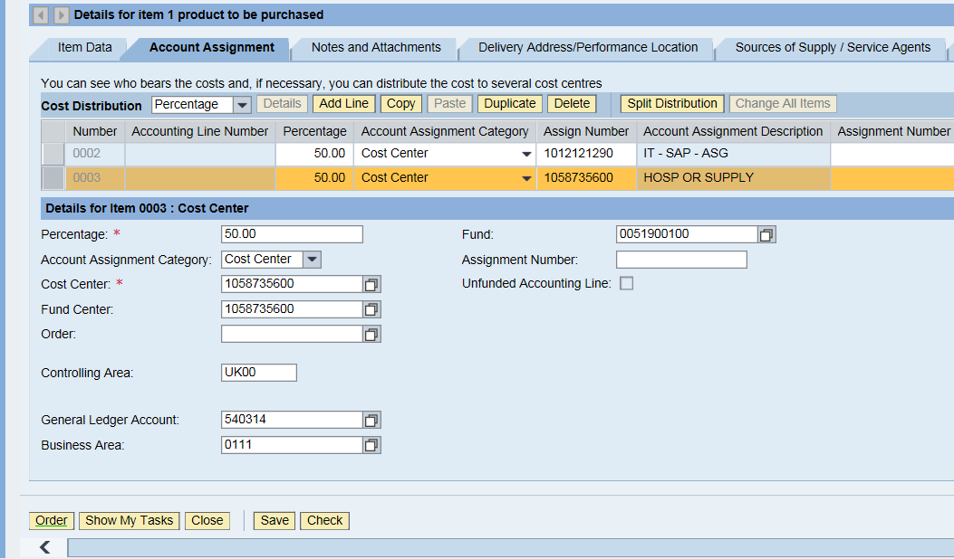
NOW, add the STATISTICAL INTERNAL ORDER NUMBER in the ORDER FIELD and PRESS ENTER KEY

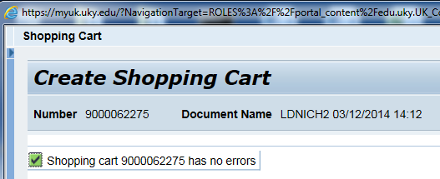

Once it has been determined that the accounting is correct, the “copy” and “paste” function at the account assignment TAB can be used for any the remaining line items.

