Process: Perform this procedure to create a new Shopping Cart by mirroring contents from an old Shopping Cart. All line items and most characteristics of the old Shopping Cart will be replicated into a new cart. Changes can be made to the new Shopping Cart data as needed prior to ordering.

Notes: A Shopping Cart that has been deleted cannot be copied to a new cart. Also, due to possible pricing fluctuations, punchout catalog Shopping Carts should not be replicated into new Shopping Carts.
Role: Shopper | Frequency: As needed

BEGINNING STEPS
Begin a new Shopping Cart as normal  From the Add Item menu, click Old Shopping Carts and Templates | 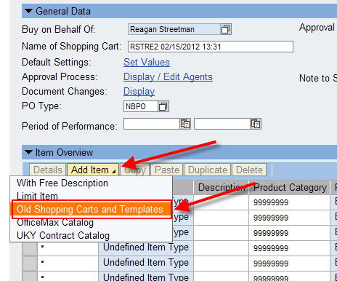
Enter number of the old Shopping Cart and click Search | 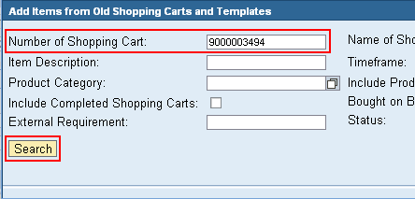
Once the cart is located, highlight entire line and click OK  TIP: If the old Shopping Cart has multiple lines, and you want to copy only specific lines, click the black icon to expand and select individual line items. | 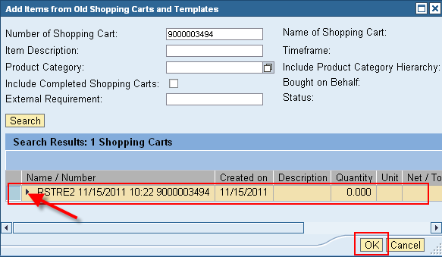
With the exception of header notes and delivery address, the new Shopping Cart should reflect all aspects and details of the old Shopping Cart.  Set contact person and room number of delivery address via Default Settings / Set Values selection  Add new header notes as necessary  Check/overwrite other details if needed | 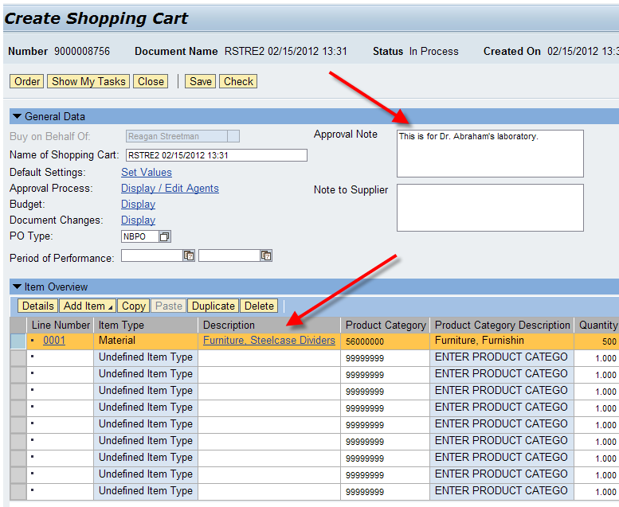
Click Check for errors  Click Order to finish  Remember – only click Save if you wish to place the cart on hold | 