In order to maintain checks and balances there is a limit on the number and structure of roles any one person may hold. The following matrix shows all permissible combinations for various procurement roles within myUK.
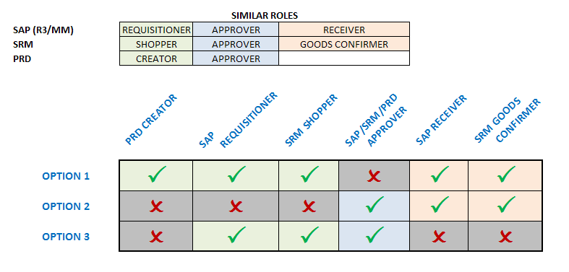
The same person is not required to hold all roles within any one option. The combinations reflect the maximum roles within each option any one person may hold.

