Process: In some instances, it may be necessary to return item(s) to the supplier for credit. This may be due to damage, incorrect item ordered, item not needed, etc. A specific protocol is built into SRM Goods Confirmations for executing Returns.
Role: Goods Confirmer | Frequency: As needed

BEGINNING STEPS
- Department notifies supplier of need to return, confirms if approved, whether there are any associated fees (restocking/freight), and requests Return Merchandise Authorization (RMA) | 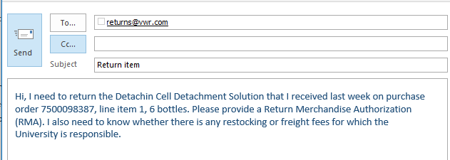
- Vendor provides RMA and vendor/department jointly execute RMA / pickup / return of item(s) | 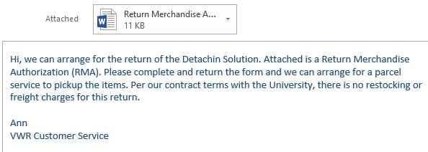
- Access the Goods Confirmation tab within myUK | 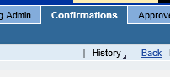
- Locate and open the Goods Confirmation for the item(s) to be returned | 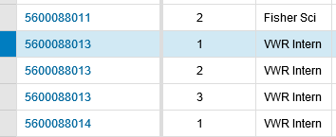
- Click Return Delivery button | 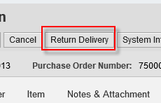
- Under the Notes and Attachment Tab, select  Add Reason for Return Delivery | 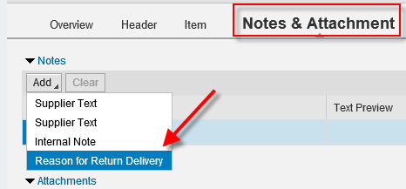
- Indicate the Reason for Return Delivery | 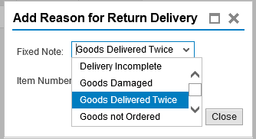
- Select the item number being returned.  Click Save | 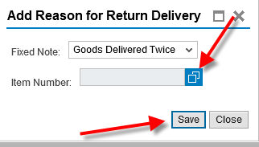
- Indicate the quantity being returned | 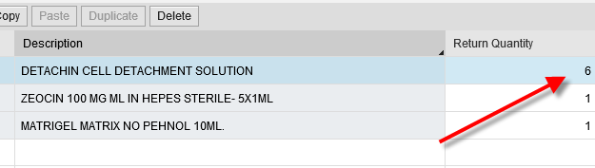
- Click Confirm Return. An SRM Return document number will be assigned. | 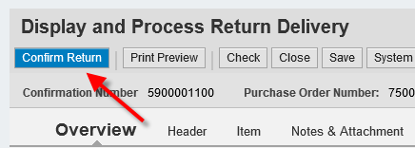
- Use T-code ME23N, if needed, to validate and track the Return Delivery posting against the PO. This can be found on the Purchase Order history tab in the bottom Details section. It will post under the Goods Receipt section.  The credit memo, when issued by the supplier, will post here under the Invoice Receipt section. | 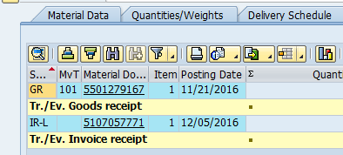
- Notify the Purchasing buyer responsible for the order via email regarding the return so s/he can monitor and close out the PO line item and remaining encumbrance.  If a partial charge results from the return (restocking fee, return freight, etc.), the Purchasing buyer will manage/correct the line item within SRM as appropriate to allow the charges.  If you have special circumstances (e.g., returning item on which the invoice has already paid) consult the Purchasing buyer for guidance. | 