Process: In some instances, it may be necessary to return item(s) to the supplier for credit. This may be due to damage, incorrect item ordered, item not needed, etc. A specific protocol is built into SAP T-code MIGO for executing Returns.
Role: Goods Receiver | Frequency: As needed

BEGINNING STEPS
- Department notifies supplier of need to return, confirms if approved, whether there are any associated fees (restocking/freight), and requests Return Merchandise Authorization (RMA) | 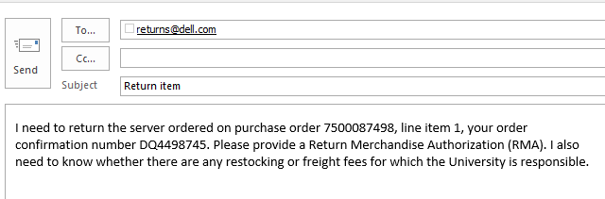
- Vendor provides RMA and vendor/department jointly execute RMA / pickup / return of item(s) | 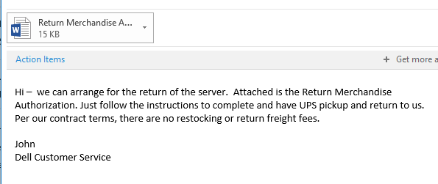
- Access T-Code MIGO through the SAP Easy Access menu | 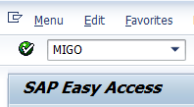
- Select Return Delivery in the first box and enter the SAP Goods Receipt number on which it was received. | 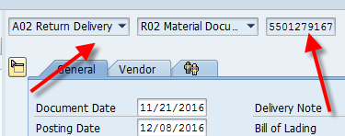
- Indicate Reason for Movement. Click the Possible Entries icon and select the appropriate reason for return. | 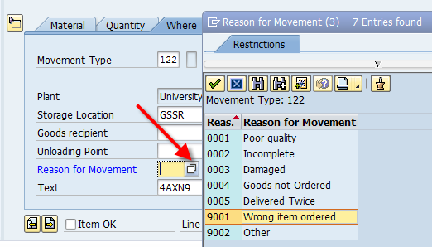
- In the bottom Details Section, check Item OK for each item on the Return. Use the left/right arrow buttons to navigate among lines. | 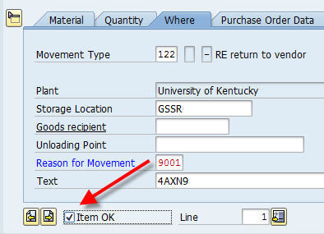
- Click Save button. An SAP Return document number will be assigned. | 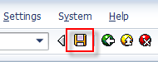
- Use T-code ME23N, if needed, to validate and track the Return Delivery posting against the PO. This can be found on the Purchase Order history tab in the bottom Details section. It will post under the Goods Receipt section.  The credit memo, when issued by the supplier, will post here under the Invoice Receipt section. | 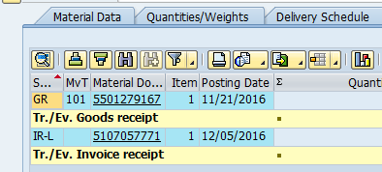
- Notify the Purchasing buyer responsible for the order via email regarding the return so s/he can monitor and close out the PO line item and remaining encumbrance.  If a partial charge results from the return (restocking fee, return freight, etc.), the Purchasing buyer will manage/correct the line item within SRM as appropriate to allow the charges.  If you have special circumstances (e.g., returning item on which the invoice has already paid) consult the Purchasing buyer for guidance. | 